EXPERIMENT 1

1.INSTALLATION OF STARUML, GIT BASH AND GITHUB ACCOUNT CREATION

Step 1 open star UML in google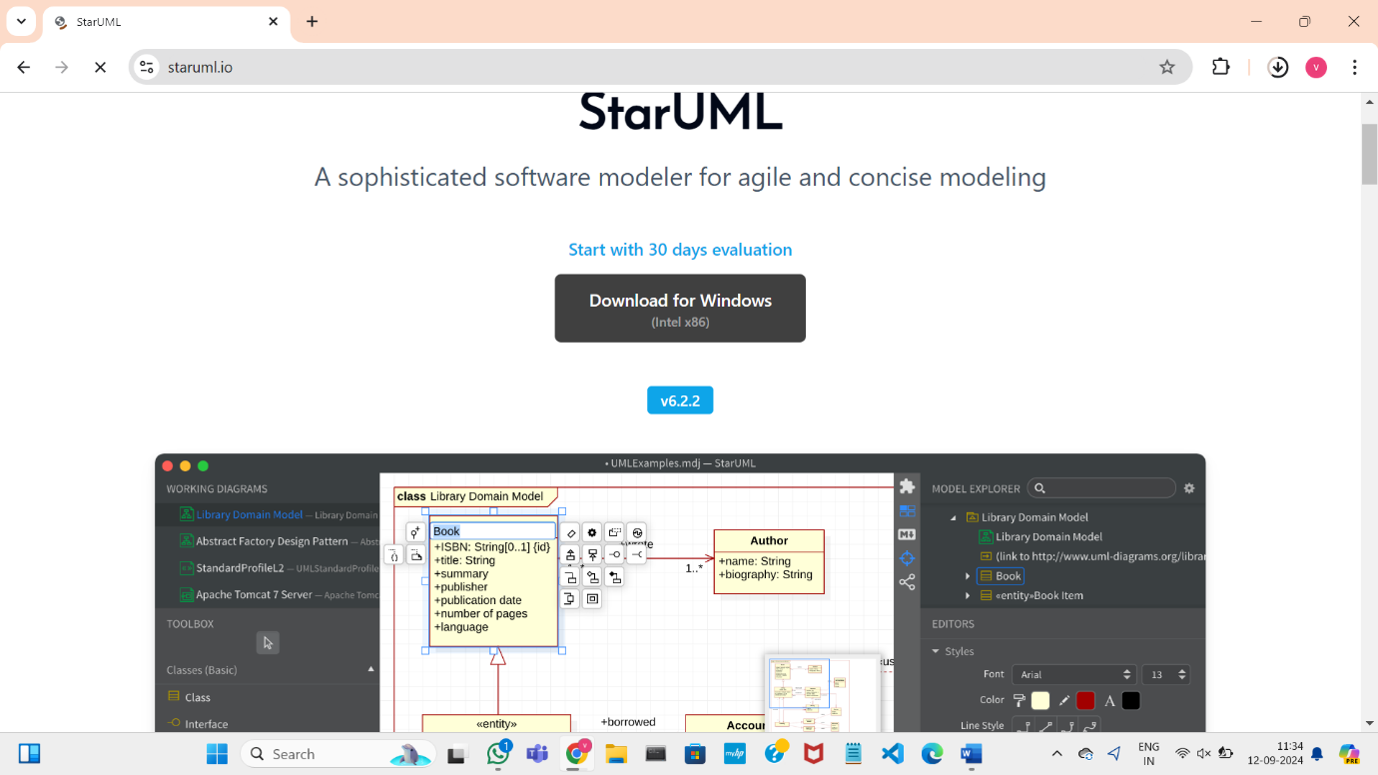

Step 2:download starUML

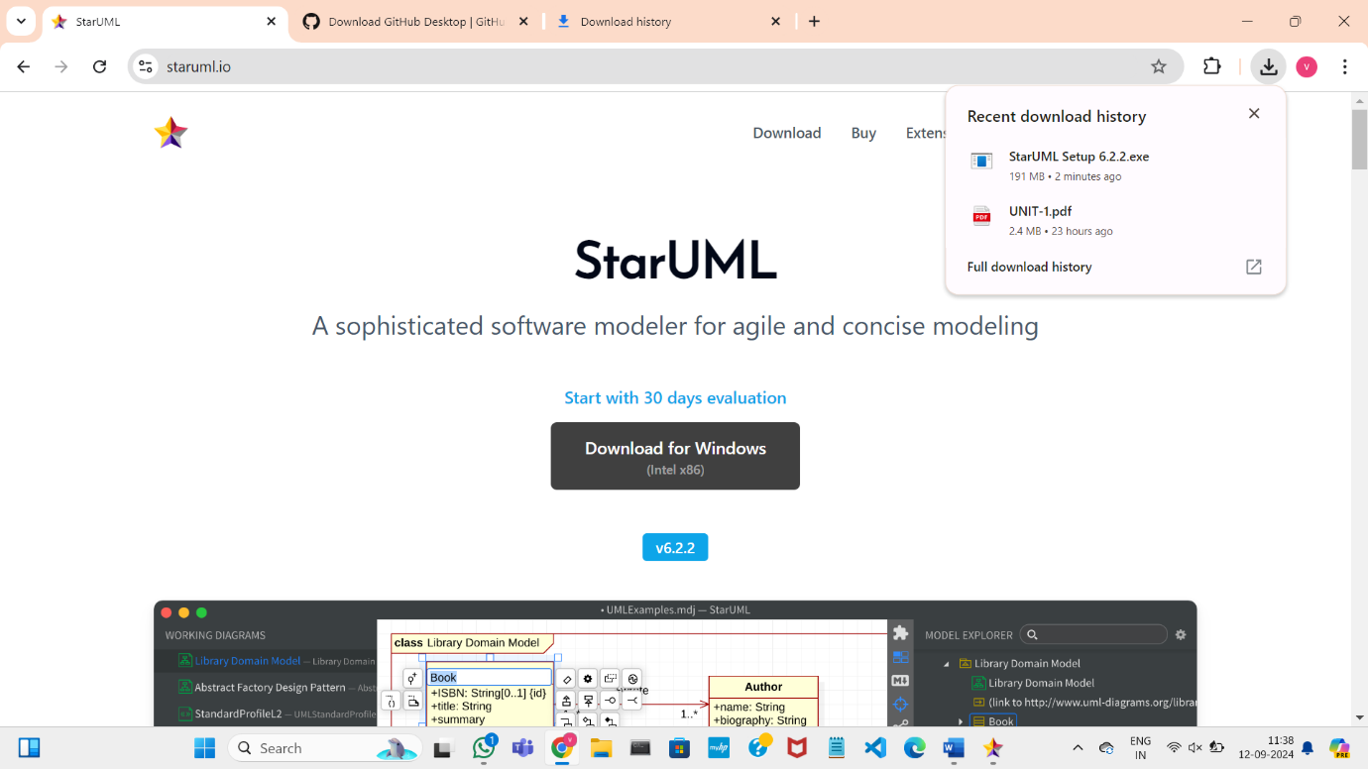

Step 3:

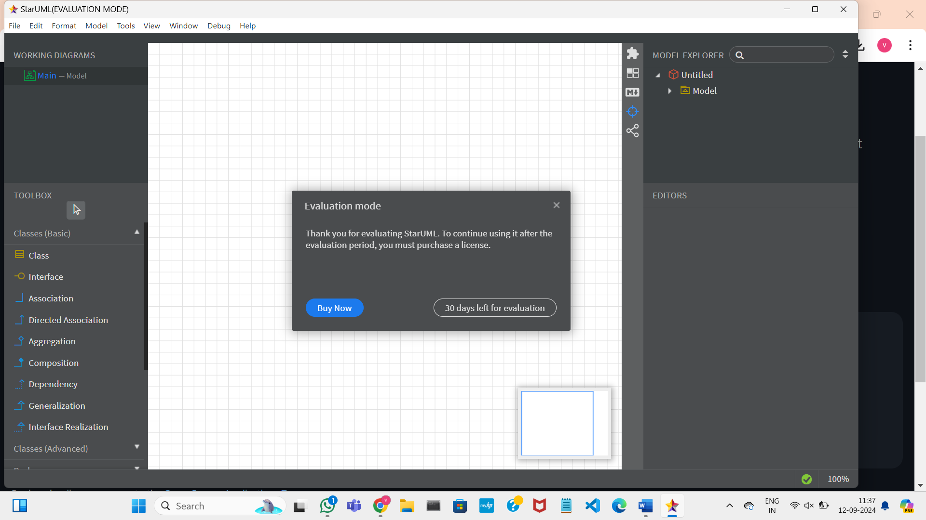

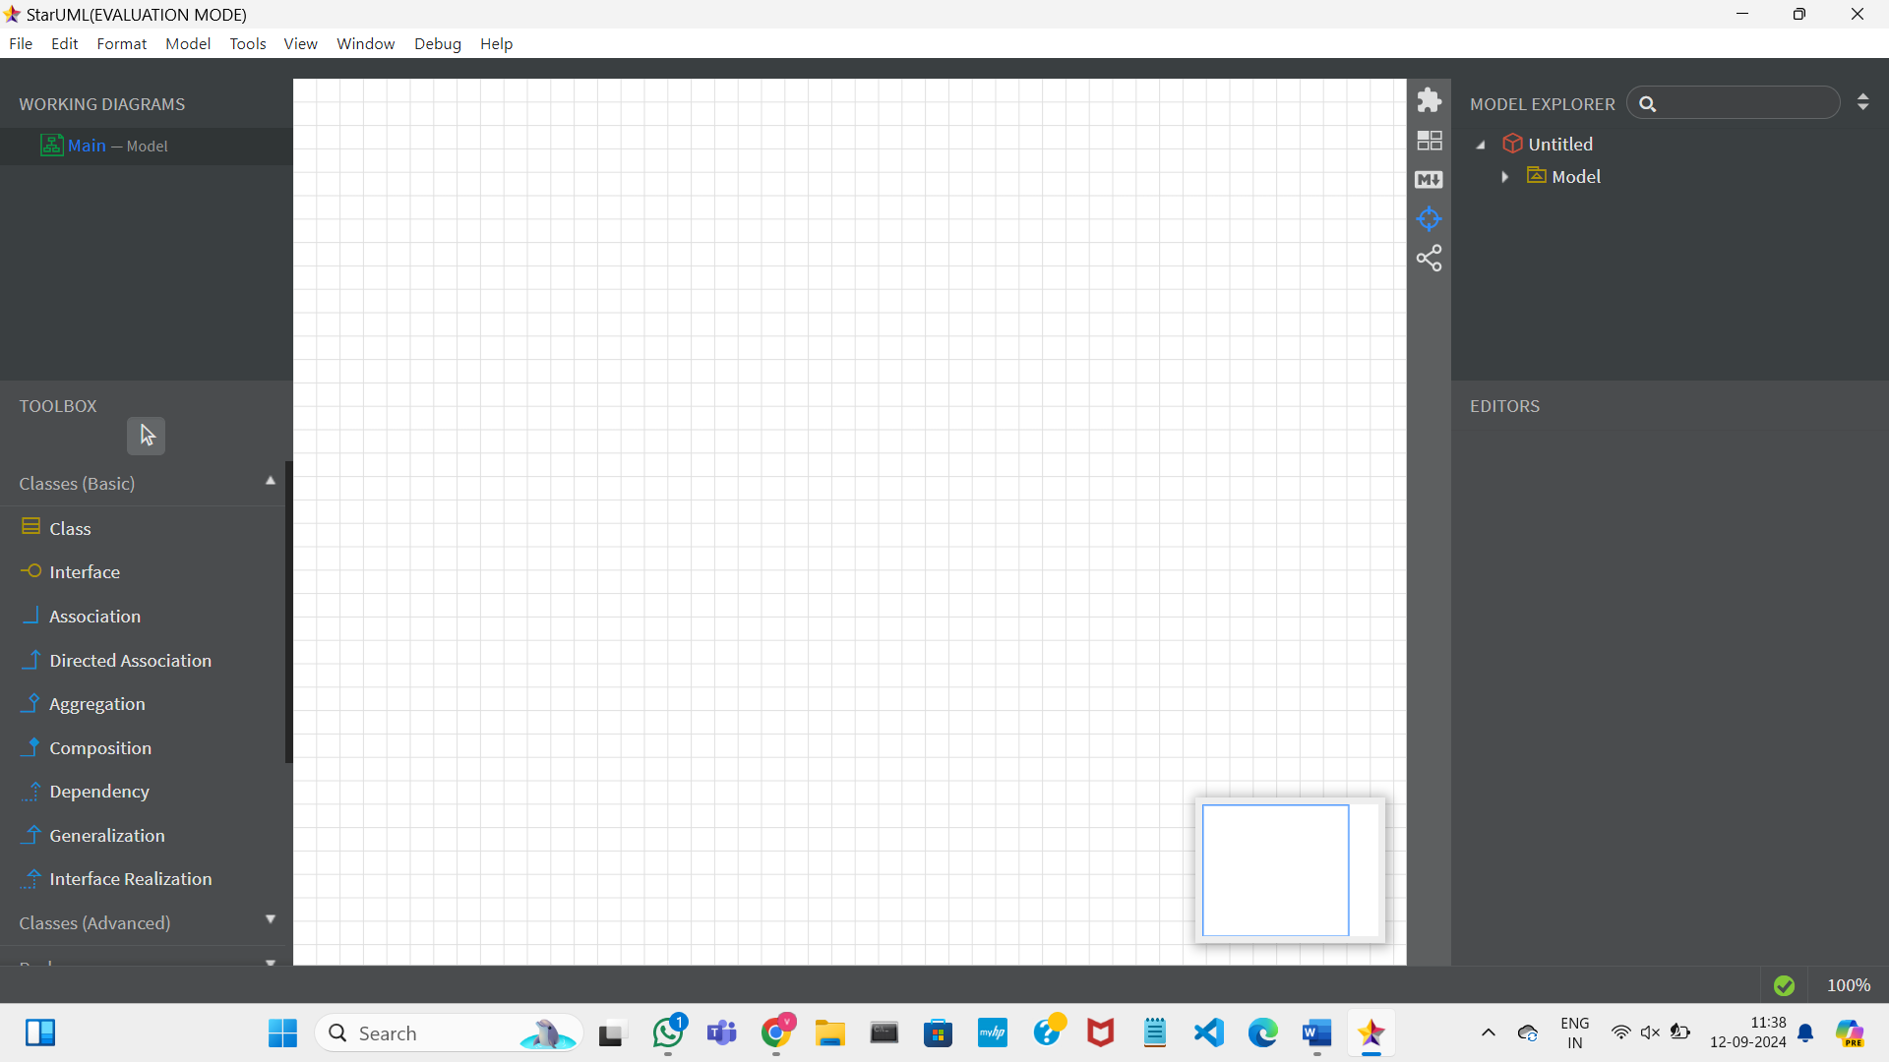

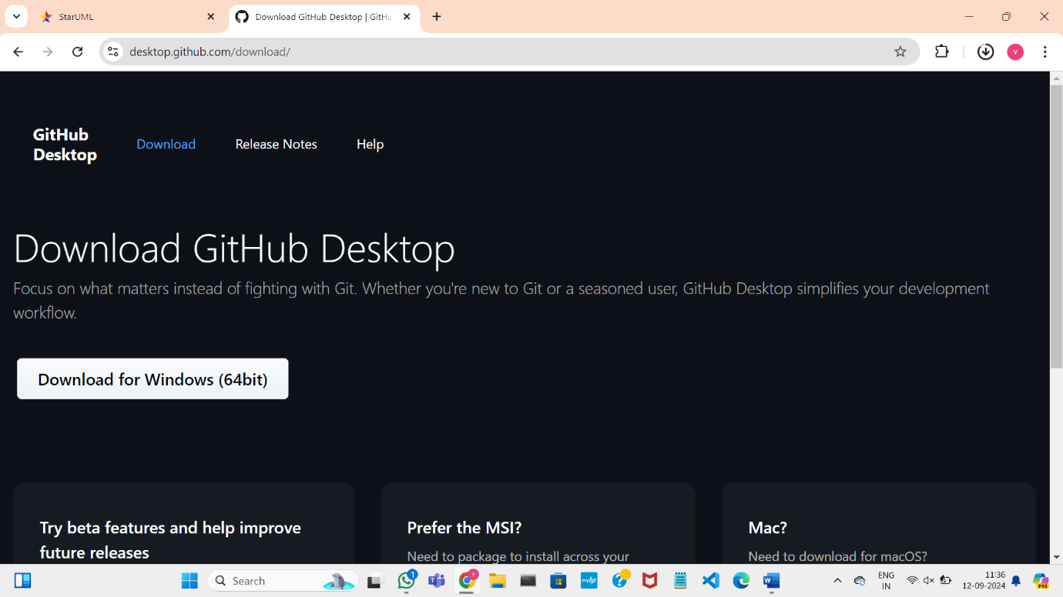

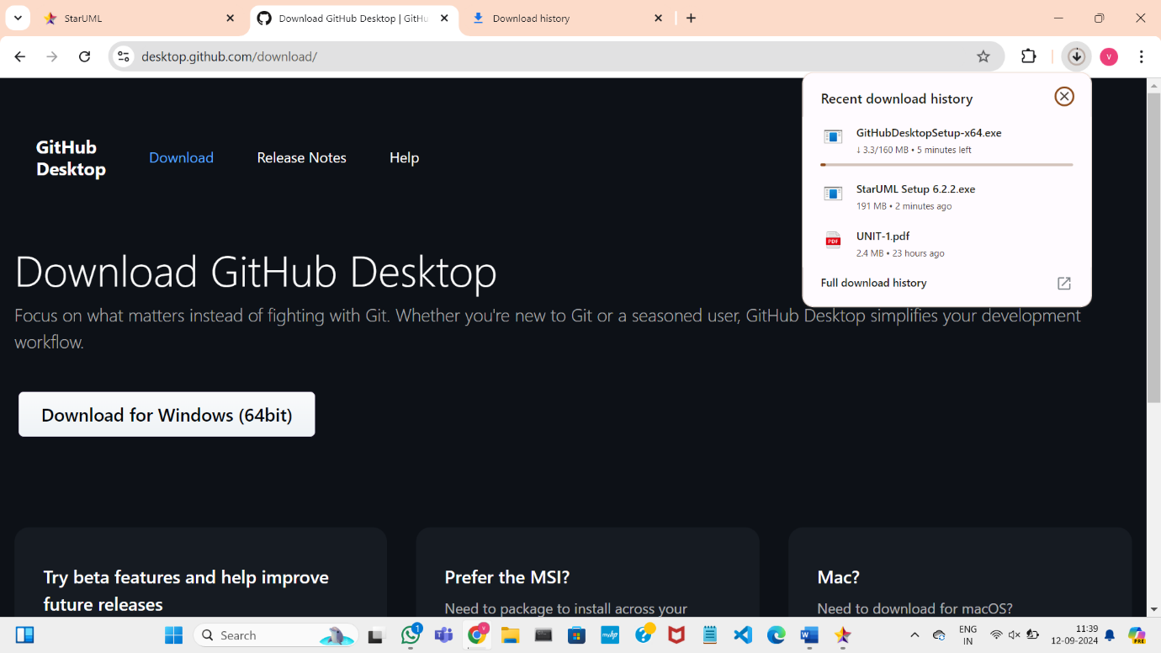

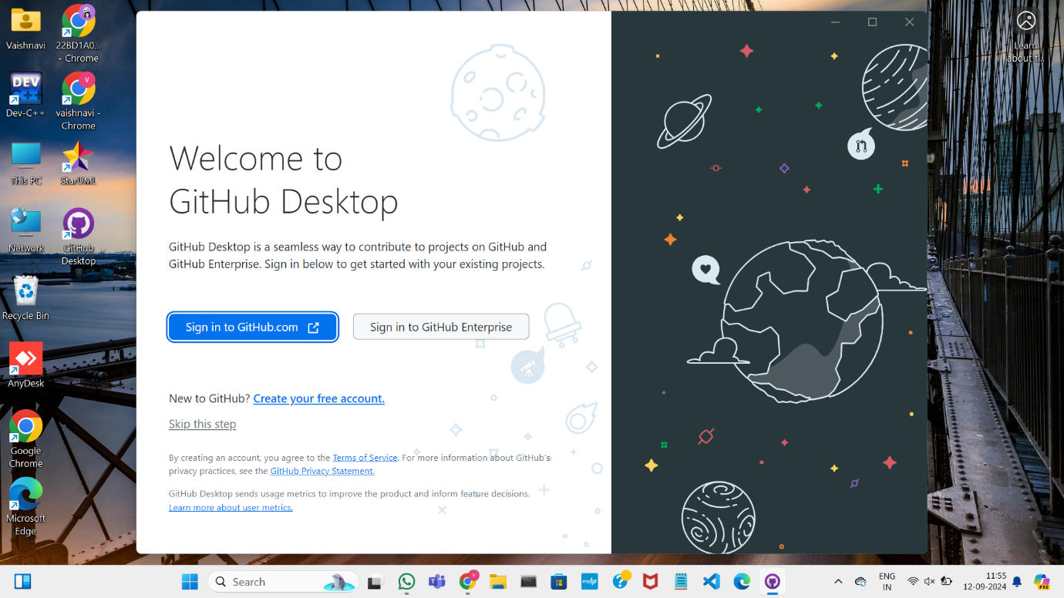

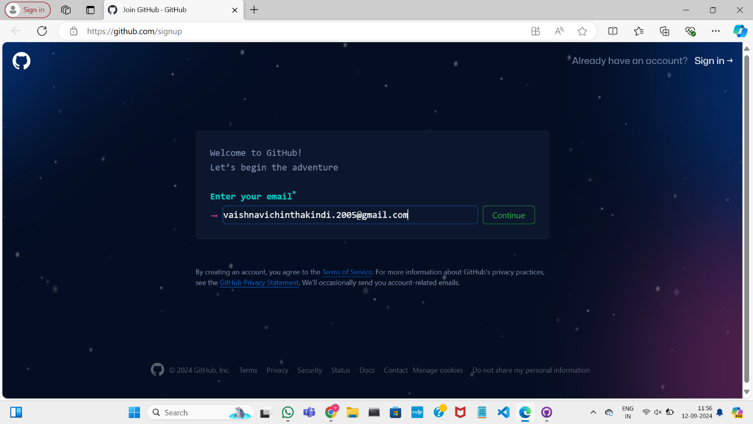

GIT BASH

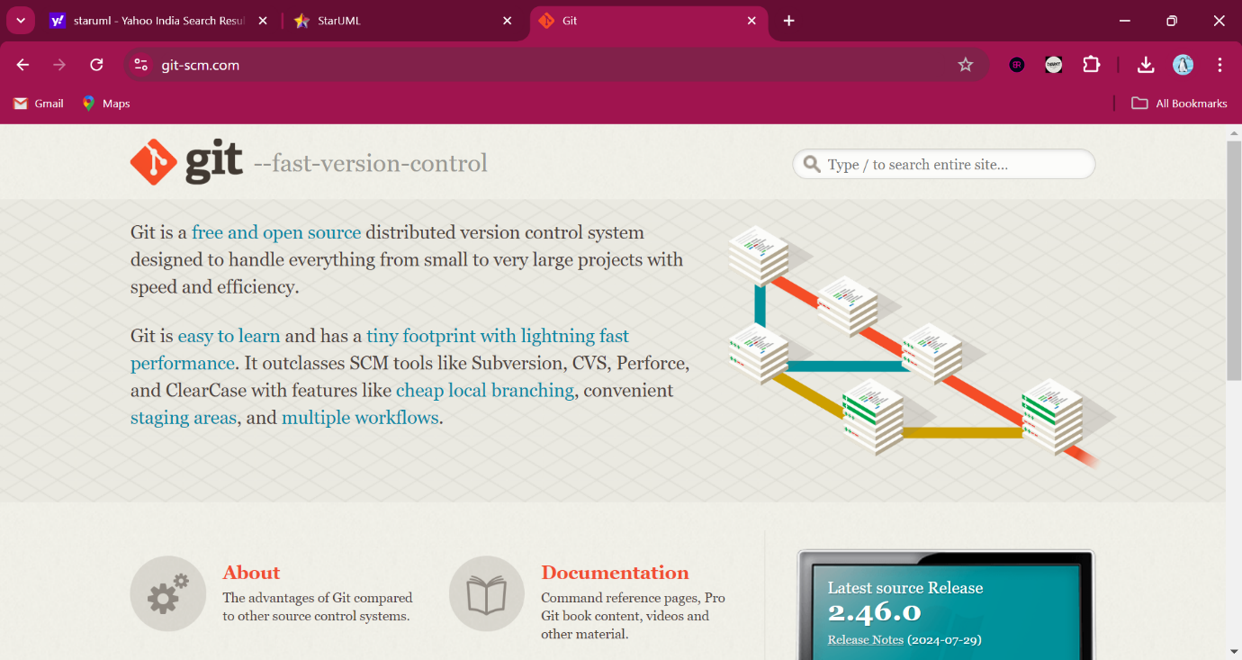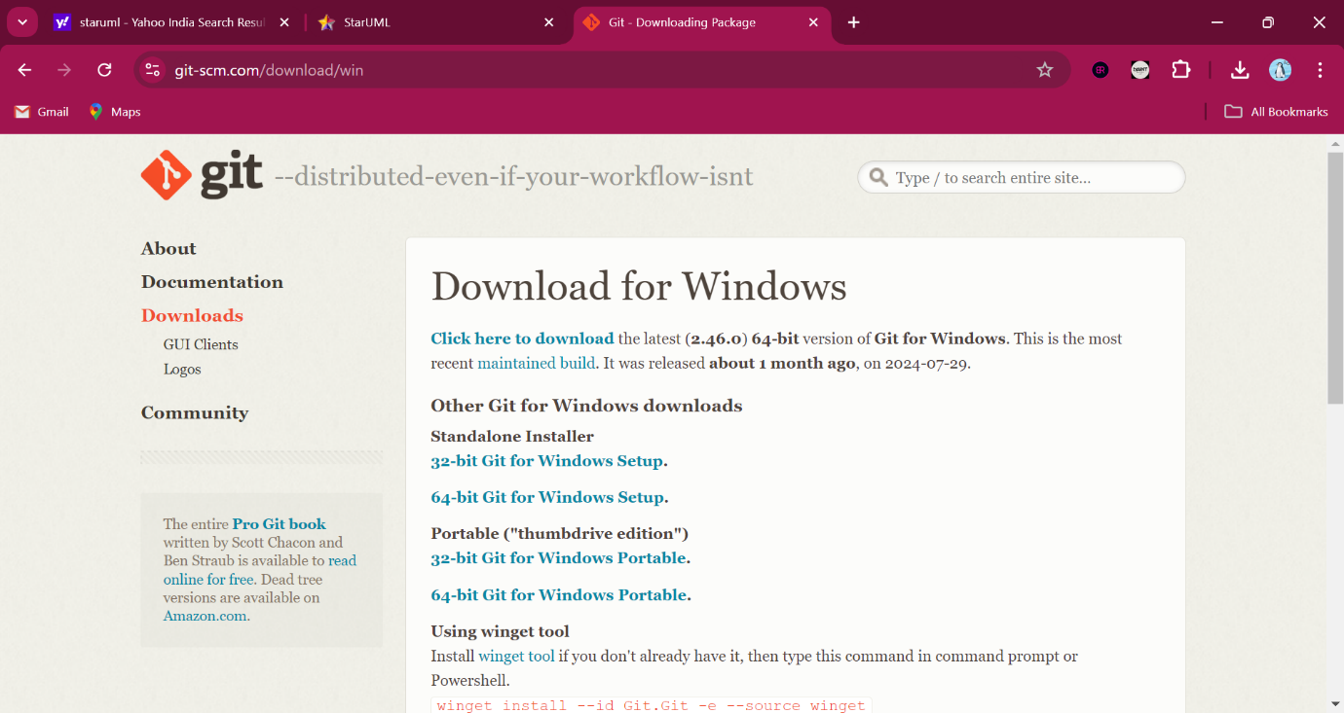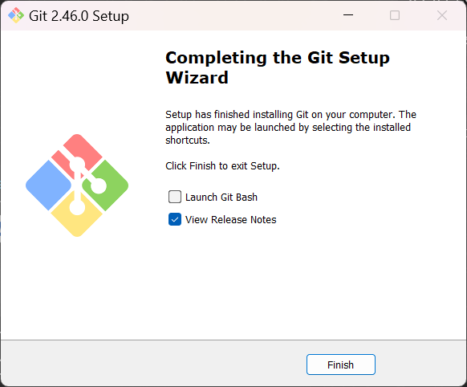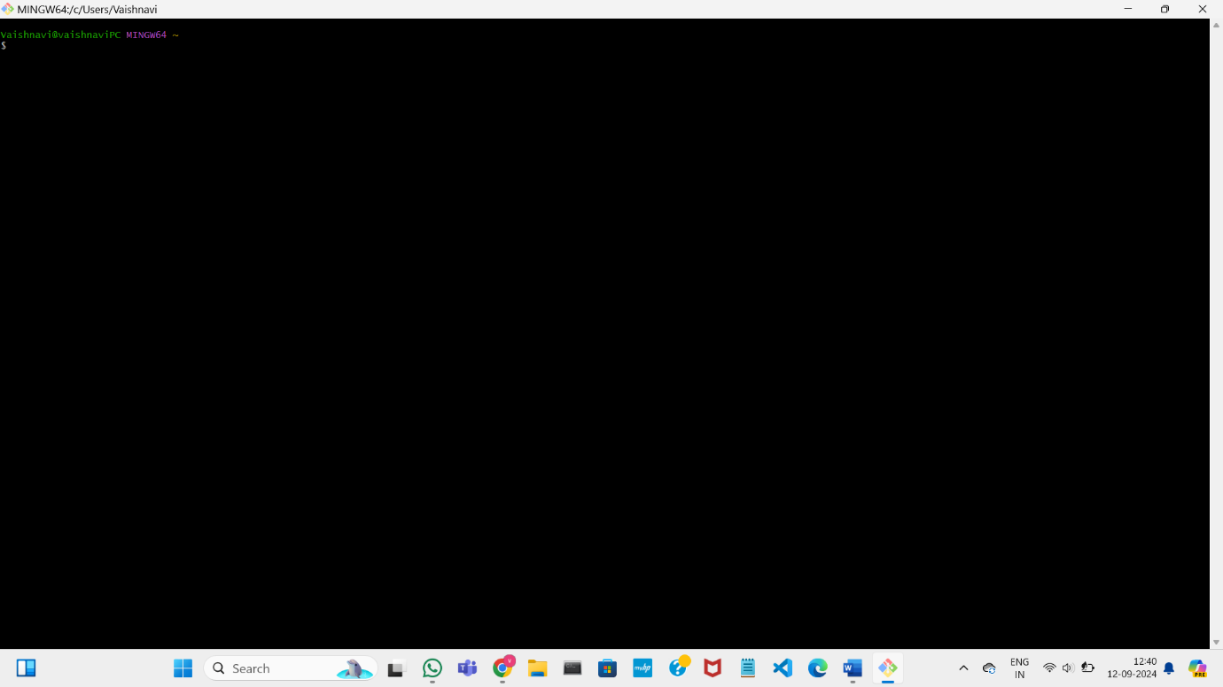

1. IEEE – SRS (SOFTWARE REQUIREMENTS SPECIFICATION) WITH UML DIAGRAMS

RECRUITMENT SYSTEM

1. B.Richitha 22BD1A05A9
2. E.Sameera 22BD1A05AK
3. Ch.Vaishnavi 22BD1A05AB
4. L.Poojitha 22BD1A05B7
5. M.Snigdha 22BD1A05BB

Problem statement

In today's competitive job market, candidates often face challenges in navigating the interview process, leading to anxiety and underperformance during crucial recruitment stages. Many organizations struggle to find the right talent, not due to a lack of qualified applicants but because candidates are not adequately prepared to present their skills effectively. Additionally, candidates must search for preparation materials like guides, previous year questions (PYQs), and job timelines across various platforms, creating an inefficient and stressful experience.

To address these challenges, there is a need for an integrated recruitment system that not only allows users to apply for jobs but also provides tailored preparation resources. This system should include an *Interview Preparation Resources* feature, offering essential materials such as practice questions, information about the hiring company, role-specific details, and tips for various interview types (behavioural, technical, situational). By consolidating application and preparation resources—such as prep guides, PYQs, and job timelines—into a single platform, candidates can prepare more effectively and confidently. This feature empowers candidates with the tools they need to succeed, allowing recruiters to evaluate applicants based on their true qualifications rather than how they handle interview pressure. Additionally, by providing company-specific insights, the system fosters better cultural alignment and improves hiring decisions, leading to higher retention rates and a more engaged workforce. Overall, this system enhances both the candidate experience and the recruitment process, making it more transparent, fair, and efficient for all stakeholders involved.

SOFTWARE REQUIREMENT SPECIFICATION

FOR RECRUITMENT SYSTEM

Version 3.0 approved

Prepared by

B.Richitha 22BD1A05A9

E.Sameera 22BD1A05AK

Ch.Vaishnavi 22BD1A05AB

L.Poojitha 22BD1A05B7

M.Snigdha 22BD1A05BB

Keshav Memorial Institute of Technology

26-10-2024.

Table of Contents

Table of Contents................................................................................................................. ii

Revision History................................................................................................................... ii

1. Introduction.................................................................................................................... 1

1.1 Purpose1.................................................................................................................... 1

1.2 Document Conventions..............................................................................................1

1.3 Intended Audience and Reading Suggestions........................................................... 1

1.4 Product Scope............................................................................................................1

1.5 Reference...................................................................................................................1

2. Overall Description........................................................................................................ 2

2.1 Product Perspective................................................................................................... 2

2.2 Product Functions...................................................................................................... 2

2.3 User Classes and Characteristics............................................................................... 2

2.4 Operating Environment............................................................................................. 2

2.5 Design and Implementation Constraints................................................................... 2

2.6 User Documentation.................................................................................................. 2

2.7 Assumptions and Dependencies................................................................................ 3

3. External Interface Requirements................................................................................. 3

3.1 Functional Requirements................................................................................................ 3

3.2 Non-Functional Requirements...................................................................................3

4. System Features............................................................................................................. 4

4.1 System Feature ......................................................................................................... 4

4.2 System Feature 2 (and so on) ....................................................................................4

5. Other Nonfunctional Requirements............................................................................. 4

5.1 Performance Requirements........................................................................................4

5.2 Safety Requirements..................................................................................................5

5.3 Security Requirements...............................................................................................5

5.4 Software Quality Attributes.......................................................................................5

5.5 Business Rules...........................................................................................................5

6. Other Requirements...................................................................................................... 5

Appendix A: Glossary......................................................................................................... 5

Appendix B: Analysis Models............................................................................................ 5

Appendix C: To Be Determined List................................................................................. 6

Revision History

|  |  |  |  |
| --- | --- | --- | --- |
| Name | Date | Reason for changes | Version |
| Week-1 | 20-09-2024 | SRS Introduction | 1.0 |
| Week-2 | 25-09-2024 | SRS updation | 1.1 |
| Week-3 | 10-10-2024 | Use case Diagram and class Diagram | 2.0 |
| Week-4 | 16-10-2024 | Sequential and Components Diagram | 3.0 |

1. Introduction

The Software Requirement Specification is designed to document and describe the agreement between the customer and developer regarding the specification of the software product requested.

This documentation is done to provide a clear idea of customer requirements. This document can be used as reference in further development of the software system.

1.1 Purpose:

The purpose of this SRS document is to outline the functional and non-functional requirements for a Recruitment System that allows users to apply for jobs and access preparation resources such as prep guides, previous year questions (PYQs), interview practice materials, and job timelines. The system will provide a seamless experience for both job seekers and recruiters, improving the hiring process.

1.2 Document Convention:

Heading:

FontSize:16 Font-Style: Bold

Font: Times New Roman

Subheading:

FontSize:14

Font-Style: Bold

Font: Times New Roman

1.3 Intended Audience and Reading Suggestions:

This SRS document is intended for the development team (frontend and backend engineers), project managers, UI/UX designers, testers, and system administrators. Developers will use it to understand functional and non-functional requirements, focusing on sections 3, 4, and 5 for implementation details. Project managers and team leads will refer to sections 1 and 2 to ensure alignment with project goals and scope. UI/UX designers should review sections 2.3 and 5.1 for user interface requirements. Testers will use the document to create test cases based on the specified functionalities, while system administrators will focus on sections 4 and 6 for security, scalability, and backup requirements.

1.4 Product Scope:

This system is designed for job seekers and recruitment teams. Job seekers will be able to search and apply for jobs, while also accessing tailored preparation materials. Recruiters will use the system to post jobs, manage applications, and track candidate progress. The system will provide features such as user registration, job search, resource retrieval, interview preparation tools, and communication channels for candidates and recruiters.

1.5 References:

Design and Implementation of an Online Recruitment System for Youth Graduates by research gate

<https://www.researchgate.net/publication/373077080_Design_and_Implementation_of_an_Online_Recruitment_System_for_Youth_Graduates>

Online Campus Recruitment System-A Machine Learning Model by International Journal on Recent and Innovation Trends in Computing and Communication

<https://ijritcc.org/index.php/ijritcc/article/view/7655>

2. Overall Description

2.1 Product Perspective

The JobSync Project is a web-based platform designed to streamline the job-seeking and hiring processes. It acts as a bridge between job seekers and employers, providing a user-friendly interface where candidates can create profiles, upload resumes, and apply for jobs, while employers can post job openings, search for candidates, and manage applications. The platform integrates with third-party services such as social media (for sign-ins and importing profiles) and job aggregators to offer users a wide array of job opportunities. Additionally, the platform supports compatibility with Applicant Tracking Systems (ATS) and Human Resource Management Systems (HRMS) to help employers manage recruitment workflows efficiently.

2.2 Product functions

2.2.1 Administrator

* Admins should be able to manage job postings by adding, modifying, and deleting listings.
* Admins can accept or reject job applications based on predefined criteria, ensuring compliance with site policies.
* Admins can manage user/vendor accounts, accepting or rejecting them as per site rules and ensuring appropriate access control.
* Admins can create and organize job categories, helping users easily navigate through job listings.
* Admins can notify candidates about available discounts on preparation materials or special offers on premium resources.
* Admins can track and log candidate engagement with the platform (e.g., applied jobs, accessed resources).

2.2.2 Customers/Users (Job Seekers)

* Users must have access to detailed information about new job postings, including relevant deadlines, roles, and qualifications.
* Users should have the ability to view and update their account information, including personal and professional details.
* Users can search for jobs based on criteria such as role, industry, location, and other job specifications.
* Users can apply for jobs by submitting resumes, cover letters, and other required documents.
* Users should be able to access tailored preparation materials, including preparation guides, previous year questions (PYQs), and job timelines.
* Users should have the option to suggest new job categories or provide feedback on employers and the recruitment process.
* Users should be able to track their application status and receive notifications about interview schedules and updates.

2.3 Operating Environment

* Web-based application accessible via modern browsers (Chrome, Firefox, Safari).
* Backend developed using Python (Flask) and integrated with a database (e.g., PostgreSQL or MySQL).
* API integration for external data sources like job listings and preparation materials.

2.4 User Classes and Characteristics

* Job Seekers: Individuals applying for jobs, looking for interview preparation materials.
* Recruiters: HR personnel posting jobs, managing candidates, and reviewing applications.
* Admin: System administrators who manage user accounts and oversee the smooth operation of the system.

2.5 Design and Implementation Constraints

* Secure user authentication and data privacy using JWT.
* Compliance with data protection regulations (GDPR, CCPA).
* Scalable design to handle high volumes of job applications and resources.

2.6 Assumptions and Dependencies

* Reliable internet connection for users accessing the system.
* The database must be continuously updated with new jobs and preparation resources.
* Third-party APIs for job listings and preparation materials.

2.7 User Documentation

* User manuals and guides will be provided for both job seekers and recruiters, detailing how to navigate the platform, utilize features, and troubleshoot common issues.

3. Specific requirements

3.1 Functional requirements

These requirements cover the development of search tools, sorting, filtering, navigation, as well as the visual components of the system, which can be maintained by the administrator.

3.1.1 Administrator

Requirement ID: RI.01.01

Title: Database Management

Description: Administrators must be able to control the entire database, including job listings, candidate information, and preparation resources. The system should ensure immediate resolution of any database access or update issues.

Priority: 2

Requirement ID: RI.01.02

Title: Candidate and Vendor Management

Description: Admins should be able to manage candidate applications and grant or deny access to job preparation resources based on specific criteria. Additionally, admins can approve vendors that provide preparation materials or interview resources on the platform.

Priority: 2

Requirement ID: RI.01.03

Title: Monitoring System Activity

Description: Admins should have the ability to monitor and view all system activity, including candidate applications, usage of preparation resources, and system-wide performance metrics.

Priority: 3

3.1.2 Customers/Users (Job Seekers)

Requirement ID: R1.02.01

Title: Registration

Description: New users must register with either their email or phone number to apply for jobs and access preparation resources such as preparation guides, previous year questions (PYQs), and job timelines.

Priority: 1

Requirement ID: R1.02.02

Title: Login

Description: Registered users must log in with valid credentials to access job postings and preparation resources.

Priority: 1

Requirement ID: R1.02.03

Title: View and Edit Profile

Description: Users can view and update their personal details, application status, and access personalized job recommendations.

Priority: 2

Requirement ID: R1.02.04

Title: Search and Compare Jobs

Description: Users should be able to search for job listings by criteria such as role, industry, and location, and compare similar positions for easier decision-making.

Priority: 4

Requirement ID: R1.02.05

Title: Job Application

Description: Users can apply to available job listings by uploading their resume and any necessary documents directly through the platform.

Priority: 2

Requirement ID: R1.02.06

Title: Access Preparation Resources

Description: Users must be able to access role-specific preparation guides, PYQs, and job timelines tailored to the positions they are applying for.

Priority: 1

Requirement ID: R1.02.07

Title: Provide Feedback on Resources

Description: After using preparation resources, users should be able to give feedback regarding the quality of the materials and how useful they were in their job preparation.

Priority: 4

3.1.3 Vendors

Requirement ID: R1.03.01

Title: Vendor Approval

Description: Vendors who want to provide preparation materials or interview resources must receive approval from the administrator. Vendors will be evaluated based on their materials' quality and relevance.

Priority: 1

Requirement ID: R1.03.02

Title: Uploading and Managing Resources

Description: Approved vendors should be able to upload and manage their preparation materials, ensuring they are up-to-date and accurate.

Priority: 2

Requirement ID: R1.03.03

Title: Receiving Feedback

Description: Vendors must receive feedback from job seekers who have used their preparation materials and be able to address any issues or improvements.

Priority: 3

Requirement ID: R1.03.04

Title: Customer Support

Description: Vendors must provide customer support for job seekers who have questions or issues with their preparation materials, ensuring quick resolution.

Priority: 2

3.2 Non-functional Requirements

3.2.1 Performance Requirements

* The system must be capable of handling a large number of users and job listings without compromising performance.
* Search and application submission responses must appear on the screen within 5 seconds.

3.2.2 Safety Requirements

* The system must ensure user safety when interacting with the platform and accessing preparation materials.

3.2.3 Security Requirements

* The system must store user and candidate data in a secure, encrypted database.
* Different user roles (admin, job seeker, vendor) must have appropriate access rights to limit unauthorized changes or access.

3.2.4 Error Handling

* The system must be able to handle both expected and unexpected errors, ensuring no loss of data and minimal downtime.
* Error messages should clearly explain what went wrong and how the user can resolve the issue.

4. System Features

4.1 Job Application Portal

* Description: The system allows users to search, view, and apply for job postings directly through the platform. Each job listing includes detailed information about the role, application requirements, and timelines.
* Functional Requirements:
  + Users can create a profile, upload resumes, and submit job applications.
  + The system provides real-time updates on application status and timelines.
  + Users can bookmark jobs for future reference.

4.2 Interview Preparation Resources

* Description: This feature provides tailored preparation resources for candidates, ensuring they are equipped with the tools needed to perform well during interviews. It includes guides, practice questions, and company-specific insights.
* Functional Requirements:
  + Users can access practice questions related to the job role (technical, behavioral, and situational).
  + Company-specific information, including cultural insights, hiring processes, and past interview experiences, is provided.
  + Role-specific guides and tips are available to help candidates prepare effectively.
  + The system provides resources like previous year questions (PYQs) and role-based preparation materials.

4.3 Customizable Interview Preparation Plans

* Description: Candidates can generate personalized interview preparation plans based on their target role and previous experiences.
* Functional Requirements:
  + Users can input their target role, and the system suggests a tailored preparation plan.
  + The system tracks preparation progress and provides reminders for upcoming interviews.
  + Users can customize the plan by adding or removing resources and deadlines.

4.4 Job and Interview Timeline Tracking

* Description: This feature offers a centralized space for users to track their application and interview timelines, reducing the stress of managing deadlines.
* Functional Requirements:
  + A dashboard displays key dates such as application submission deadlines and interview schedules.
  + Users receive notifications and reminders for upcoming milestones in the application and interview process.
  + The system allows users to sync these timelines with personal calendars.

4.5 Feedback and Performance Analytics

* Description: After each interview, the system provides users with feedback on their performance, allowing them to improve for future opportunities.
* Functional Requirements:
  + Users can request feedback from recruiters after interviews.
  + The system provides analytics on user performance, highlighting areas of strength and improvement based on past interview performance.
  + Personalized recommendations are generated for improving interview skills.

4.6 Integrated Communication Platform

* Description: A communication tool within the system allows candidates and recruiters to interact seamlessly during the hiring process.
* Functional Requirements:
  + The system supports messaging between candidates and recruiters for clarification or follow-up questions.
  + The platform notifies users of any updates from recruiters, such as interview invitations or feedback.

4.7 Enhanced Reporting for Recruiters

* Description: Recruiters can access detailed reports on candidates, helping them make informed decisions and improve the hiring process.
* Functional Requirements:
  + Recruiters can view comprehensive profiles of candidates, including their performance in practice questions and interview preparation.
  + The system generates reports on cultural alignment and role-specific qualifications for each candidate.
  + Recruiters can track the progress of interviews and review notes in one place.

5. Other Nonfunctional Requirements

5.1 Performance Requirements

The system must perform efficiently under various circumstances to ensure smooth user experience:

* The system should handle up to 10,000 concurrent users during peak times, such as recruitment drives or large-scale interviews.
* Loading and retrieval of data (e.g., job listings, interview preparation resources, candidate profiles) should occur within 3 seconds under normal load conditions and within 5 seconds during peak loads.
* For real-time systems, such as live updates on interview status or job applications, the system must ensure that notifications are sent to the user within 1 second of an event occurring.
* The system must also support high-volume uploads of preparation resources like guides, practice questions, and timelines without significant delay (under 10 seconds for large files).
* Rationale: This ensures that both job candidates and recruiters can interact with the platform efficiently without delays, reducing frustration and maintaining user engagement during critical recruitment stages.

5.2 Safety Requirements

The system must be designed with safety considerations to prevent harm, loss, or damage:

* The platform shall not result in any harm or physical injury to users.
* The system must prevent accidental data loss by implementing regular backups of critical data, such as user profiles, job applications, and preparation materials.
* If a user unintentionally attempts an invalid action (e.g., applying for a job already applied for), the system must gracefully handle the error and inform the user without crashing.
* The system must comply with relevant safety regulations and standards regarding digital platforms, ensuring that the platform usage is secure and free from malicious actions that could harm users’ data.

Rationale: This ensures a safe and secure environment for users, protecting their data and preventing unintended errors from causing significant issues.

5.3 Security Requirements

Security and privacy are critical in handling sensitive candidate and recruitment data:

* All user data must be stored in a secured database with encryption mechanisms, ensuring protection against unauthorized access.
* The system shall require strong password policies and offer two-factor authentication (2FA) for user login to protect accounts from unauthorized access.
* Role-based access control (RBAC) must be implemented, ensuring different levels of access (e.g., candidates can only view their data, recruiters can access candidate profiles, and administrators can manage the platform).
* The platform must comply with data privacy regulations like GDPR (General Data Protection Regulation) or India's PDP (Personal Data Protection) to safeguard user information.
* All personal and sensitive data, such as candidates' details or interview results, should be protected with end-to-end encryption.
* Security logs shall be maintained to track suspicious activities, and in case of a breach, users should be notified within 24 hours.

Rationale: These requirements ensure that the system protects sensitive data, avoids unauthorized access, and complies with external security and privacy standards.

5.4 Software Quality Attributes

The software should meet certain quality attributes to enhance user experience and maintainability:

* Availability: The system must be available 99.9% of the time, ensuring minimal downtime.
* Reliability: The system should maintain consistent performance, with a failure rate of less than 1%.
* Scalability: The system must be able to scale horizontally to handle an increasing number of users and data.
* Maintainability: The system must allow for easy updates and patch deployments without major service disruption.
* Usability: The interface must be user-friendly, allowing candidates and recruiters to easily navigate the system with minimal learning time.
* Flexibility: The platform should be adaptable to various job markets and allow for customization to meet specific company or industry needs.
* Interoperability: The system should be able to integrate with third-party recruitment platforms and tools, such as LinkedIn or ATS (Applicant Tracking Systems).

Rationale: These attributes ensure that the system is efficient, reliable, and user-friendly, contributing to its long-term success and user satisfaction.

5.5 Business Rules

The system must adhere to certain business rules to ensure proper functionality:

* Candidates can only apply for jobs they meet the eligibility criteria for, and they can view their applications' status but not modify them post-submission.
* Recruiters have the ability to post jobs, view candidate applications, and access interview preparation resources, but they cannot view candidates’ personal information without consent.
* Administrators have full control over the platform, including managing user roles, adding/removing preparation resources, and ensuring security protocols are up to date.
* The system should ensure that job postings follow proper formatting guidelines, with recruiters providing clear details on job roles, timelines, and preparation resources.
* All user actions must be logged for auditing purposes, ensuring that actions are traceable in case of disputes or data security checks.

Rationale: These rules help in governing the interactions between candidates, recruiters, and administrators, ensuring the smooth operation of the platform within its intended design.

6. Other Requirements

This section outlines additional requirements not covered by previous sections, including legal, compliance, environmental, and compatibility considerations.

6.1 Compliance Requirements

The system must comply with industry-standard security and data protection regulations, including:

* General Data Protection Regulation (GDPR) for handling user data privacy.
* California Consumer Privacy Act (CCPA) ensuring data transparency and user rights.
* Any other relevant local and international data privacy and security laws applicable to the regions in which the system operates.

6.2 Legal and Regulatory Requirements

The platform should adhere to employment laws in the regions where it operates, ensuring that job postings comply with labor laws, anti-discrimination policies, and fair hiring practices. Any job listing or application process must conform to the legal stipulations of the corresponding jurisdiction.

6.3 Environmental Requirements

The platform is primarily a web-based service and does not directly impact the physical environment. However, it should aim for minimal resource consumption to support environmentally friendly, energy-efficient practices in server and data center operations. Wherever possible, cloud infrastructure services used should aim for carbon neutrality.

6.4 Compatibility Requirements

The system should ensure compatibility with commonly used web browsers such as:

* Google Chrome (Version 80 and above)
* Mozilla Firefox (Version 70 and above)
* Safari (Version 13 and above)
* Microsoft Edge (Version 80 and above)

Additionally, the platform should integrate seamlessly with Applicant Tracking Systems (ATS) and third-party job aggregator platforms.

6.5 Internationalization and Localization

The system must support internationalization features to allow for future localization. This includes support for multiple languages, date and time formats, and the ability to accommodate different currencies for job postings and application fees.

Appendix A: Glossary

This section defines specific terms and acronyms used throughout the document.

* Administrator: A user role responsible for managing the platform, including job postings, user accounts, and system-wide settings.
* API (Application Programming Interface): A set of functions and protocols that allow different software components to communicate with each other.
* ATS (Applicant Tracking System): Software used by recruiters to track the status of candidates throughout the hiring process.
* CCPA (California Consumer Privacy Act): A law that gives California residents control over the personal data collected by businesses.
* Compliance: Adherence to rules, regulations, and standards set by governing bodies, ensuring legal and security obligations are met.
* GDPR (General Data Protection Regulation): A European Union regulation governing the protection of personal data and privacy.
* Job Aggregator: A service that collects job listings from multiple sources, providing candidates with a broad view of available job opportunities.
* Job Seeker: A user of the platform who searches for and applies to job postings, as well as accesses interview preparation resources.
* PYQs (Previous Year Questions): A collection of questions from past interviews or exams, used for preparation purposes.
* Recruiter: A user role responsible for posting job openings, reviewing candidate applications, and managing the recruitment process.
* RAG (Retrieval-Augmented Generation): An AI-based system that improves answer generation by retrieving relevant documents to provide more accurate responses.
* Role-Based Access Control (RBAC): A method of restricting access to system features based on user roles, such as administrator, recruiter, or job seeker.
* SRS (Software Requirement Specification): A document that outlines the functional and non-functional requirements of a software product.
* System: Refers to the JobSync platform being developed, which includes job application, preparation tools, and administrative features.
* Two-Factor Authentication (2FA): A security process that requires users to provide two forms of identification (e.g., password and code) to access their accounts

Appendix B: Analysis Models

This section includes the analysis models used to represent the system’s architecture, functionality, and behavior. These models help stakeholders visualize how different components of the system interact and provide a foundation for further design and implementation.

B.1 Use Case Diagram

The Use Case Diagram provides a high-level overview of the interactions between different user roles (e.g., Job Seekers, Recruiters, Administrators) and the system’s features. It helps visualize the functional requirements of the system and its interactions with external actors.

* Actors: Job Seeker, Recruiter, Administrator
* Use Cases:
  + Job Seeker: Register, Login, Search Jobs, Apply for Jobs, Access Preparation Resources, View Application Status
  + Recruiter: Post Jobs, Review Applications, Manage Interviews, Communicate with Candidates
  + Administrator: Manage User Accounts, Approve Vendors, Monitor System Activity

B.2 Class Diagram

The Class Diagram shows the system’s static structure, highlighting the major classes, their attributes, and relationships. It represents the object-oriented model of the system, defining how data will be organized.

* Classes:
  + User (attributes: ID, Name, Email, Role)
  + Job Seeker (inherits from User; additional attributes: Resume, Skills)
  + Recruiter (inherits from User; additional attributes: Company Name, Job Postings)
  + Job Posting (attributes: Job ID, Title, Description, Requirements)
  + Application (attributes: Application ID, Job ID, User ID, Status)
  + Preparation Resource (attributes: Resource ID, Type, Content)
  + Administrator (inherits from User; manages system settings and accounts)

B.3 Sequence Diagram

The Sequence Diagram details the interaction between system components over time, particularly focusing on key functionalities such as job application and interview preparation. It illustrates the order of operations and message flow between objects.

* Scenario 1: Job Seeker applies for a job
  1. Job Seeker searches for available jobs.
  2. Job Seeker selects a job and submits an application.
  3. System validates the application and sends confirmation.
  4. Recruiter receives notification of the new application.
* Scenario 2: Job Seeker accesses preparation resources
  1. Job Seeker logs in and navigates to preparation resources.
  2. System retrieves relevant preparation guides and practice questions based on the job role.
  3. Job Seeker reviews the materials.

B.4 Activity Diagram

The Activity Diagram shows the workflow of key processes in the system, such as job search and application submission. It highlights the decision points and flow of control.

* Job Application Process:
  + Start → Search Jobs → Filter Results → Select Job → Submit Application → Confirmation → End
* Interview Preparation:
  + Start → Access Preparation Resources → Select Job Role → View Practice Questions → Complete Preparation → End

B.5 Data Flow Diagram (DFD)

The Data Flow Diagram depicts how data moves within the system, identifying the flow between various components such as databases, user interfaces, and external systems.

* Level 0 (Context Diagram): Shows the system as a single process and its interactions with external entities (e.g., job seekers, recruiters, third-party job aggregators).
* Level 1 DFD: Breaks down the system into sub-processes such as "Job Search," "Apply for Job," "Access Resources," and "Admin Management."

B.6 Entity-Relationship Diagram (ERD)

The ERD represents the database structure, illustrating the relationships between different entities (e.g., users, job postings, applications).

* Entities: User, Job Posting, Application, Resource, Vendor
* Relationships:
  + One-to-Many: A recruiter can post many jobs.
  + One-to-Many: A job posting can have many applications.
  + Many-to-Many: A user can apply to many jobs, and a job can have many applicants.

Appendix C: To Be Determined (TBD) List

This section captures the items that are yet to be defined or decided during the ongoing development process. These items require further clarification, decisions, or design choices and will be addressed in future revisions of the project.

| TBD Item | Description | Resolution Deadline | Assigned To | Notes |
| --- | --- | --- | --- | --- |
| API Integration Specifications | Finalize third-party APIs for job aggregators and preparation resources. | October 31, 2024 | Backend Team | Potential providers: LinkedIn, Indeed, Glassdoor. |
| Preparation Resource Formats | Confirm accepted formats for preparation materials (e.g., PDFs, videos). | October 24, 2024 | Admin Team | Support for multimedia resources needs evaluation. |
| Localization Requirements | Determine the languages to be supported for international users. | November 10, 2024 | Product Manager | Languages will depend on the regions being targeted. |
| Security Compliance Checklist | Finalize security measures in compliance with GDPR and CCPA. | October 20, 2024 | Security Team | Must cover encryption, data access controls, and audits. |
| Payment Gateway for Vendors | Select and integrate payment gateway for vendor services (if applicable). | November 15, 2024 | Finance Team | Possible providers: PayPal, Stripe, Razorpay. |
| Data Backup Strategy | Confirm the frequency and method of backing up critical user data. | October 22, 2024 | DevOps Team | Consider cloud-based backup solutions. |
| User Feedback Mechanism | Define the method and frequency of collecting feedback on preparation resources. | November 5, 2024 | UX/UI Team | Options: Surveys, star ratings, or comment sections. |
| Recruiter Dashboard Metrics | Finalize the metrics and analytics available to recruiters on the dashboard. | October 28, 2024 | Data Analytics Team | Include candidate performance, engagement stats. |

This TBD list provides a clear overview of unresolved aspects in the project, setting deadlines and assigning responsibility to ensure timely decisions and progress.

CLASS DIAGRAM

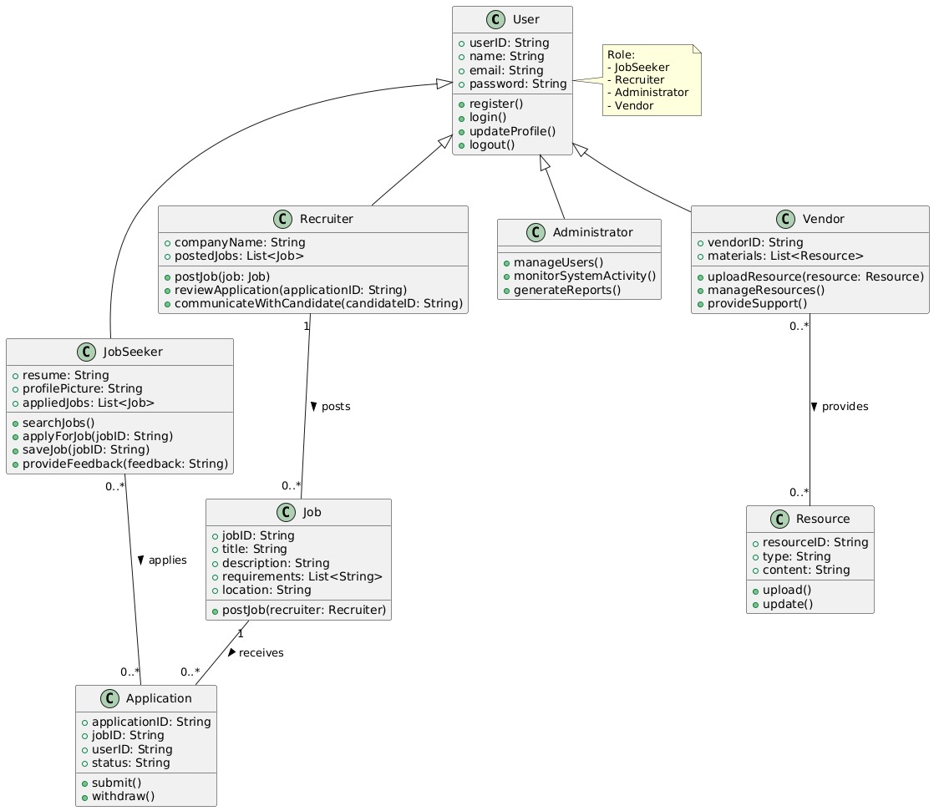

USE CASE DIAGRAM

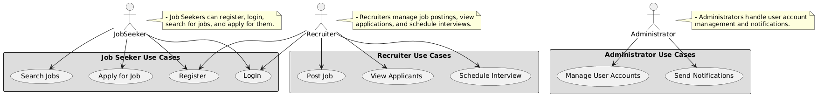

SEQUENCE DIAGRAM

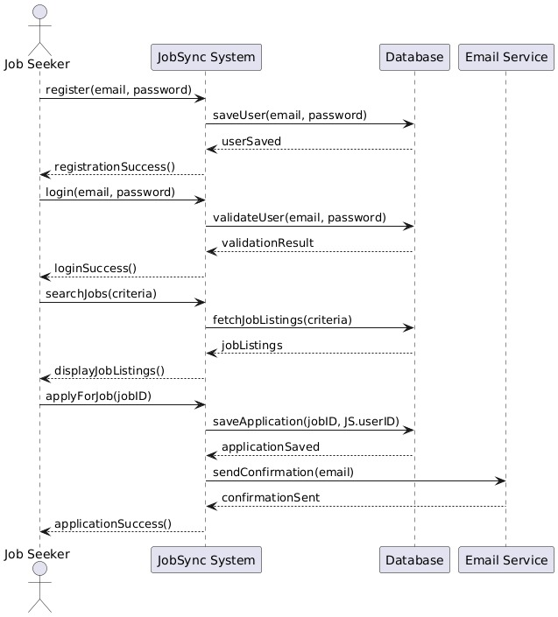

COMPONENTS DIAGRAM

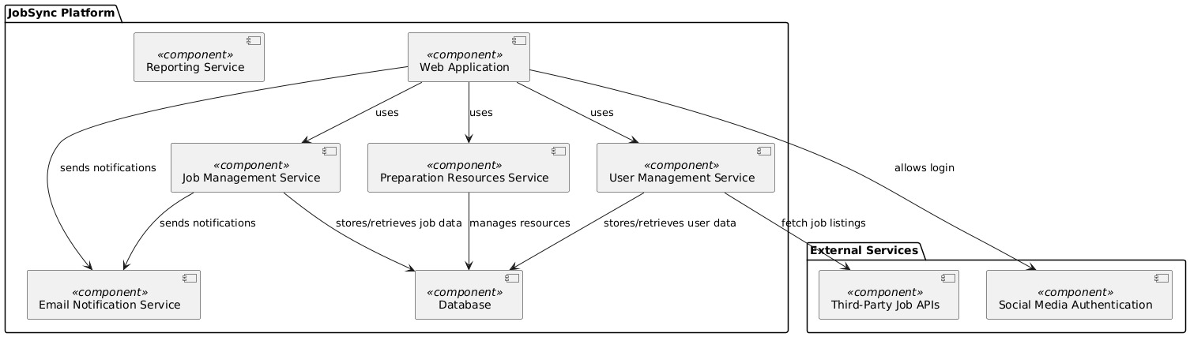

EXPERIMENT:3

INSTALLATION OF ECLIPSE, MAVEN, JDK, TOMCAT, CONFIGURING TOMCAT TO ECLIPSE

Java installation

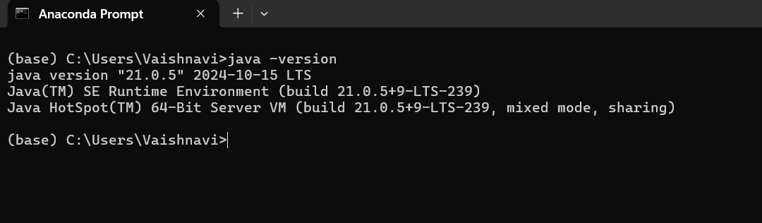

Downloading maven

Go to maven website and click on the download option

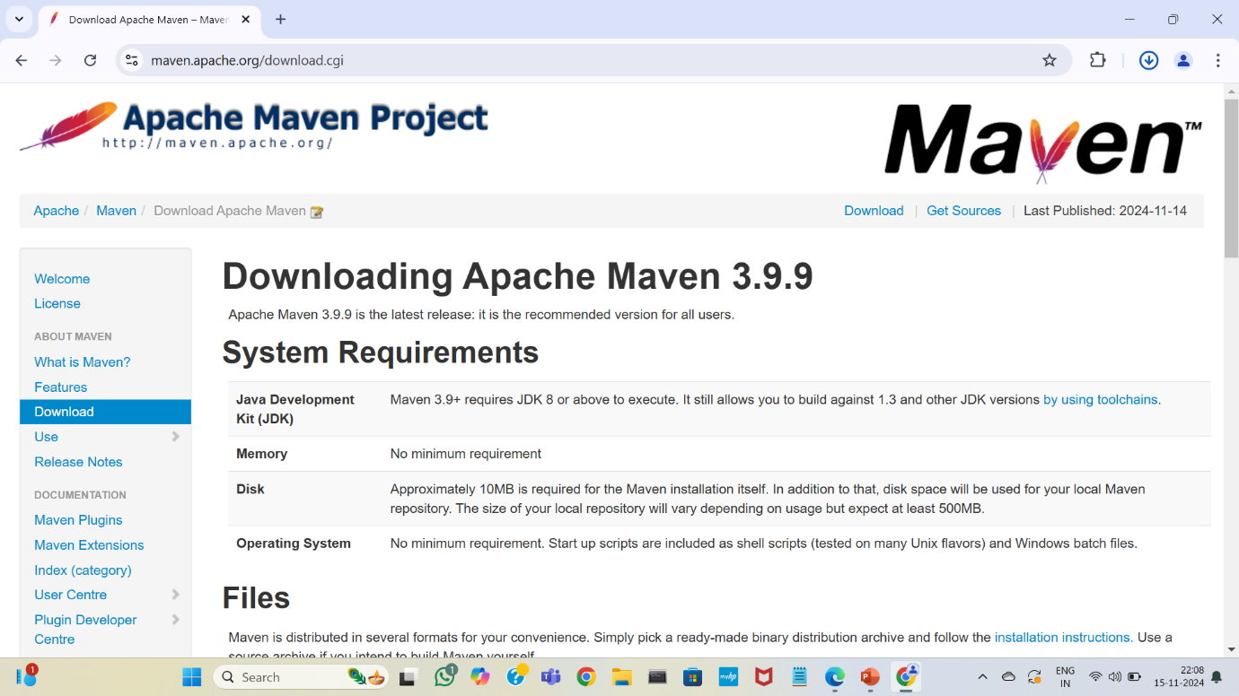

Click on the 3.3.9 bin version for the download

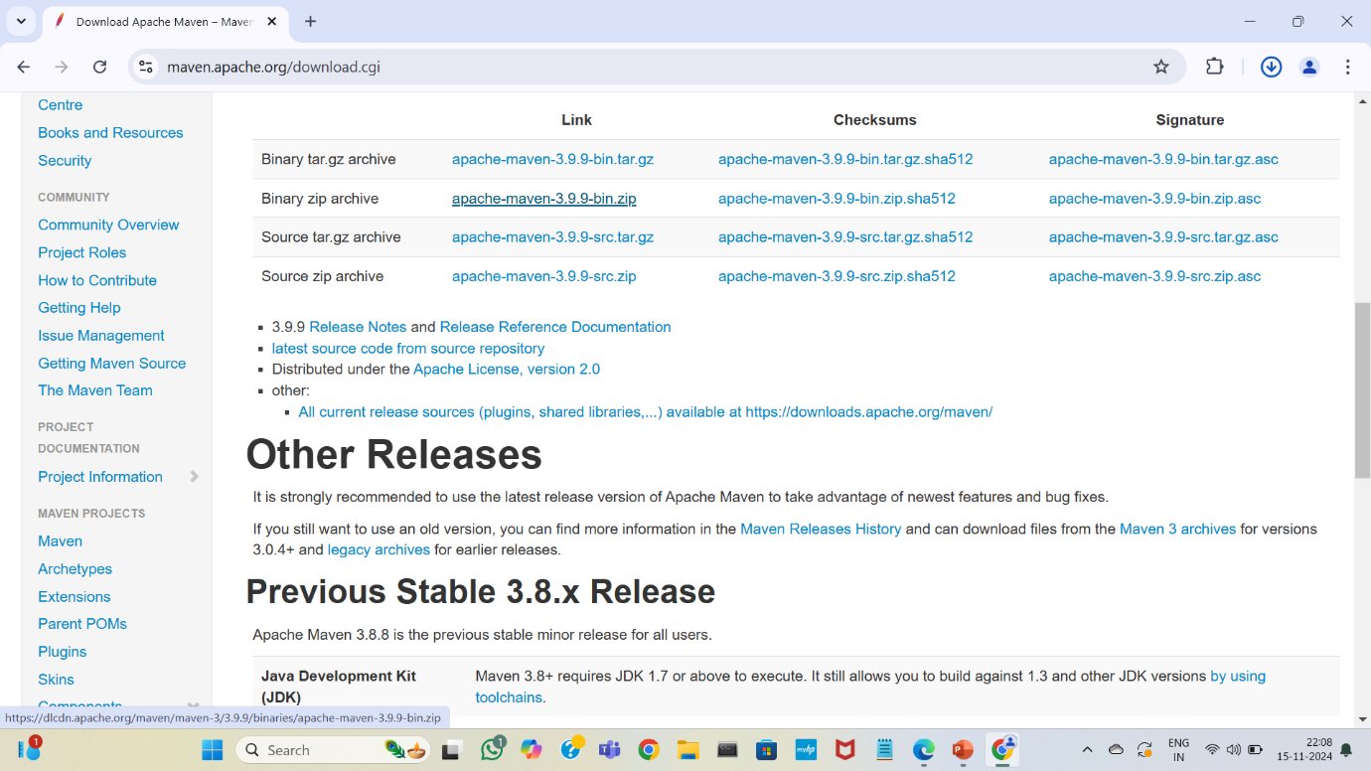

Unzip the file and set the path in environment variables

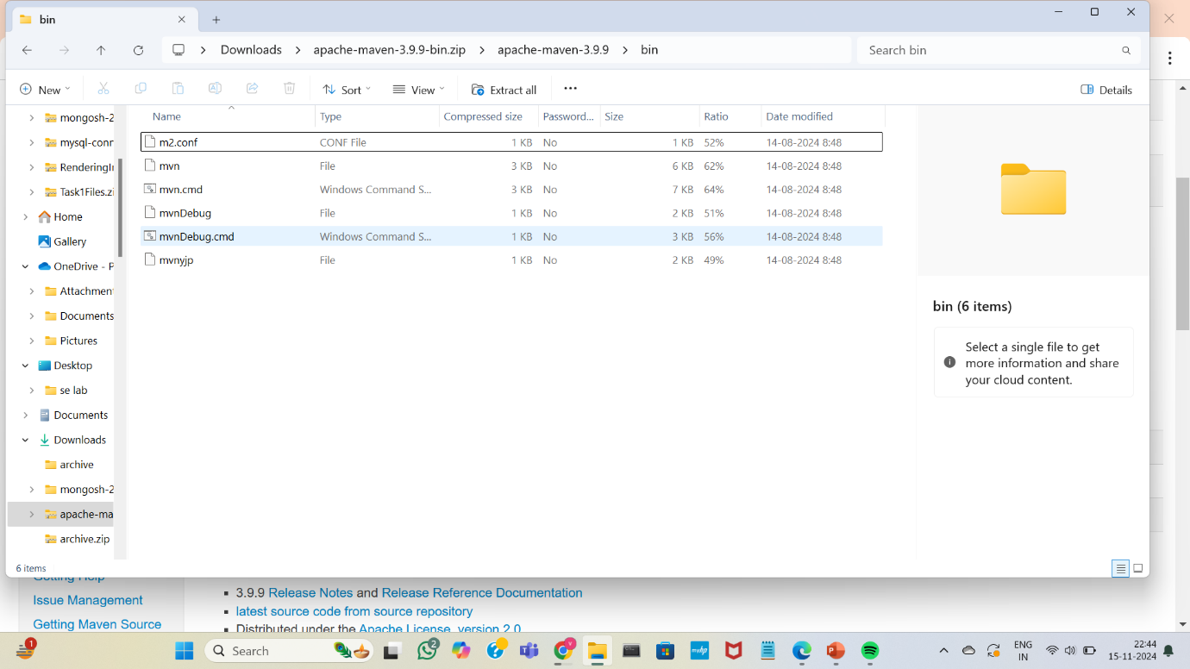

Check the installed version using command prompt

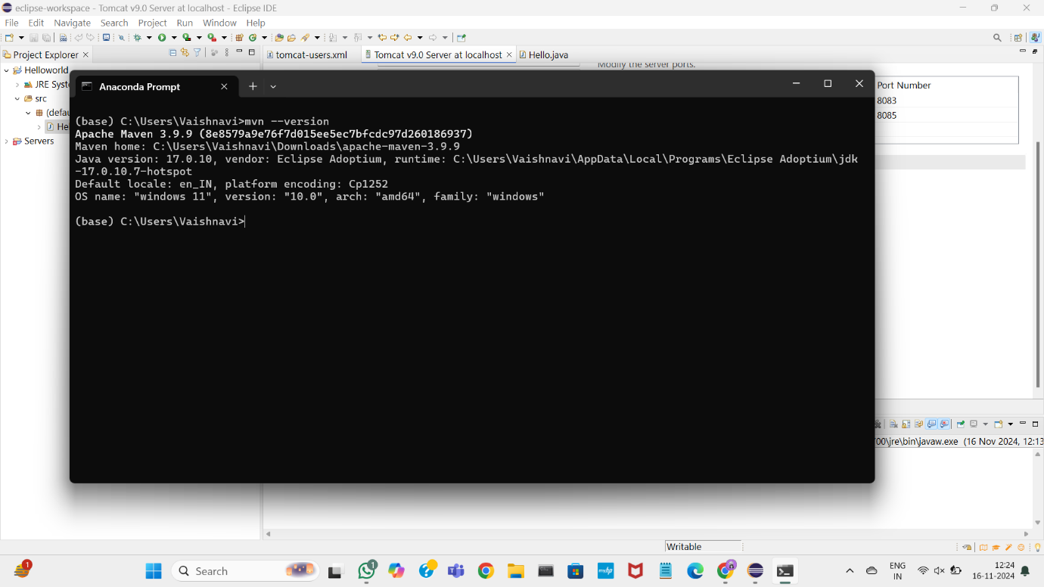

Eclipse

Go to the official eclipse website

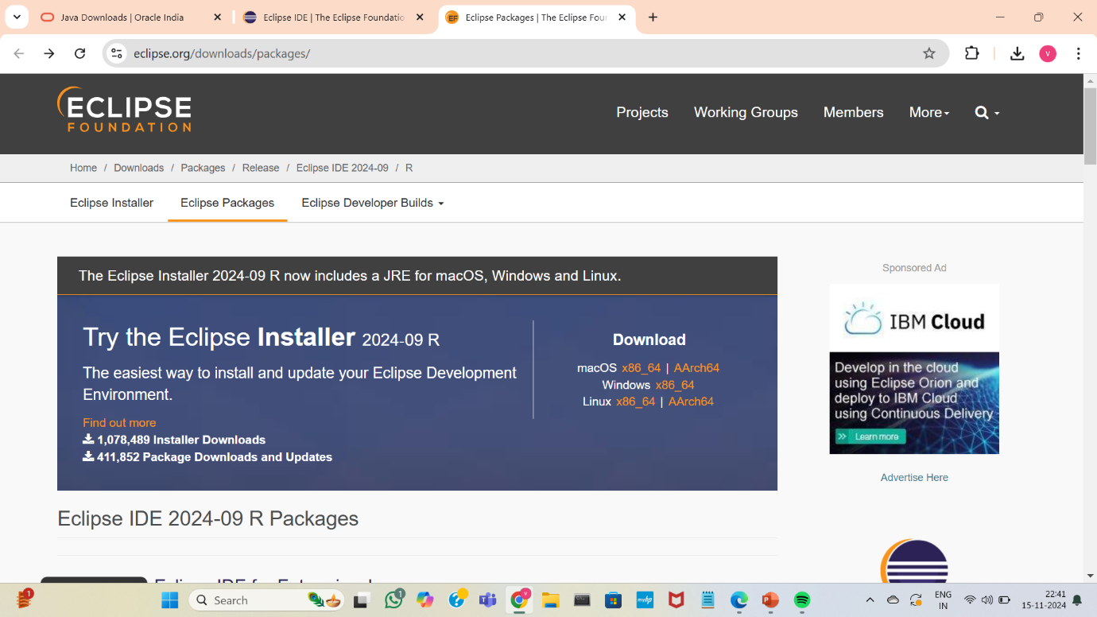

Click on the windows version

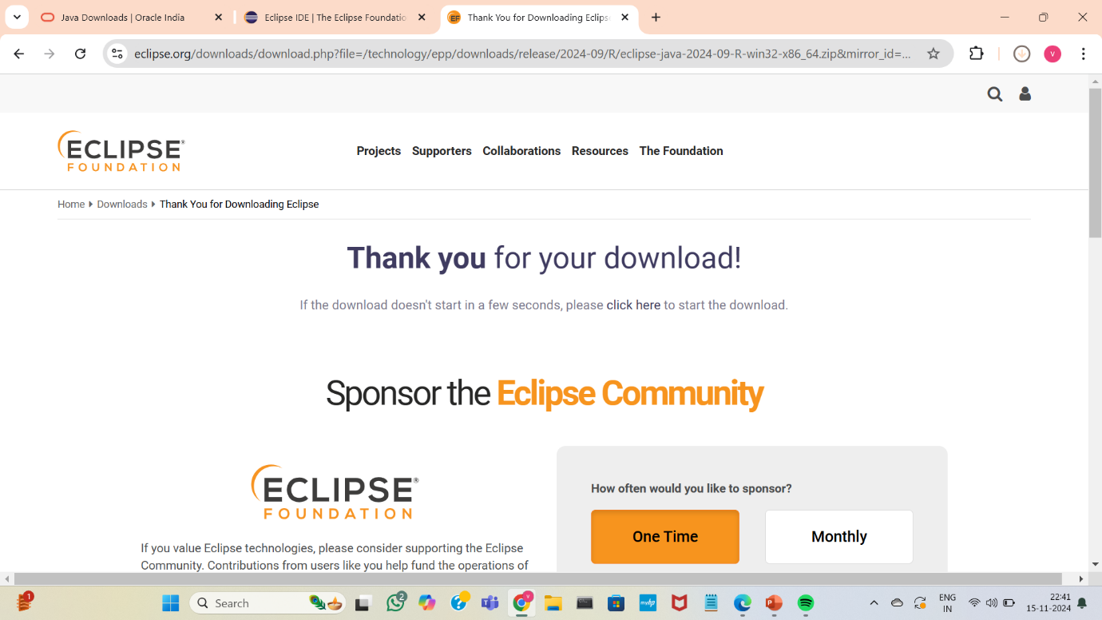

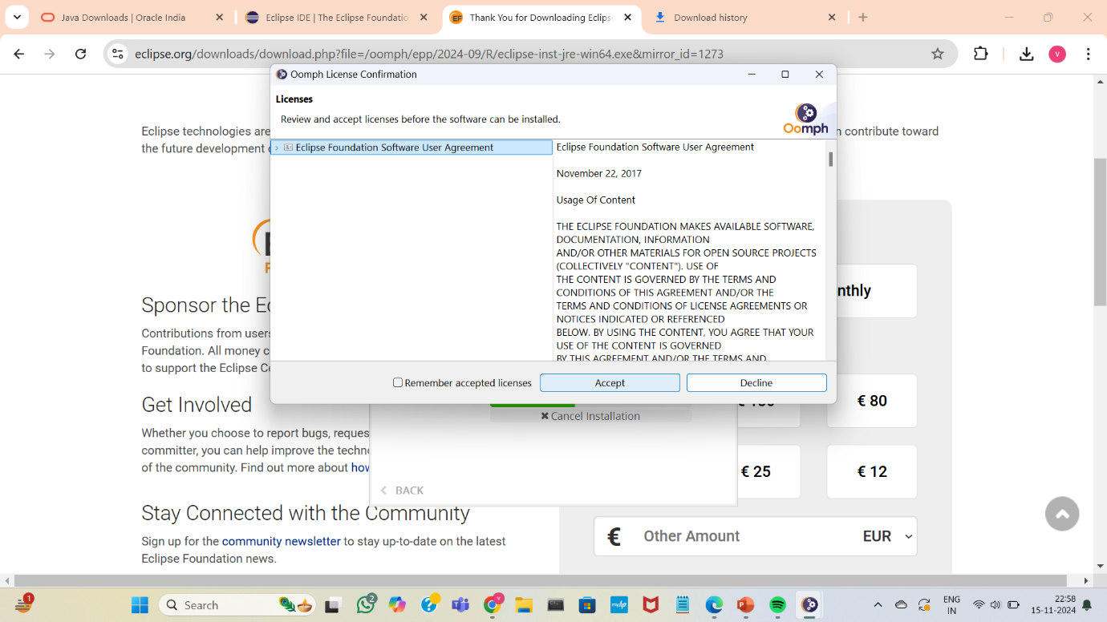

Select the “eclipse IDE for java developers” and install it

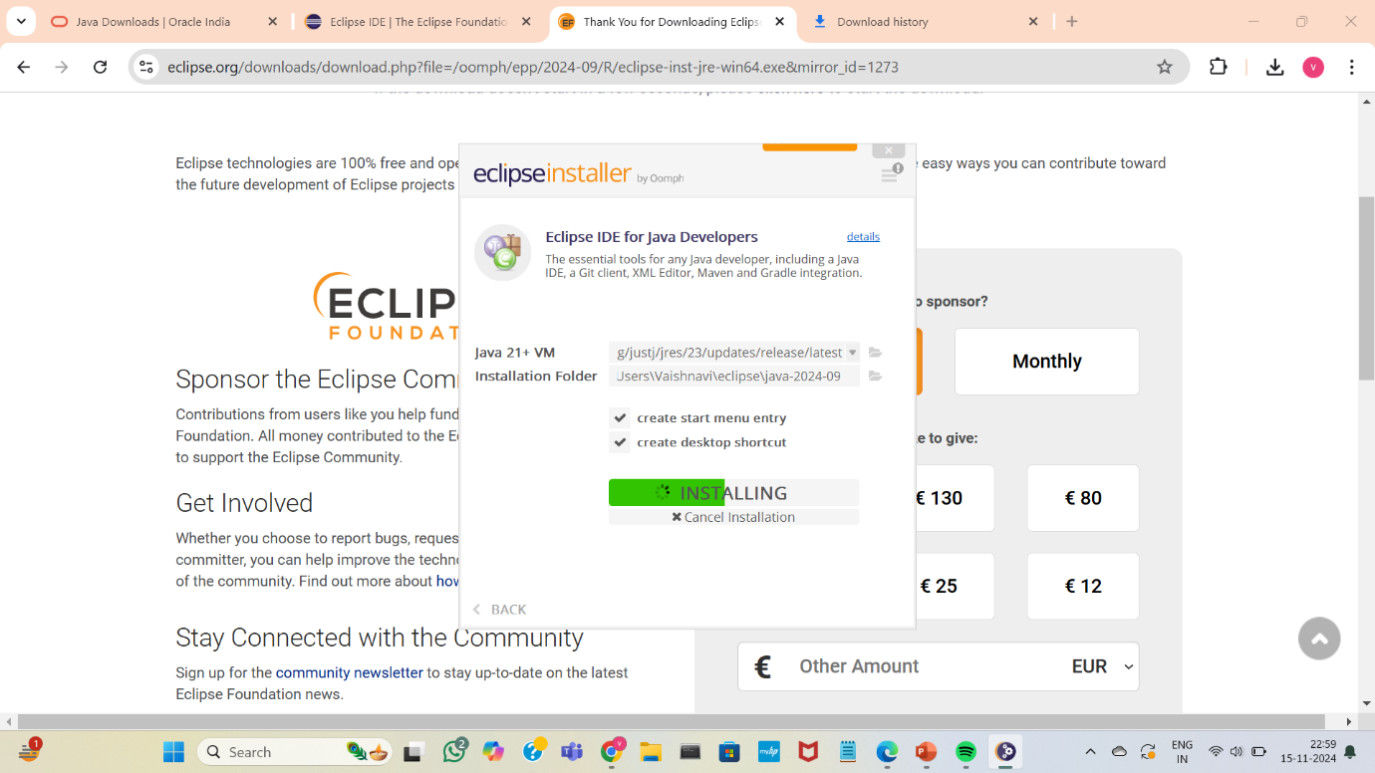

Tomcat

Click on the first website that appears on the screen for downloading the tomcat

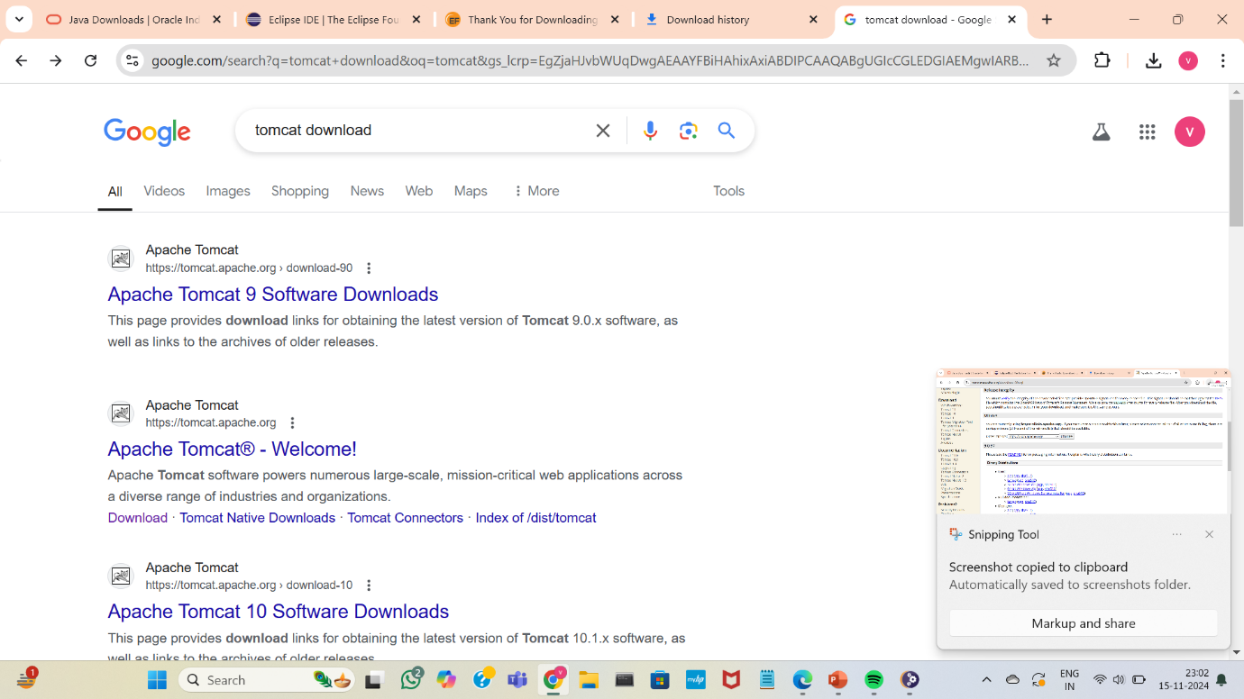

Click on the 64-bit zip version

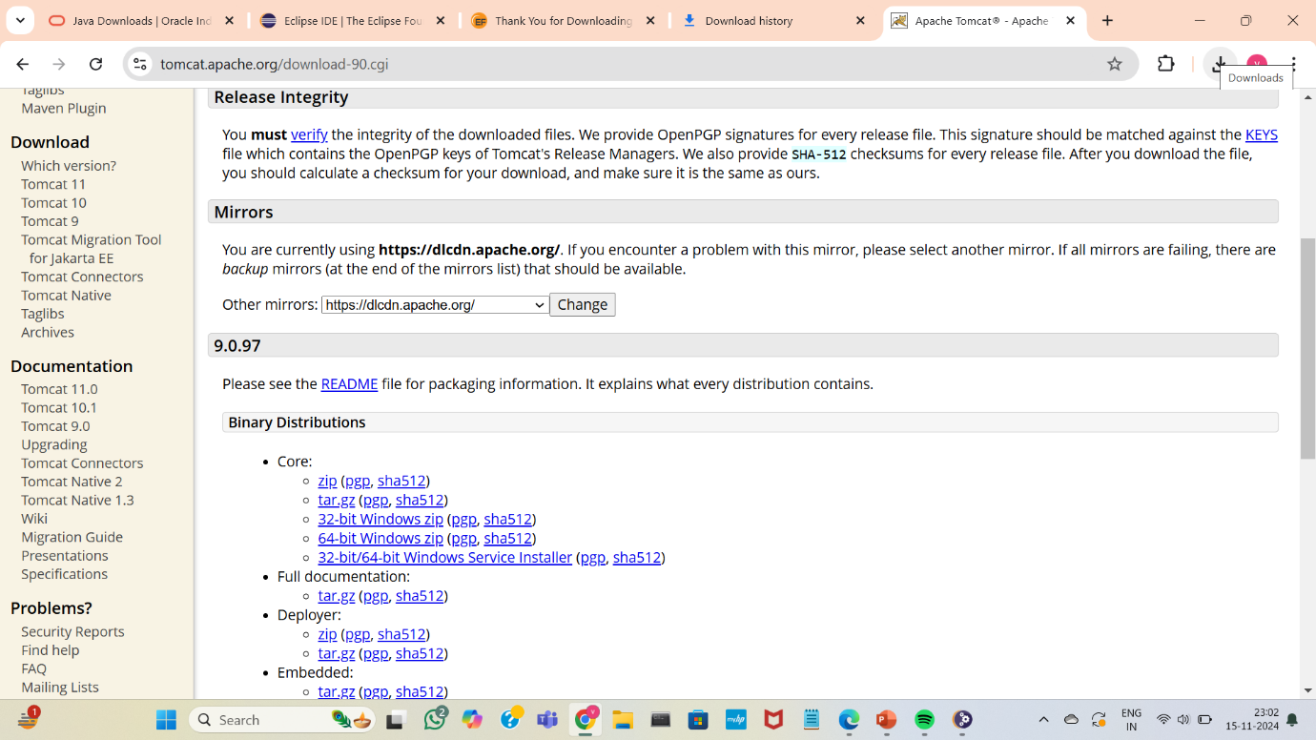

Click on “help” and select “Install new software”

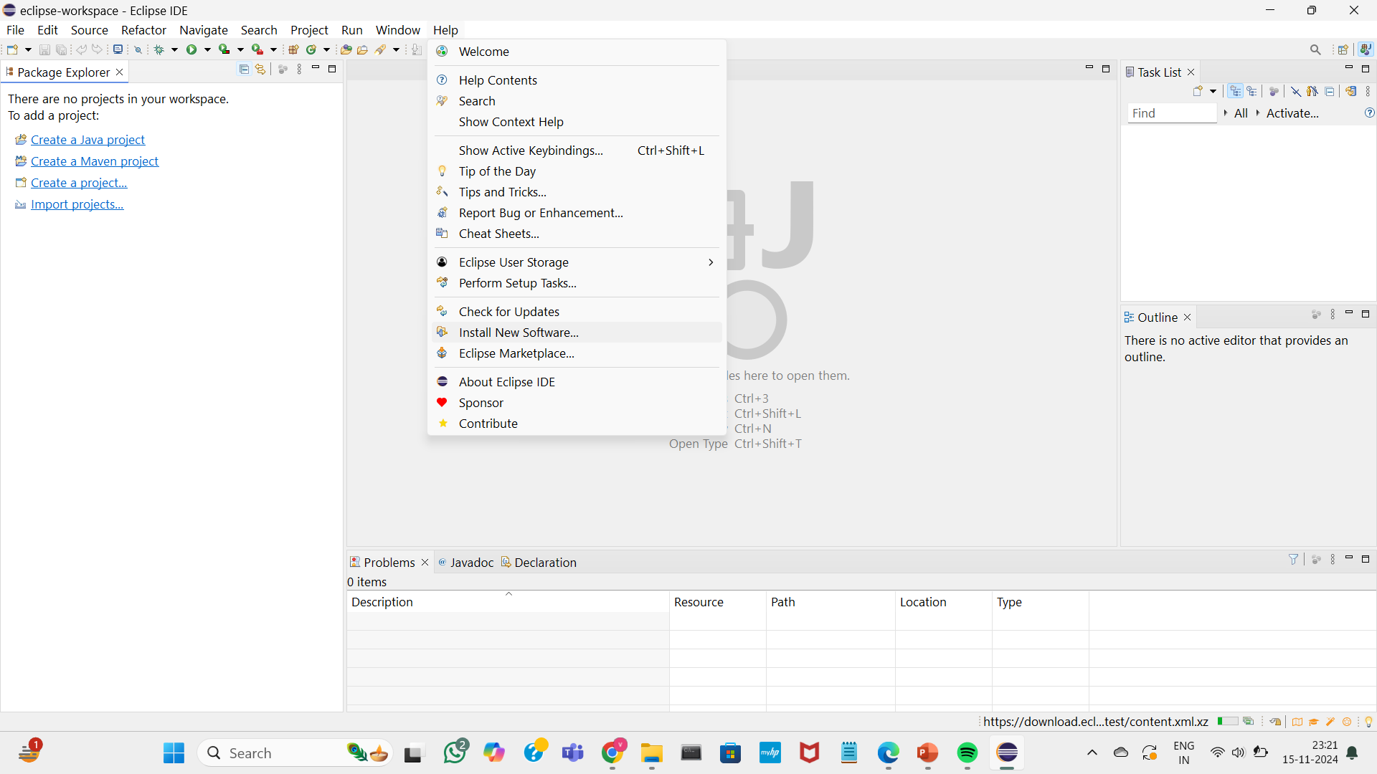

To install servers-select the first website

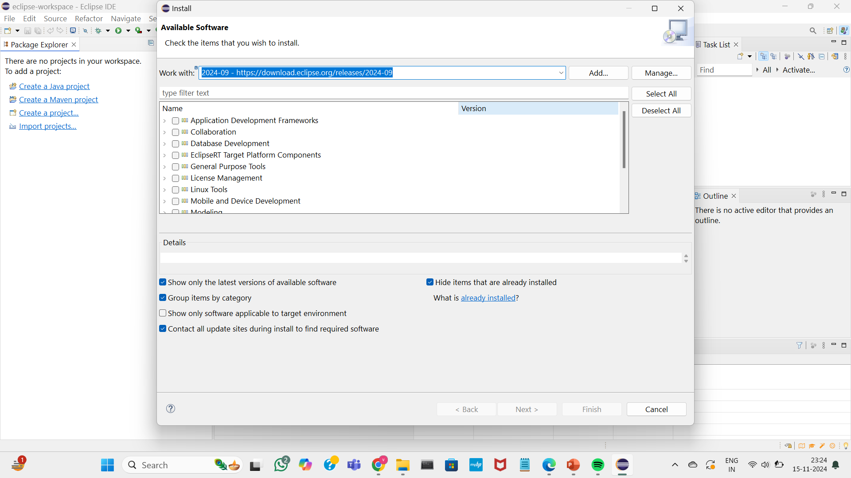

Search for Jst servers and install them

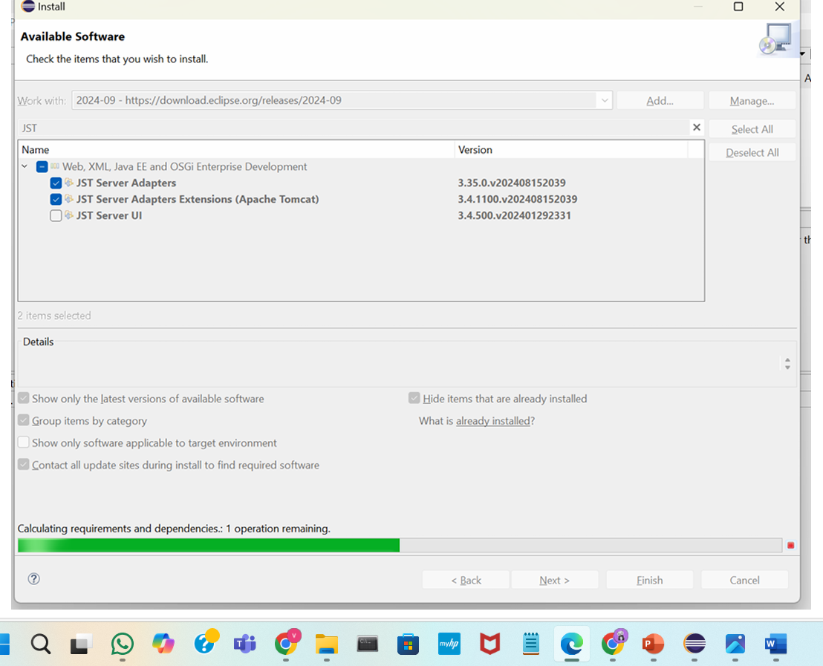

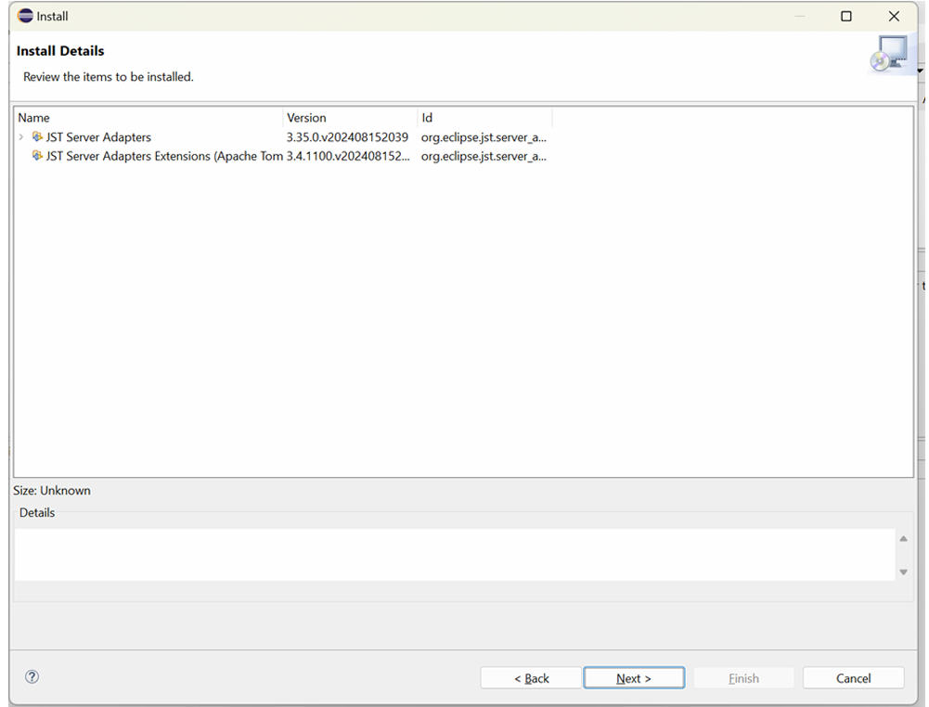

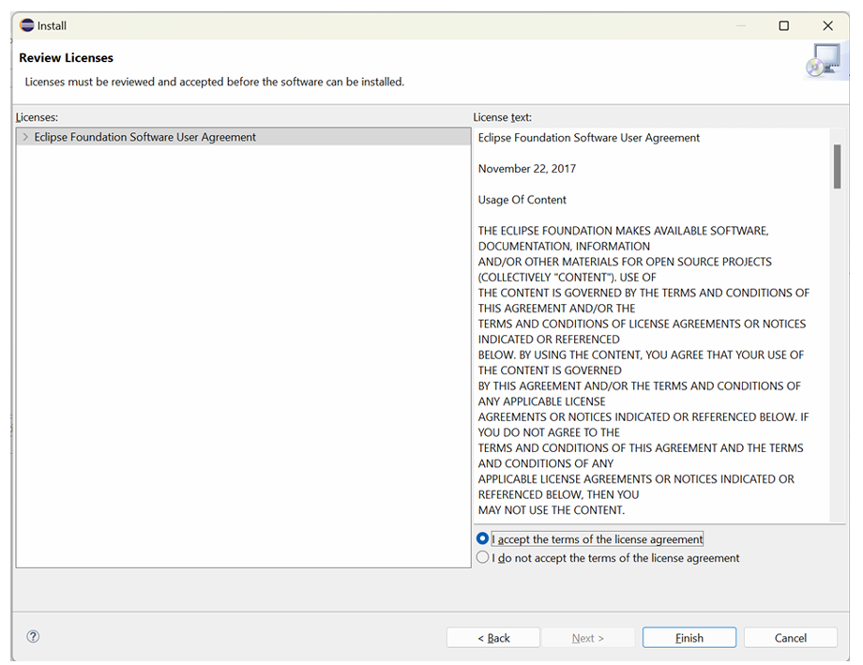

Click on restart

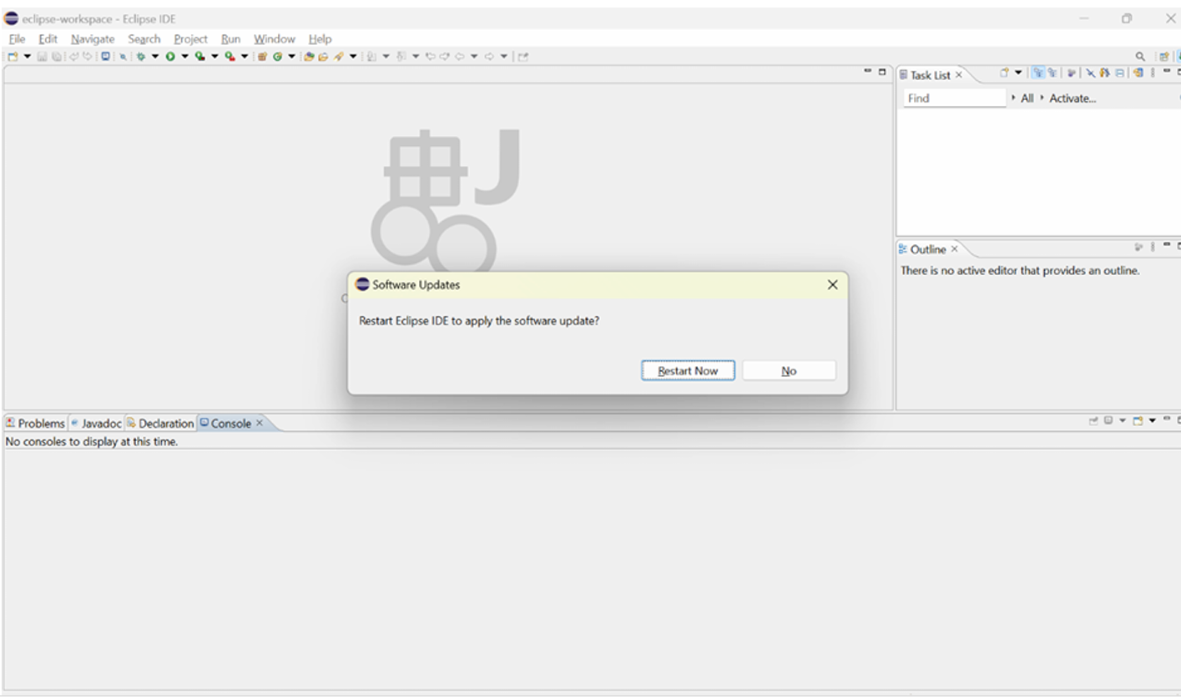

Click on window->show->view->other

Search for servers to know whether they are installed or not

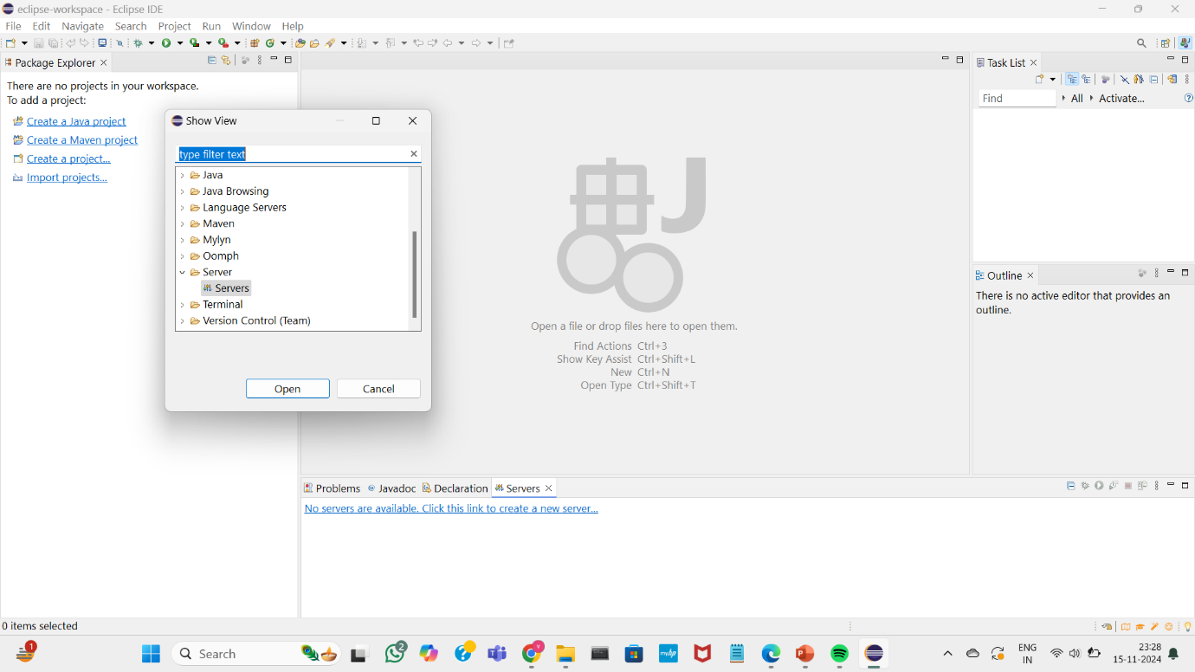

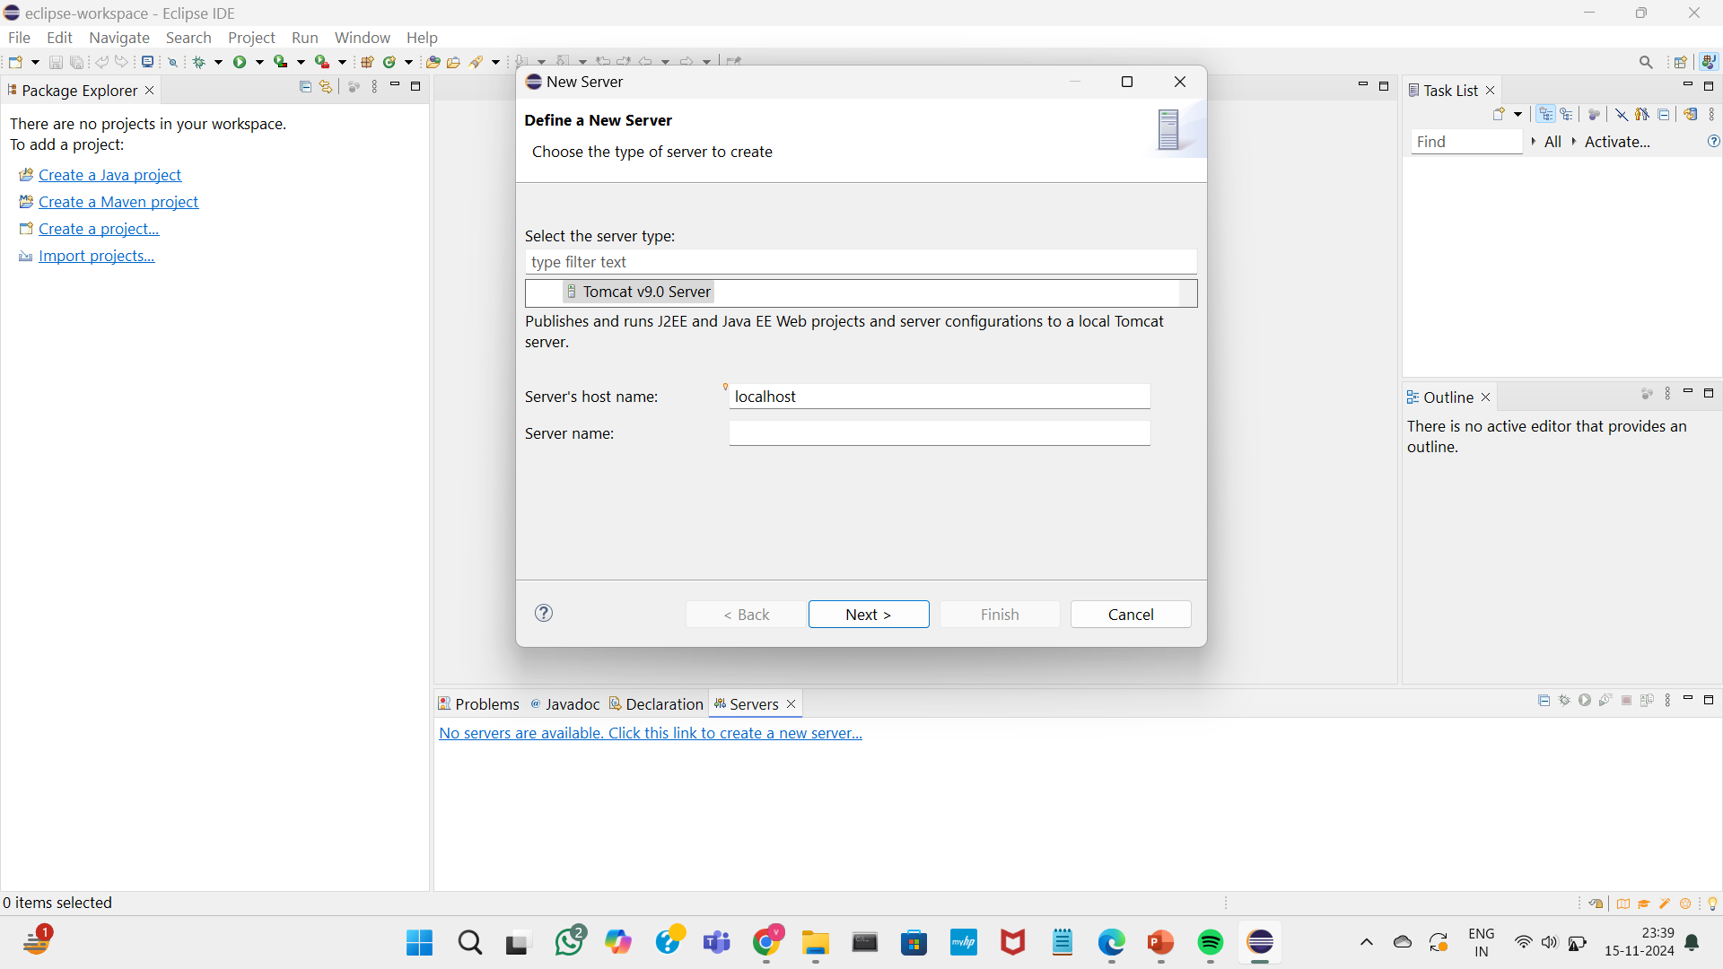

Select the tomcat-users.xml file and add the last two lines of code at the end and save the file

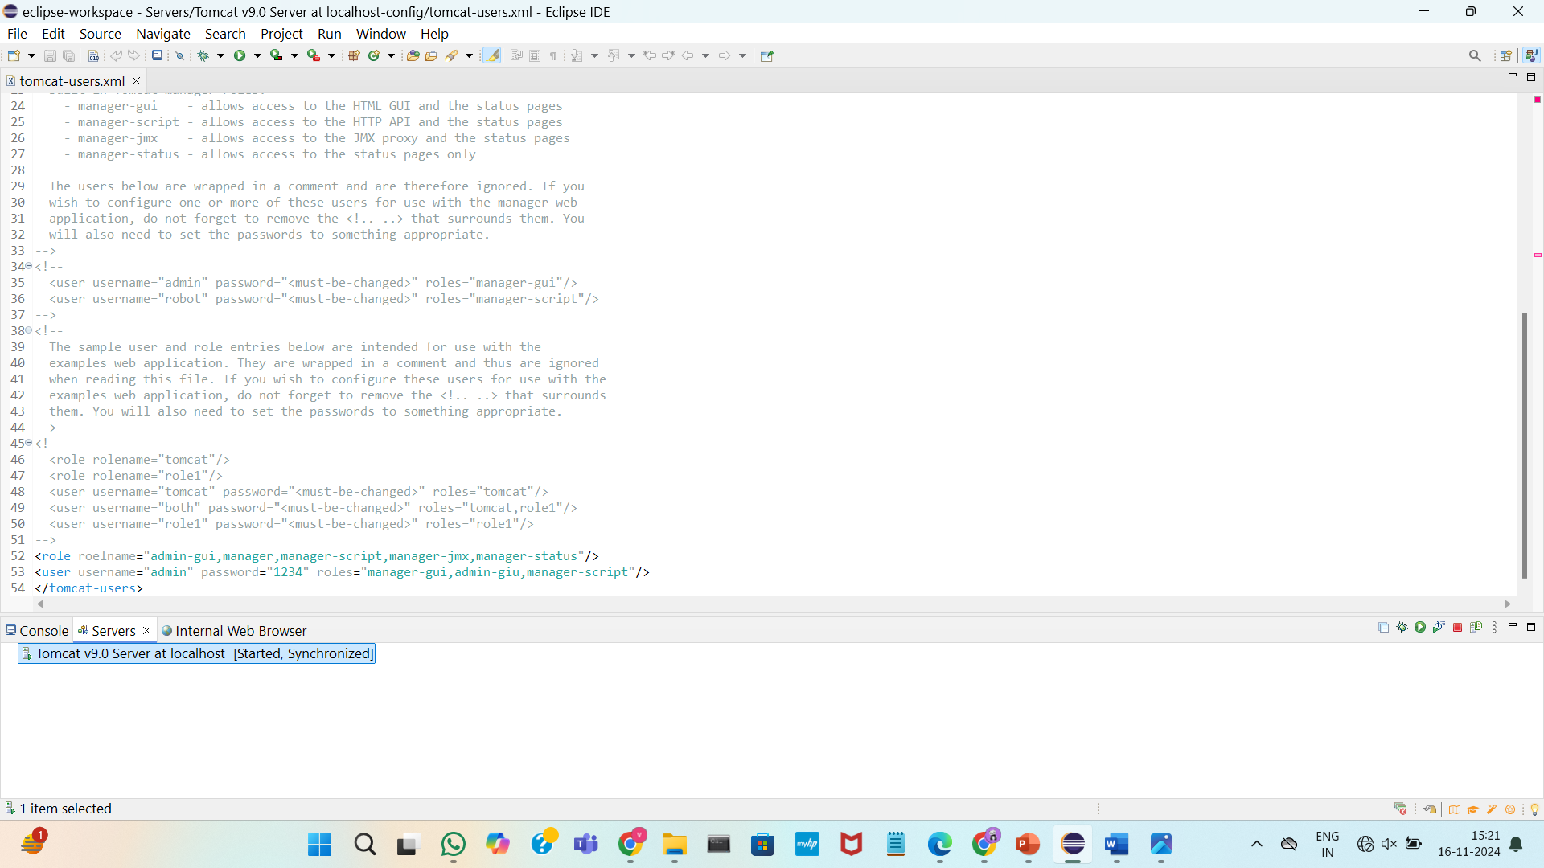

Double Click on the tomcat server and click on the “start” to start the server

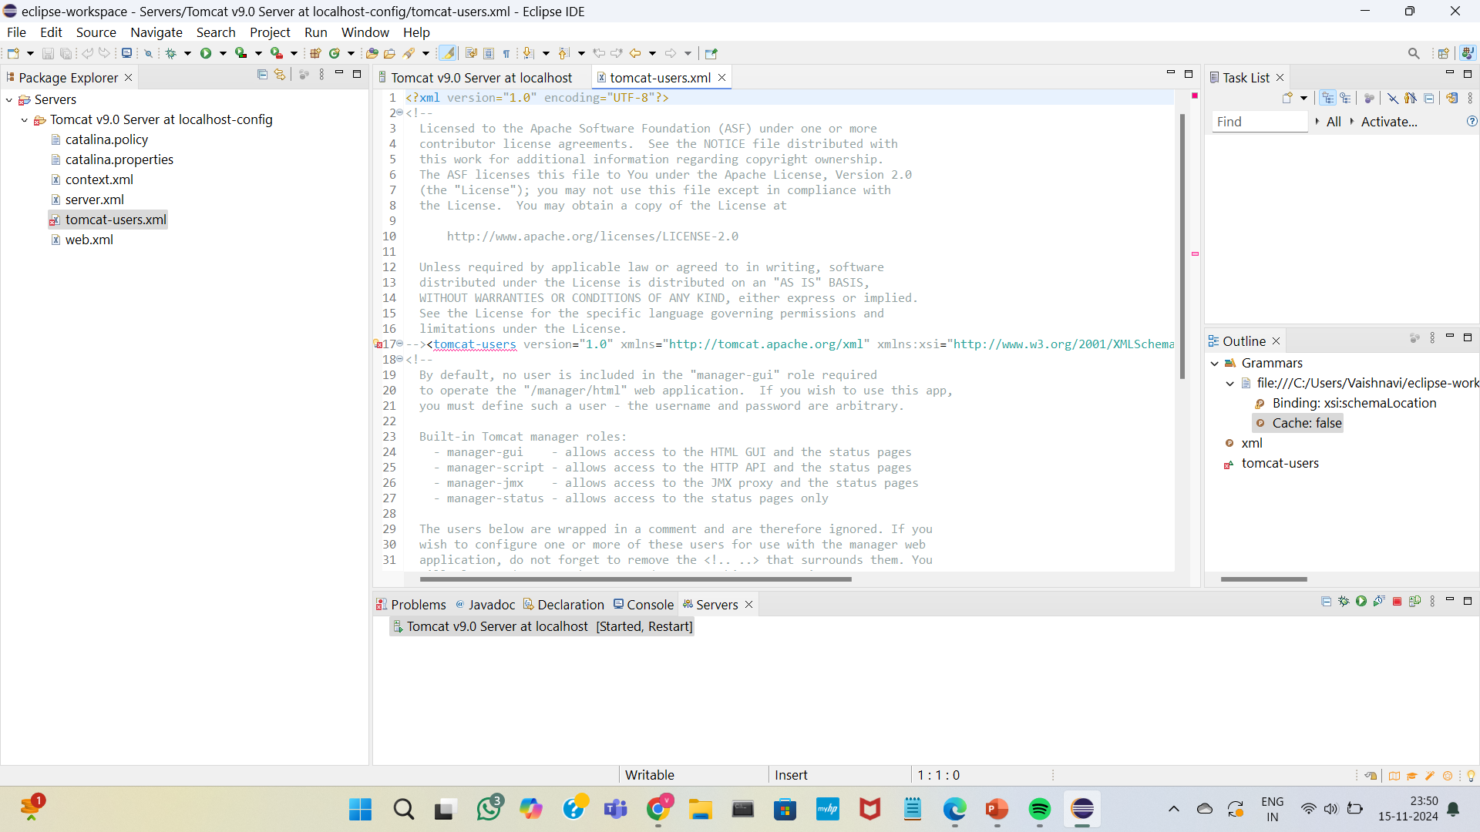

Change the port number and server location

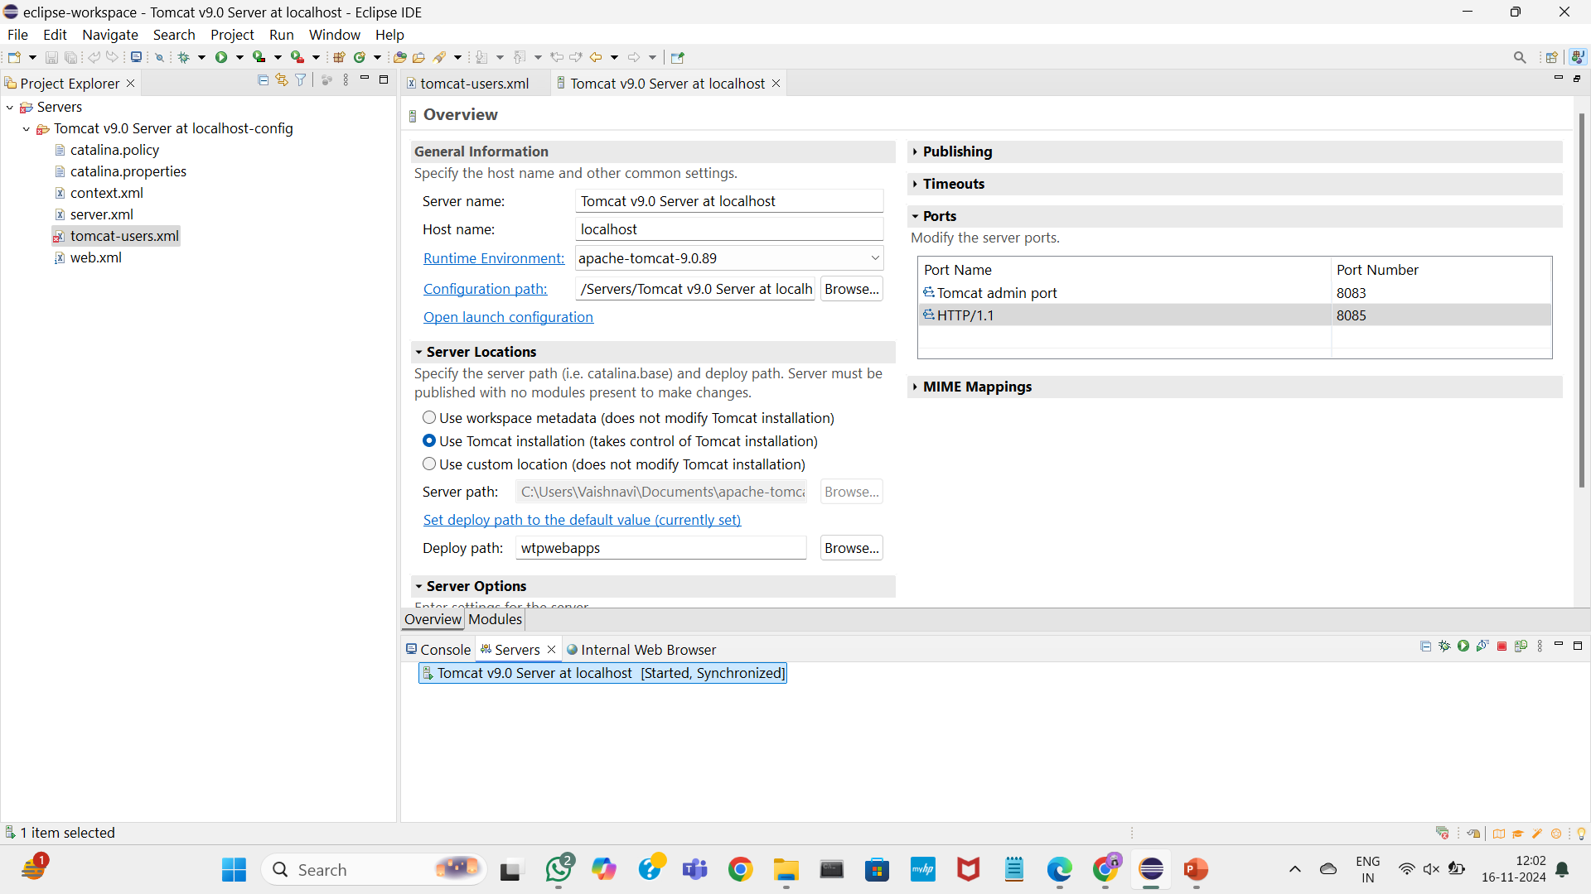

Open the localhost port you will find tomcat running on the mentioned port

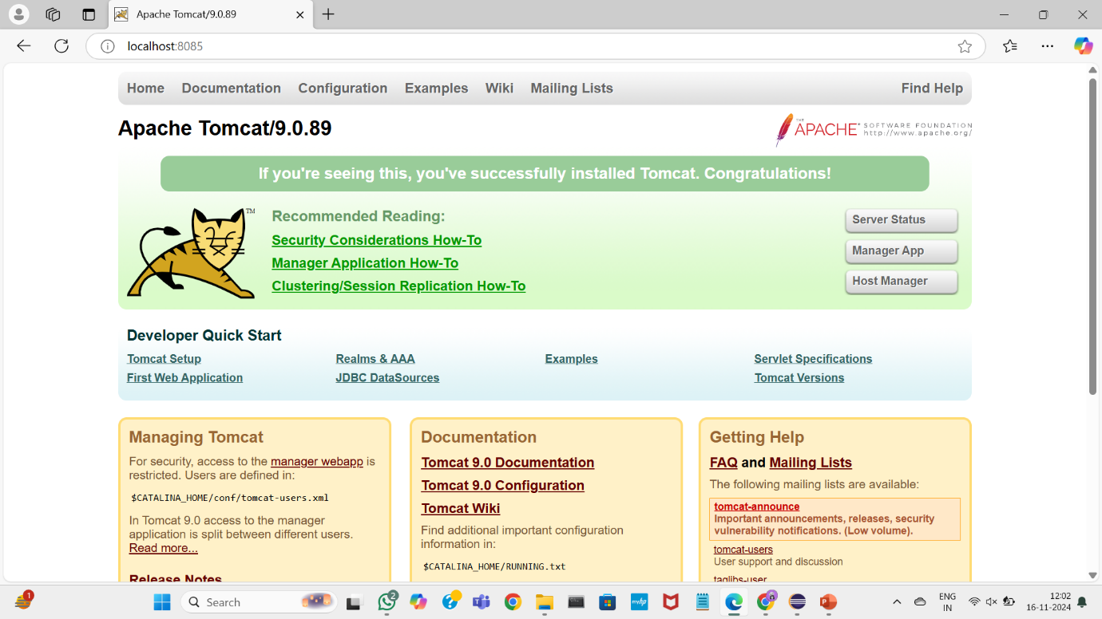

EXPERIMENT 4

A. BASIC GIT COMMANDS - VERSION, CONFIG, INIT, STATUS, ADD, COMMIT, DIFF, HELP

1.git version

Git version Git version indicates the release of the Git software you’re using, with each version p

2.Git init command

The git init command initializes a new Git repository in your current directory, creating a .git folder that tracks all changes and versions of your project files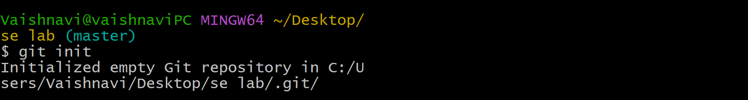

3.Config for giving username and email

Use git config --global user.name "YourUsername" and git config --global user.email "youremail@example.com" to set your Git username and email globally.

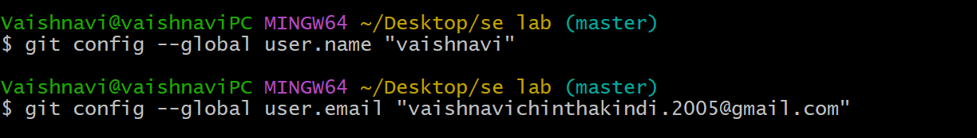

4. Creating a new file with name a

This will create an empty file named “a”in your current directory. You can then open it with a text editor to add content



5. Writing notes in file - Use nano a.txt to open the file, type your notes, then save and exit with crt+x

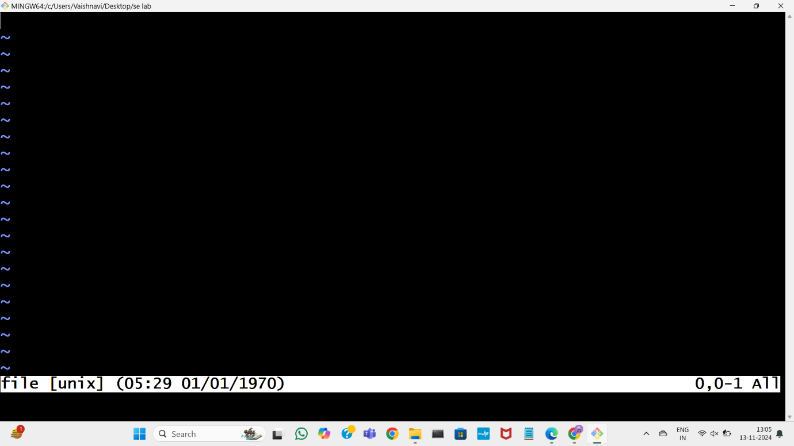

6.Use the ls command to list all files and directories in the current directory:

7. Checking the status by status command Before tracking fi, git status shows it as "Untracked files," and after running git add fi, it shows fi under "Changes to be committed."

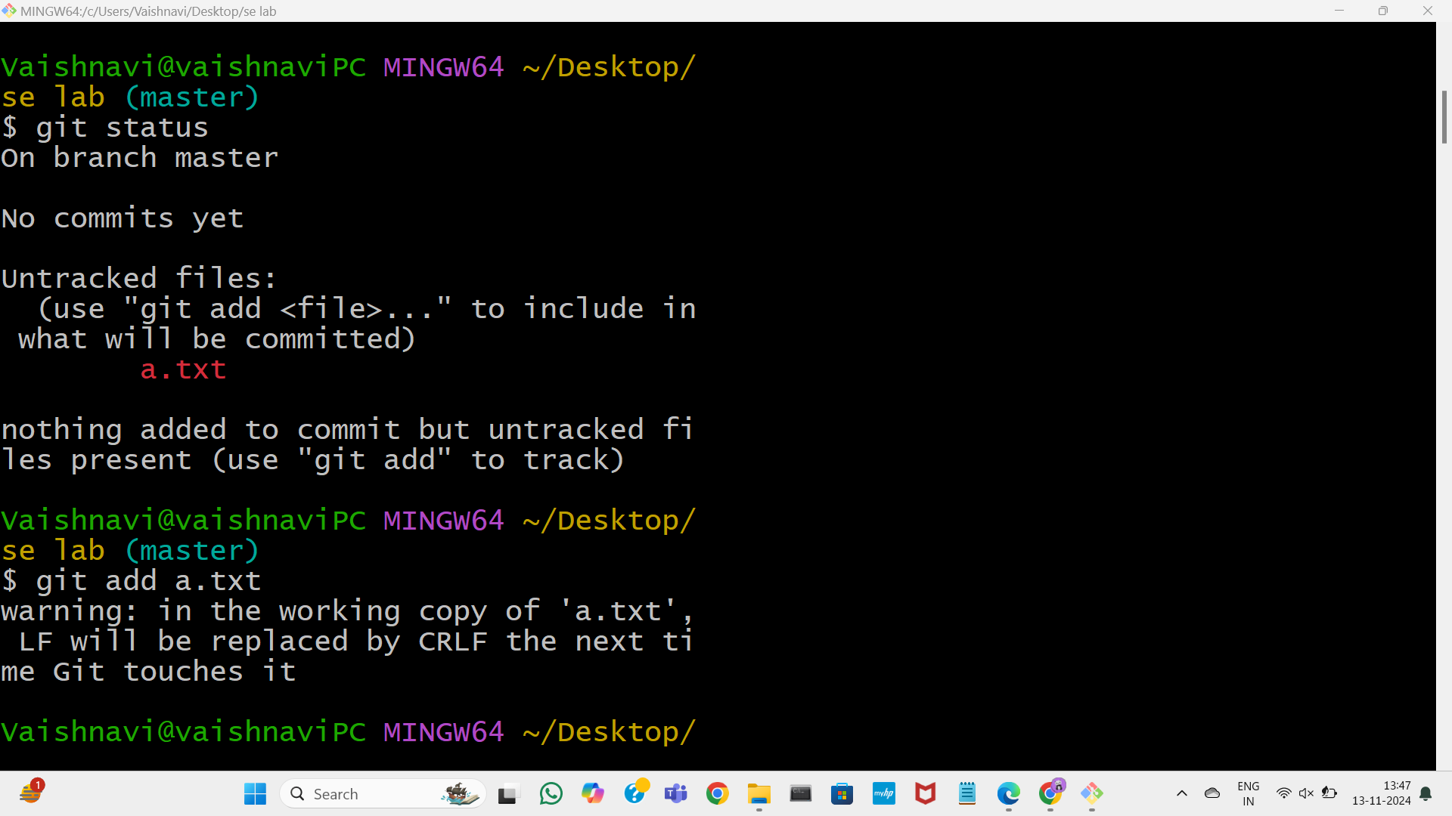

8. To commit the changes made to the f1 file, use the following command: git commit -m "Your commit message here"

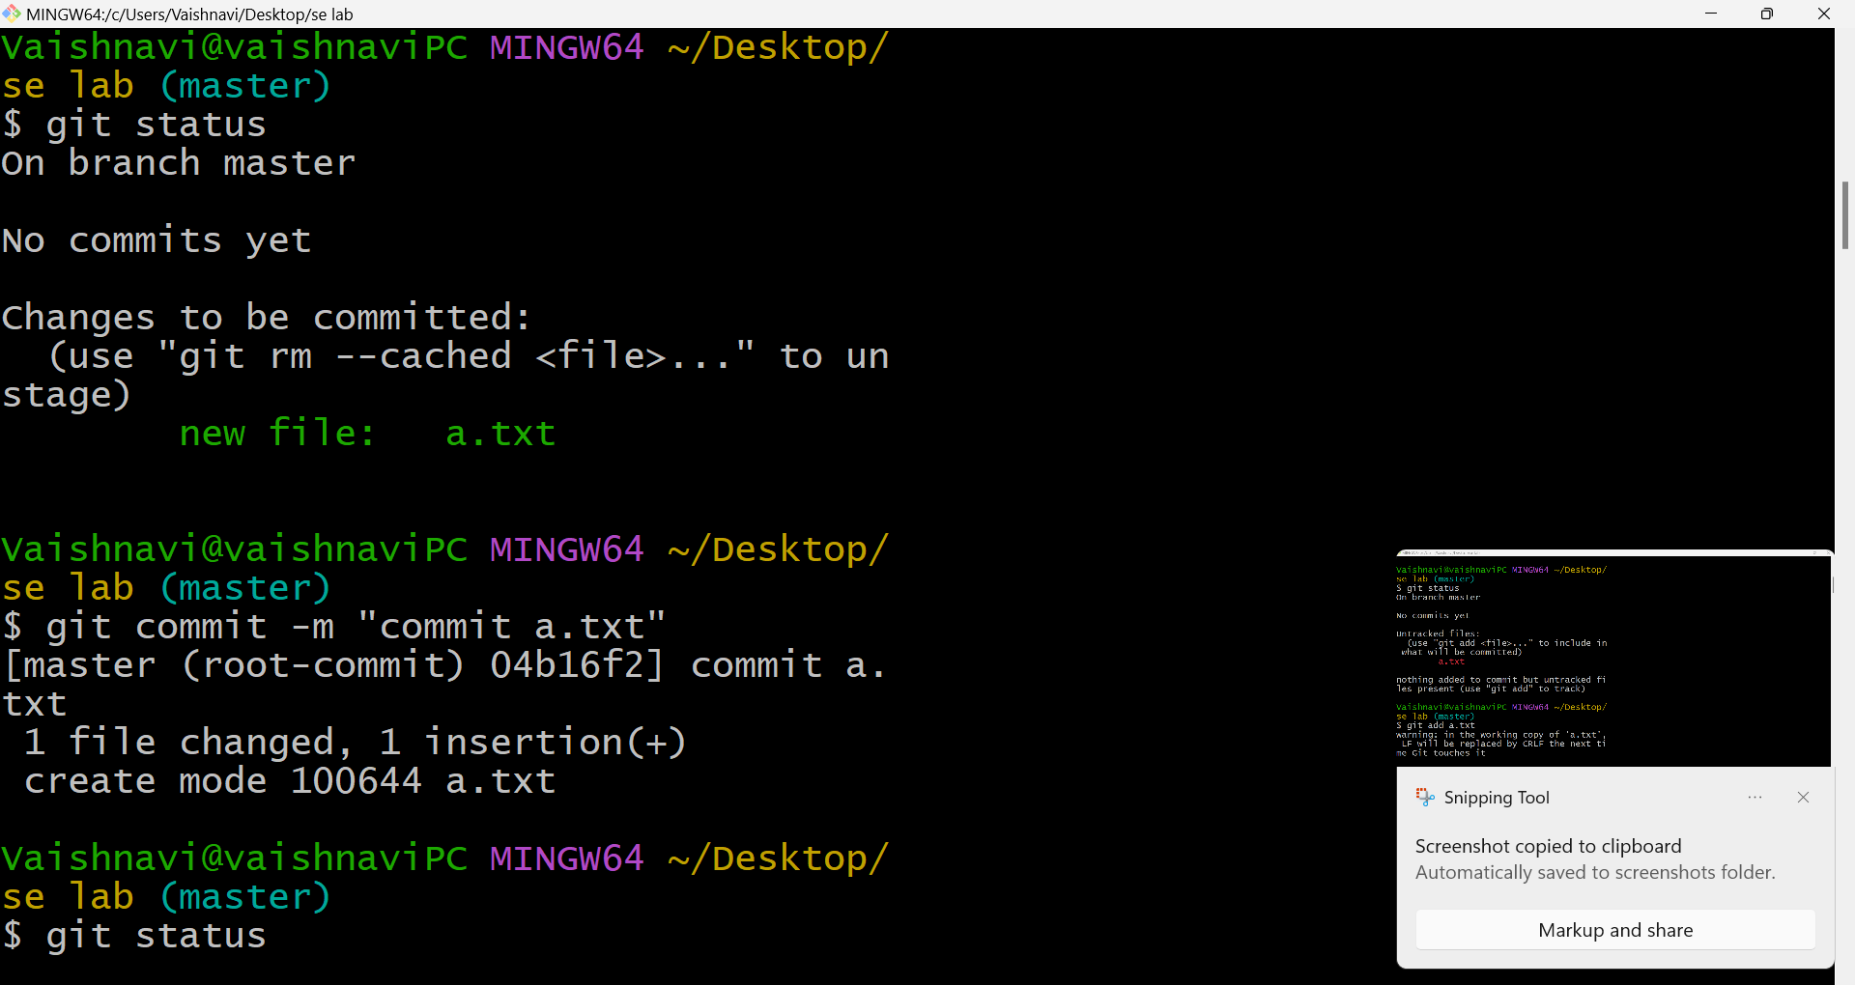

9. Updating file contents and checking the difference

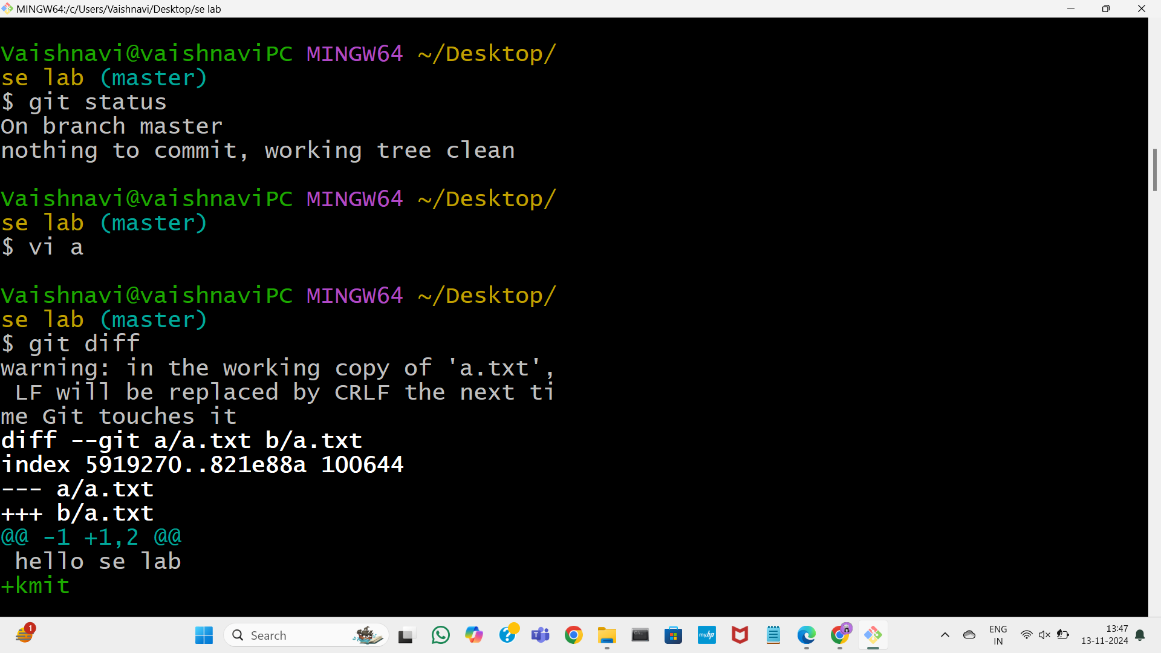

10. Committing after updating the file fi content Stage the changes in “a” by running git add “a”, then commit the updates with git commit -m "Updated fi content" to save the changes

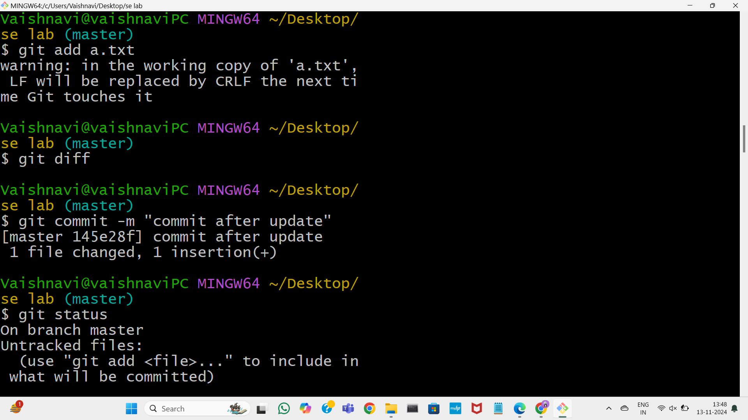

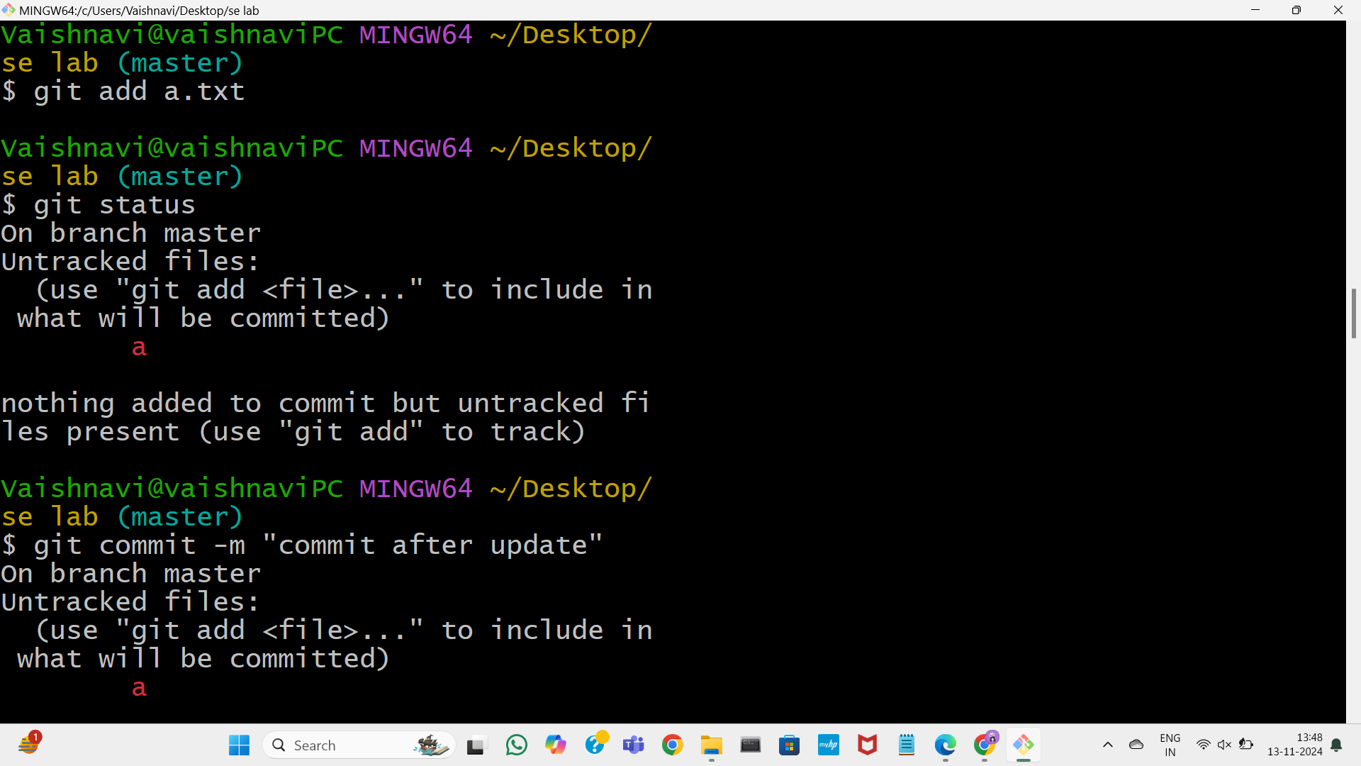

B. GIT COMMANDS: WORKING WITH LOCAL AND REMOTE REPOSITORIES - BRANCHES, CHECKOUT, MERGE, REVERT, LOG

11. To check how many branches exist in your Git repository, use the command git branch.

12.Creating a new branch called test

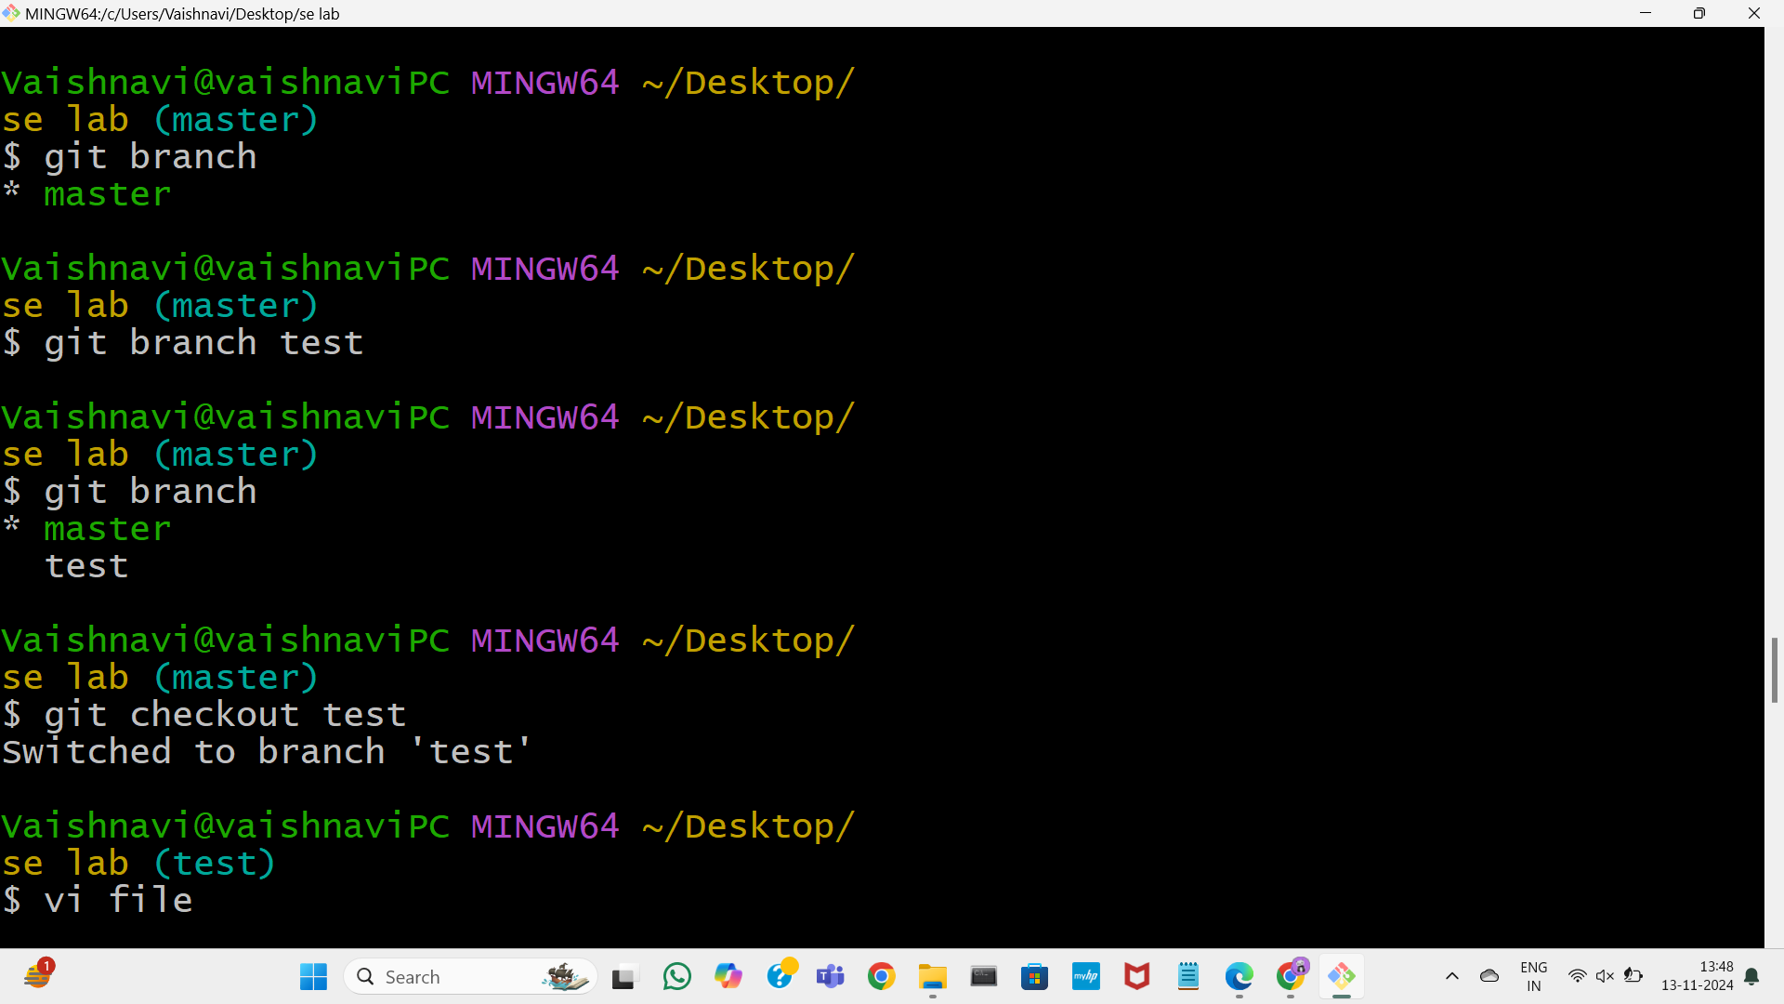



13. This Git workflow demonstrates switching between branches, adding a file to staging, and committing changes:

1. The user switches between master and test branches, adding a file (f2) in the test branch

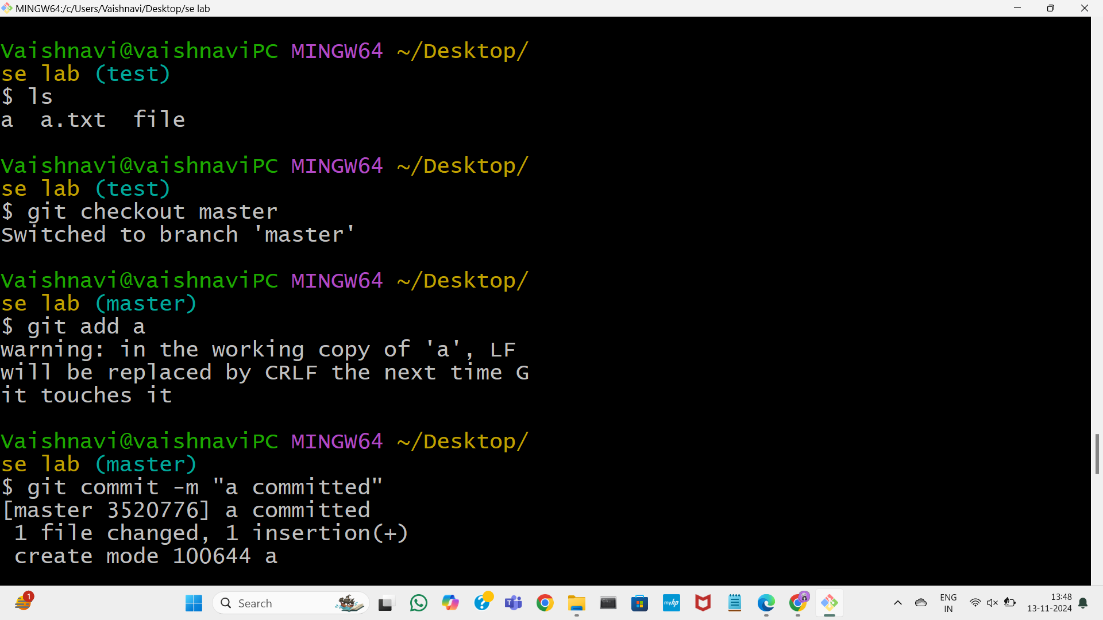

After staging f2, the user returns to the test branch and commits it with a message. The commit creates a new version of f2 specifically in the test branch without affecting the master branch.

C. GIT COMMANDS: WORKING WITH REMOTE REPOSITORIES - REMOTE, CLONE, PULL, PUSH, FORK

14. This Git workflow performs the following actions:

1. The user tries to add a remote named origin, but it's already set, so an error is shown.

2. The git branch -M main command renames the current branch to main. 3. Finally, git push -u origin main pushes the main branch to the remote repository, setting up tracking between the local and remote branches.

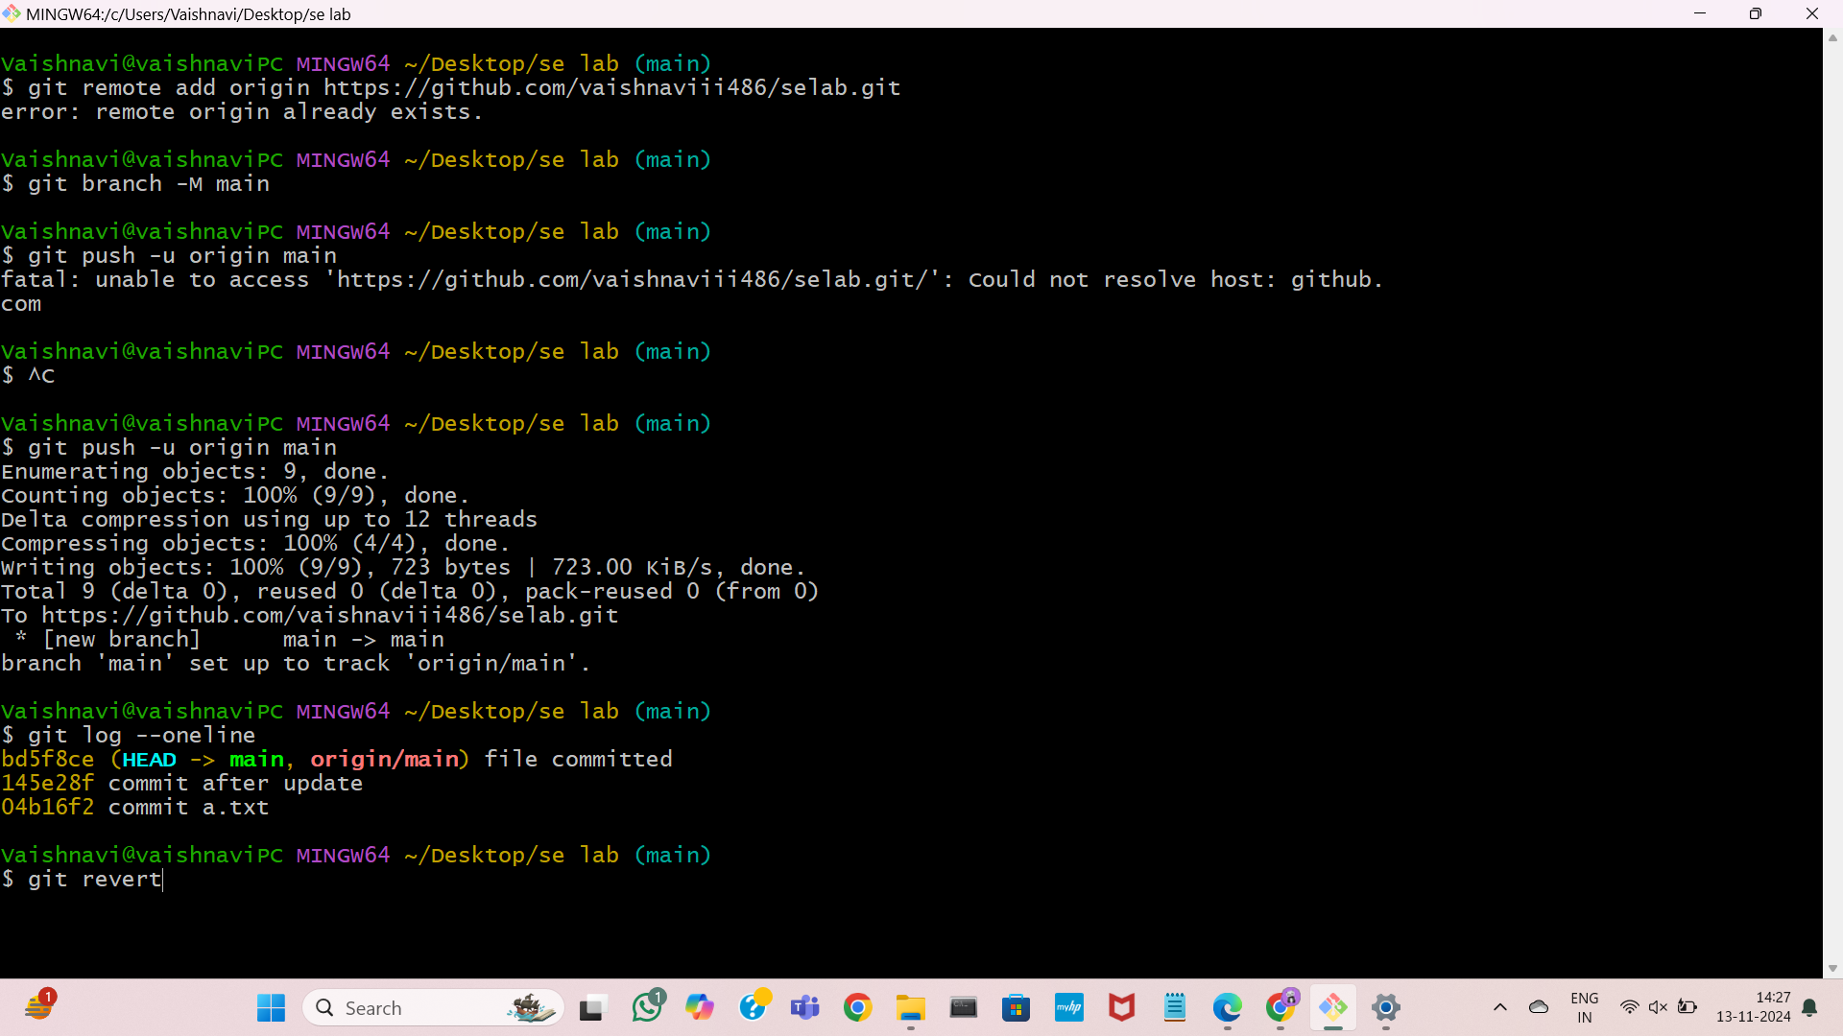

15.Git repository after pushing files

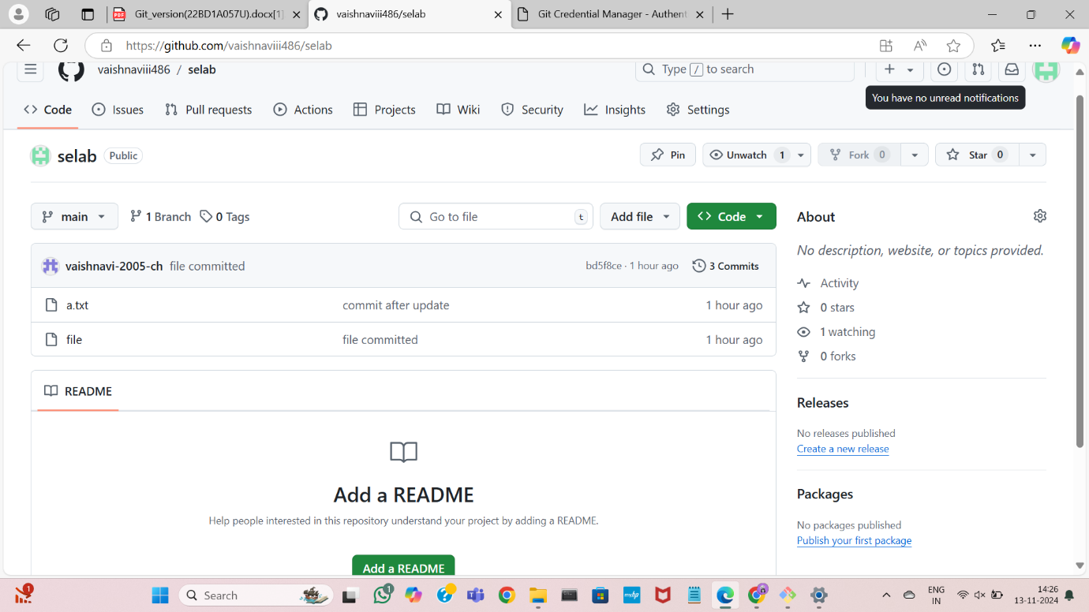

16. Listing and Reverting Commits This Git log shows a sequence of commits and reverts. The user initially made two commits, titled “commit of fi” and “commit of fi after update.” The second commit was then reverted using git revert (accbc0e), resulting in a new commit titled “Revert 'commit of fi after update.'” Later, this revert was itself reverted using git revert 922eba8, restoring the changes from “commit of fi after update.” This process created a clean history where the latest commit is identical to “commit of fi after update.

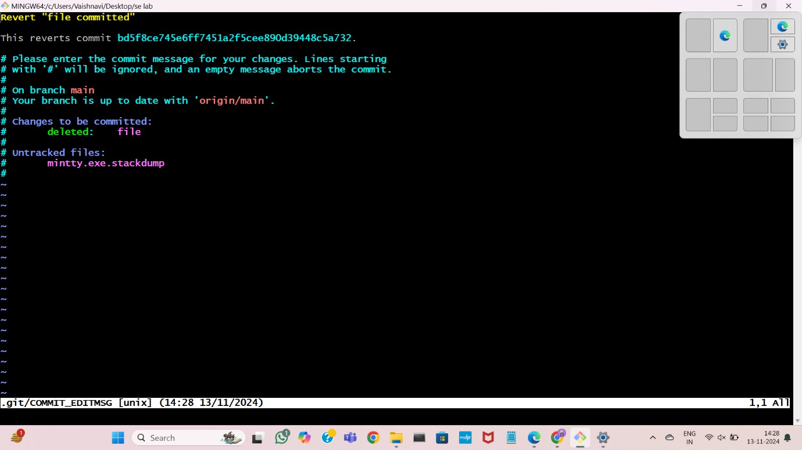

merge conflict and resolving it: A merge conflict occurs in Git when changes in different branches cannot be automatically combined. This usually happens when: 1. Two branches modify the same part of a file — If two branches have edited the same line(s) in a file differently, Git doesn’t know which version to keep, resulting in a conflict. 2. One branch deletes a file that the other modifies — If one branch deletes a file while the other branch modifies it, Git can't automatically determine what to do

push

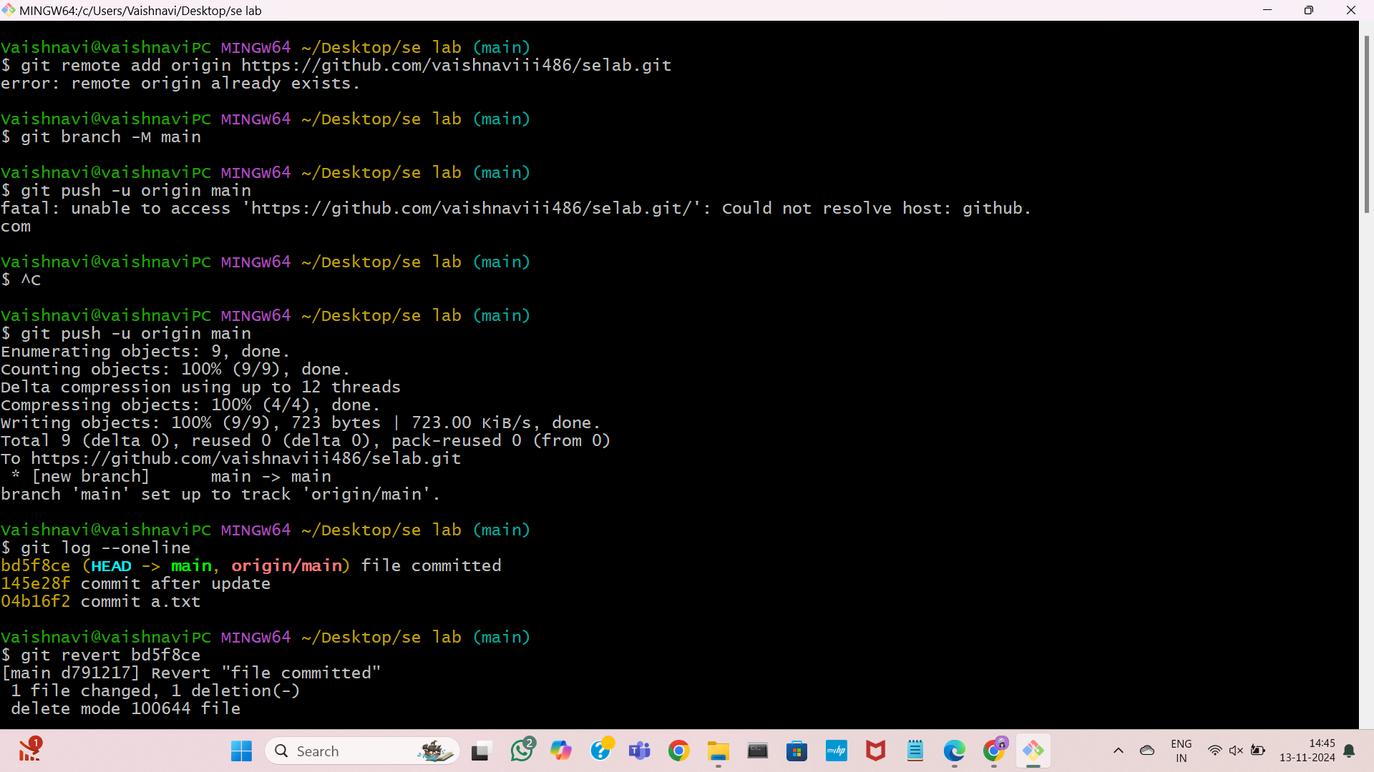

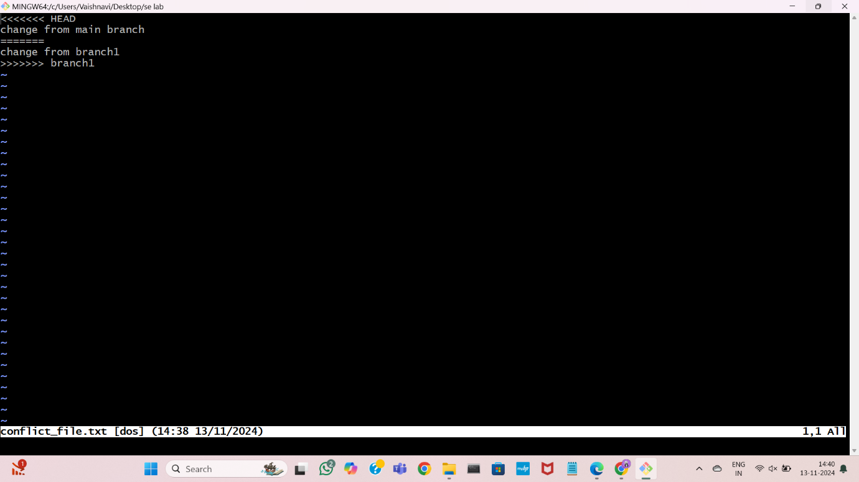

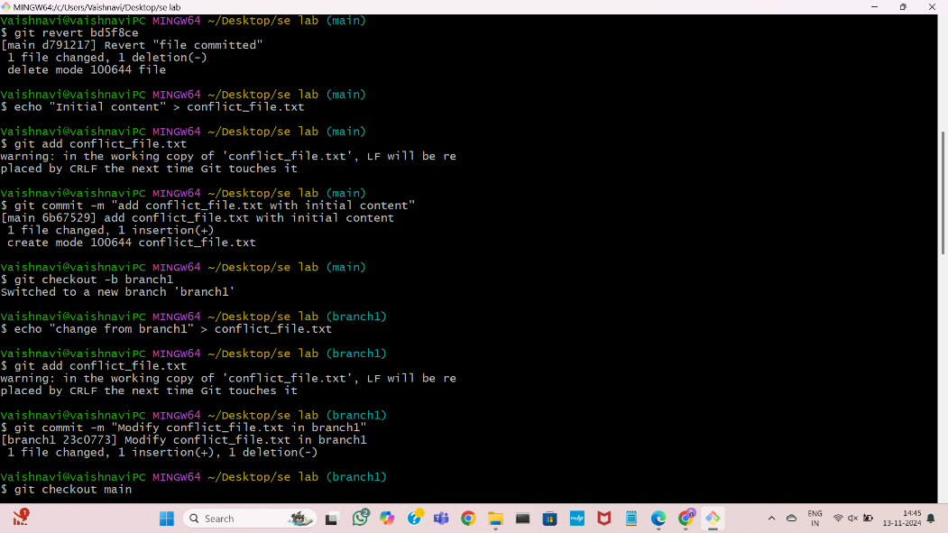

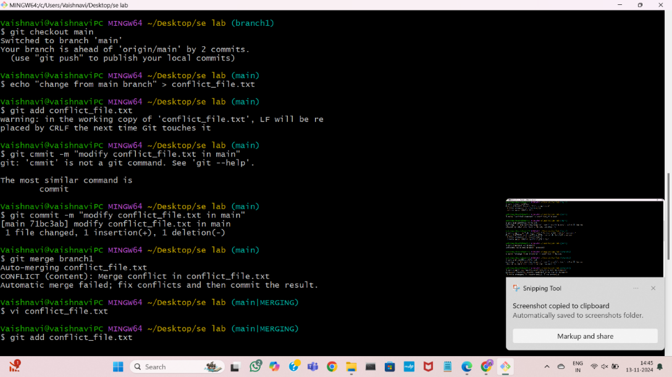

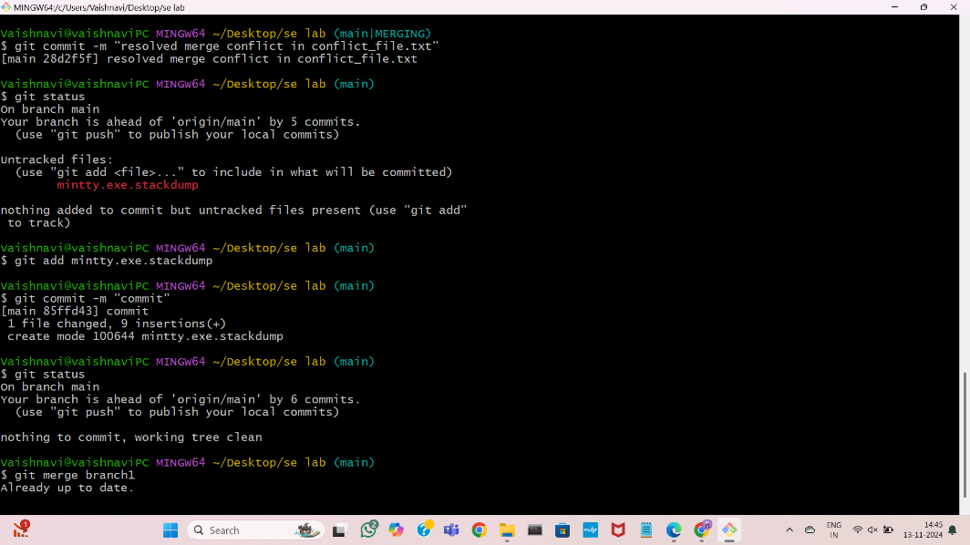

SSH key gen

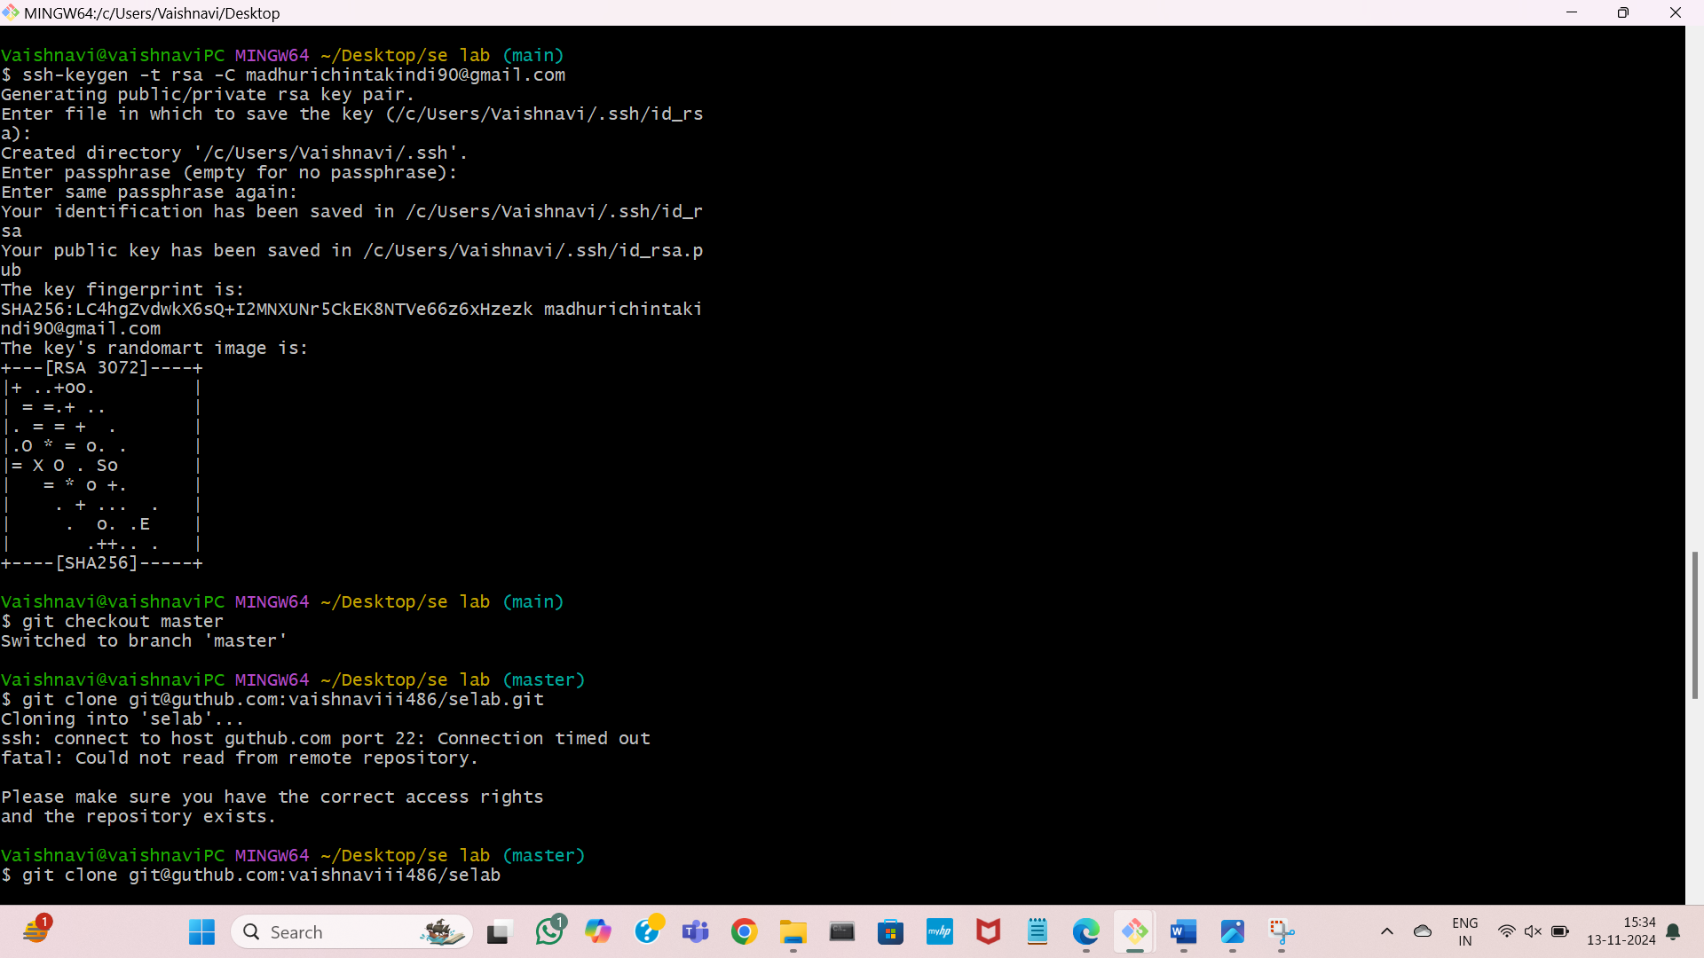

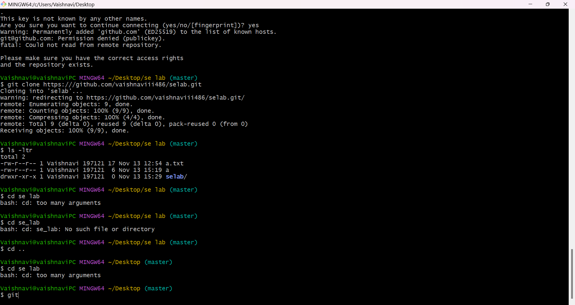

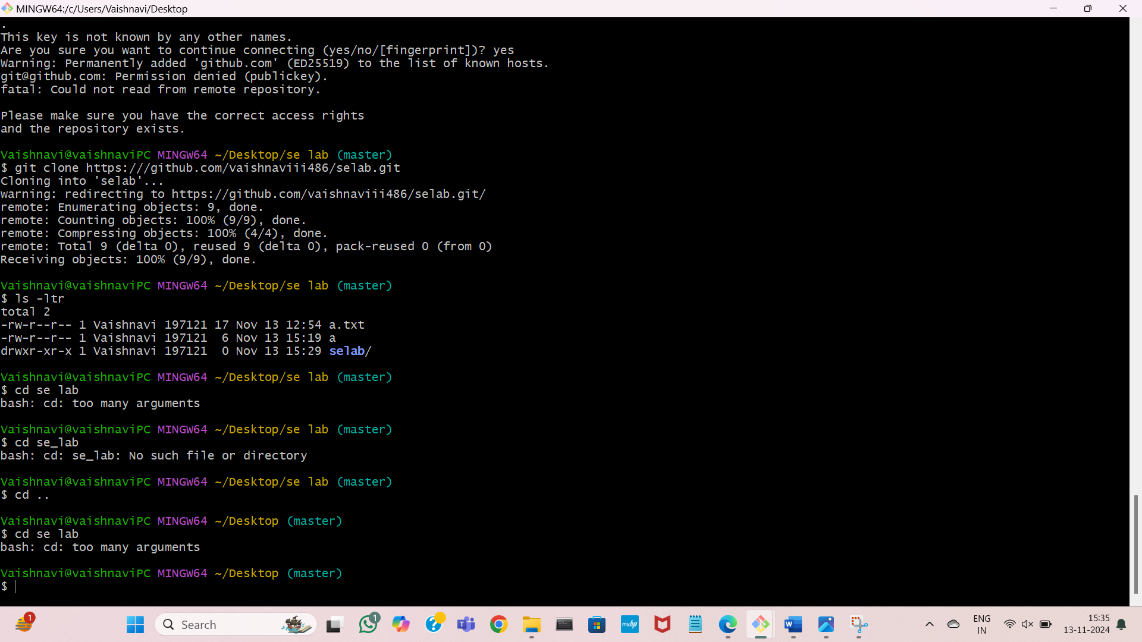

Pull

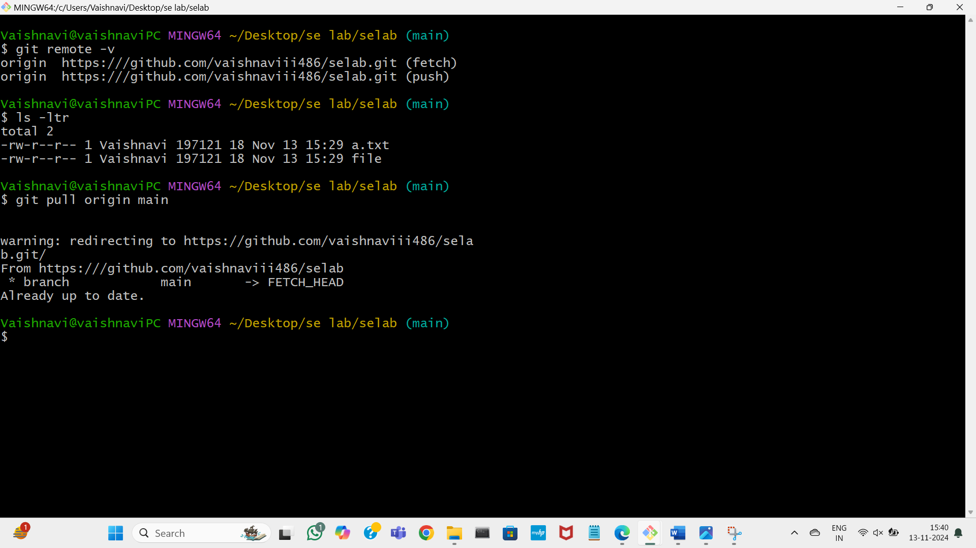

fork

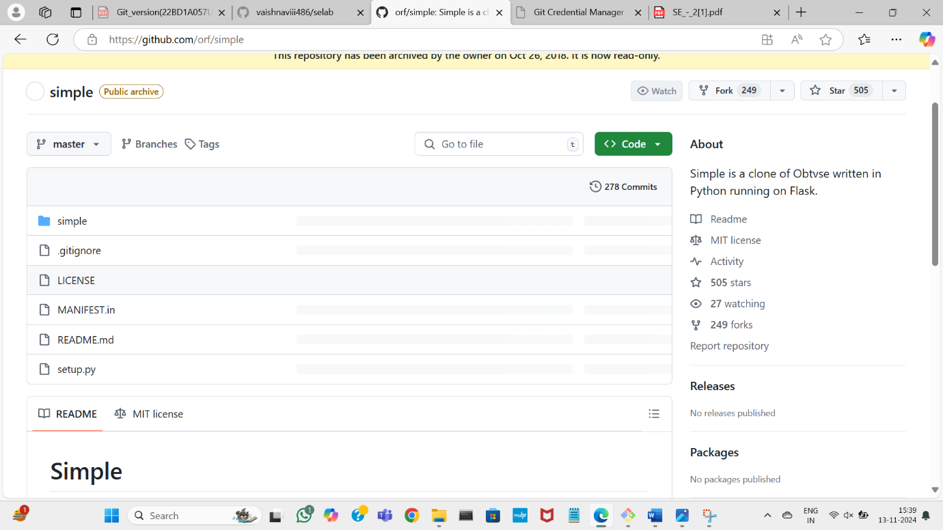

EXPERIMENT 5

A) CREATING MAVEN JAVA PROJECT USING ECLIPSE AND PUSH INTO TO GITHUB.

Creating maven java project

Open file>new>other

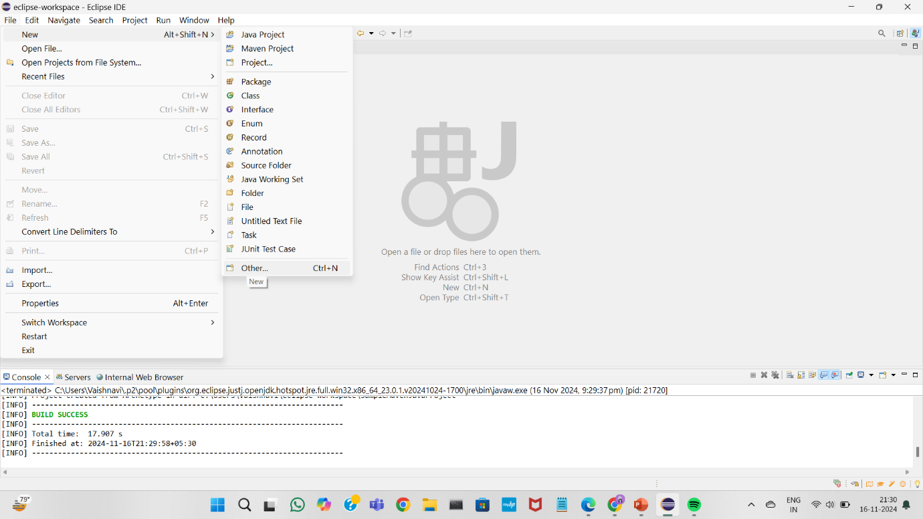

Select maven project

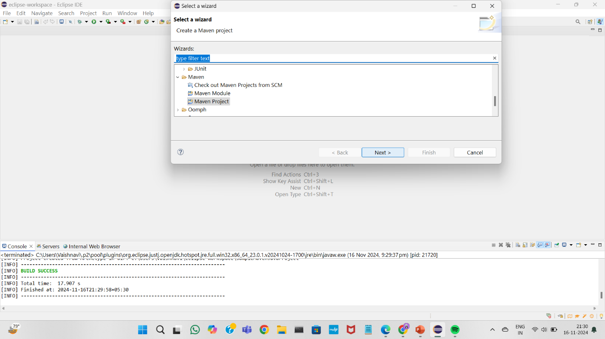

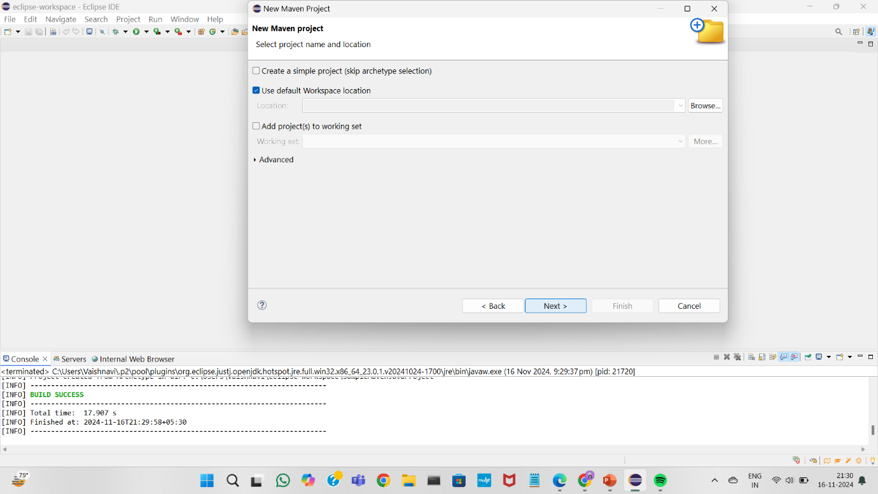

Select filter and choose quicksort version 1.4

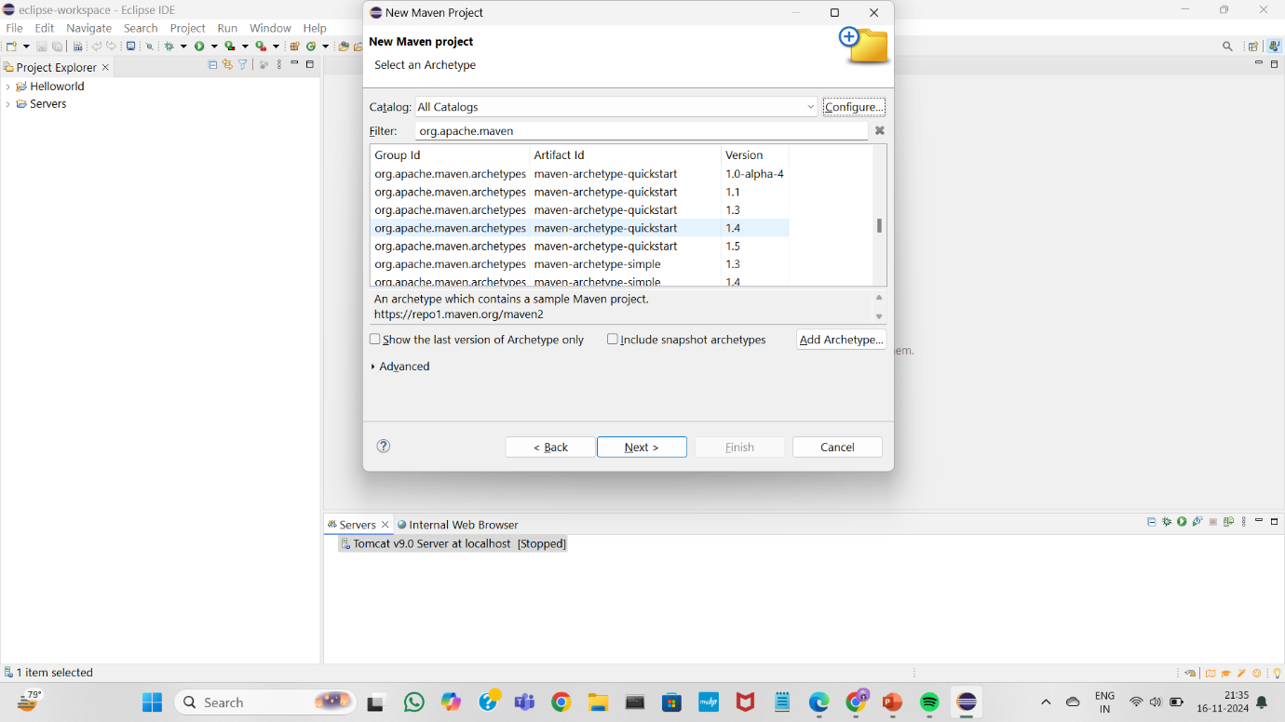

Name your project using Artifact id

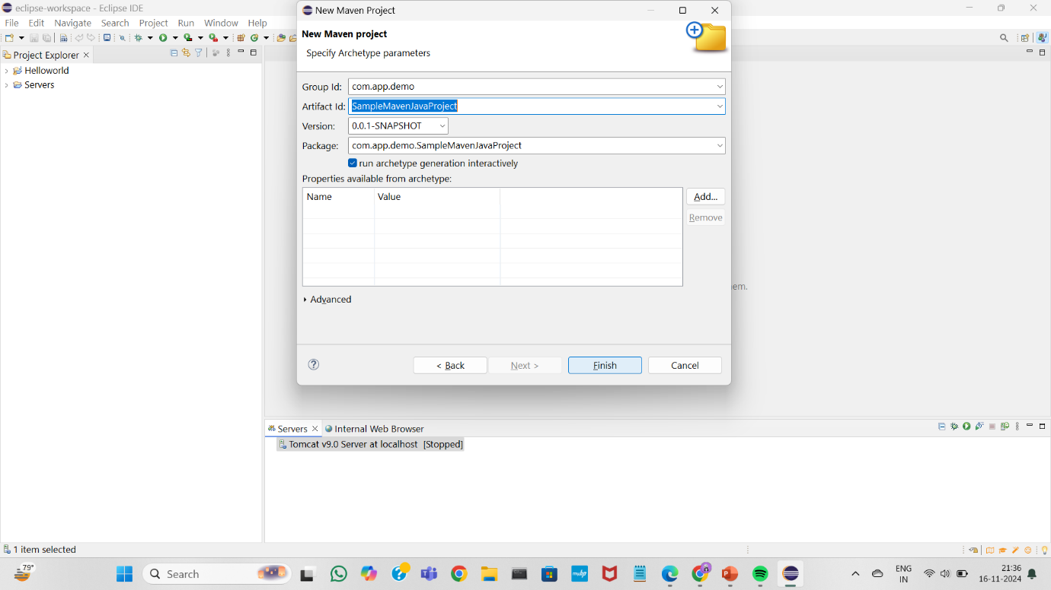

Your maven java project is creating…

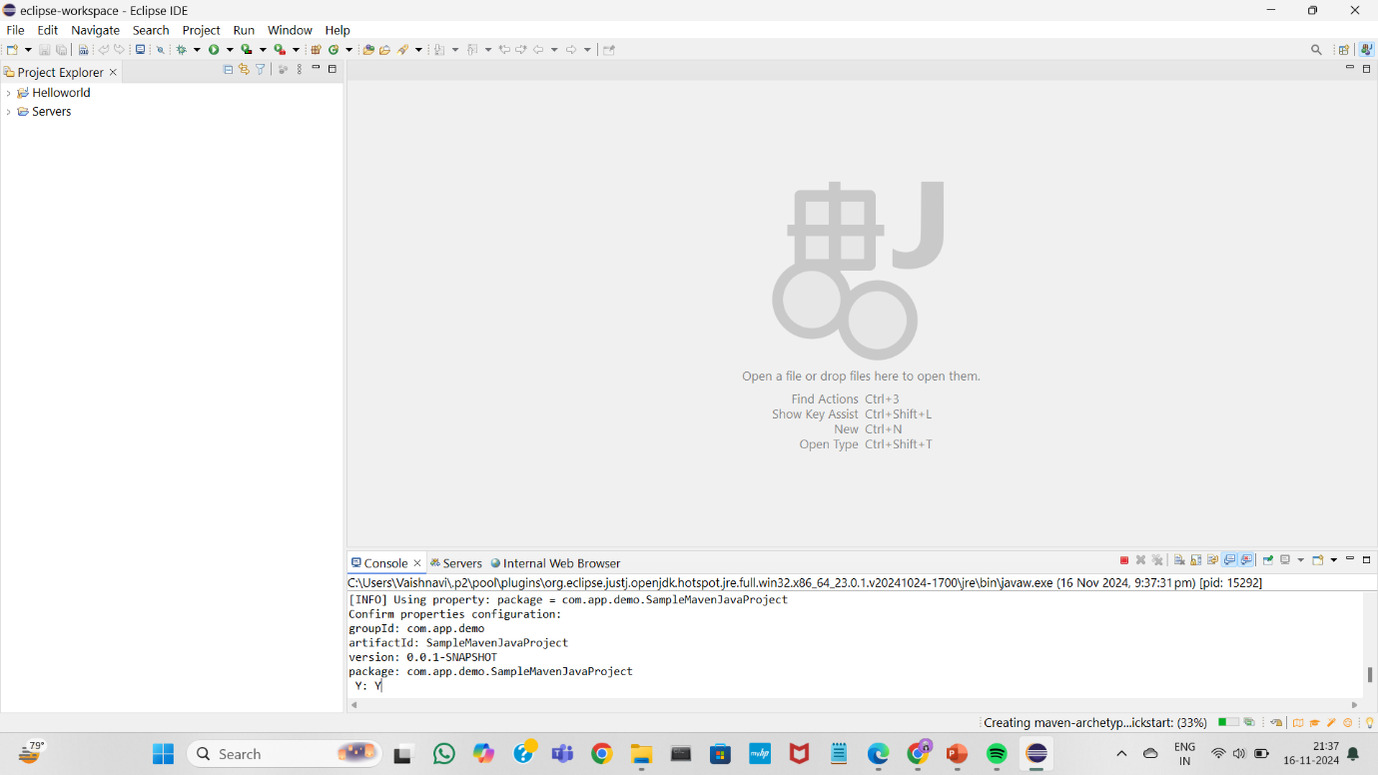

You will find your project in project explorer

Open app.java file in it

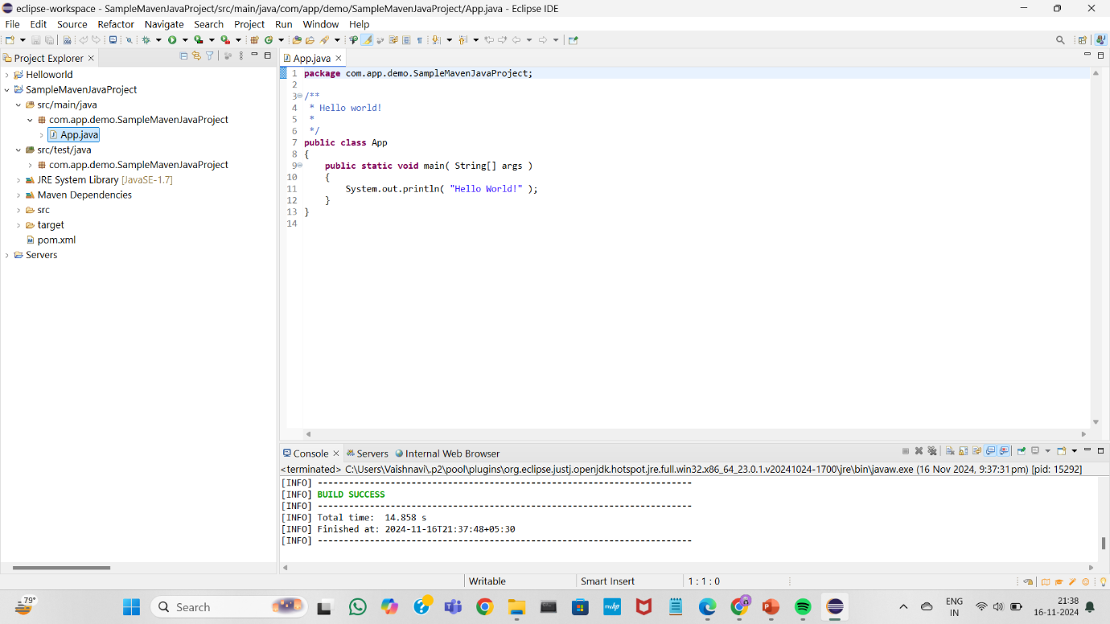’double click on project and select “run as” -> ”maven clean”

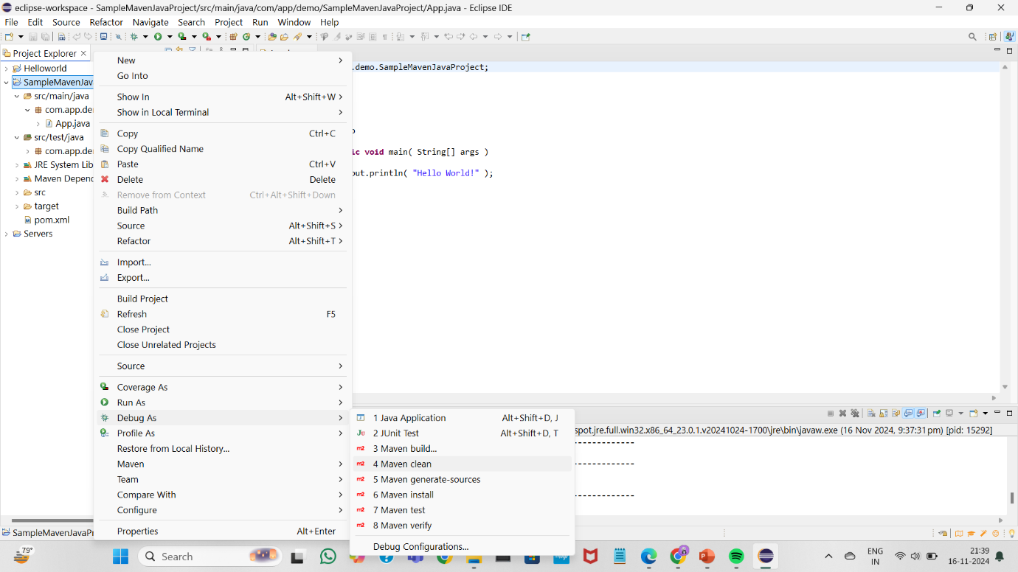

And then run as maven install

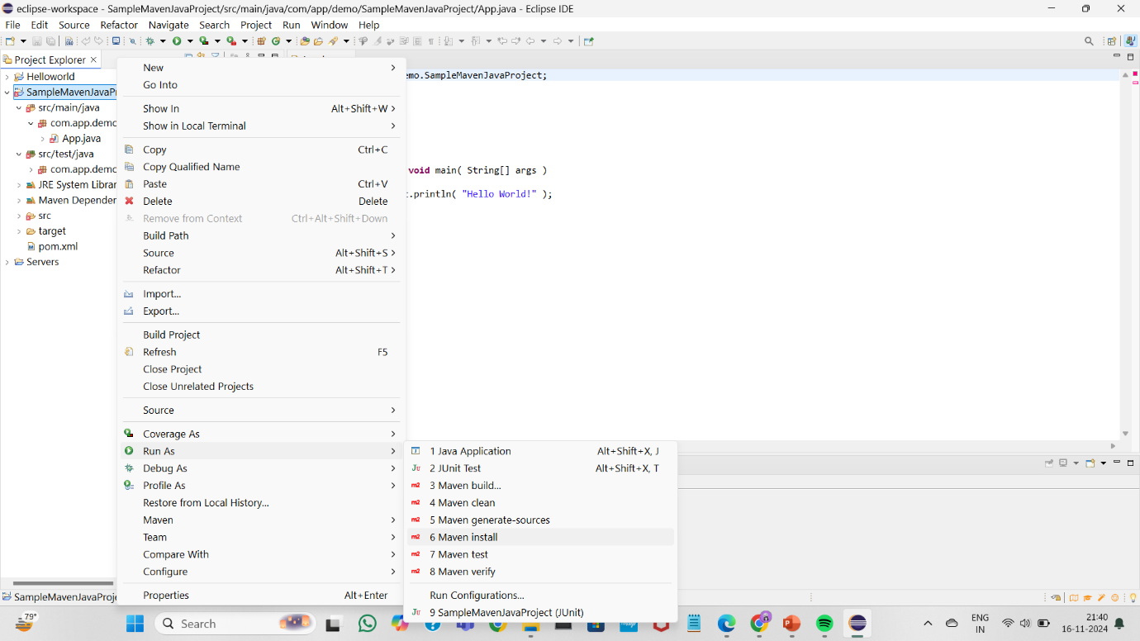

Run as maven test

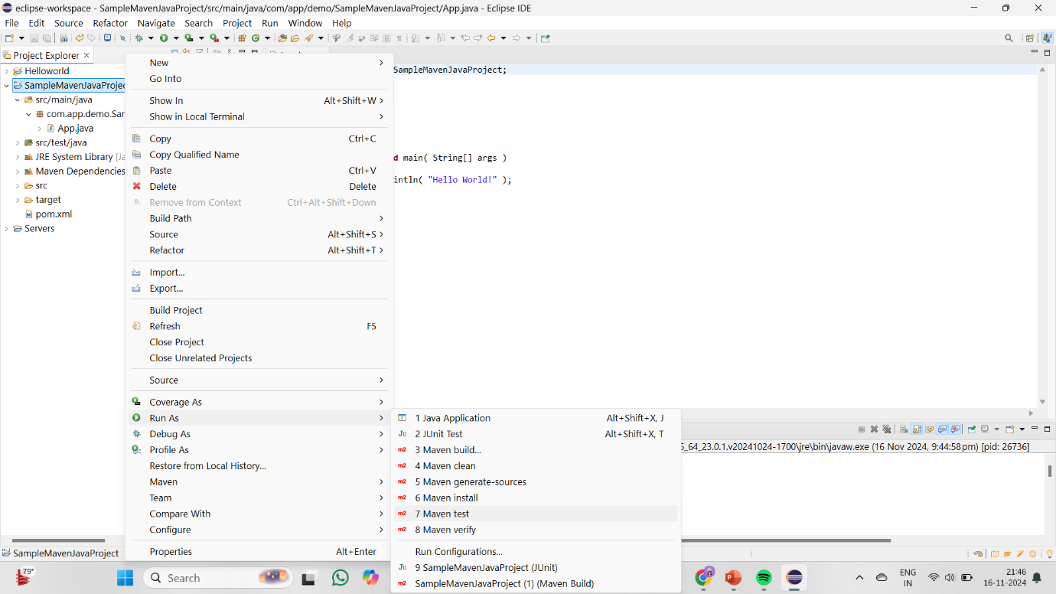

Run as maven build

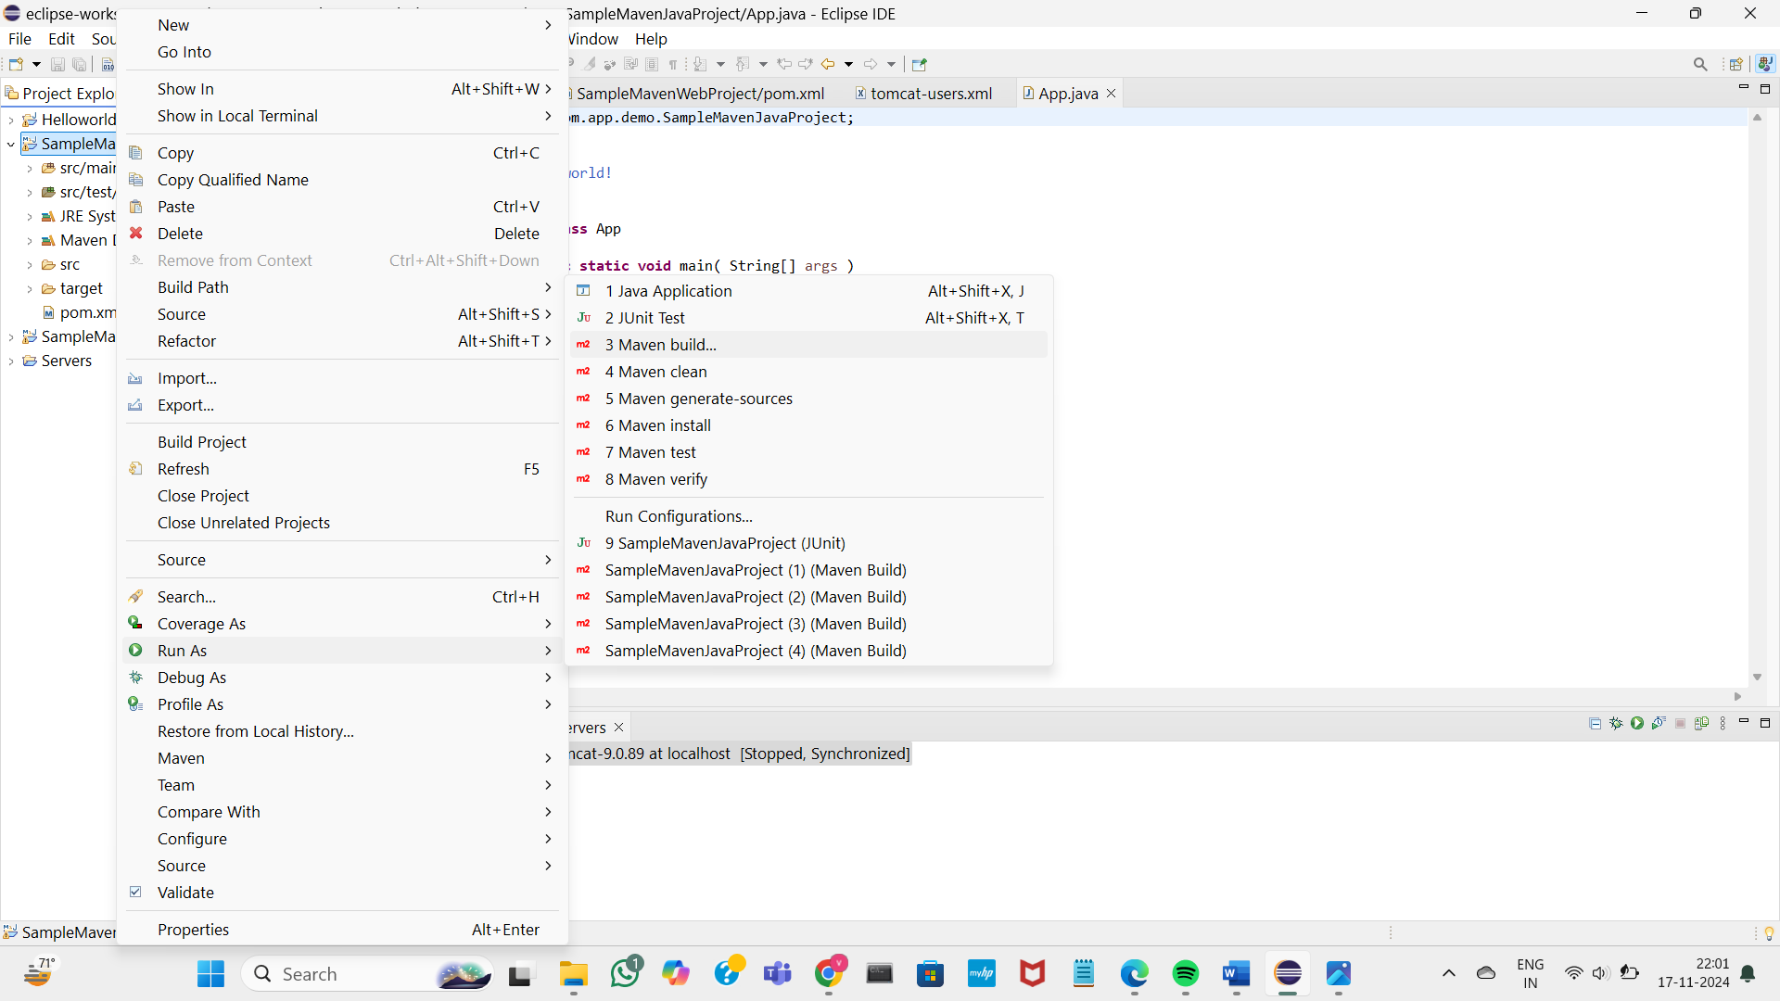

Enter your goals as “clean install test” and apply them

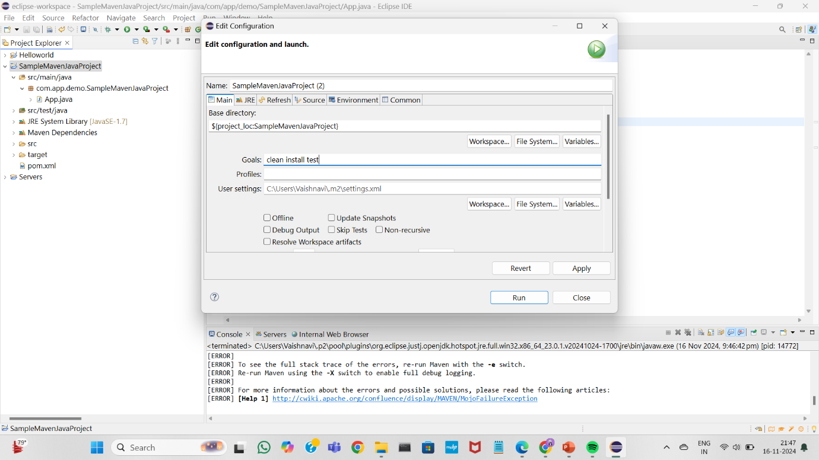

You will find SampleMavenJavaProject.jar version in target files

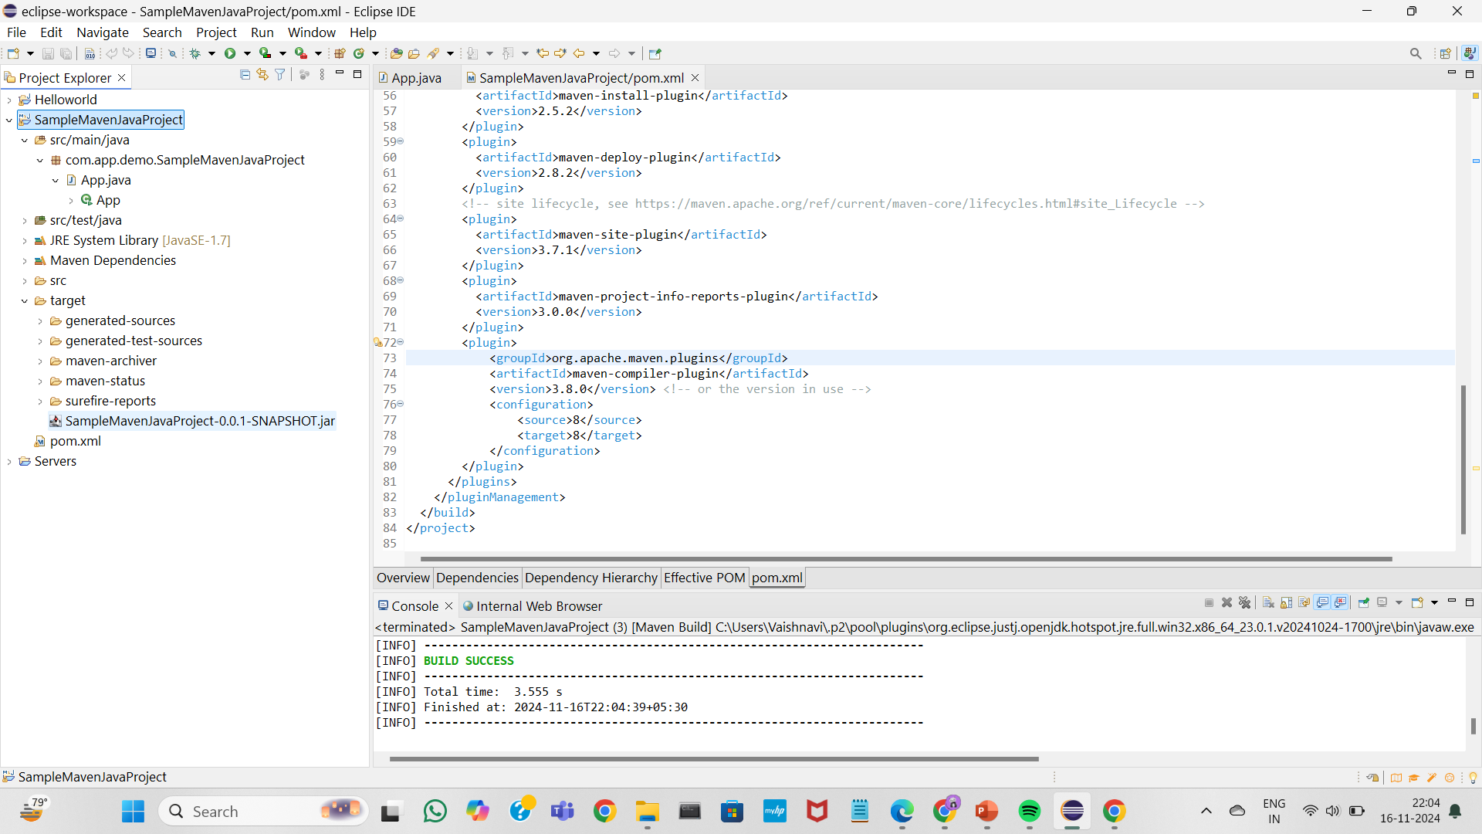

Now run as Java Application

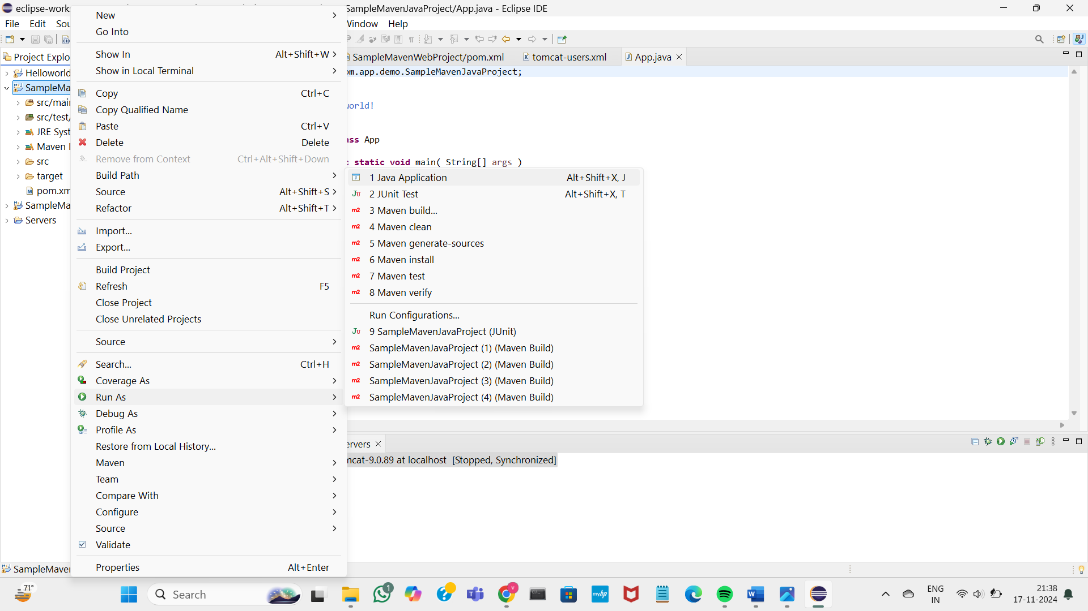

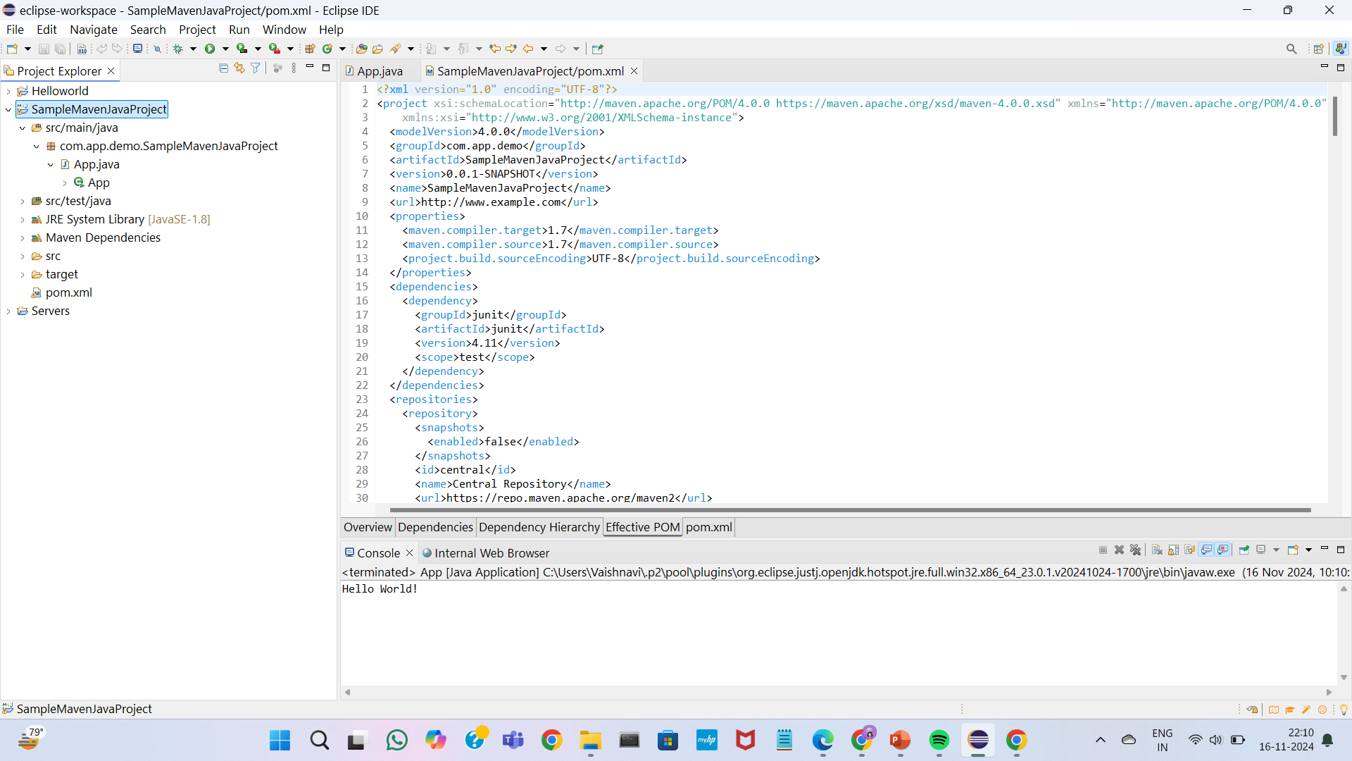

Open github account click on New to create new repository

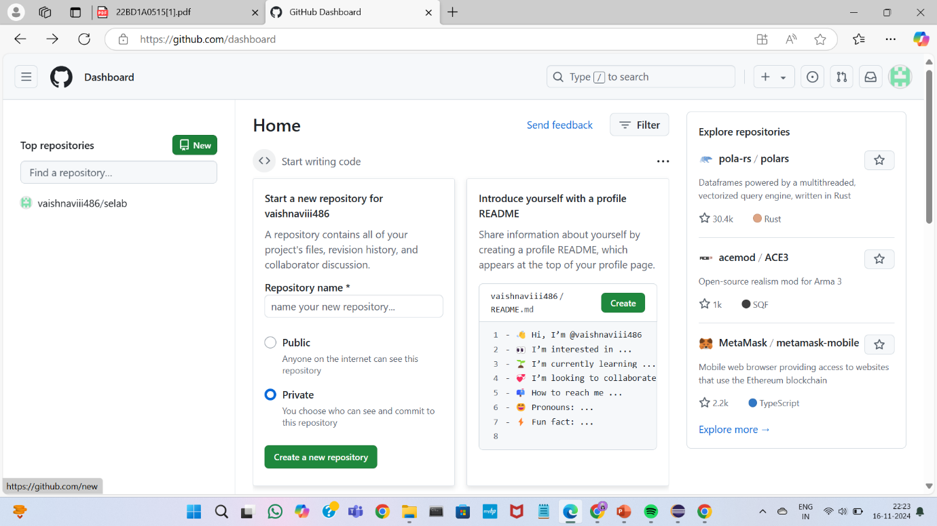

Give name for the repository and click on add.gitignore ,select “maven”

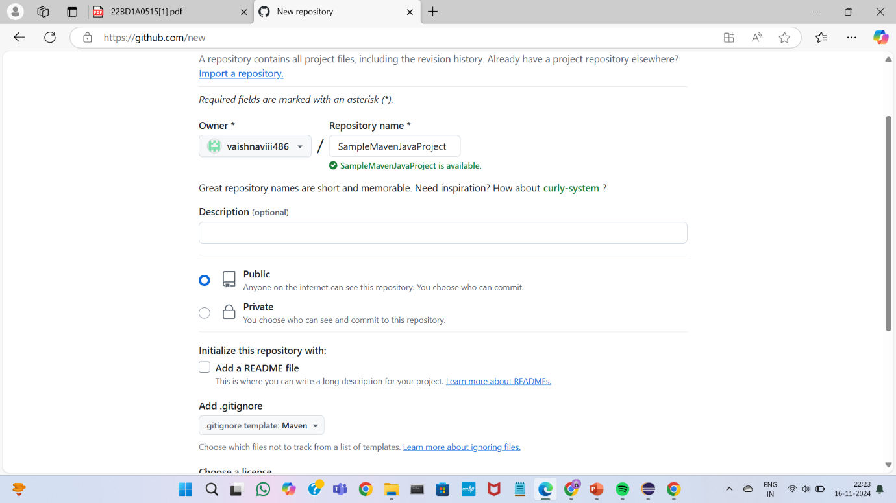

Your new repository has been created

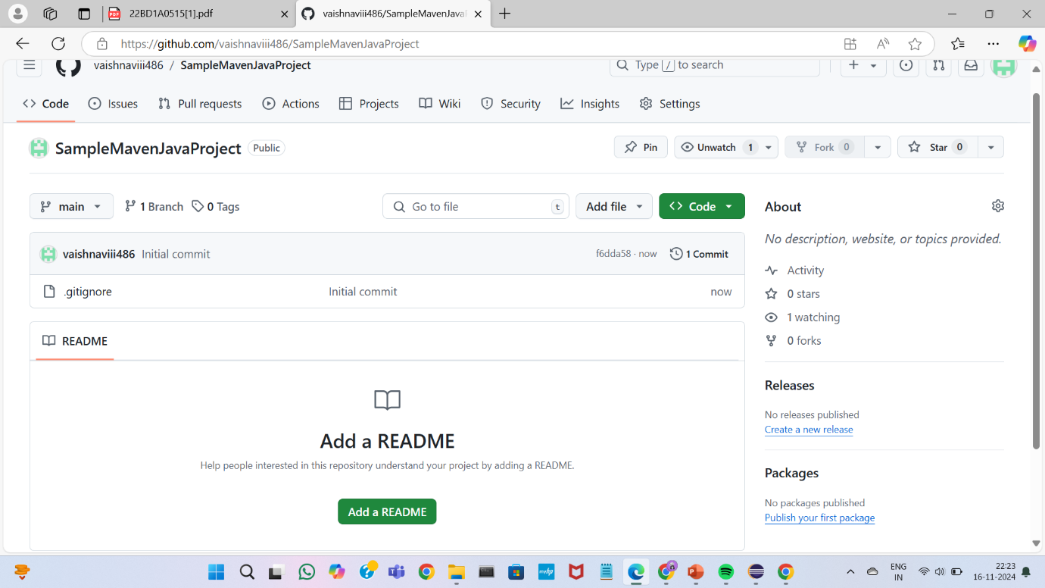

Copy the url to the clipboard

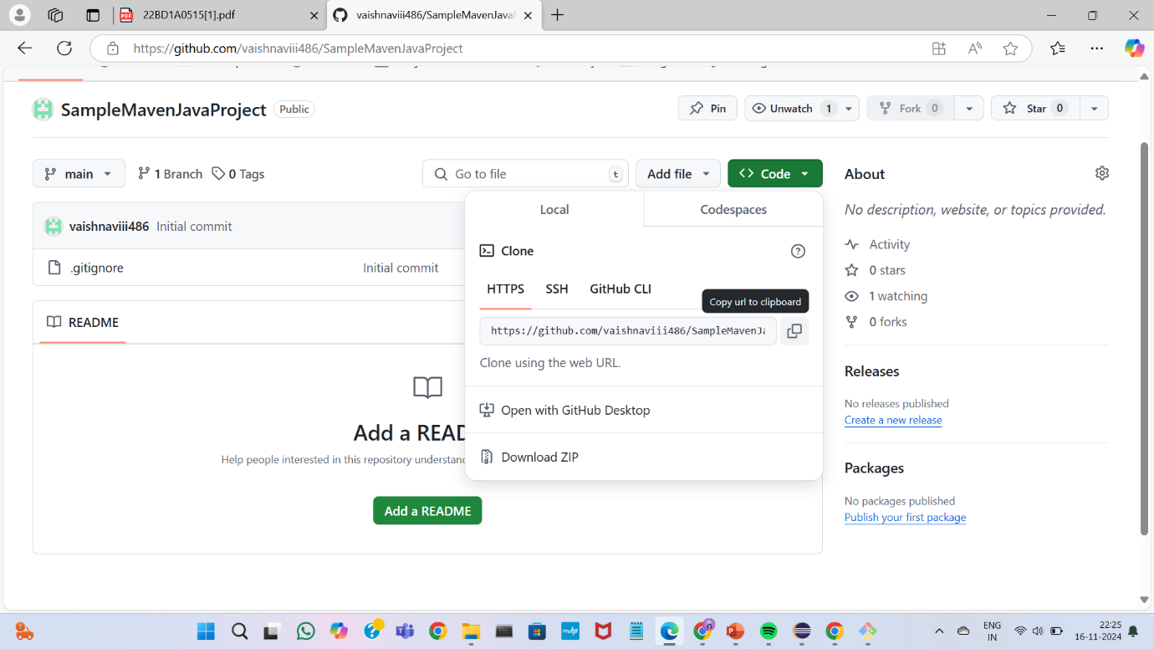

Open gitbash and clone the repository using the url link and git clone commnd

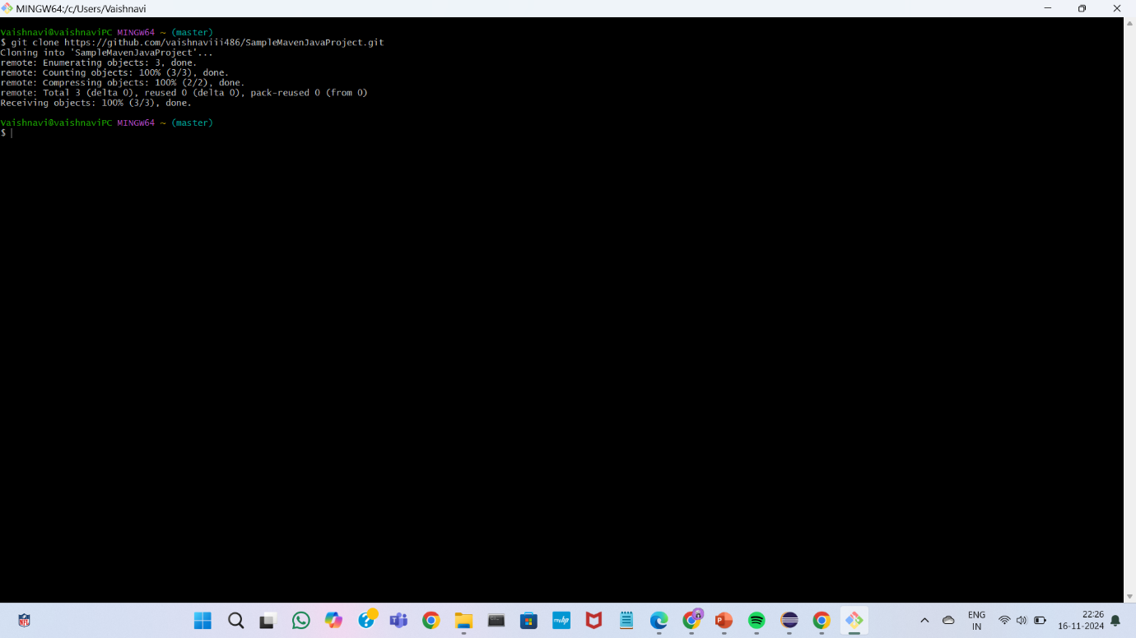

Open your eclipse workspace-SampleMavenJavaProject in file explorer and copy the files

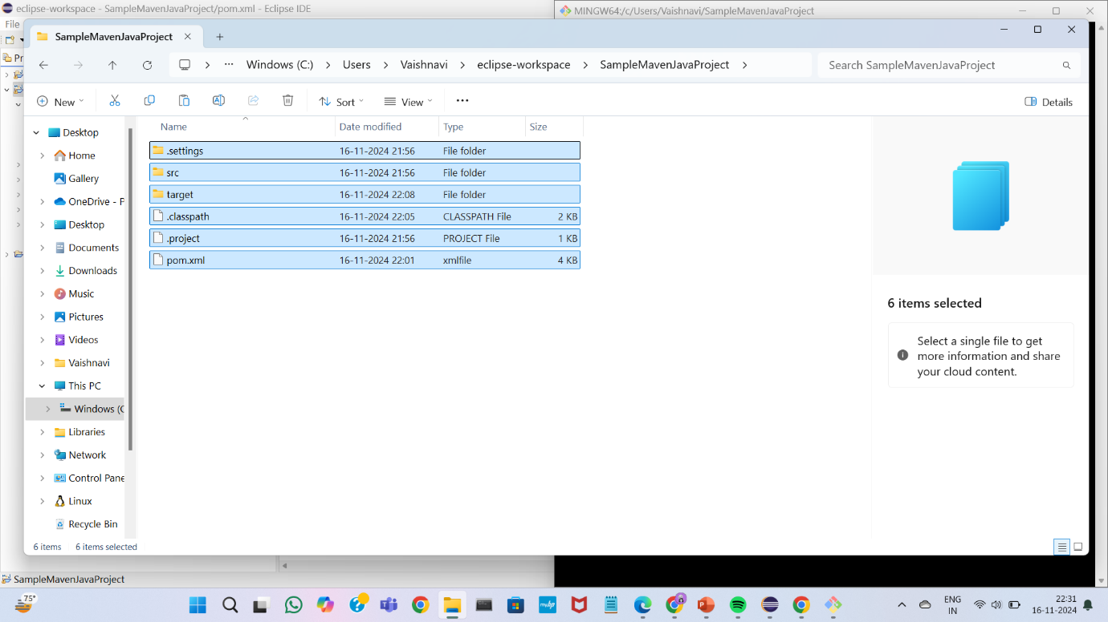

Open This pc > windows > users and your directory name you will find your maven java project select it

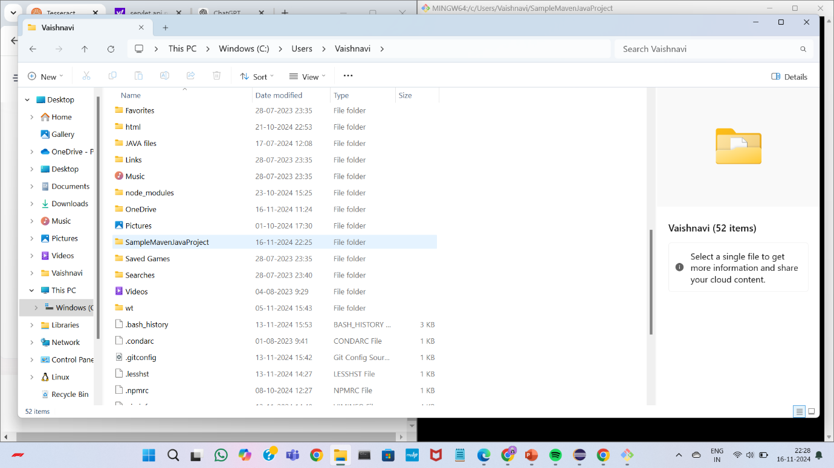

Copy the files into it.

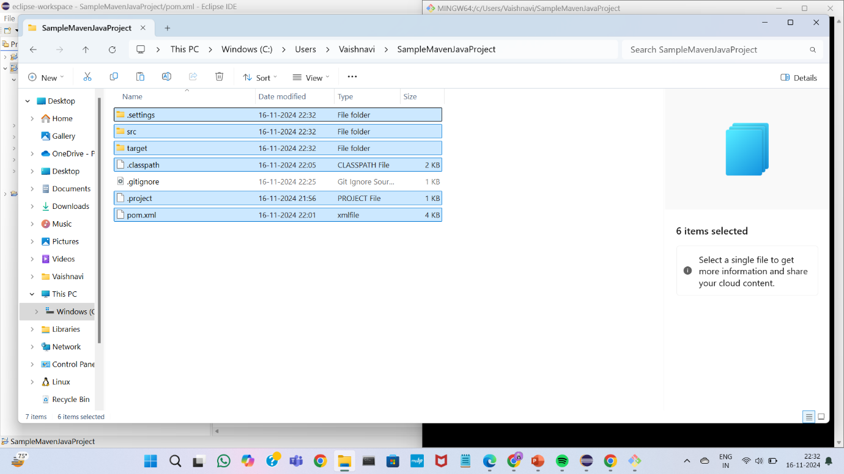

Go to the working directory of the project

Add the files to the staging area using git add command

Commit -using git commit command

Push them into repository using git push command

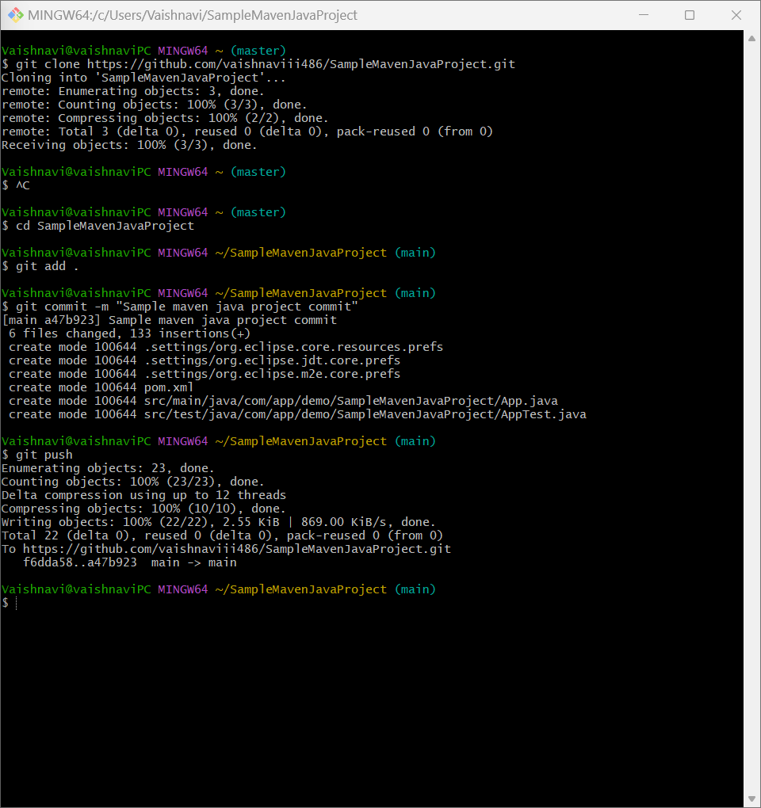

Open the repository in the github

You will find the files pushed into repository

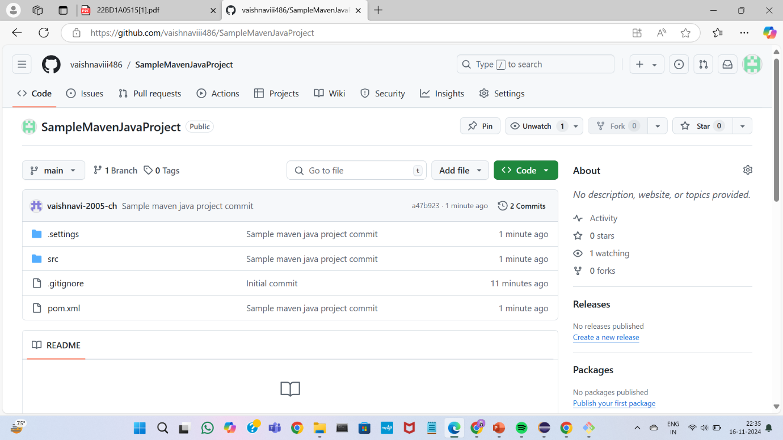B) CREATING MAVEN WEB PROJECT USING ECLIPSE AND PUSH INTO TO GITHUB.

Creating maven web project

Open files->new->other

Select maven project

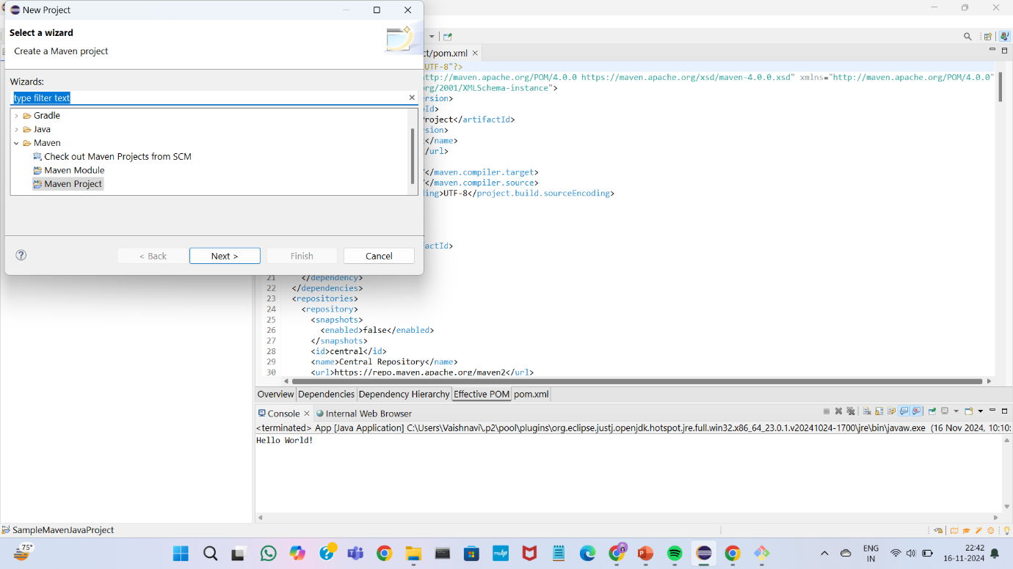

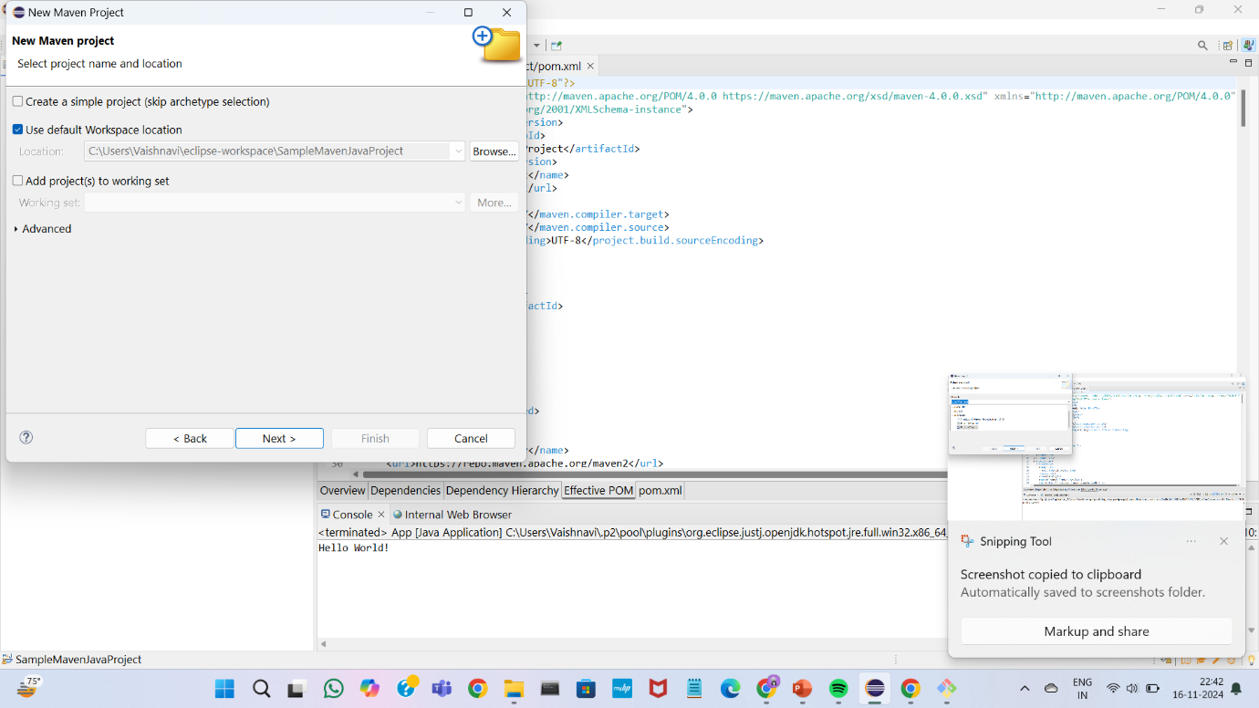

Filter using webapp version 1.4

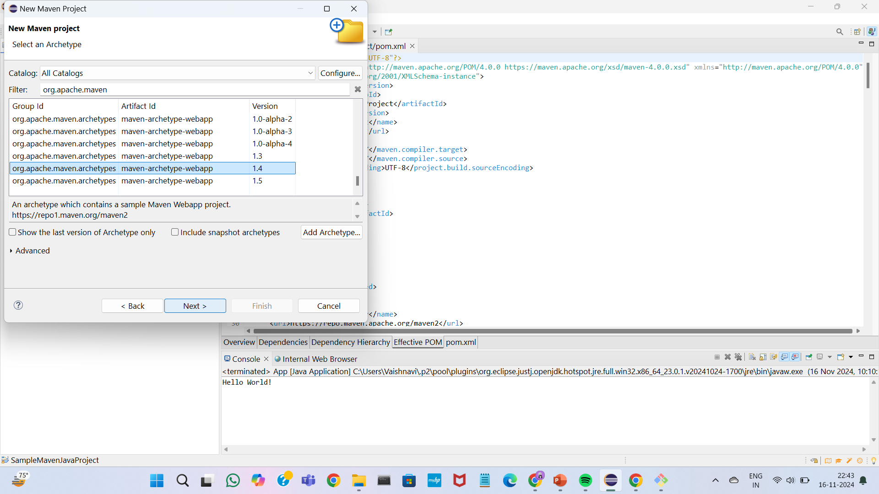

Give artifact id for the project

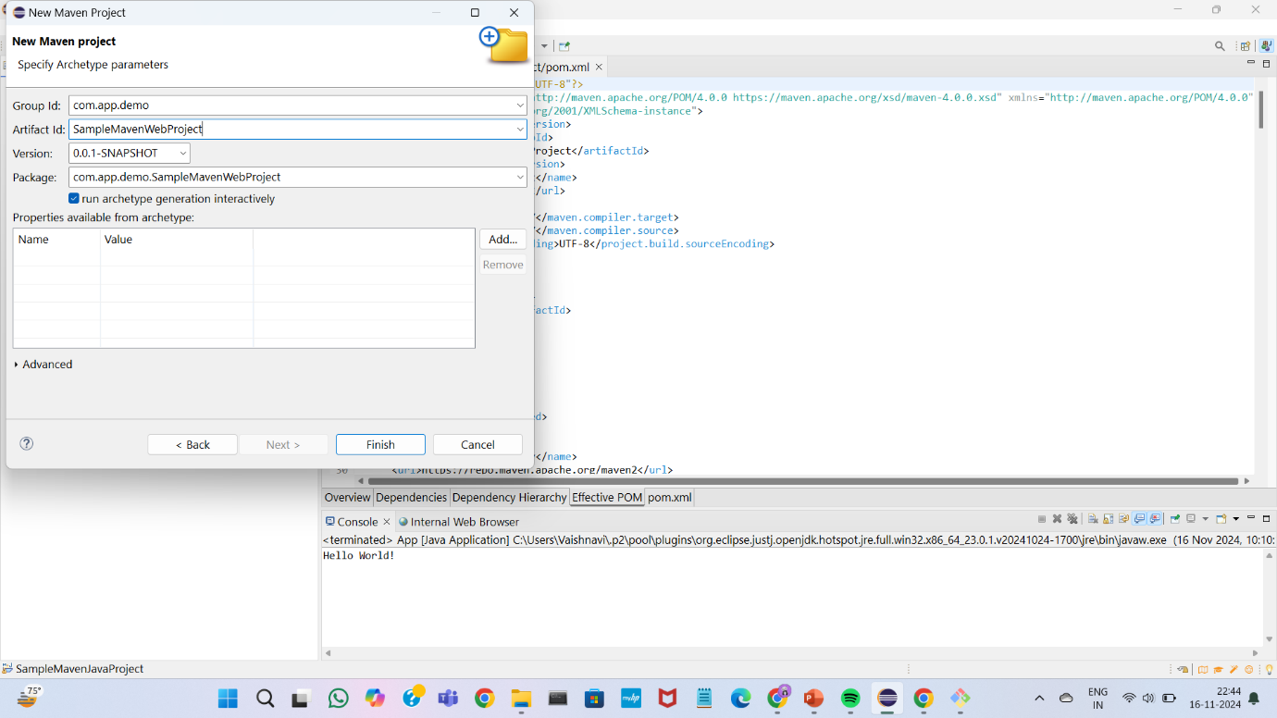

Your maven web project has been created in the project explorer

Open index.jsp file

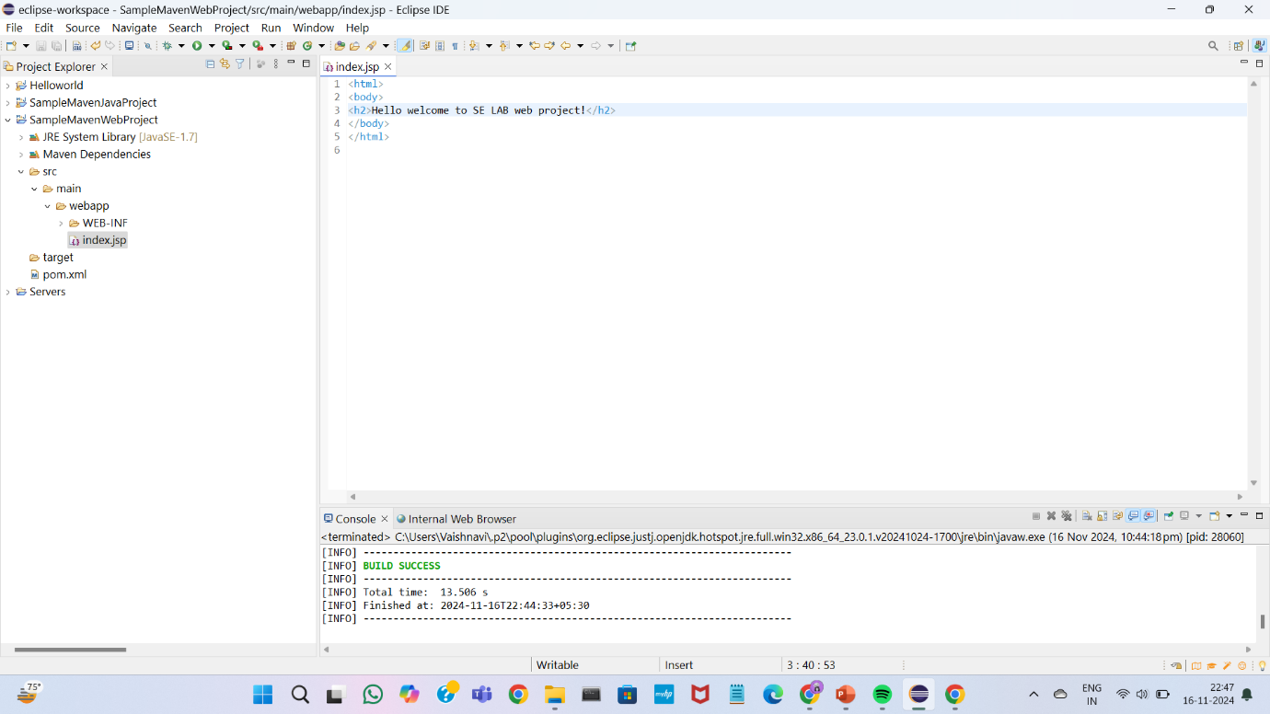

Open pom.xml file and the dependency that needed

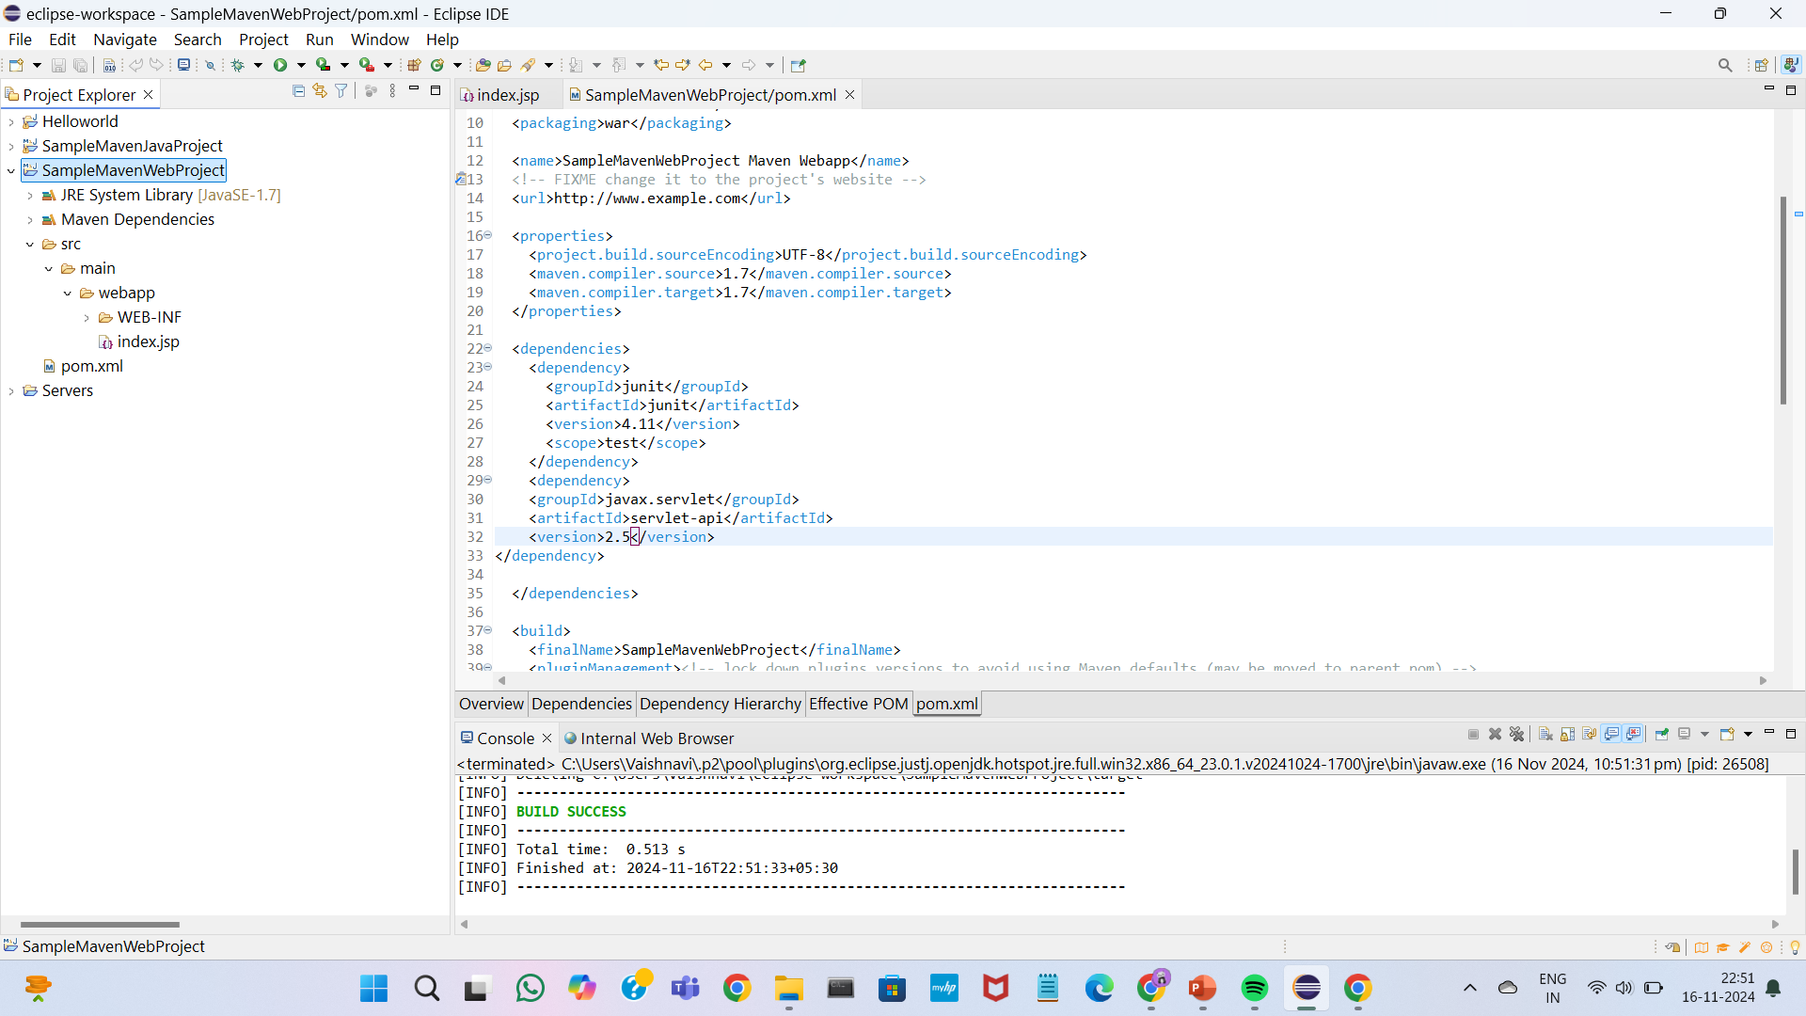

Double click on the project and run as maven clean

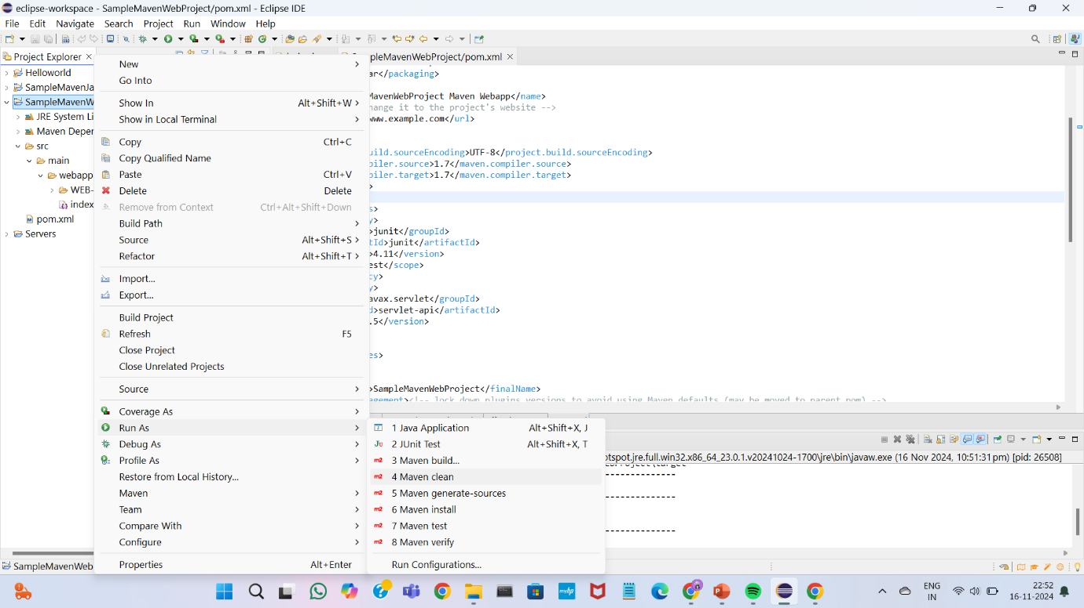

Select run as maven install

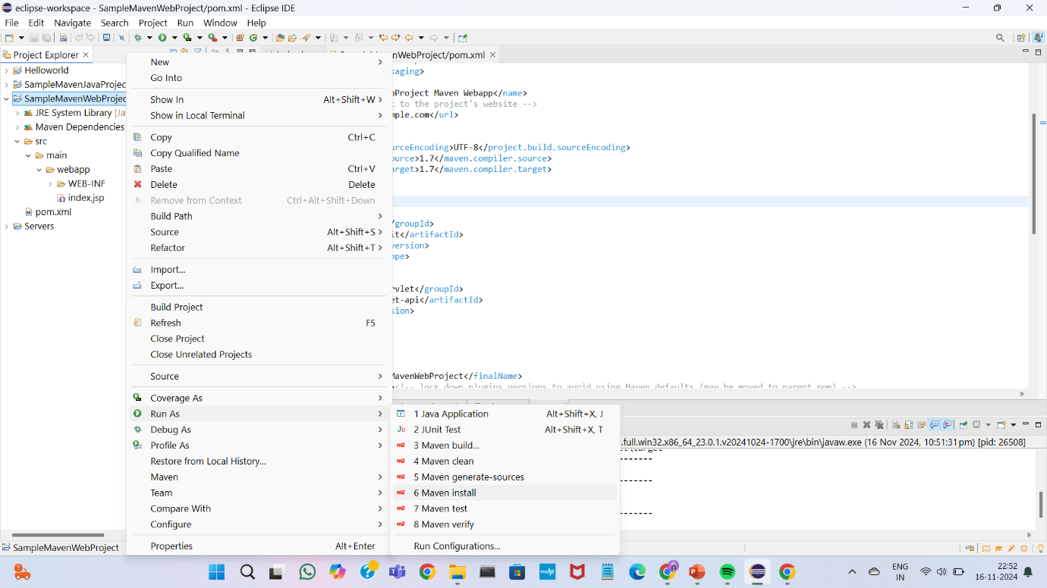

Select run as maven test

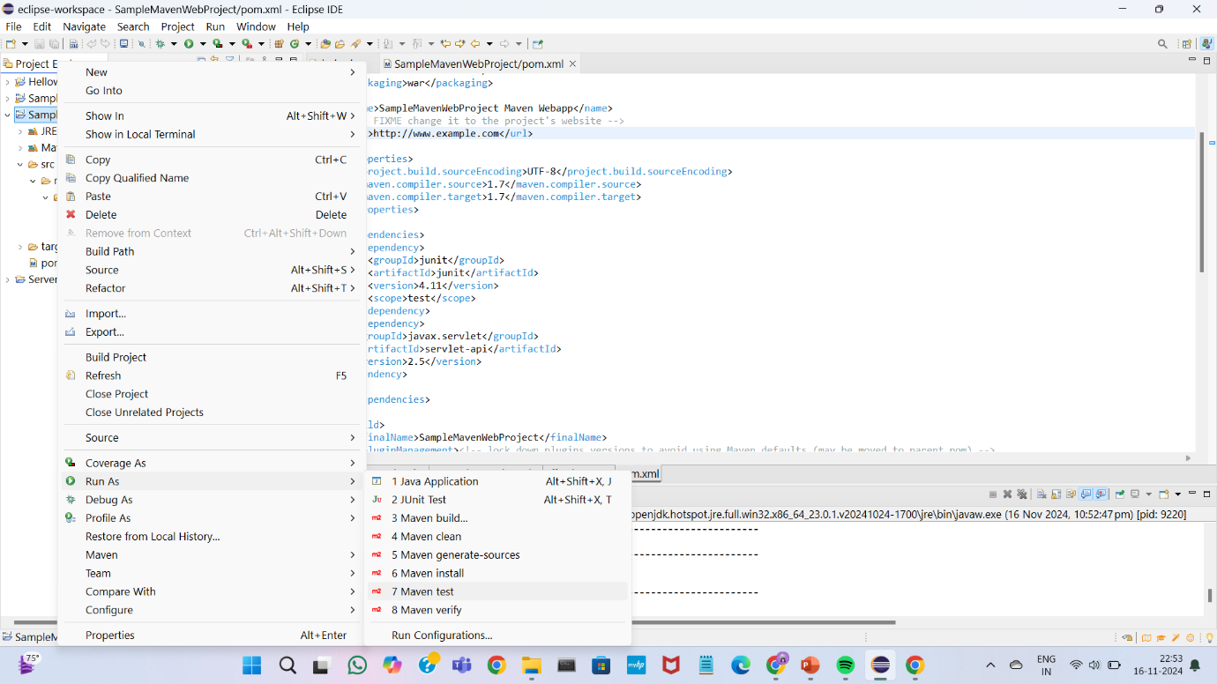

Select run as maven build and add your goals like clean install test aplly them and run

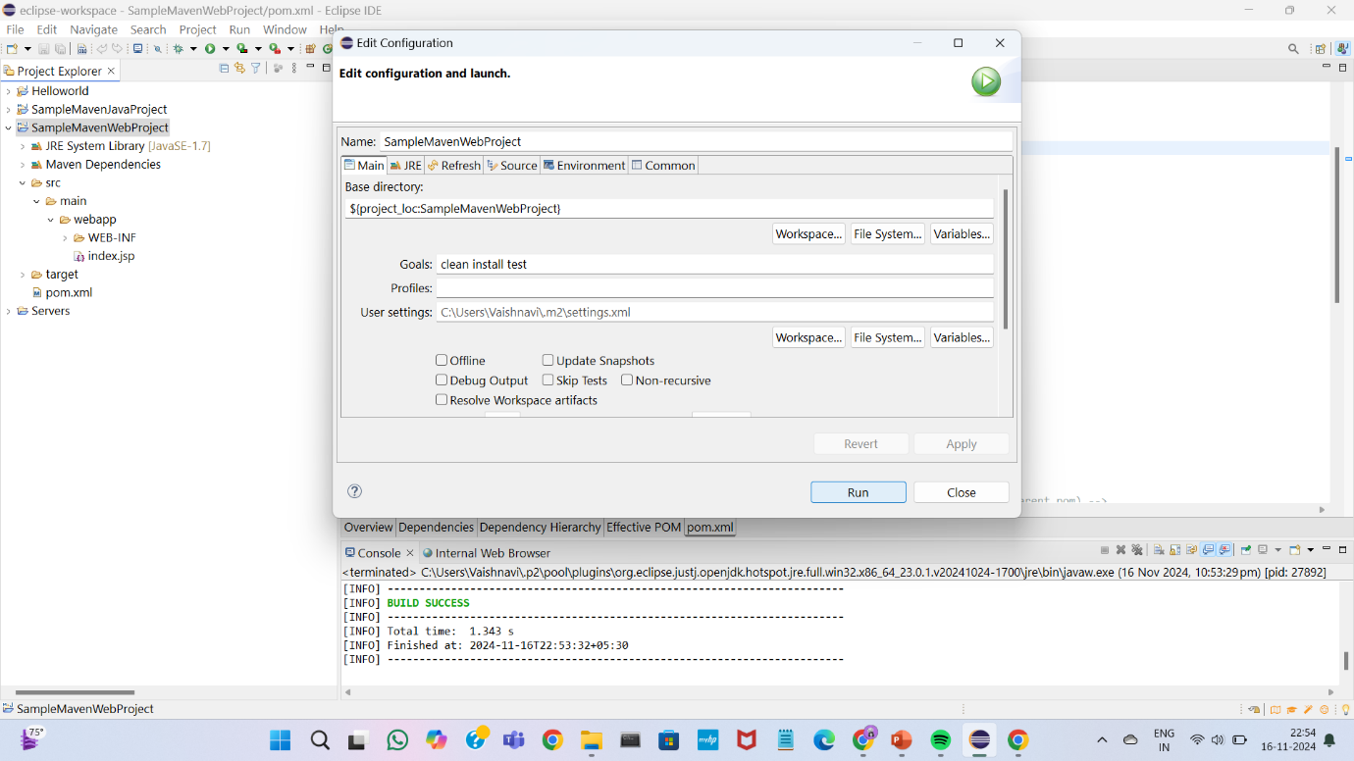

Select run as “run on server”

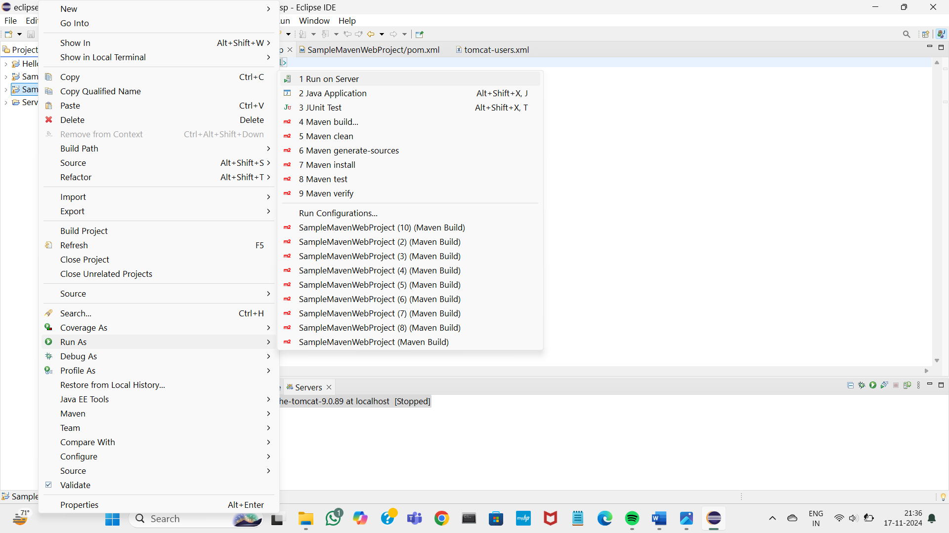

Choose the existing server

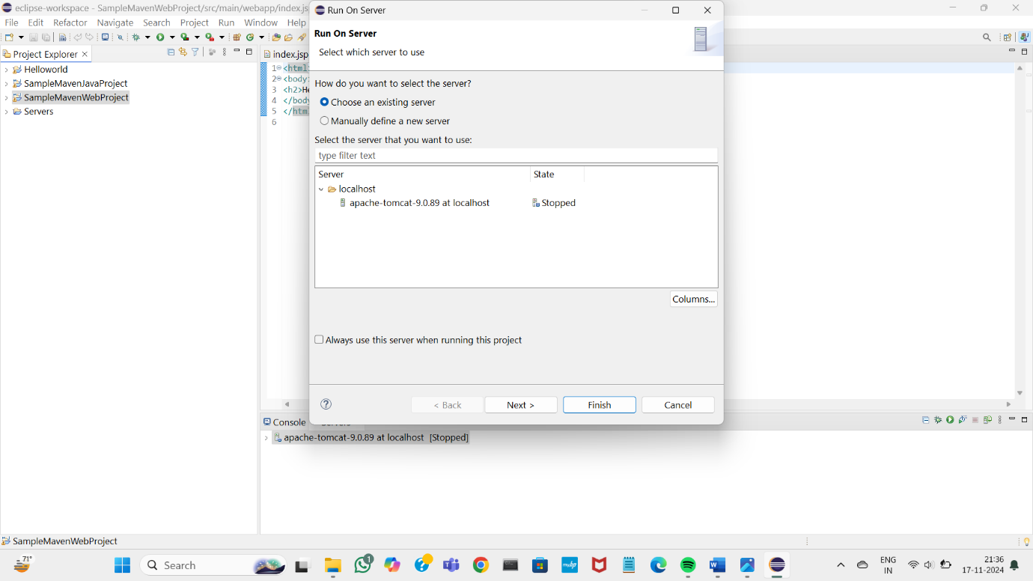

Move to file into configured box using “add all” and then finish

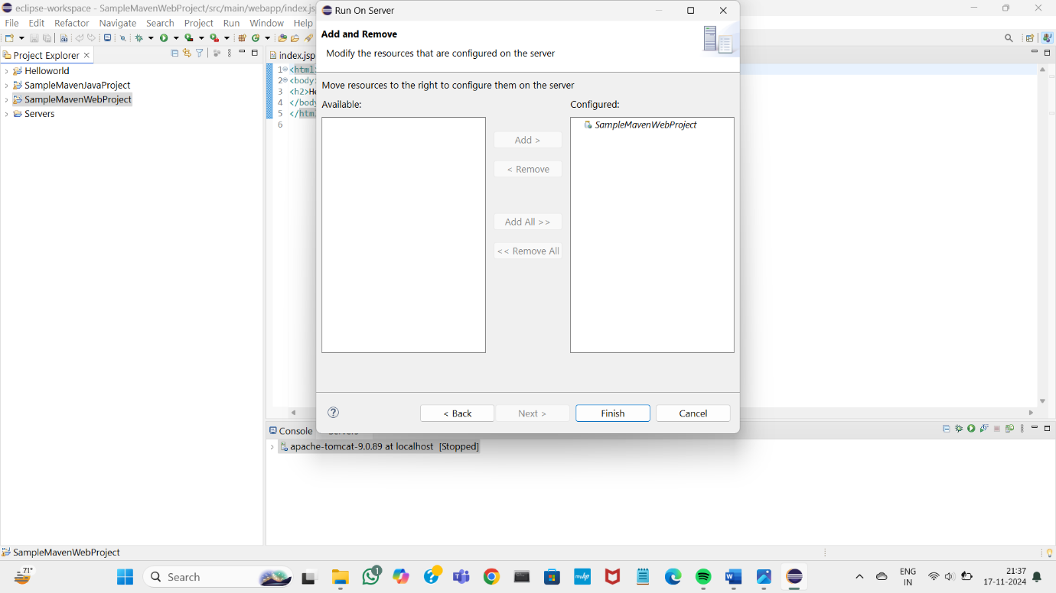

The server has started

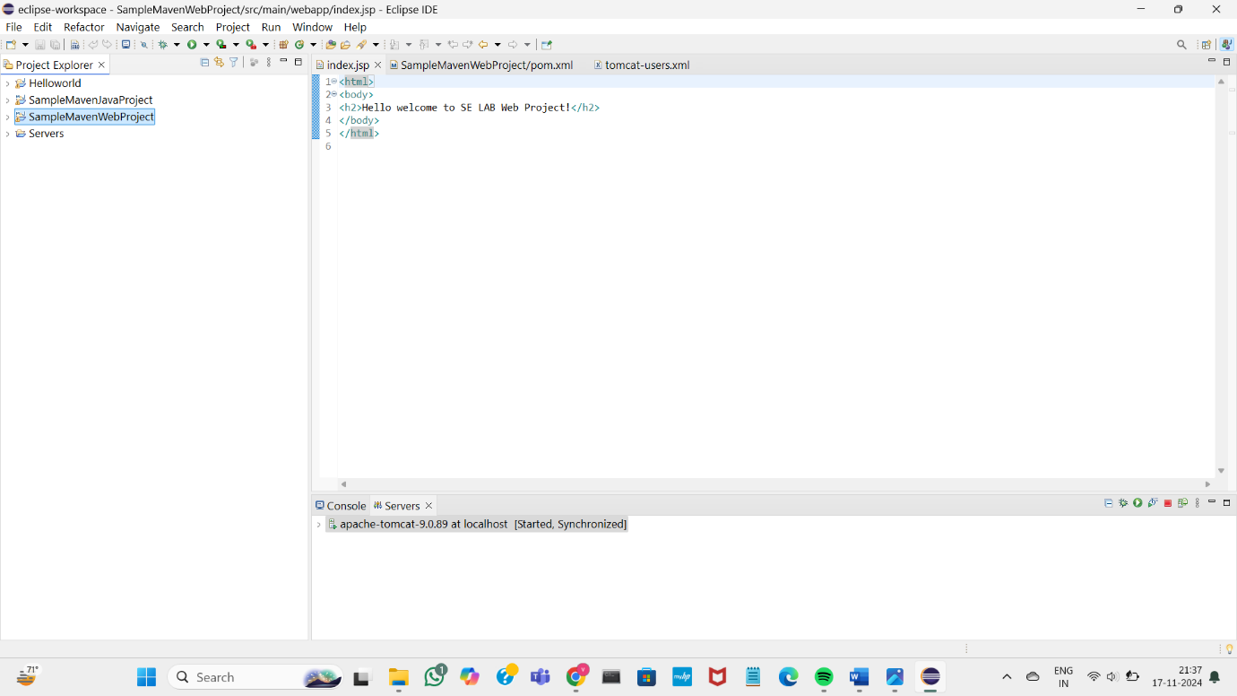

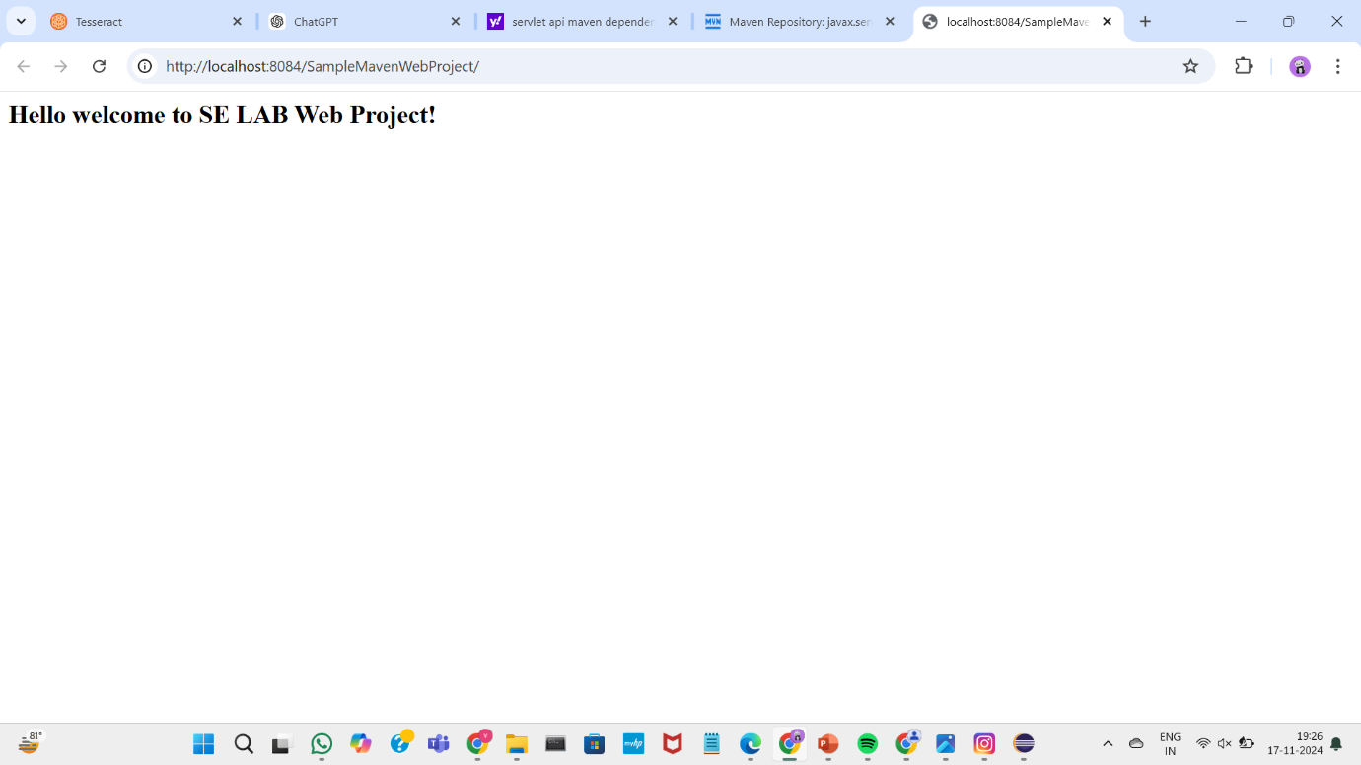

Open your github account click on “new” to create new repository

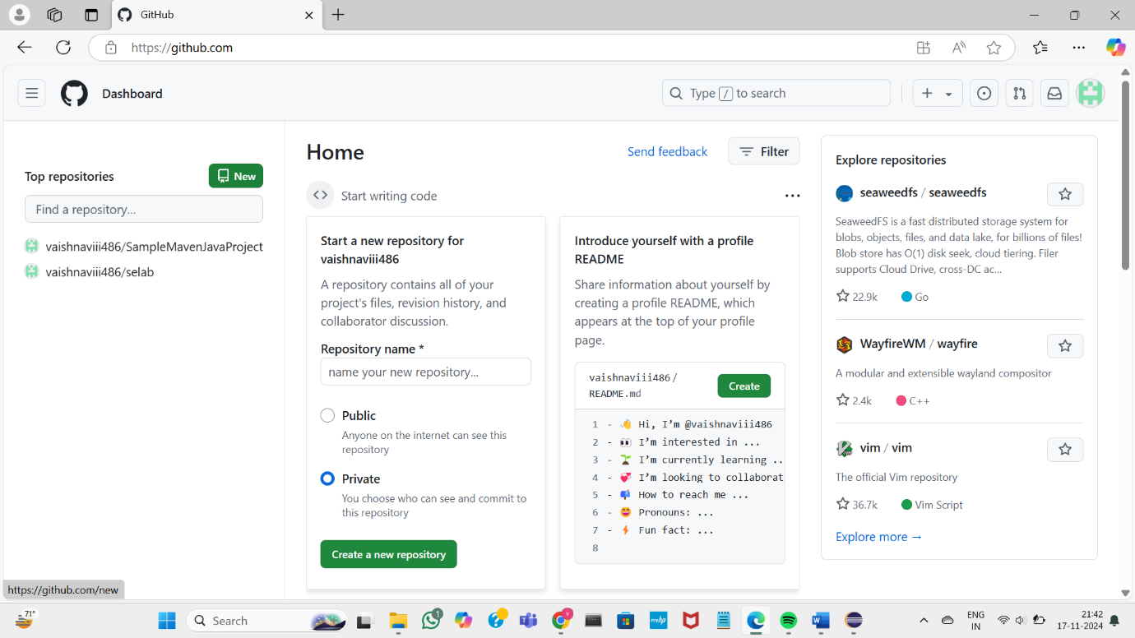

Name the repository and select Maven in the .gitignore option

Open the repository and copy the url

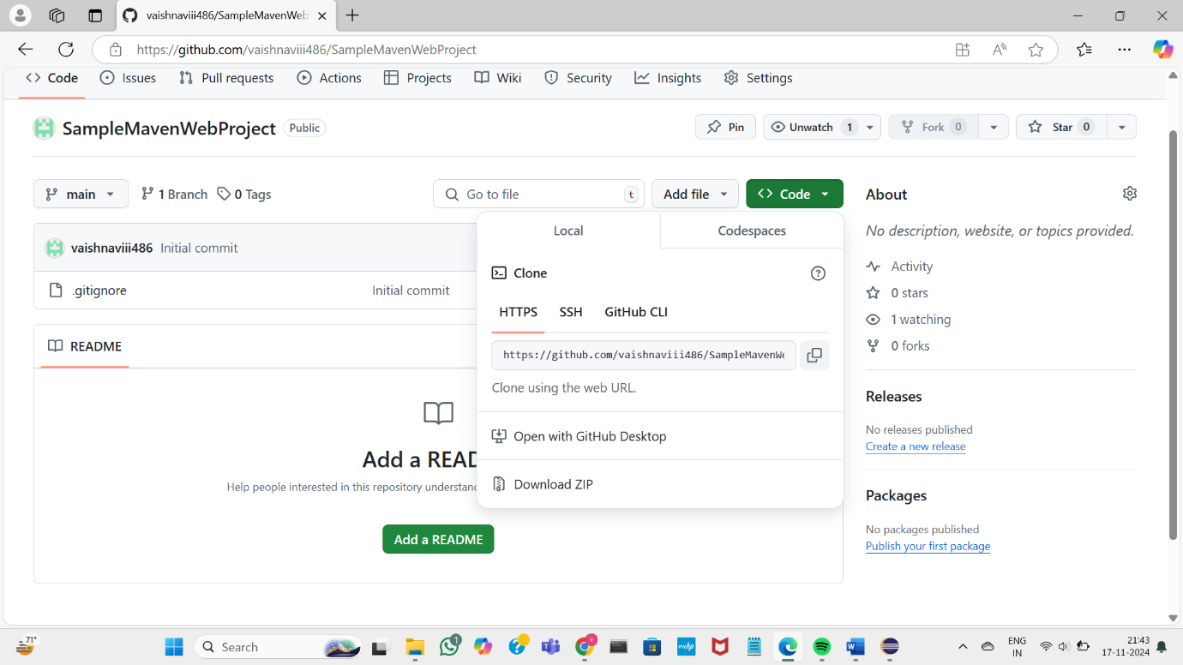

Open this pc-> windows->users->directory name->eclipse workspace->project name and copy all the files

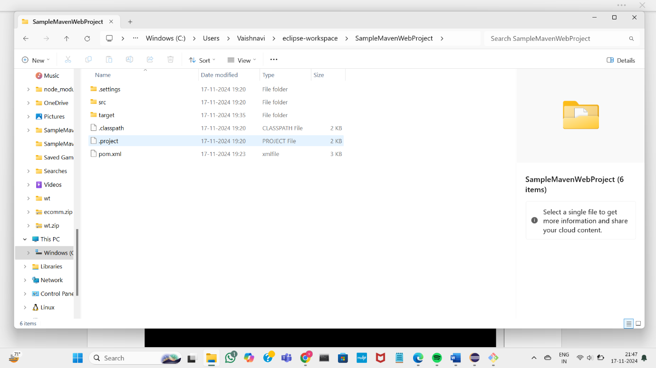

Open the eclipse-workspace directory

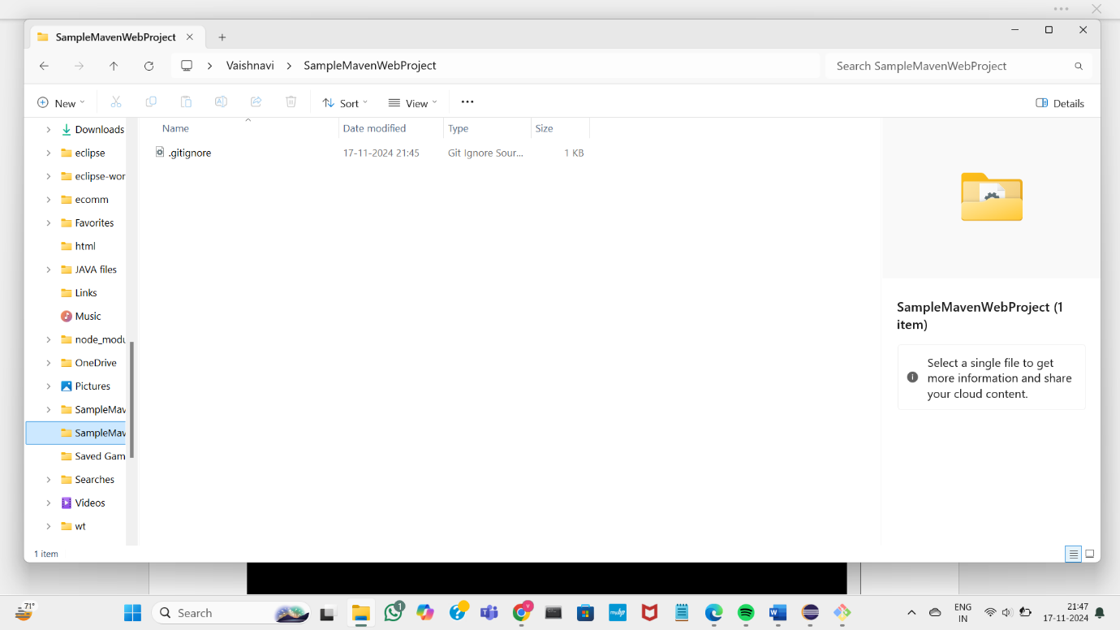 and paste the files

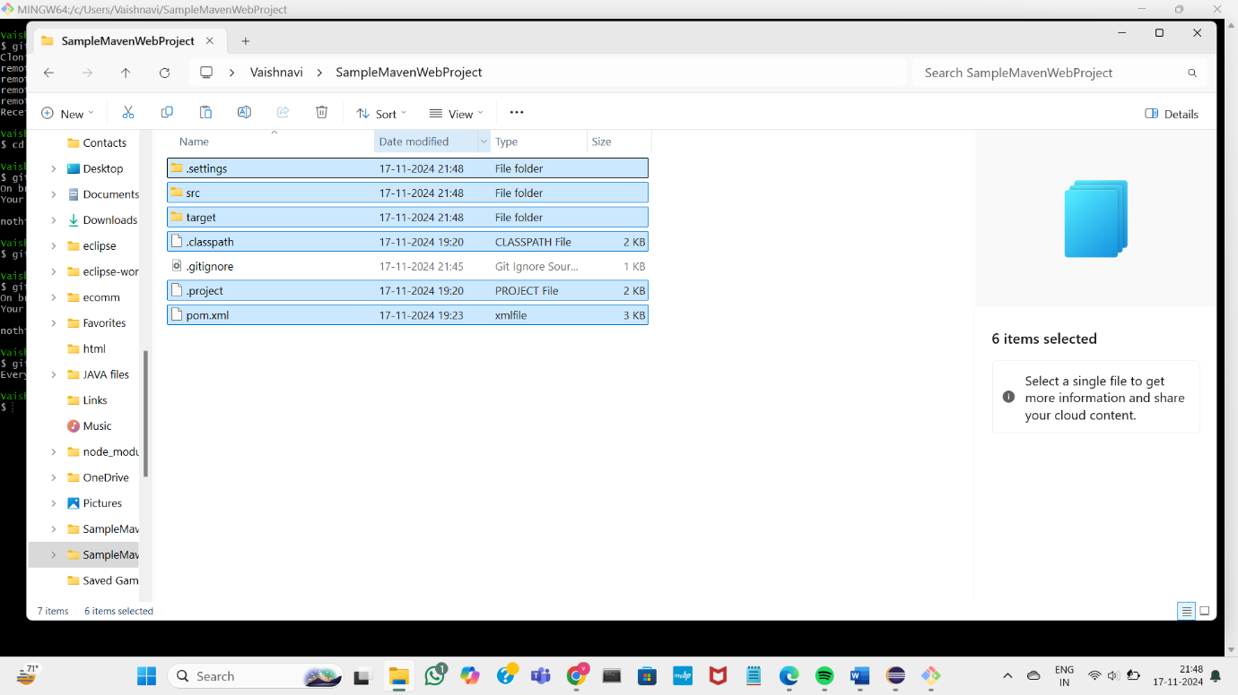

Open gitbash

Clone the repository using the url and git clone command

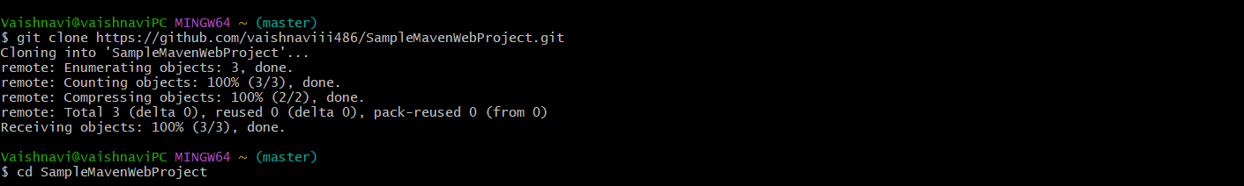

Go to the working directory of the project

Add the files to the staging area using git add command

Commit -using git commit command

Push them into repository using git push command

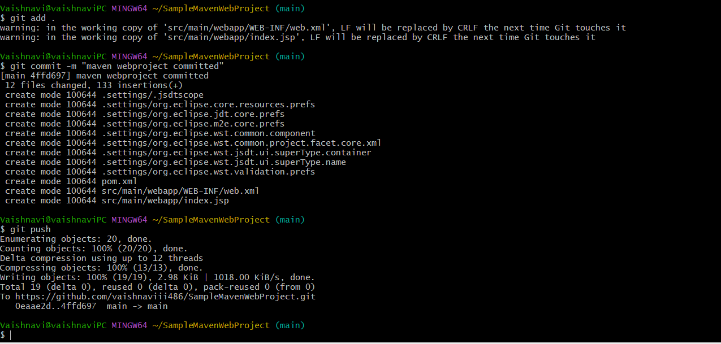

The project is committed in the repository

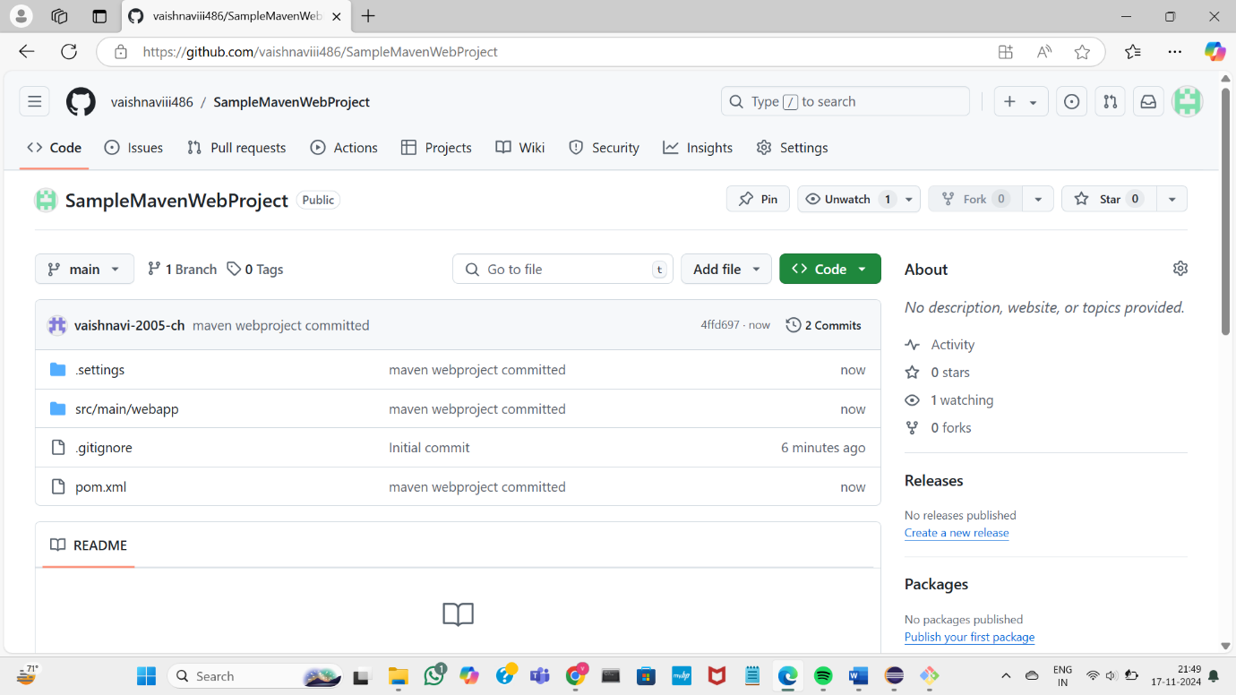



C) INSTALLATION OF JENKINS.

JENKINS INSTALLATION

Open Jenkins official website select windows zip version to download

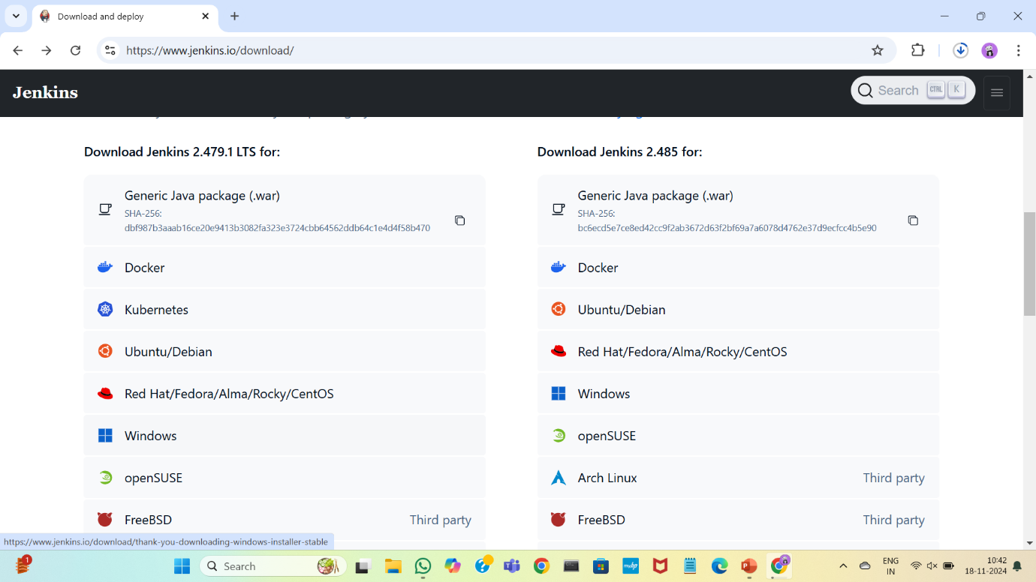

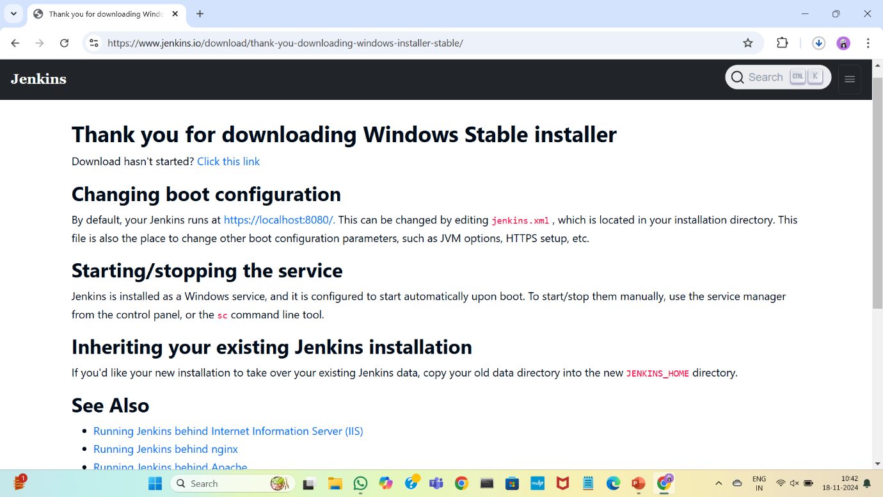

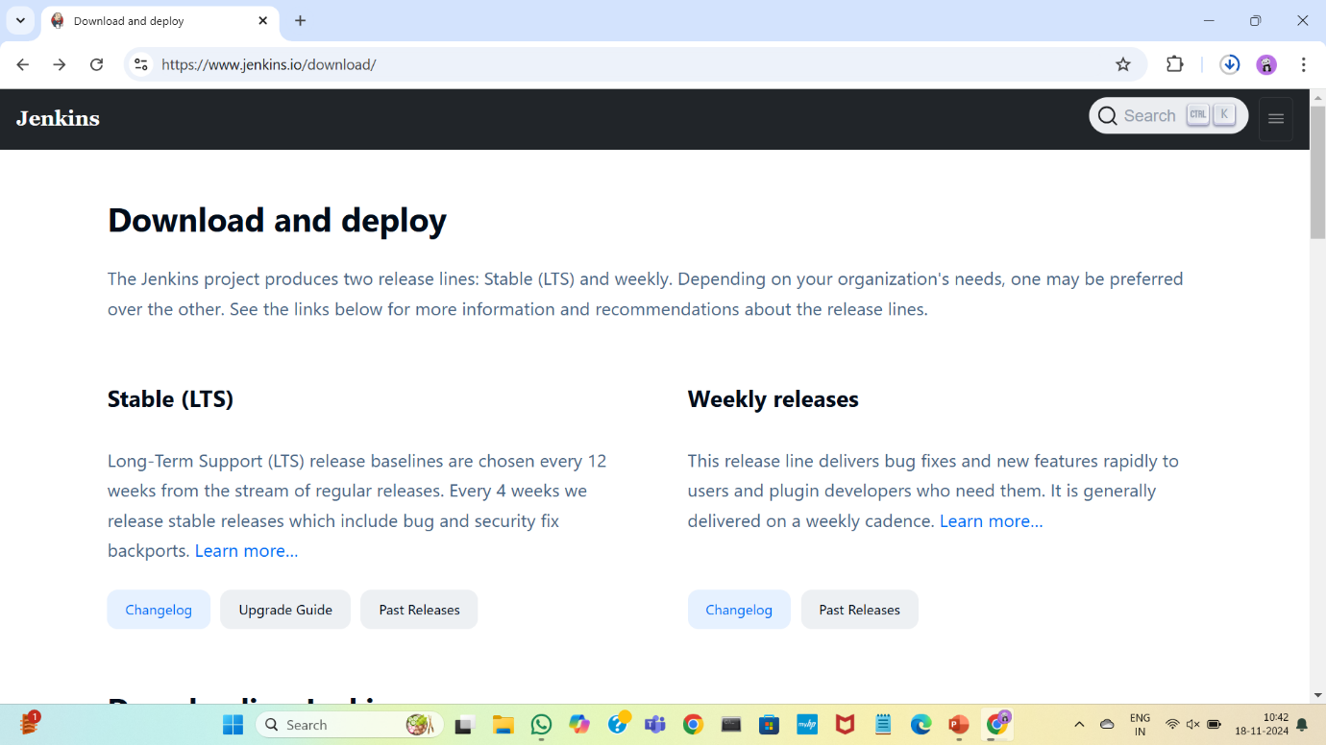

Complete the installation process

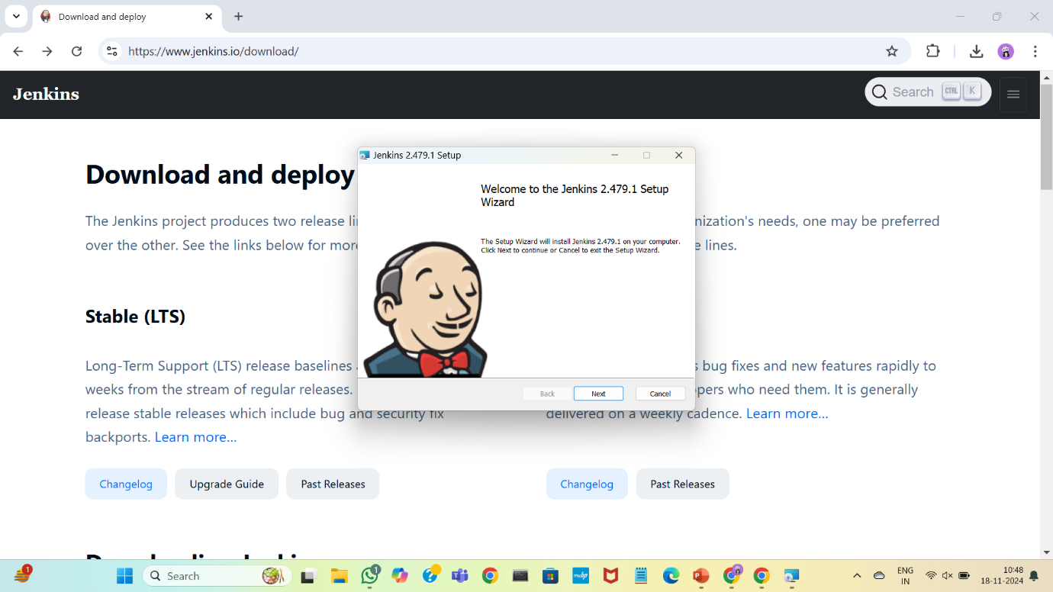

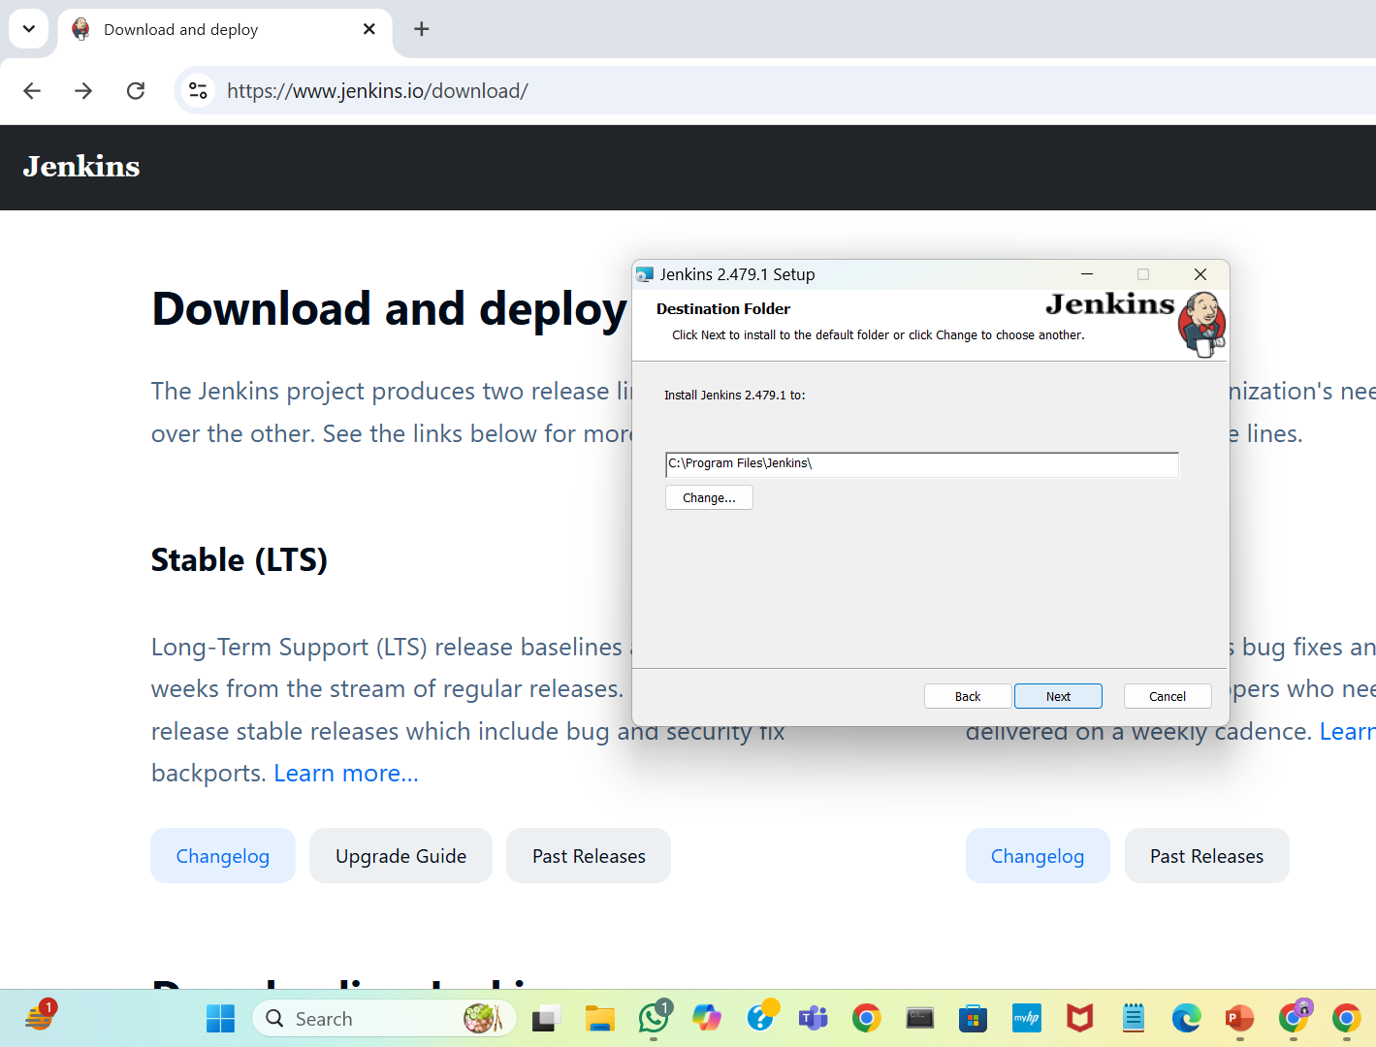

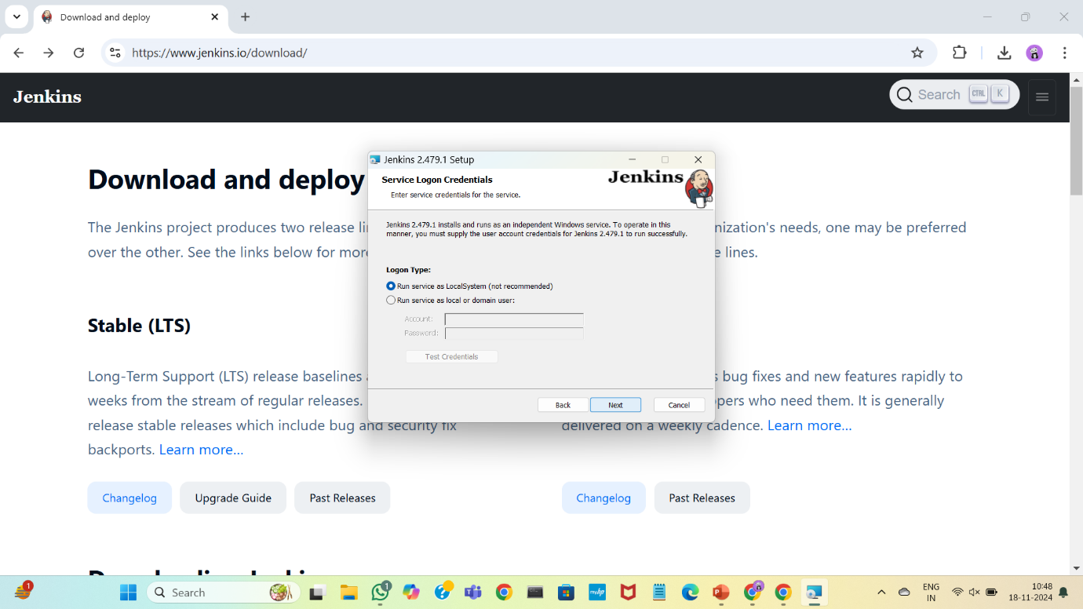

Make sure the port number is free for Jenkins by testing the port number

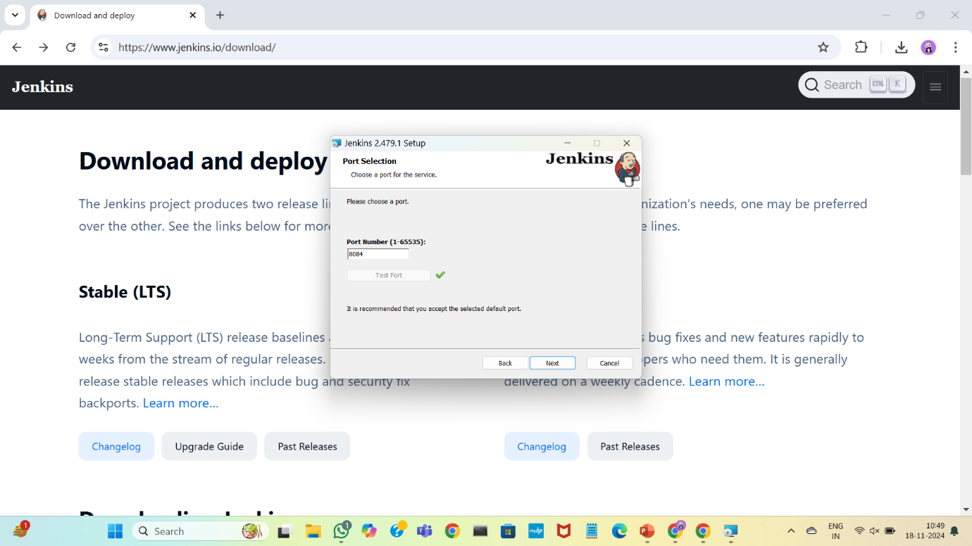

Add the jdk-21 path

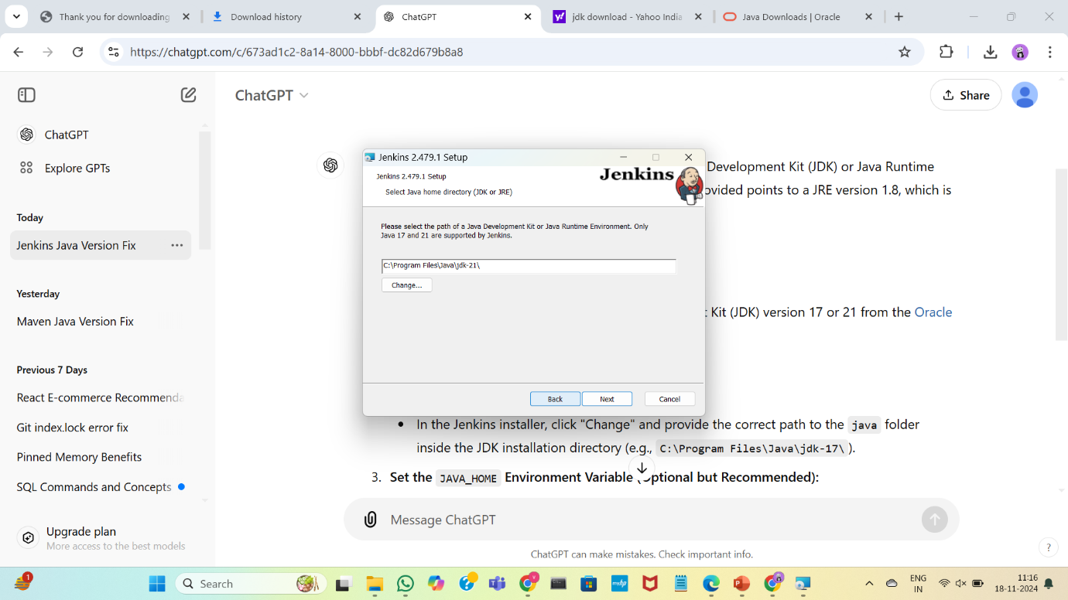

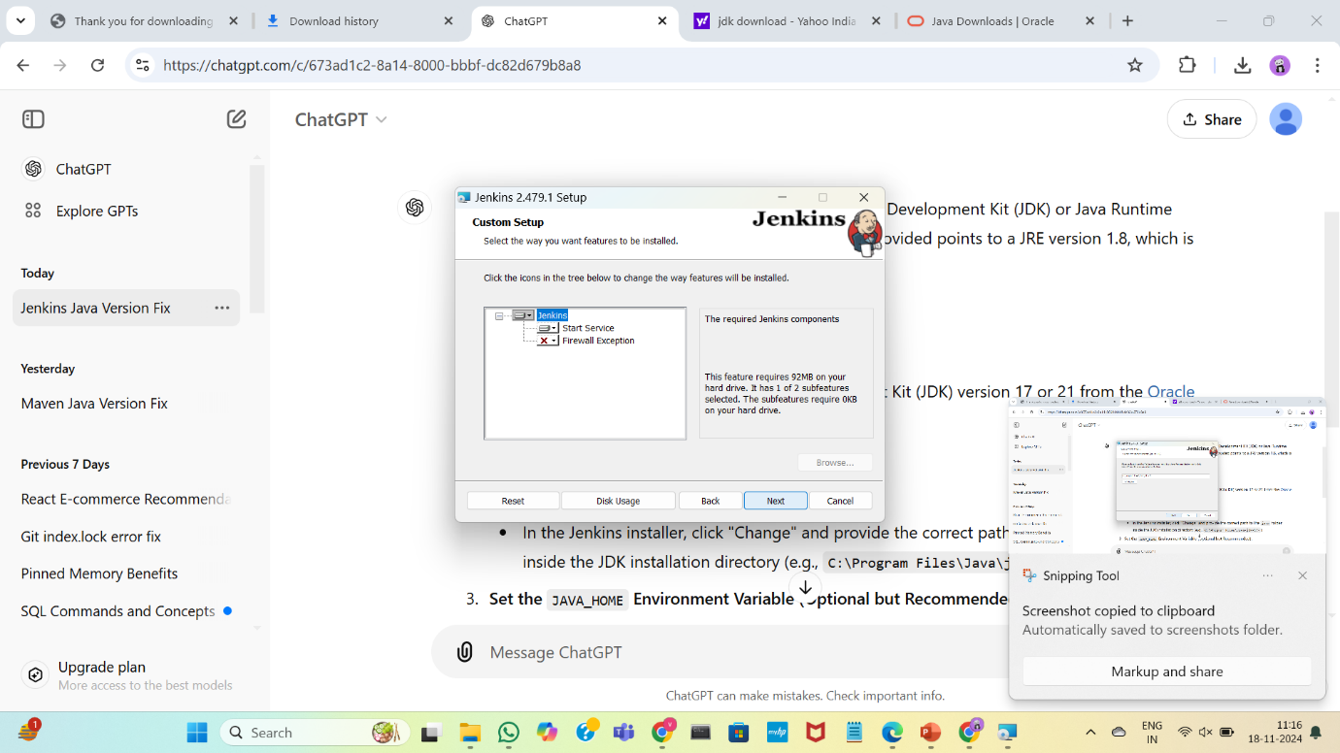

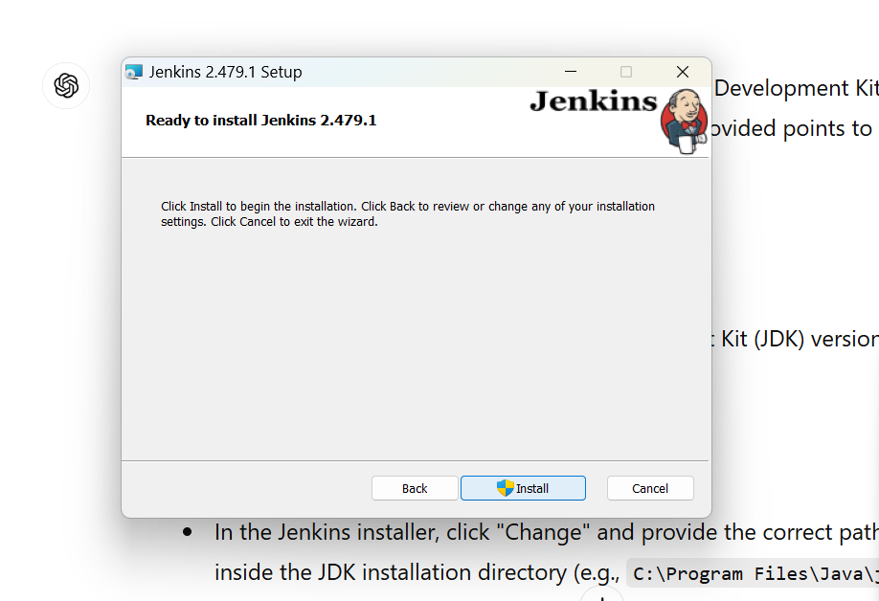

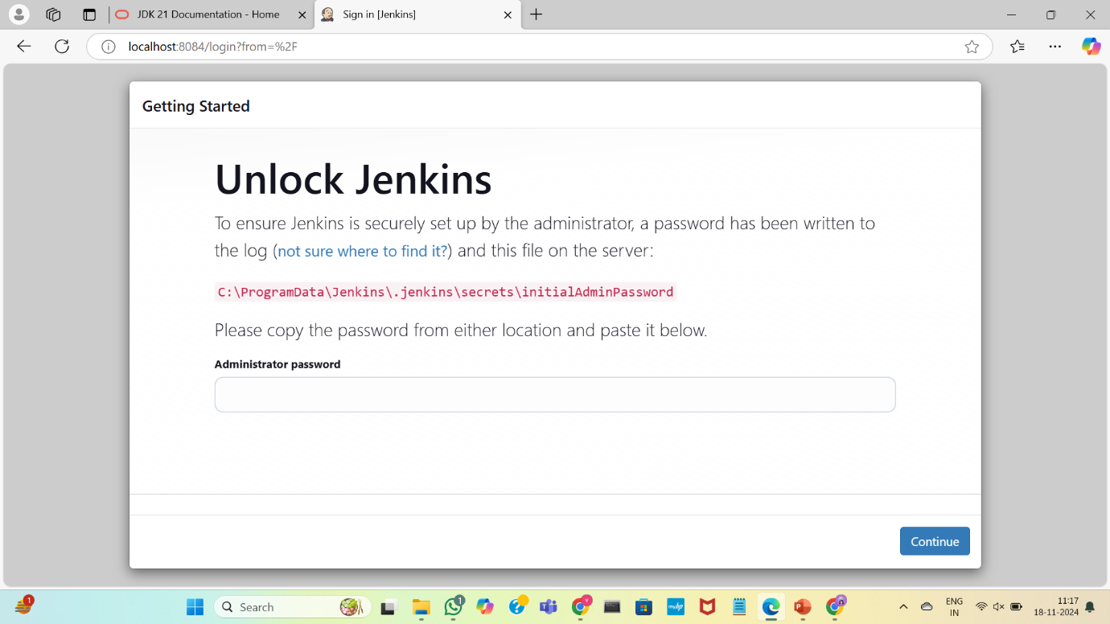

Open Jenkins in program files and select .err.log file to abstract the administrator password

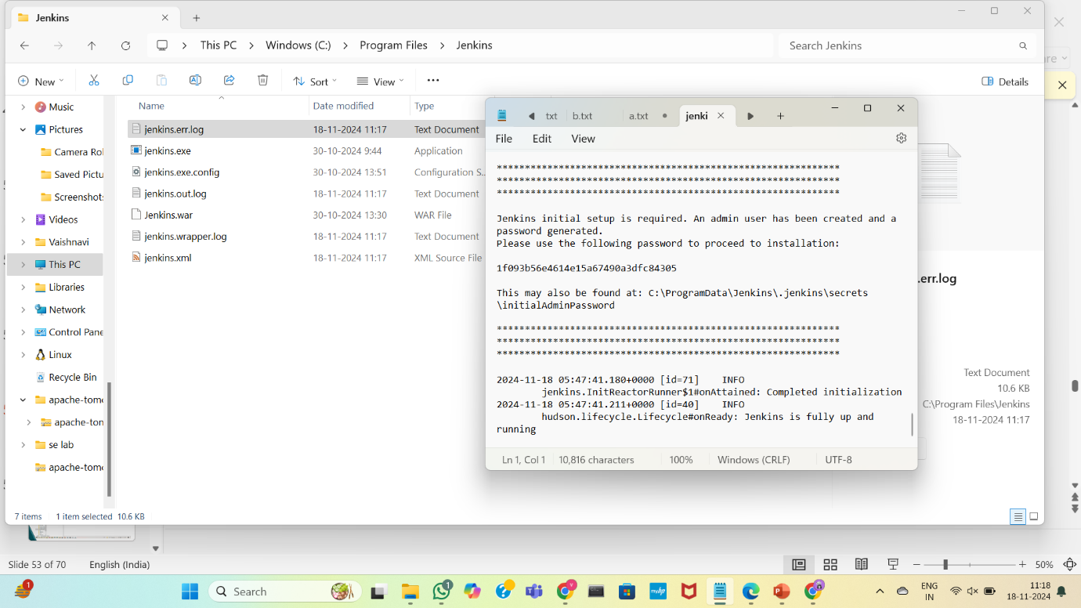

Paste the password here to continue

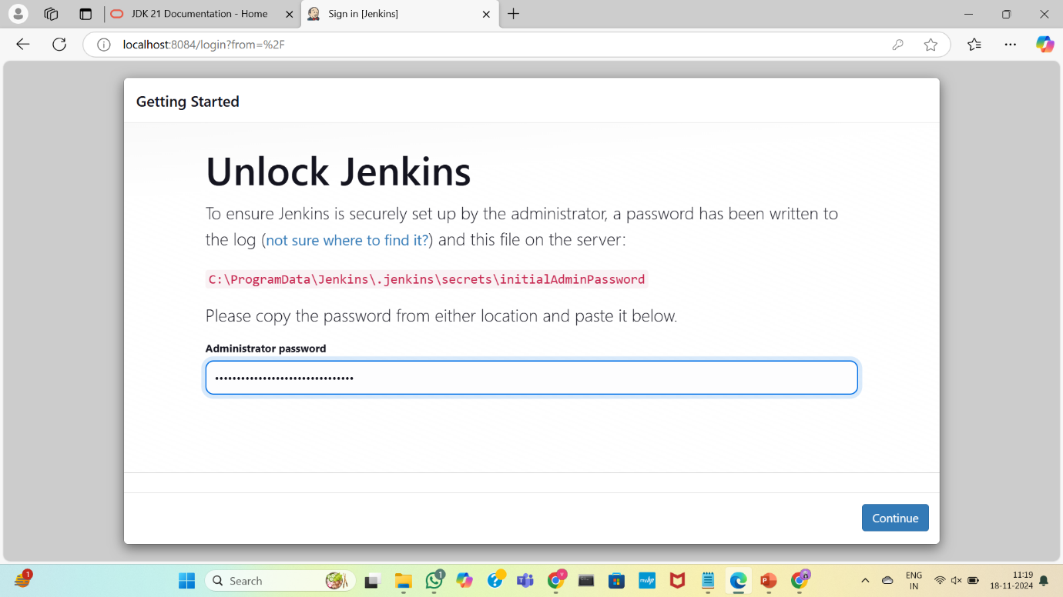

Install the plugins

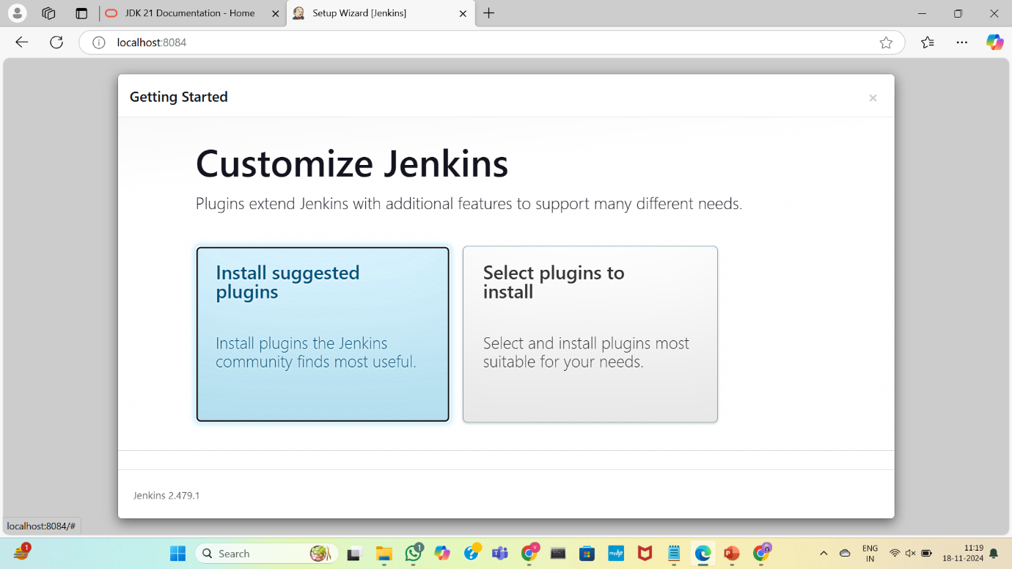

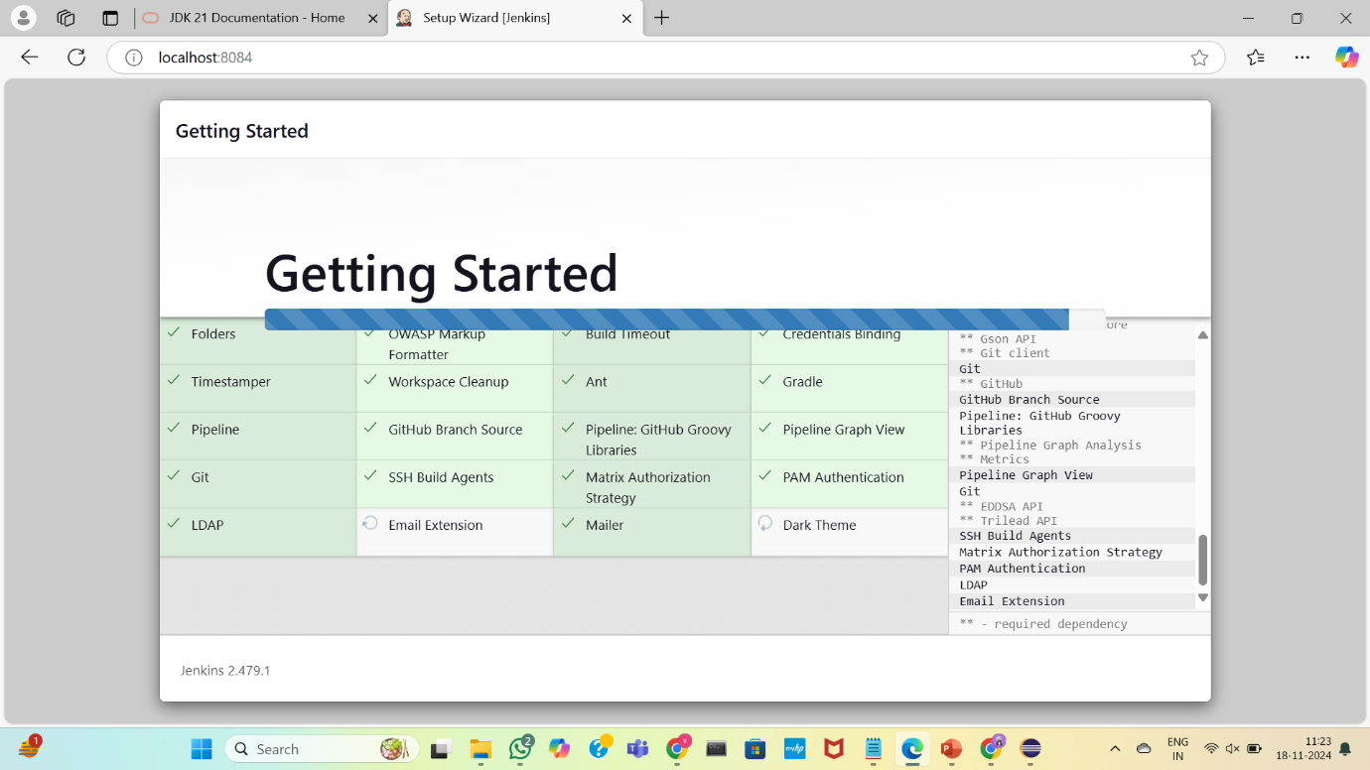

Create username and password

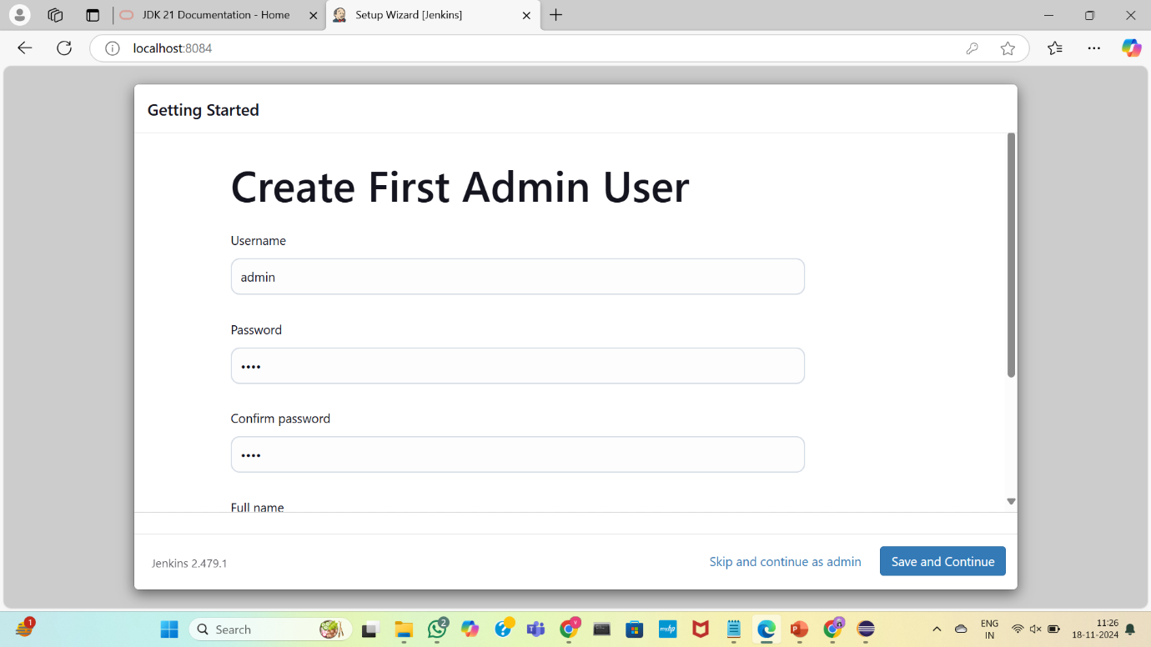

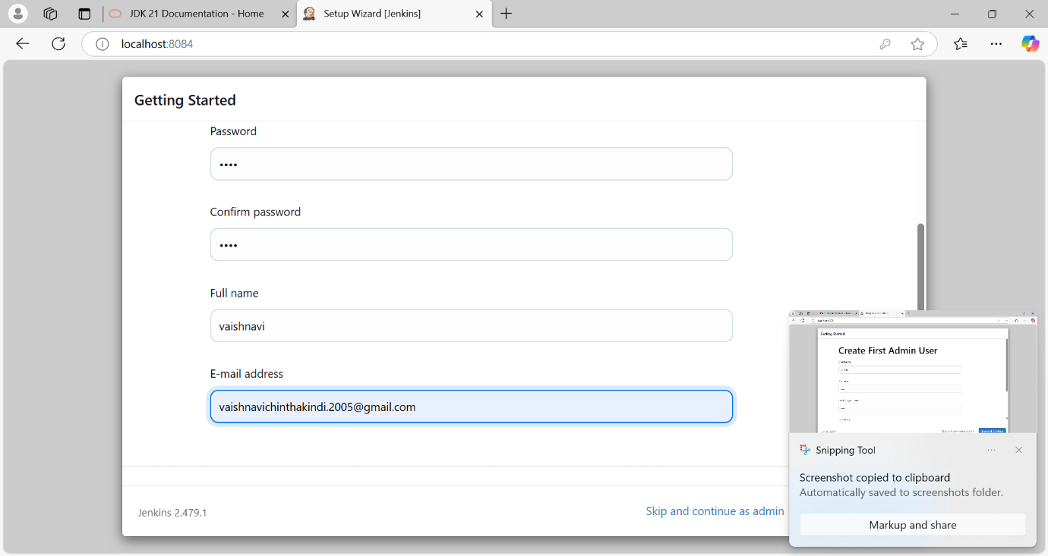

Check the port number for the jenkins

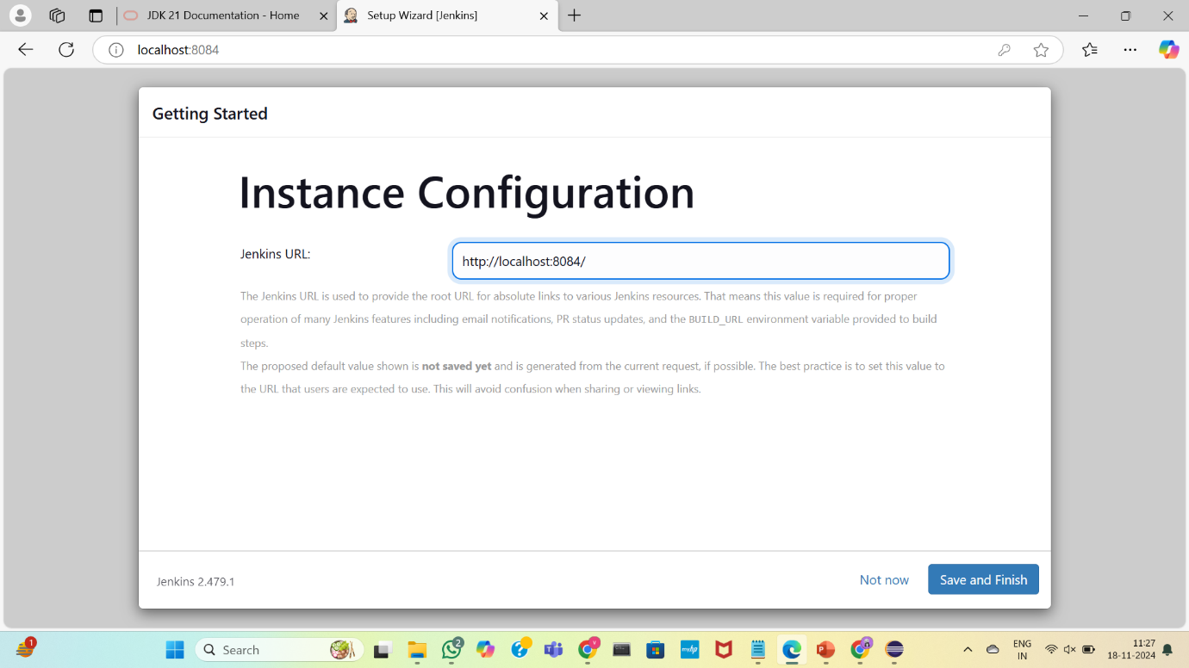

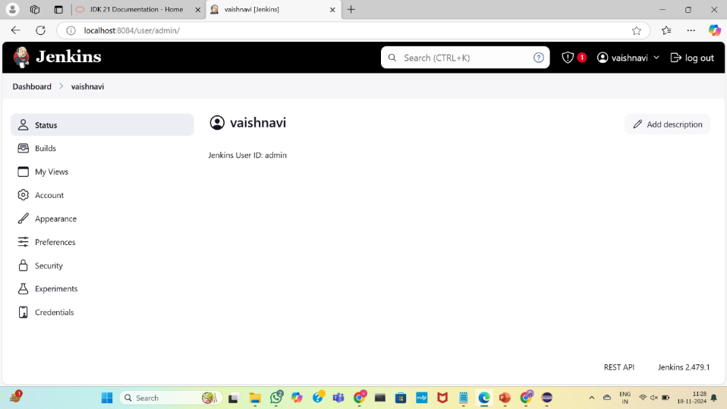

Install plugins from dashboard>manage Jenkins>plugins

Install the following plugins

Maven integration plugin

Copy artifacts plugin

Deploy to container plugin

Build pipeline plugin

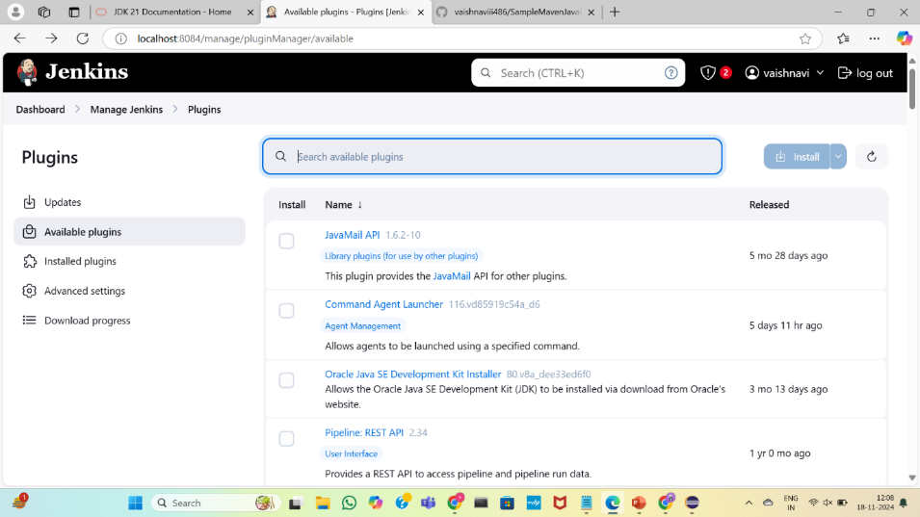

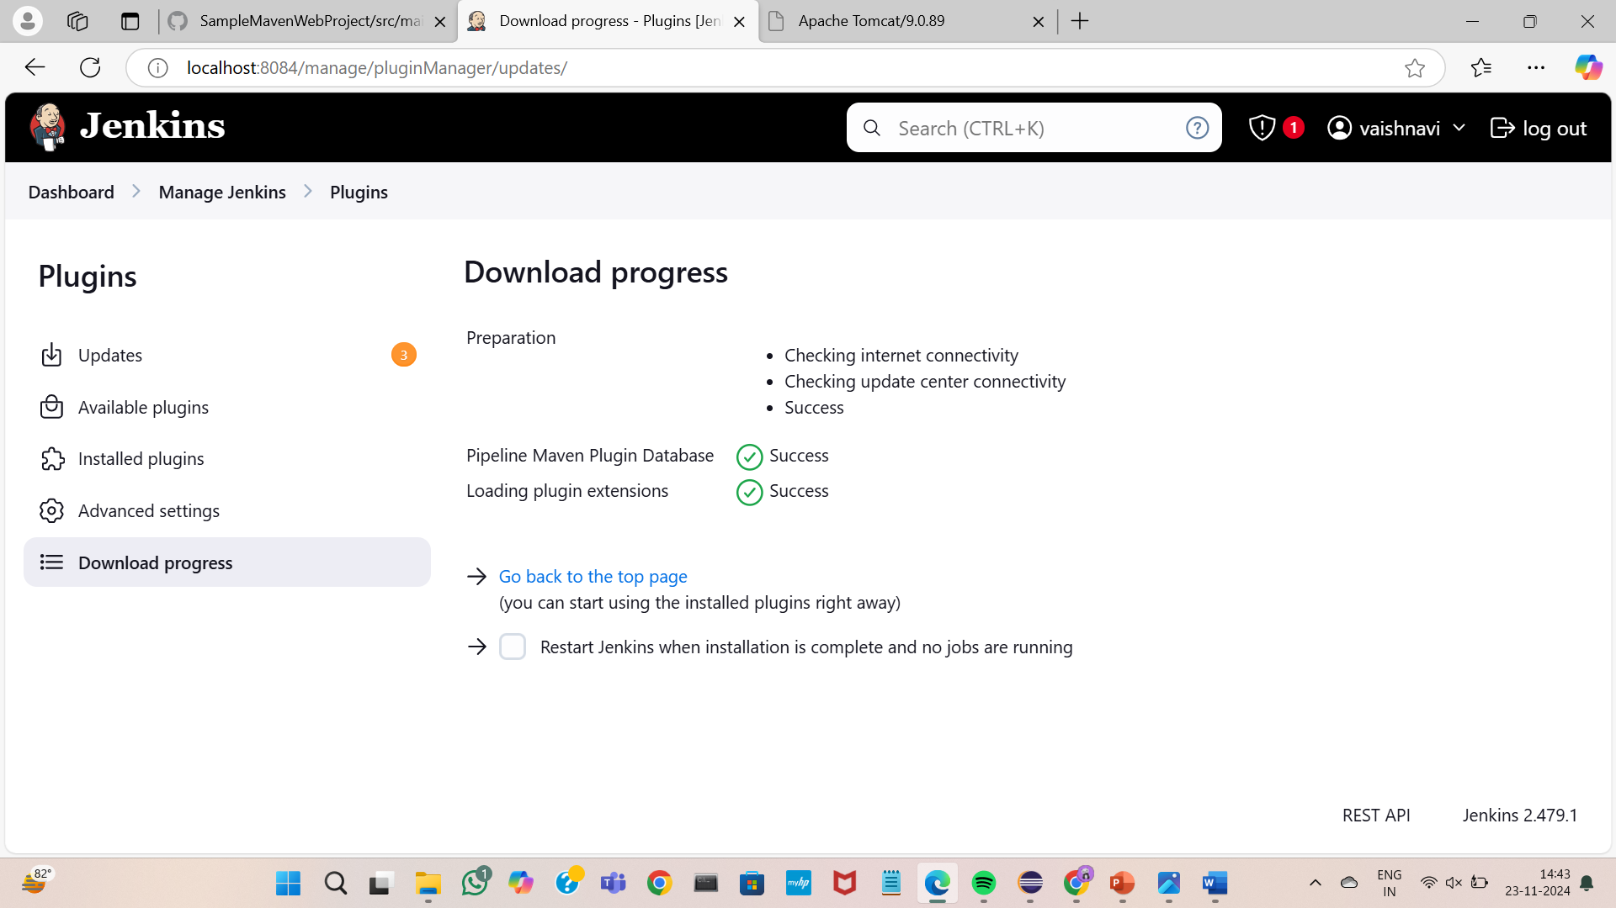

Select dashboard>manage Jenkins>tools and add maven version ,jdk path

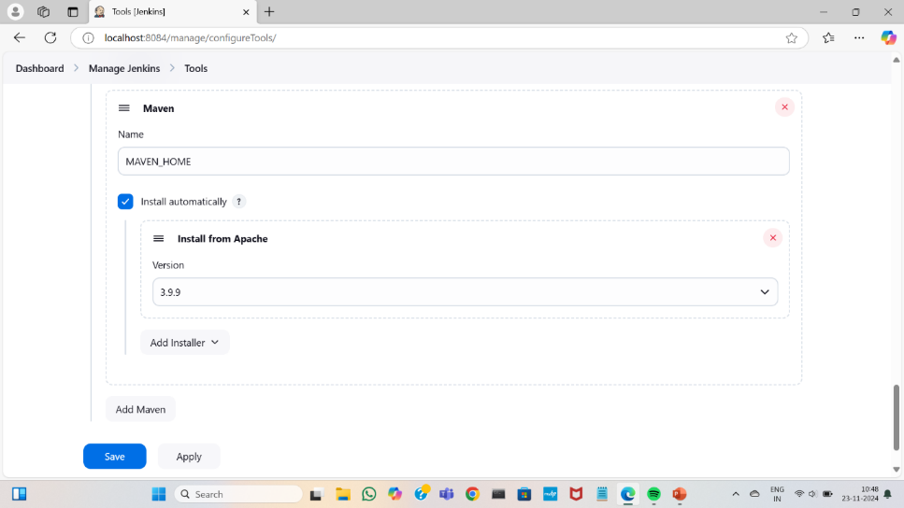

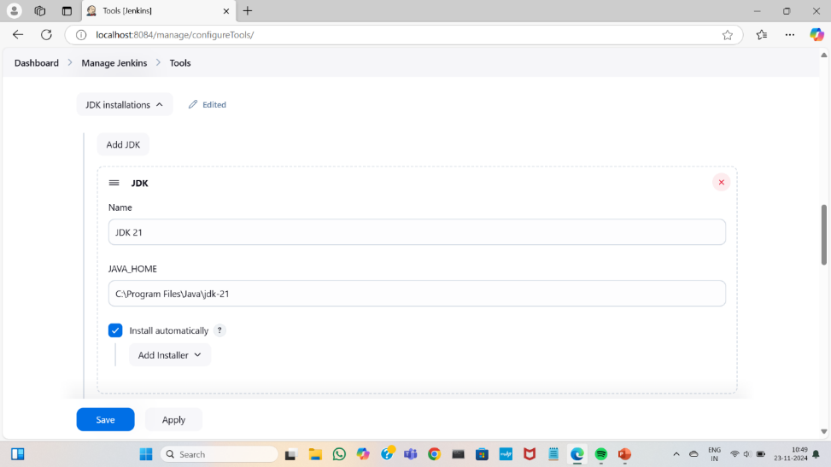

Set the path for git.exe file

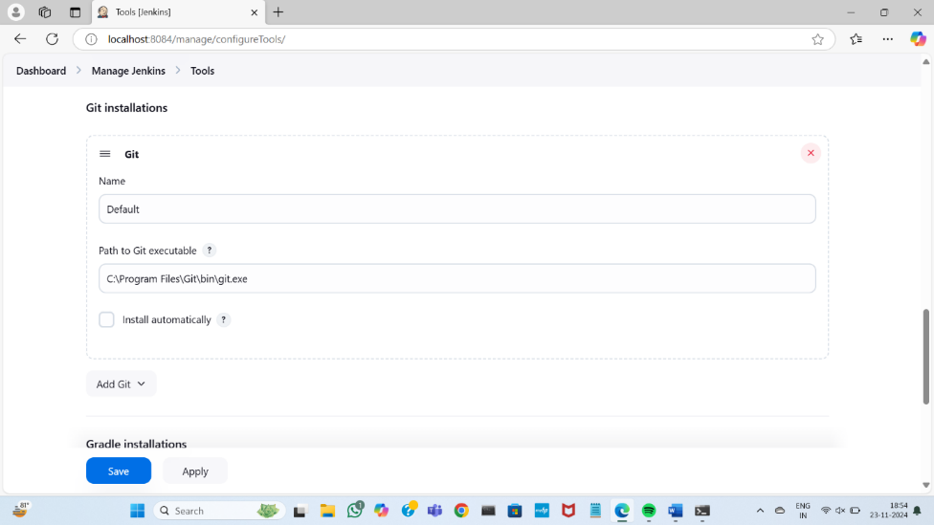

Save and apply

EXPERIMENT:6

1. BUILDING THE CI/CD FREESTYLE PIPELINE USING JENKINS FOR MAVEN JAVA PROJECT

Open dashboard and click on add new item ,give name as SampleMavenJava_build

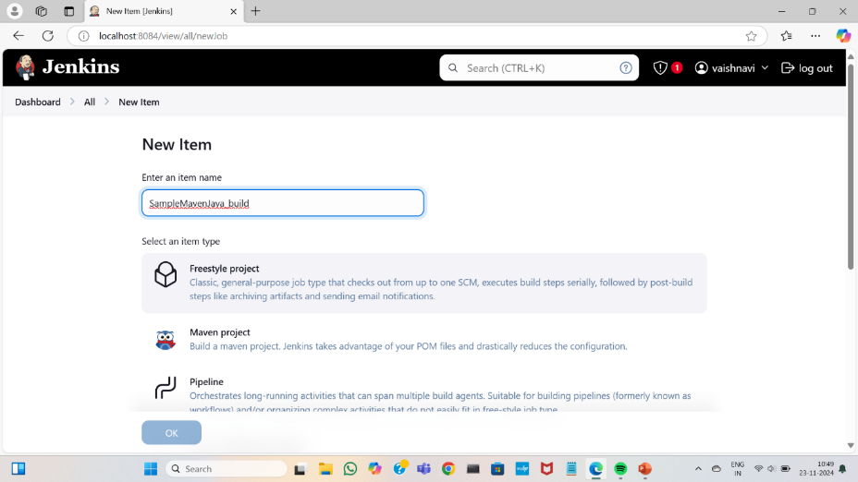

Select source code management as git and copy the repository of the maven java project

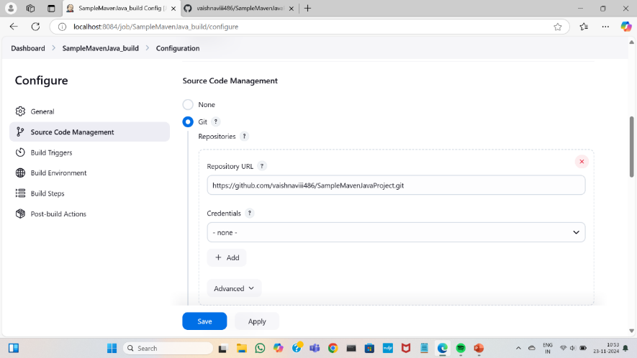

Specify the branch as main

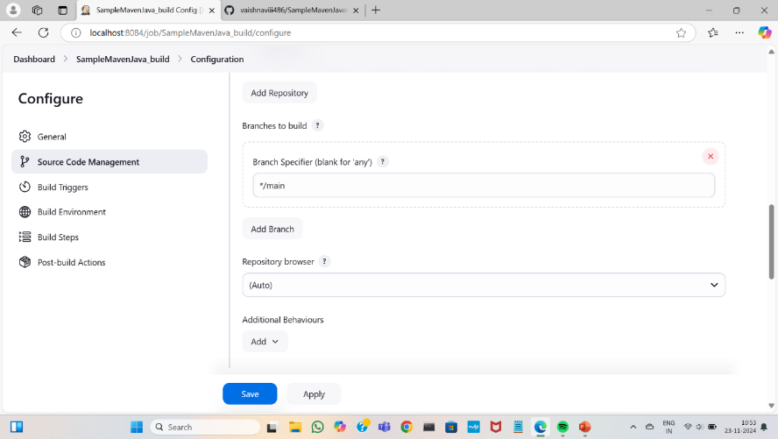

Add build steps by selecting the “invoke top-level Maven targets”,set maven version as “MAVEN_HOME” and set goals as clean and then next as install

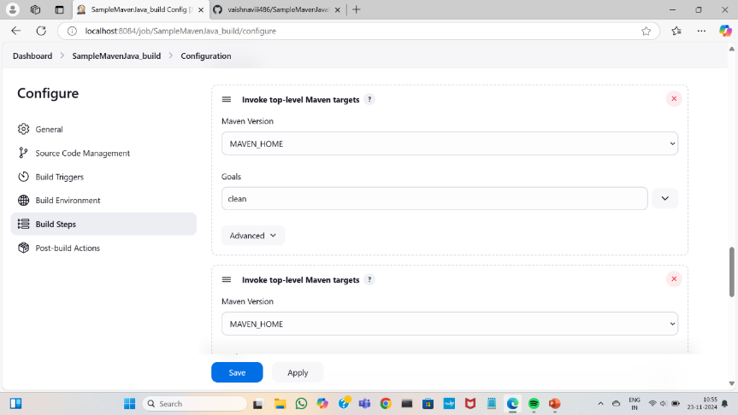

Save and apply

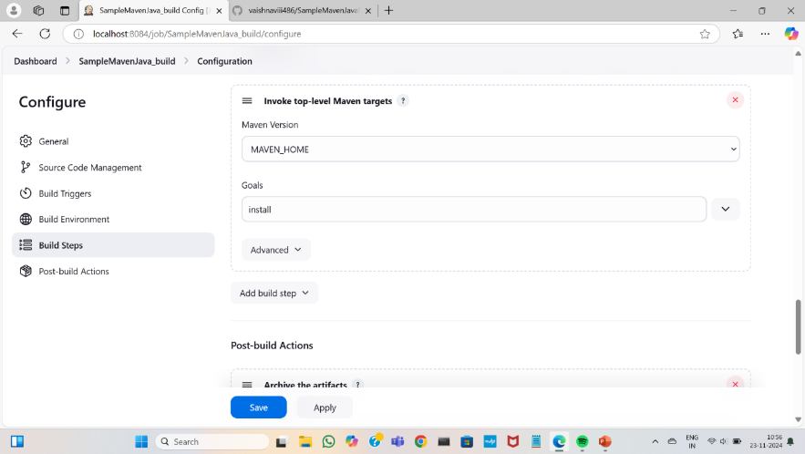

Select post-build Action as “archive the artifacts”,select the files to archive.

Build another project as “SampleMavenJava_test”

Save and apply

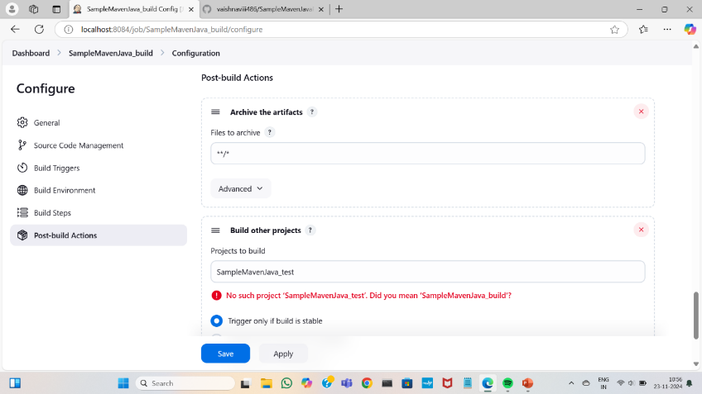

Create new item as “SampleMavenJava_test”,and select free style project

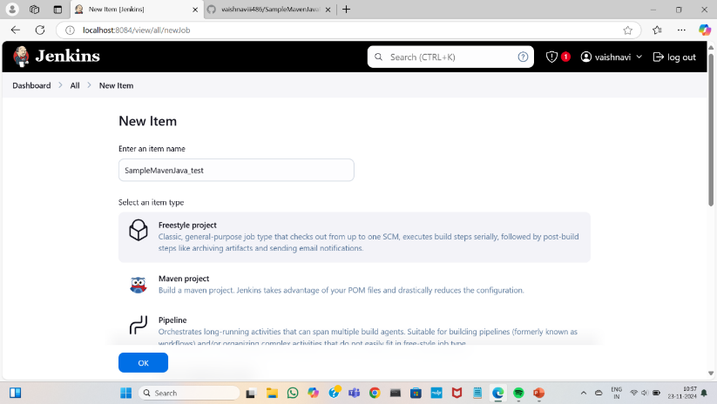

Select source code management as none and build environment as delete workspace before buid starts

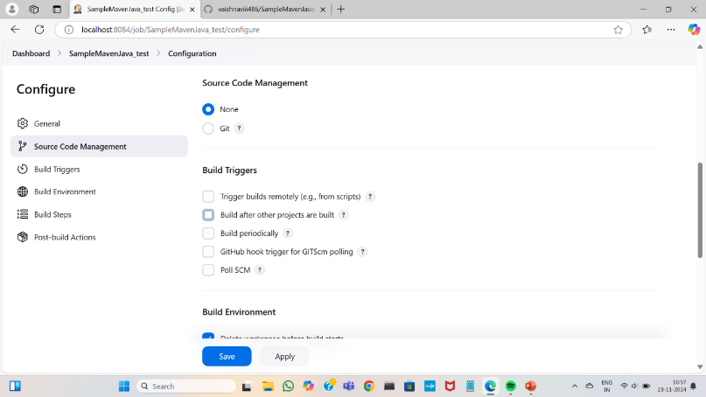

Select the build step as “copy the artifacts from another project”

Give the project name that build before(SampleMavenJava_build) and copy the artifacts into it

Save and apply

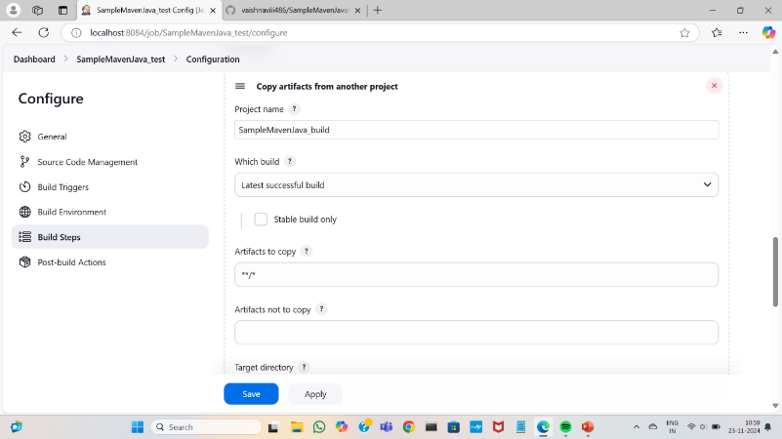

Click on new to create new pipeline give name for the pipeline

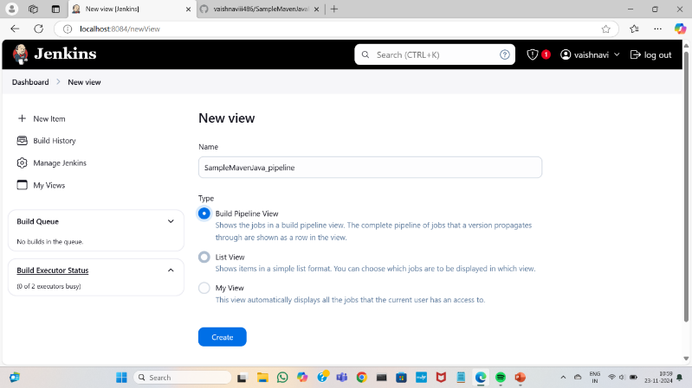

Select the project that has build initially

Save and run the pipeline

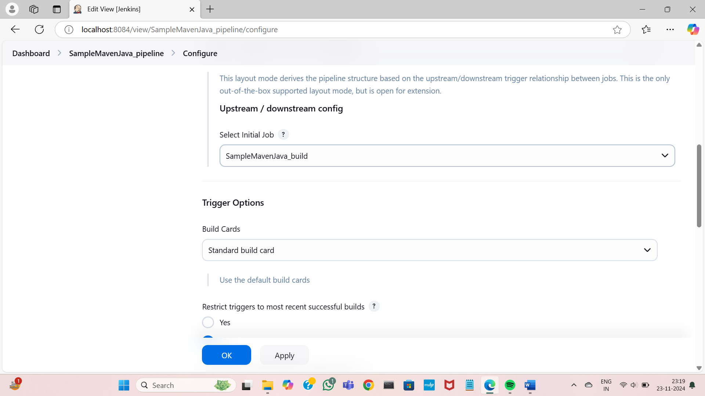

Build ,test will be completed once it appears green

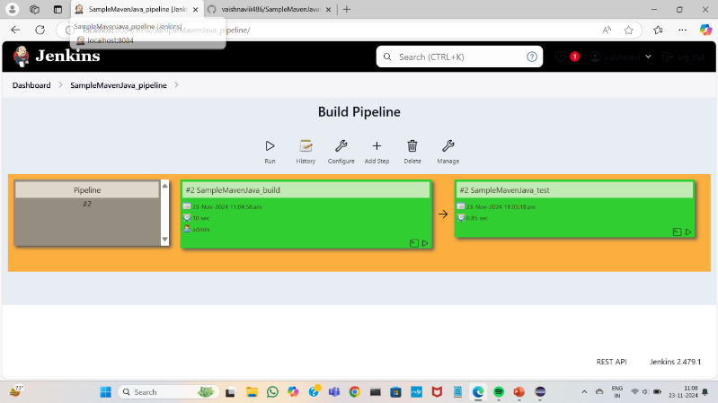

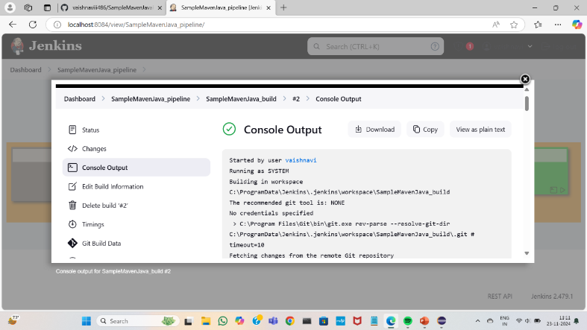

B) BUILDING THE CI/CD FREESTYLE PIPELINE USING JENKINS FOR MAVEN WEB PROJECT WITH POLL SCM

Go to dashboard click on new item to create new project as “SampleMavenWeb_build”,selec free style project

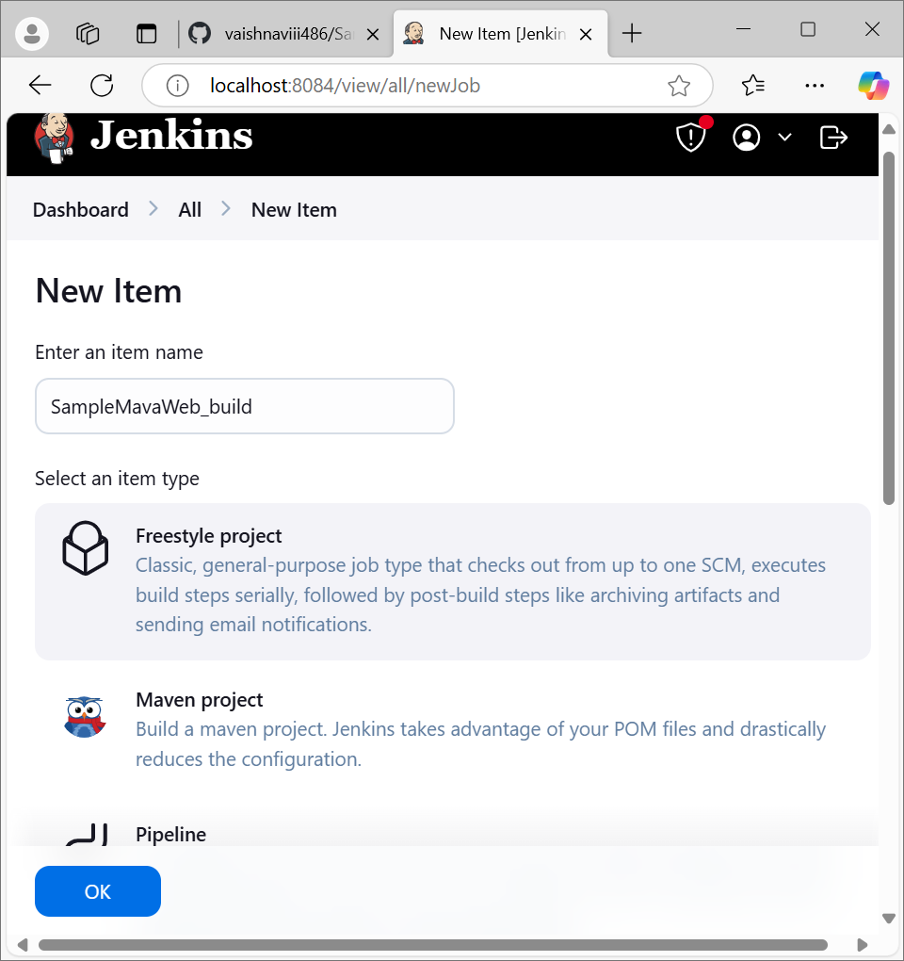

Copy the repository link of the maven web project from github

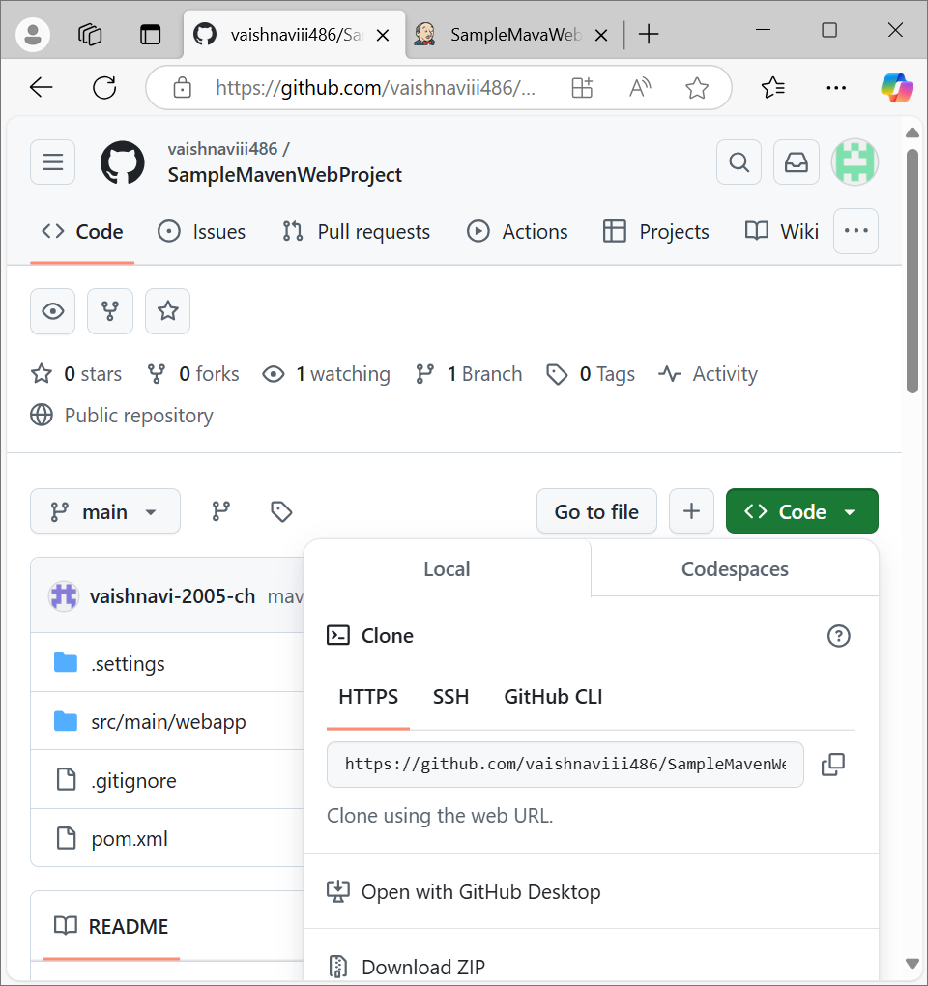

Select source code management as git and paste the url of the repository

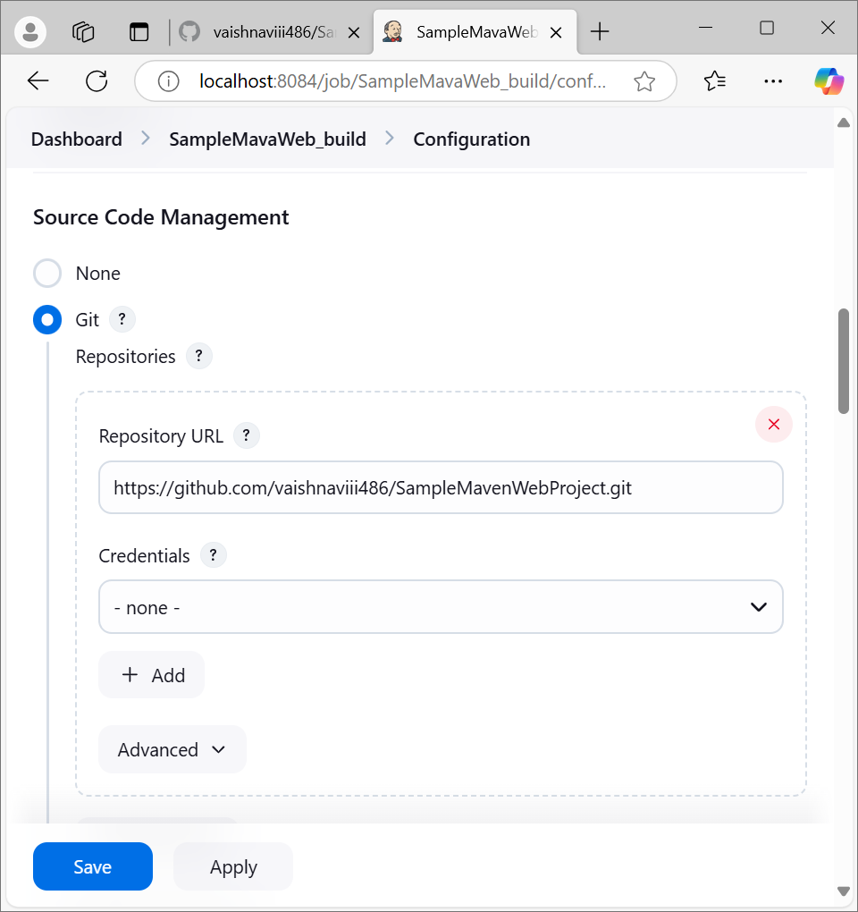

add the branch of the project if it is master or main

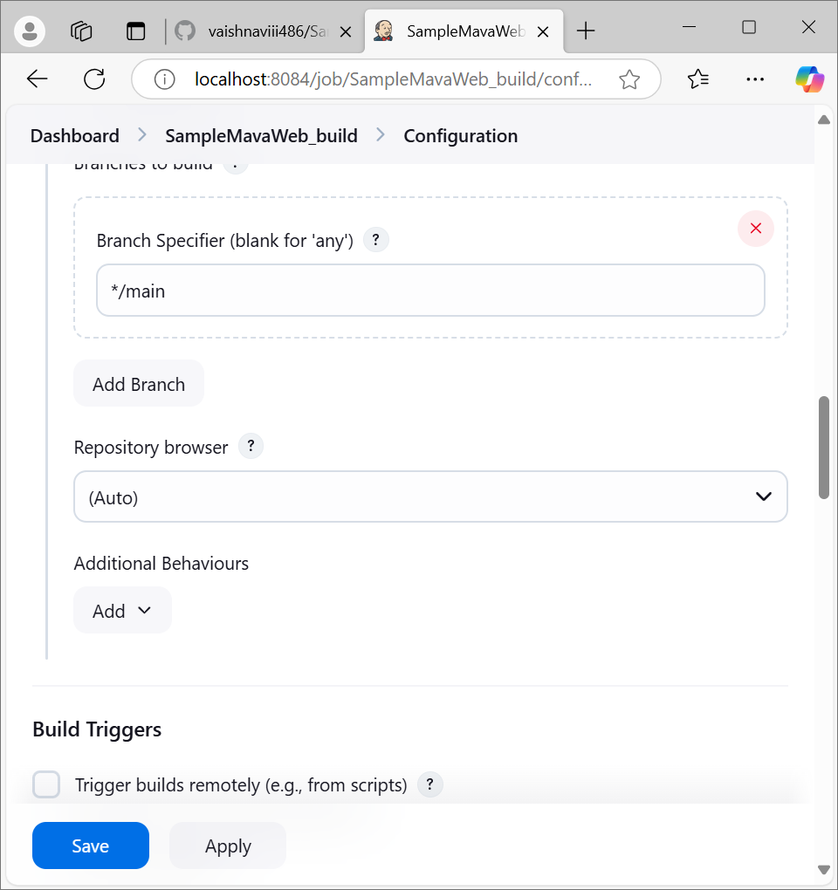

Select build trigger as poll SCM and select the schedule(here we selected per every minute)

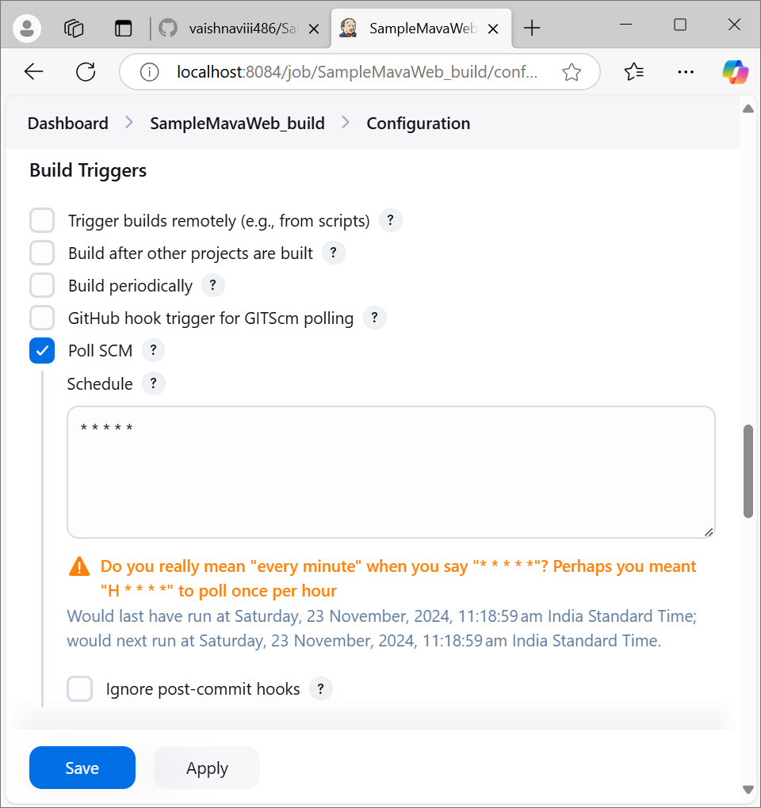

Add the build step as clean and install

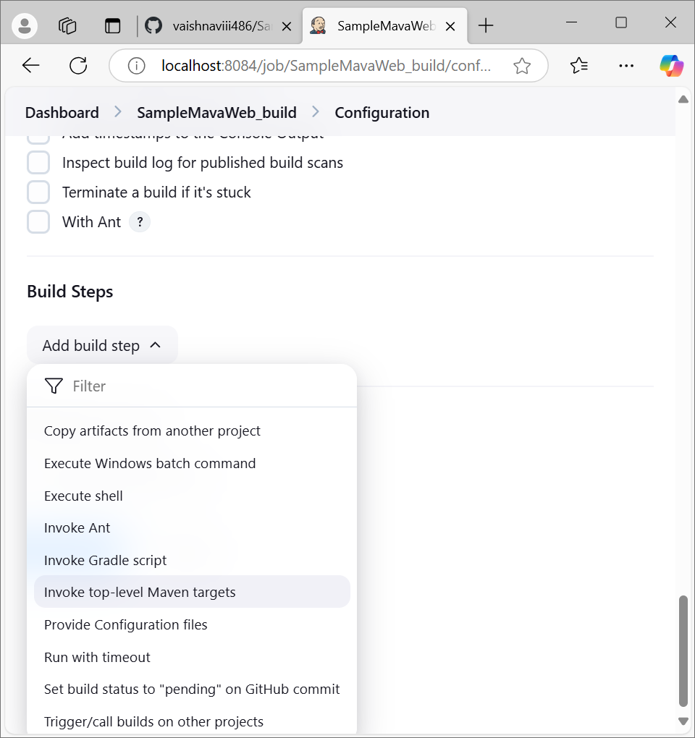

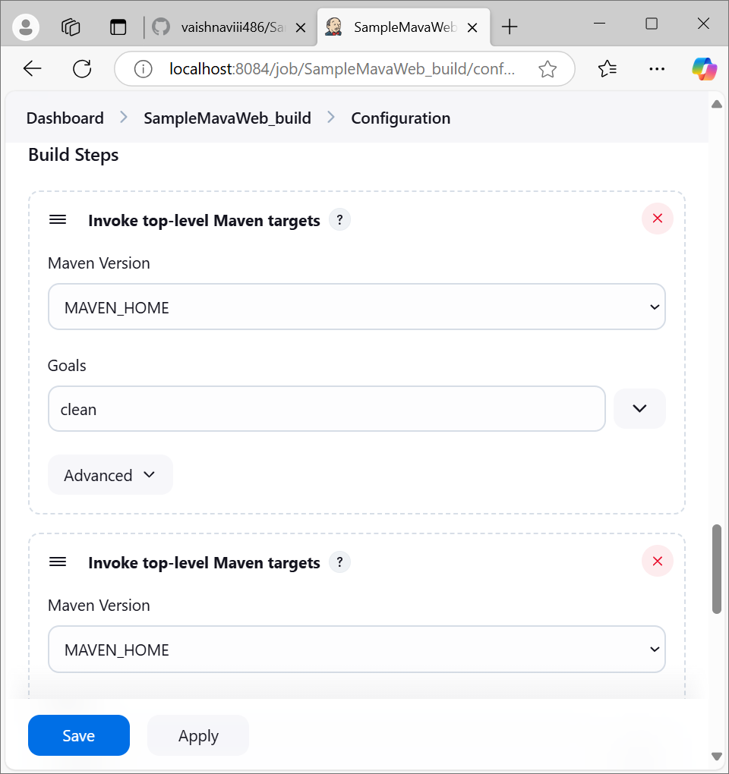

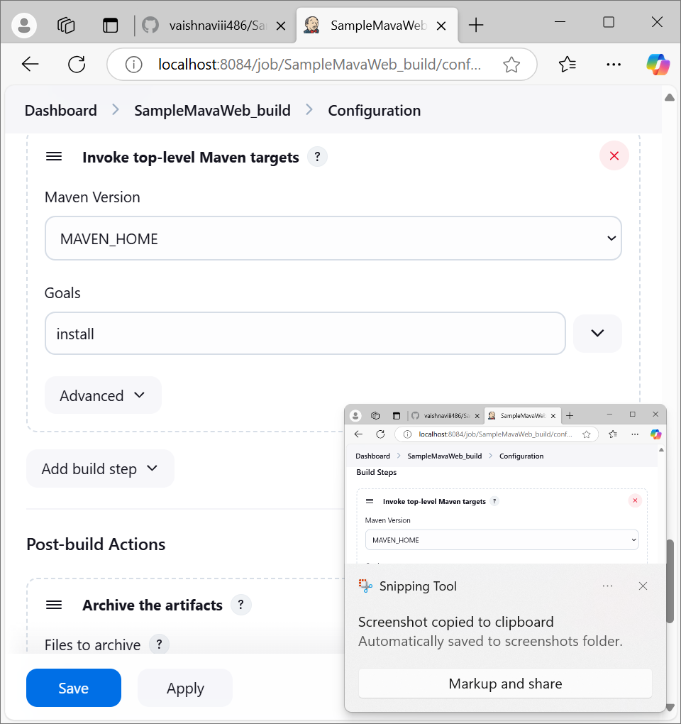

Select the post build action as archive the artifacts and build another project as “SampleMavenWeb_test”

Add trigger and save the changes

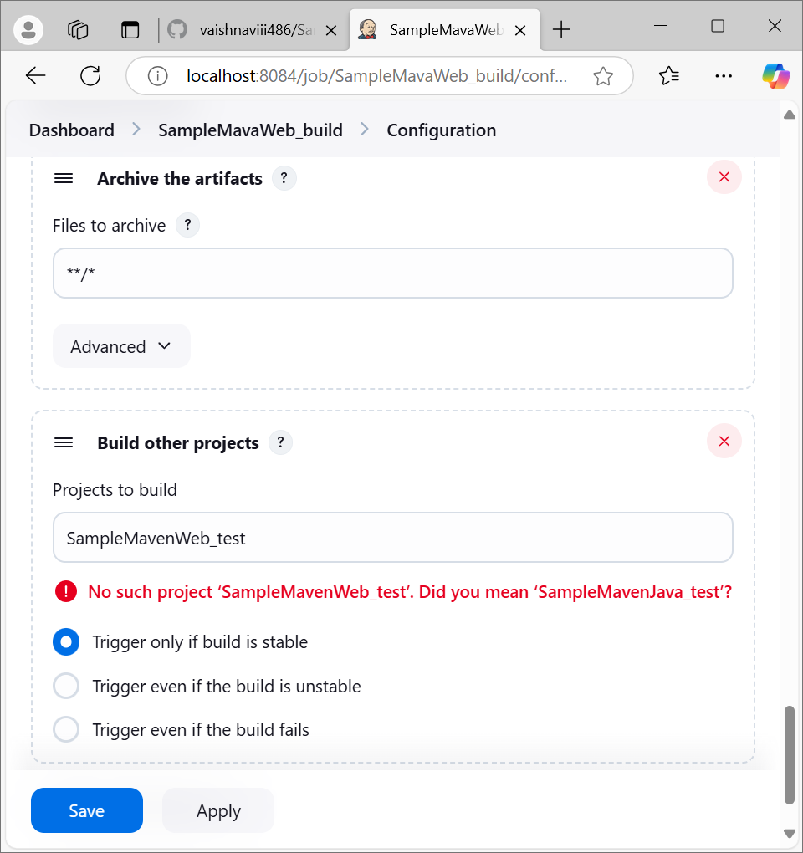

Create new test project as “SampleaveWeb_test”,select free-style project

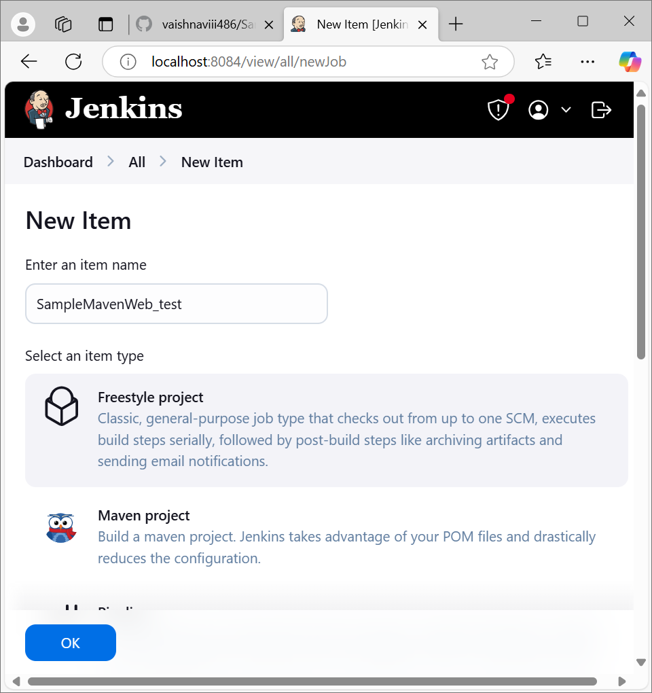

Select build environment as “delete workspace before build”

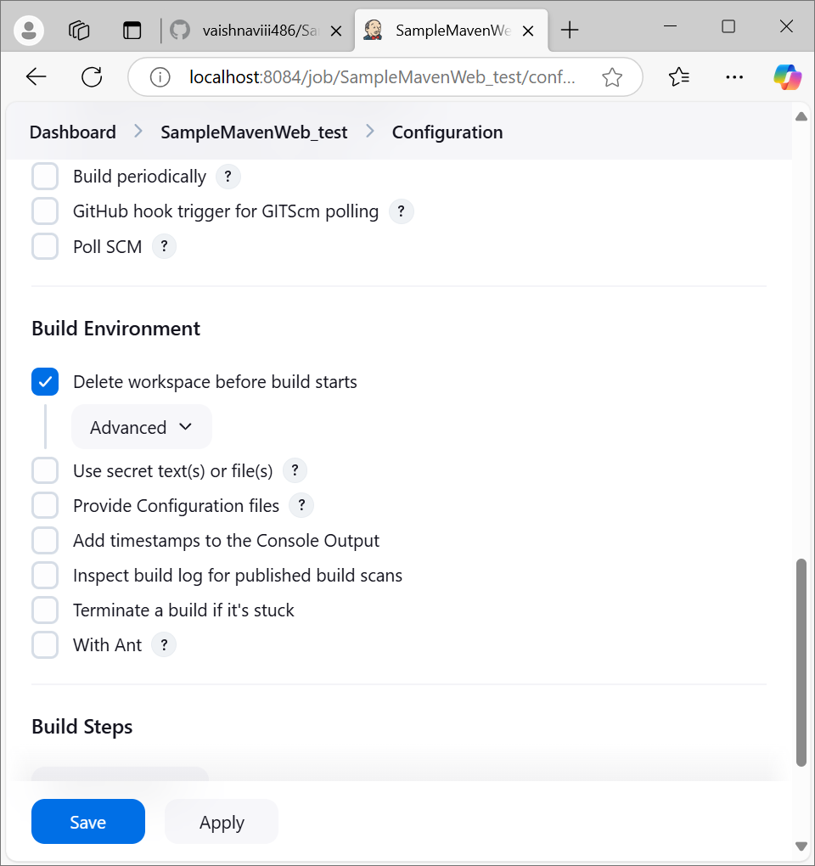

Select the build action as copy the artifacts

Copy the artifacts from previous project that has build

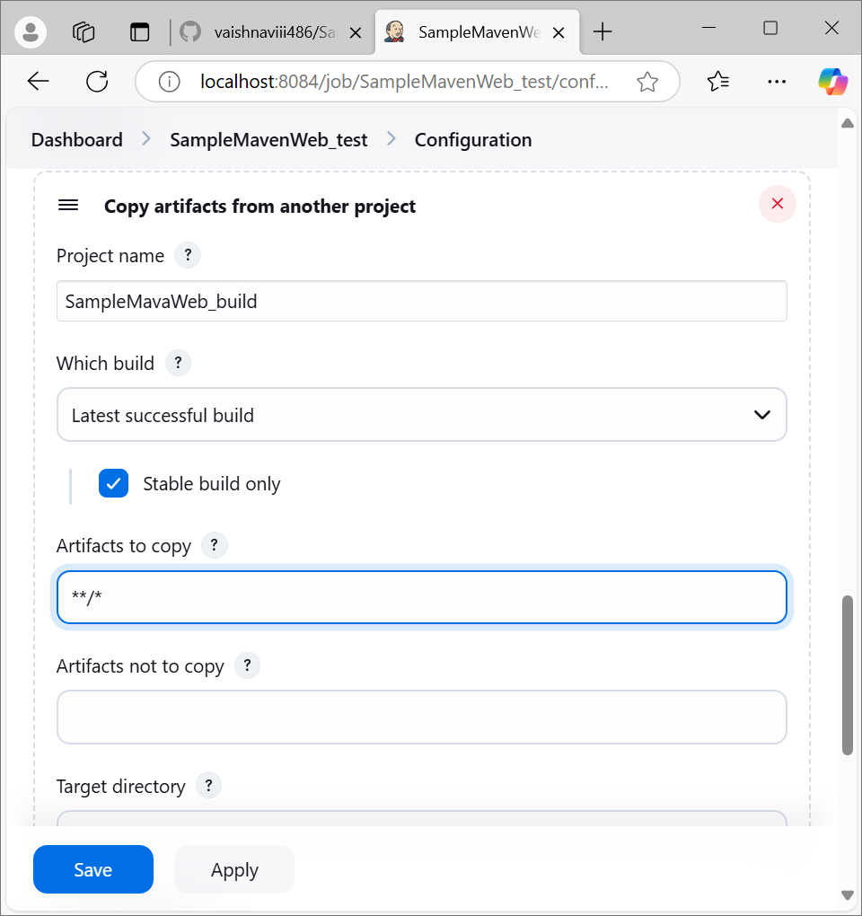

Select another build action as “maven test”

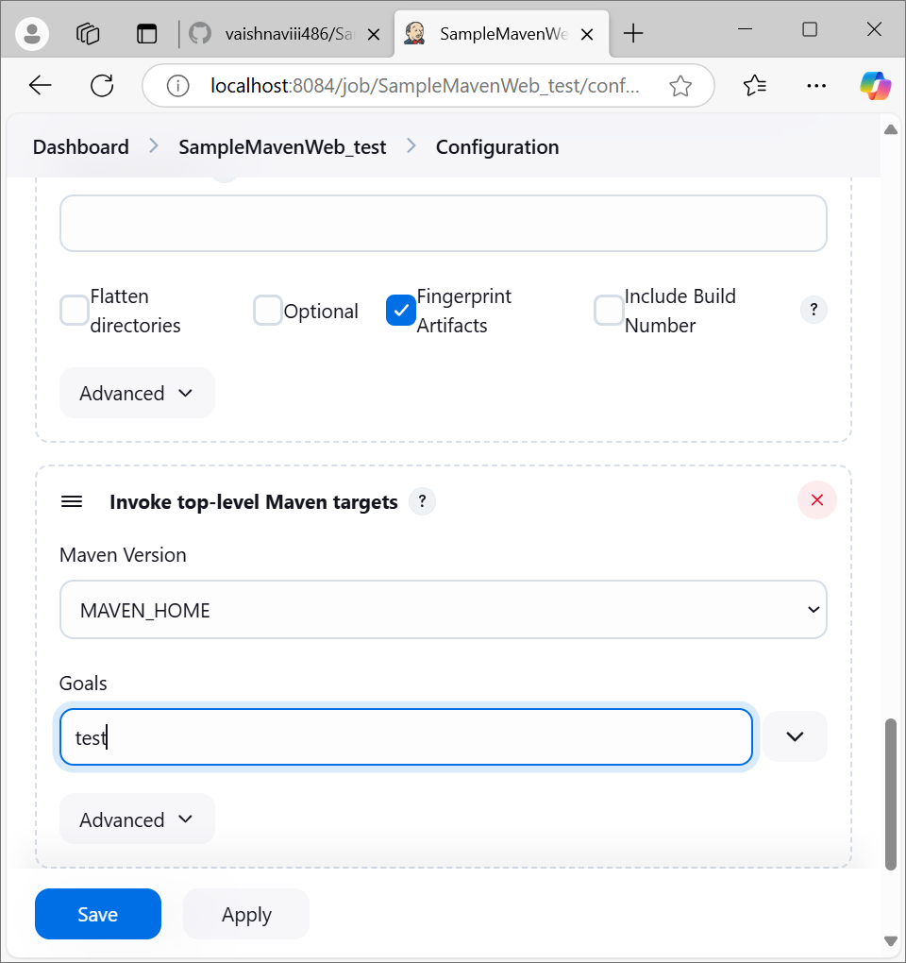

Select the post build actions as archive the artifacts and archive all files

Build another project as “SampleMavenWeb_deploy” for deployment

Save and apply

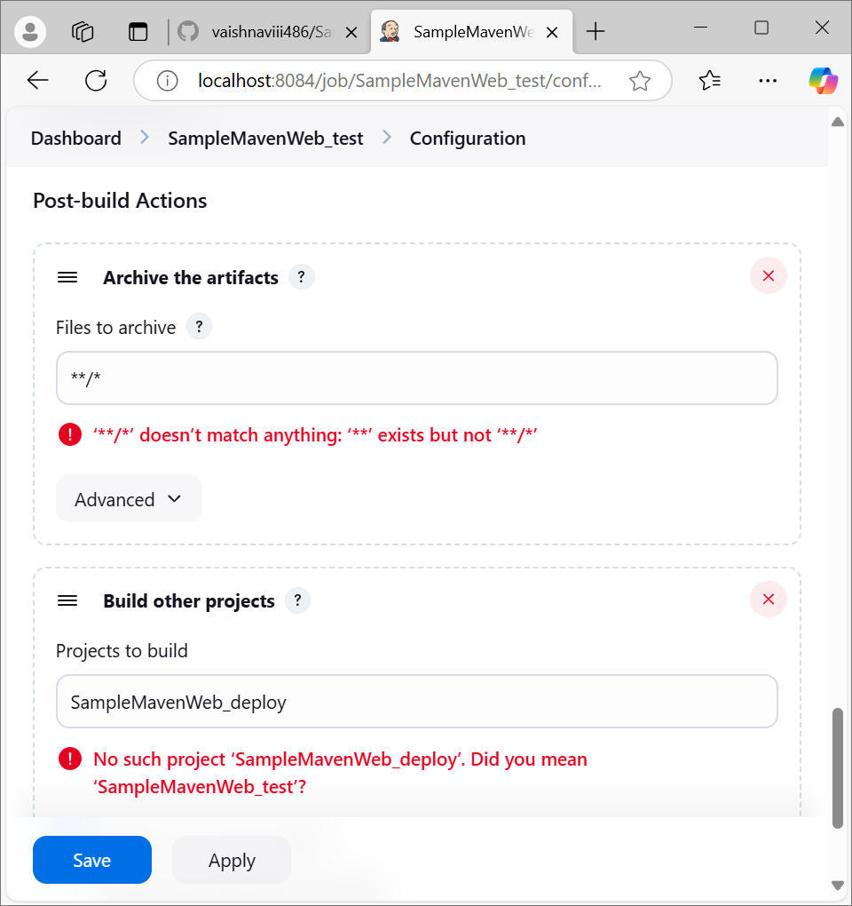create new project as “SampleMavenWeb_deploy” for deployment

Select free-style project

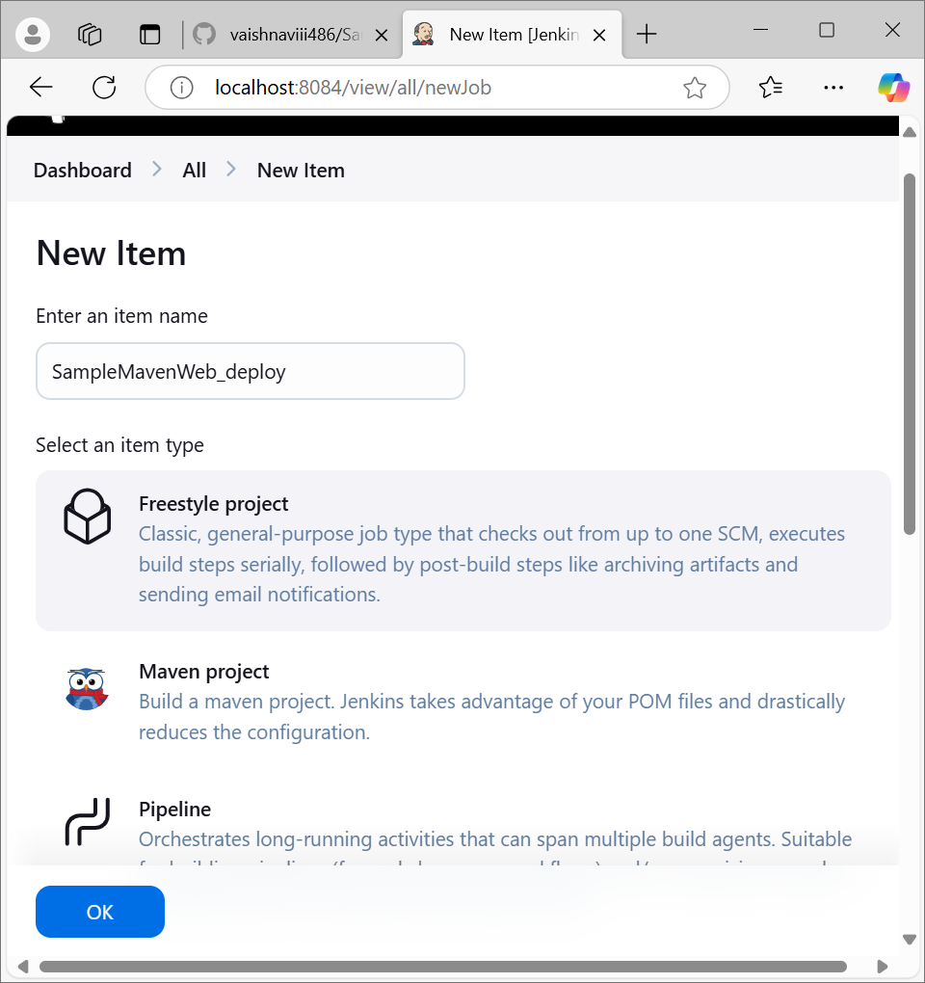

Select build environment as delete workspace befor build starts

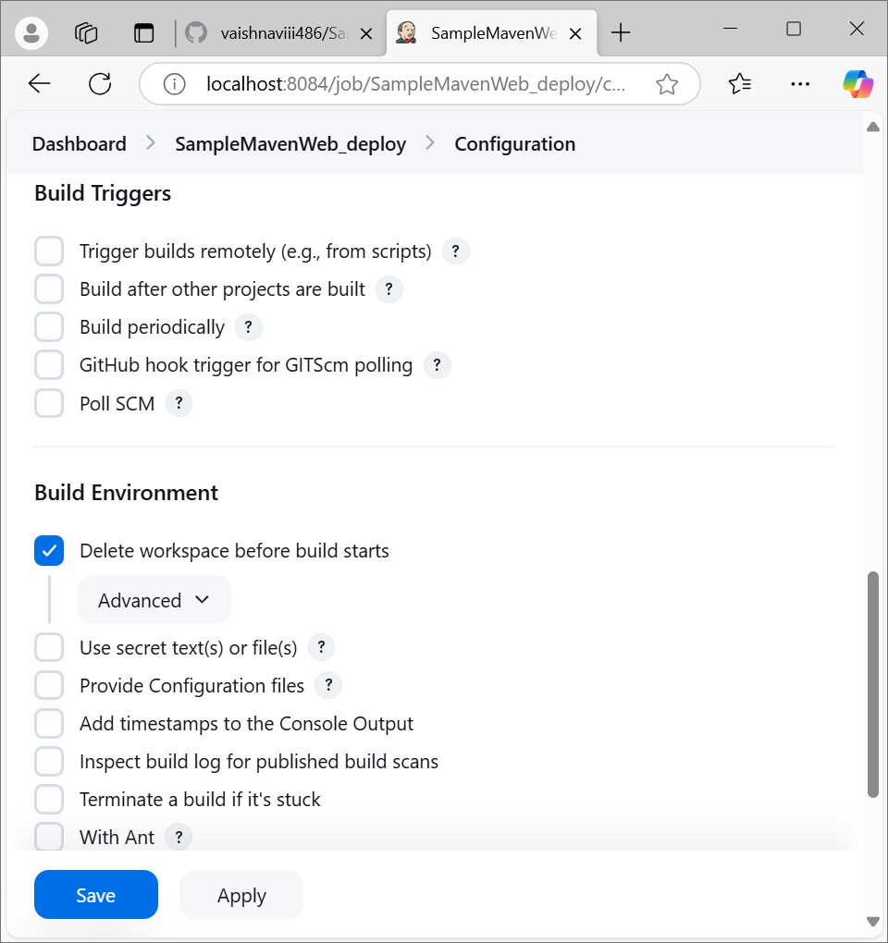’select build actions as copy the artifacts

Give the project name that has build previously

Copy the artifacts

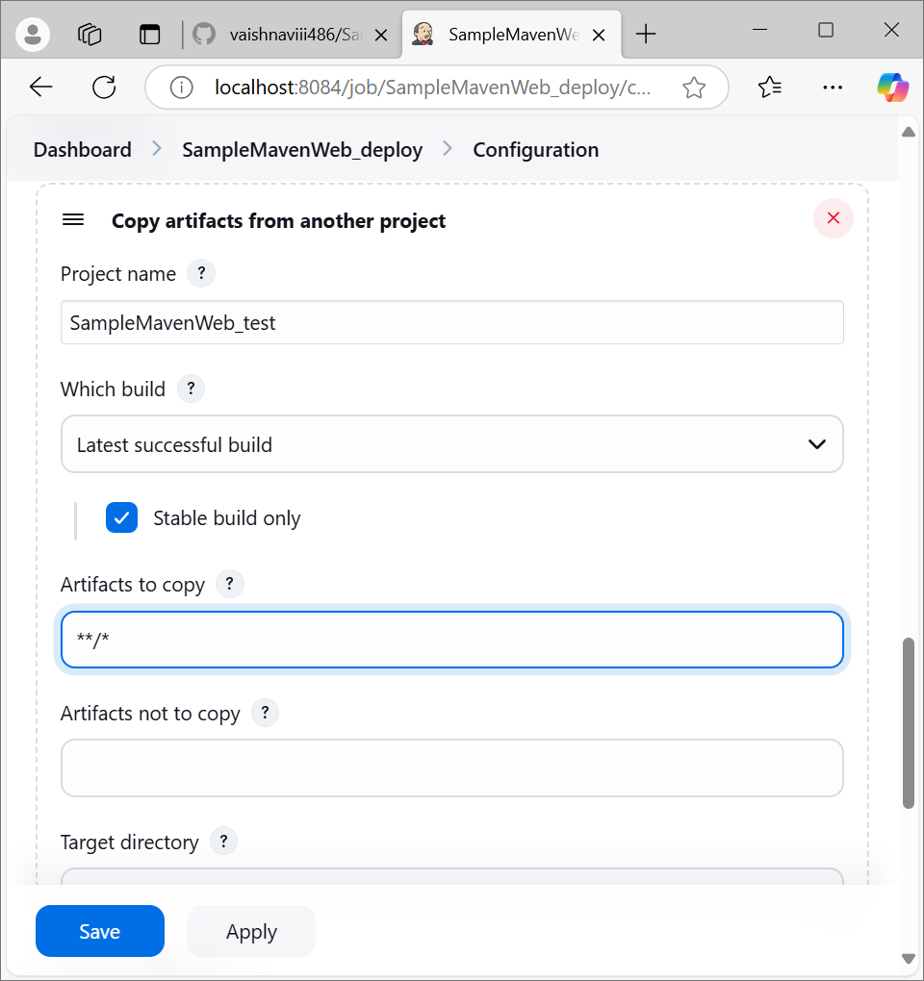

Select the post-build actions as deploy war/war to container

Select .war files

Give the context path

Select the container as Tomcat v9.0

Give the credentials

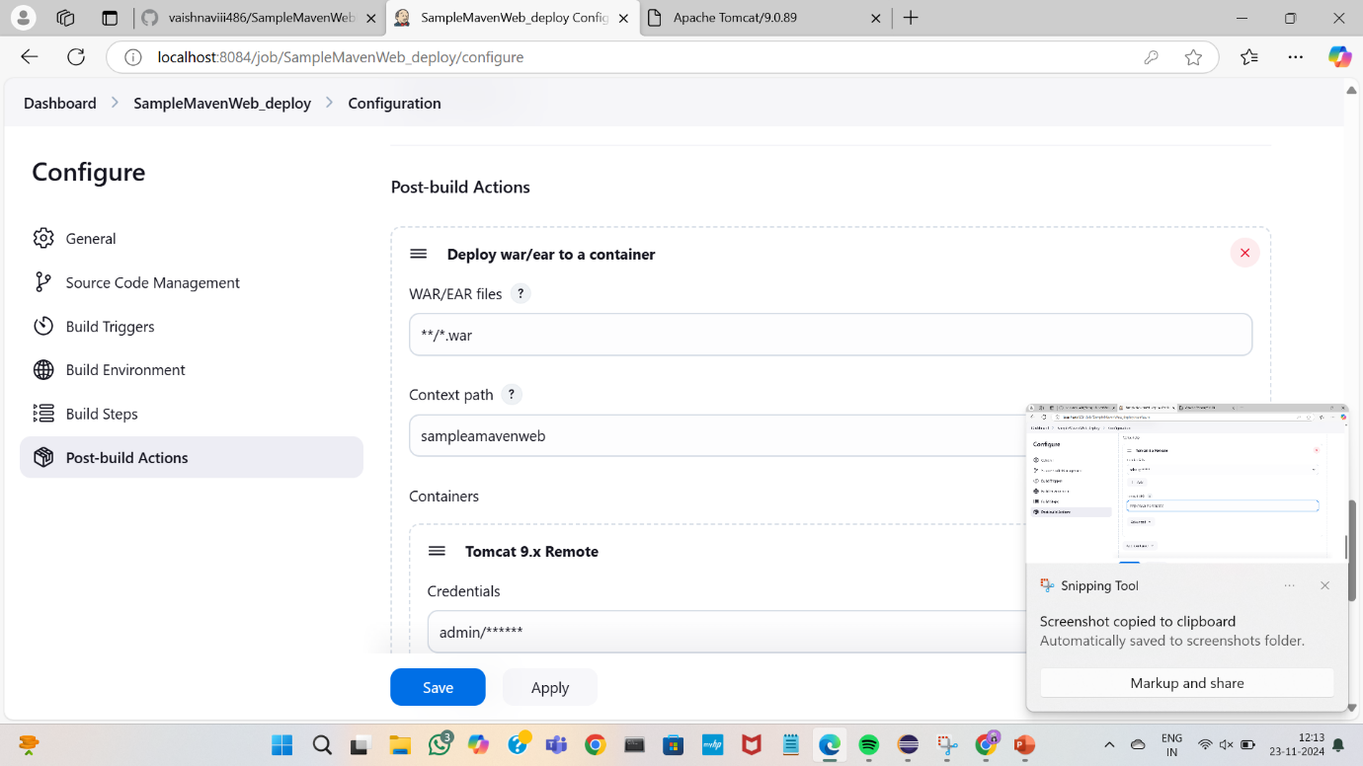

Open the tomcat server and copy the server link

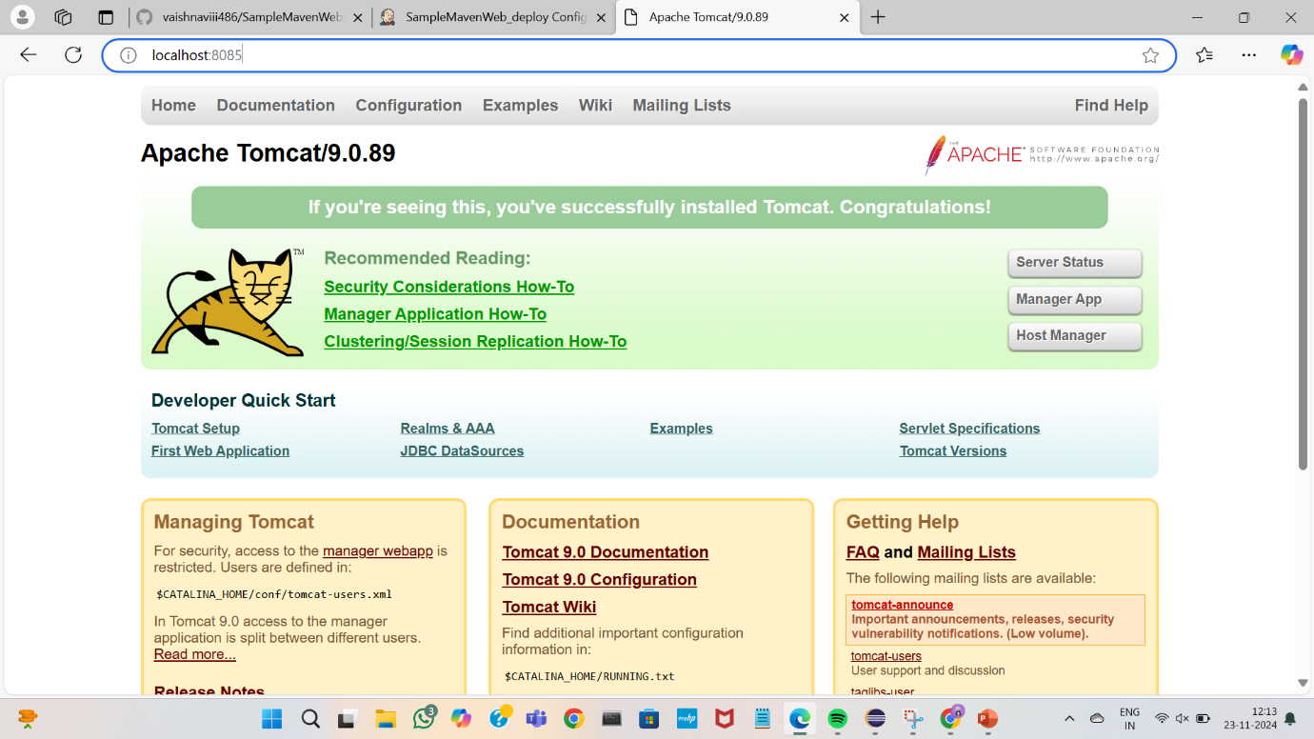

Paste it on tomcat url

Apply and save

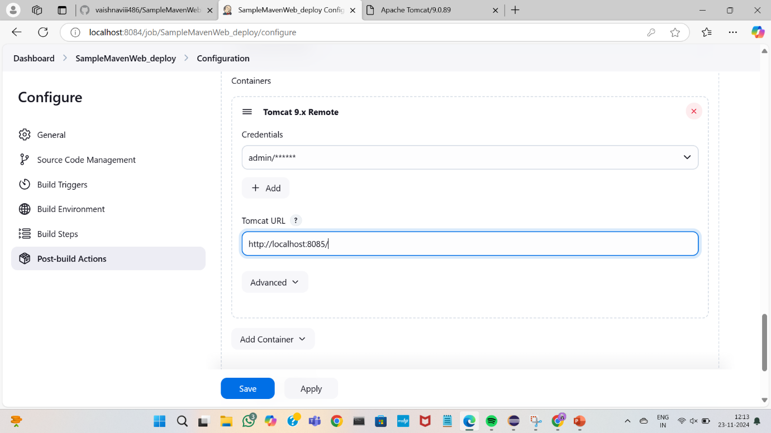

Create a new pipeline on the dashboard as “SampleMavenWeb_pipeline”

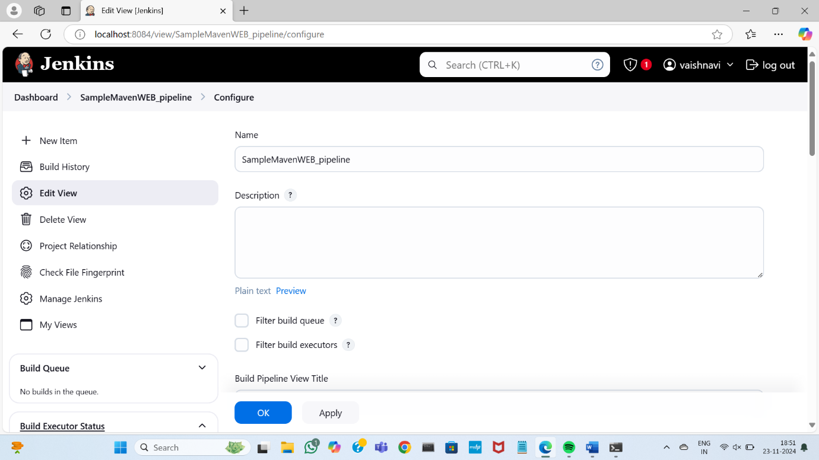

Select the initial job that has been build first (build project)

Apply and ok

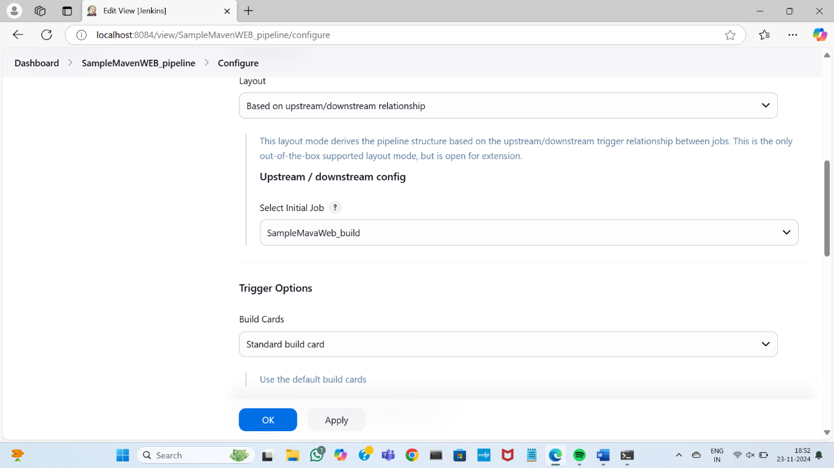

Run the pipeline

Once the build,test,deploy completes it appears green

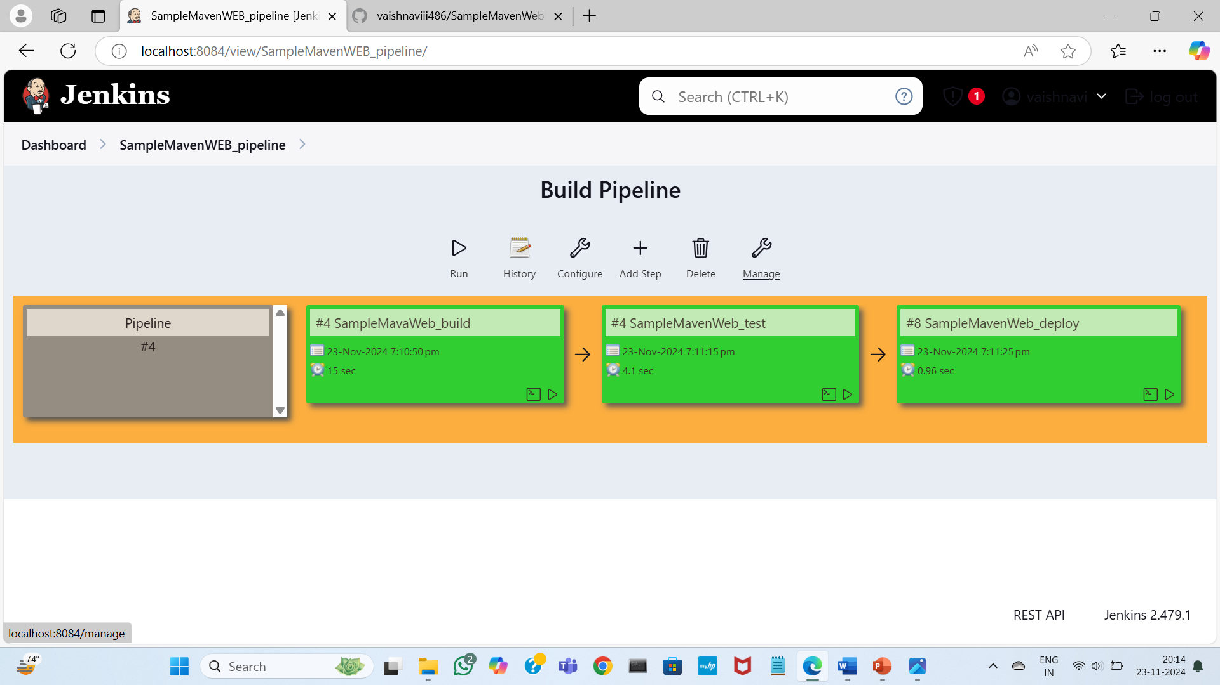

Go to tom cat server click on manager select your Maven Web project

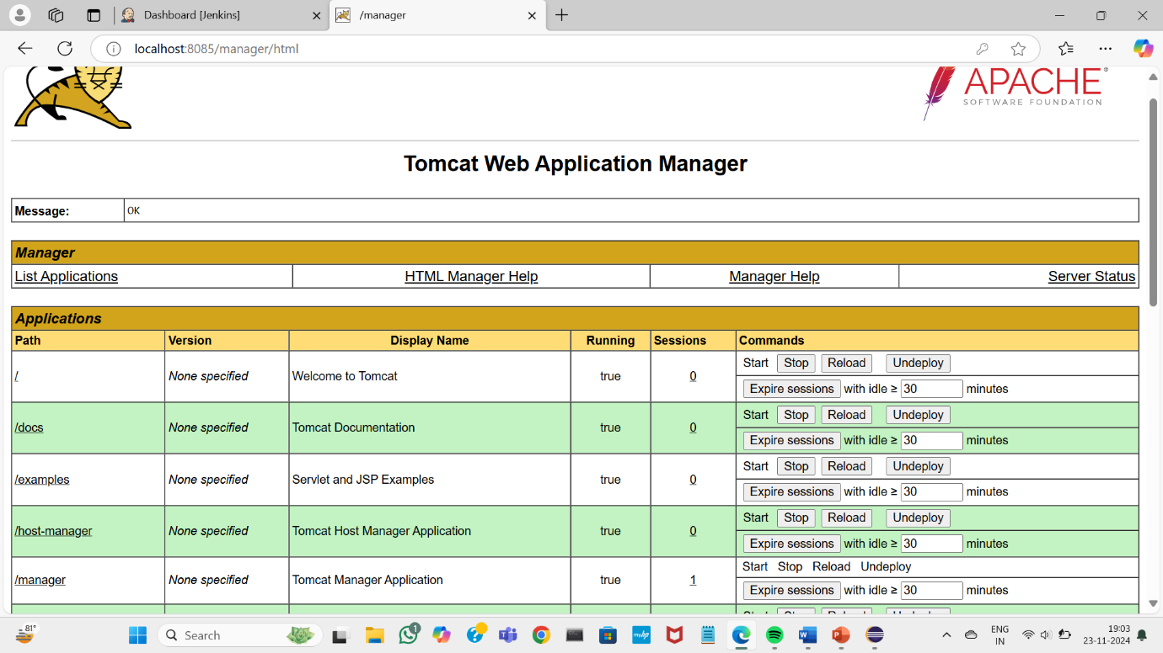

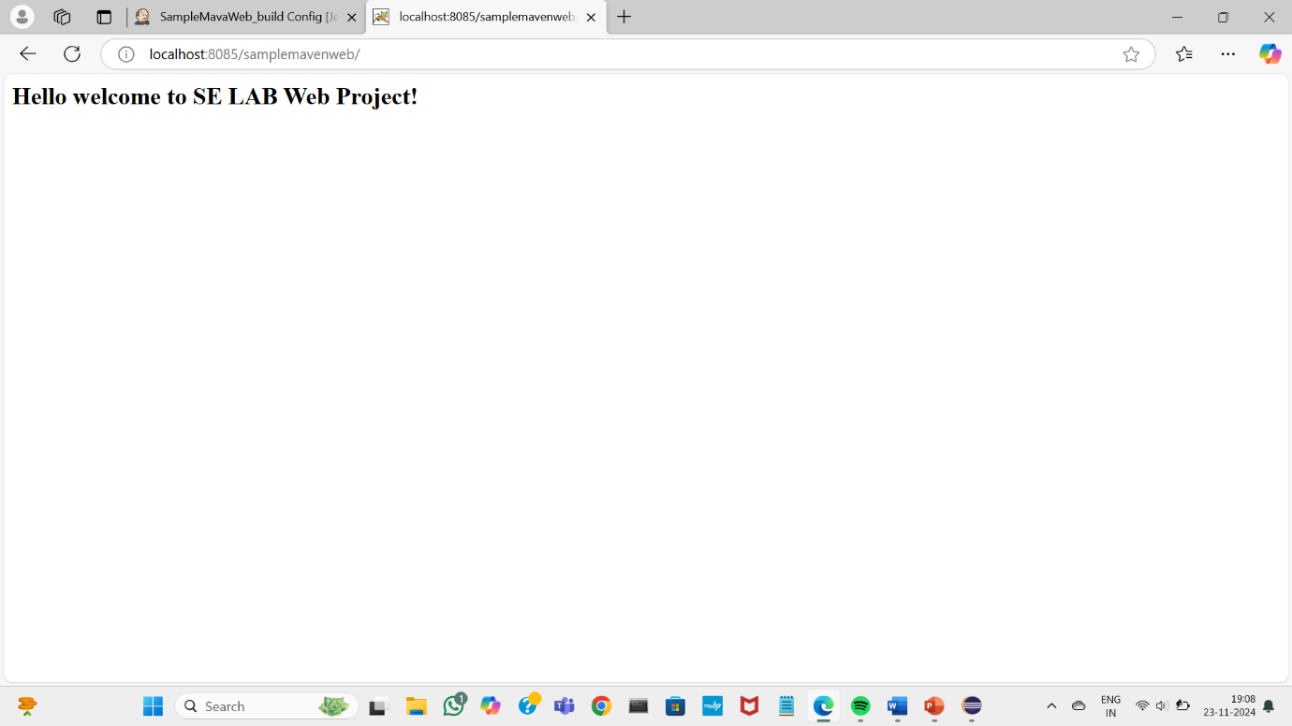

Open your mavenWeb project in git hub

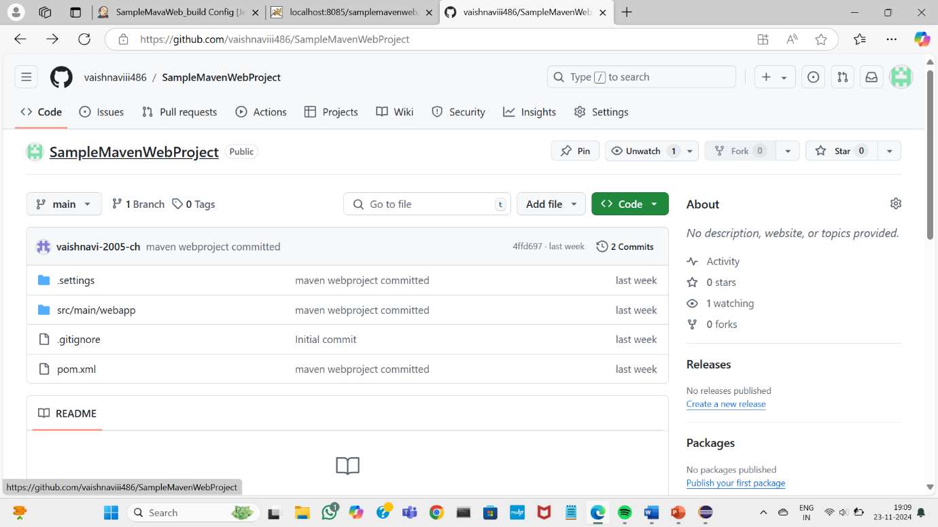

Select index.jsp file

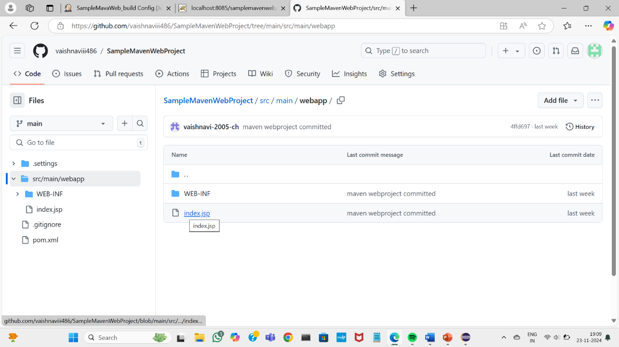add some text in the file or make some changes

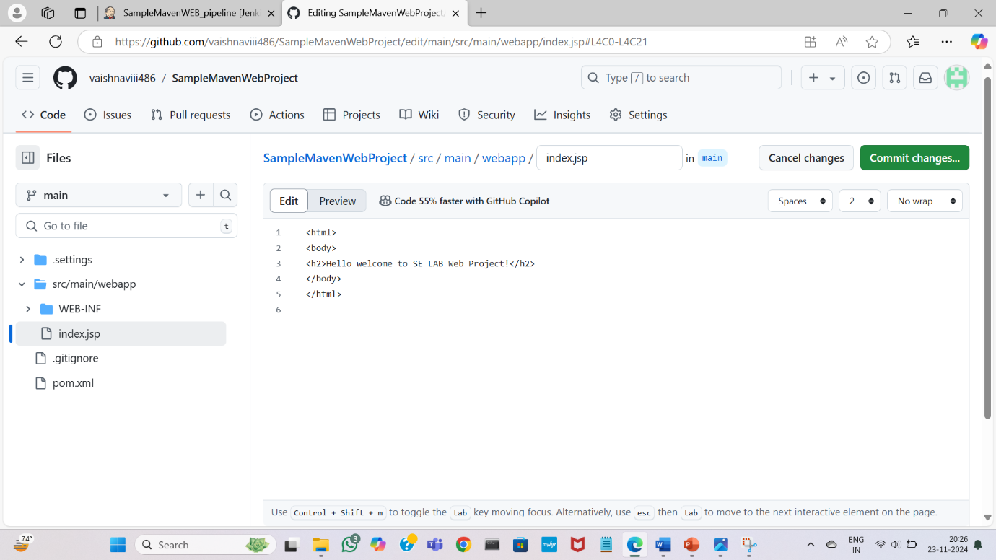

Commit the changes

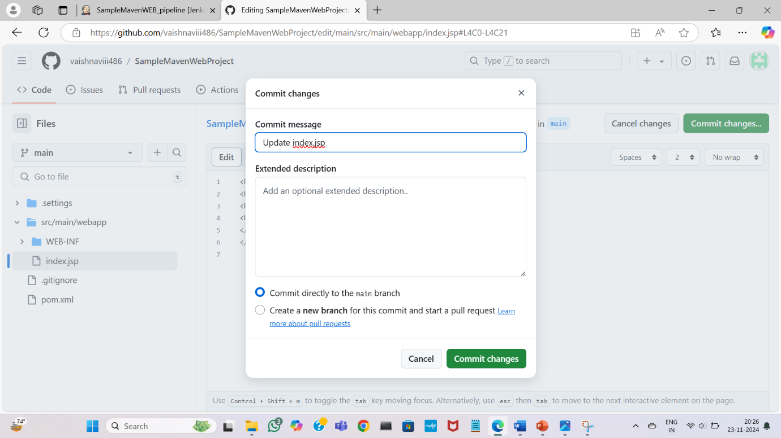

Run the pipeline again

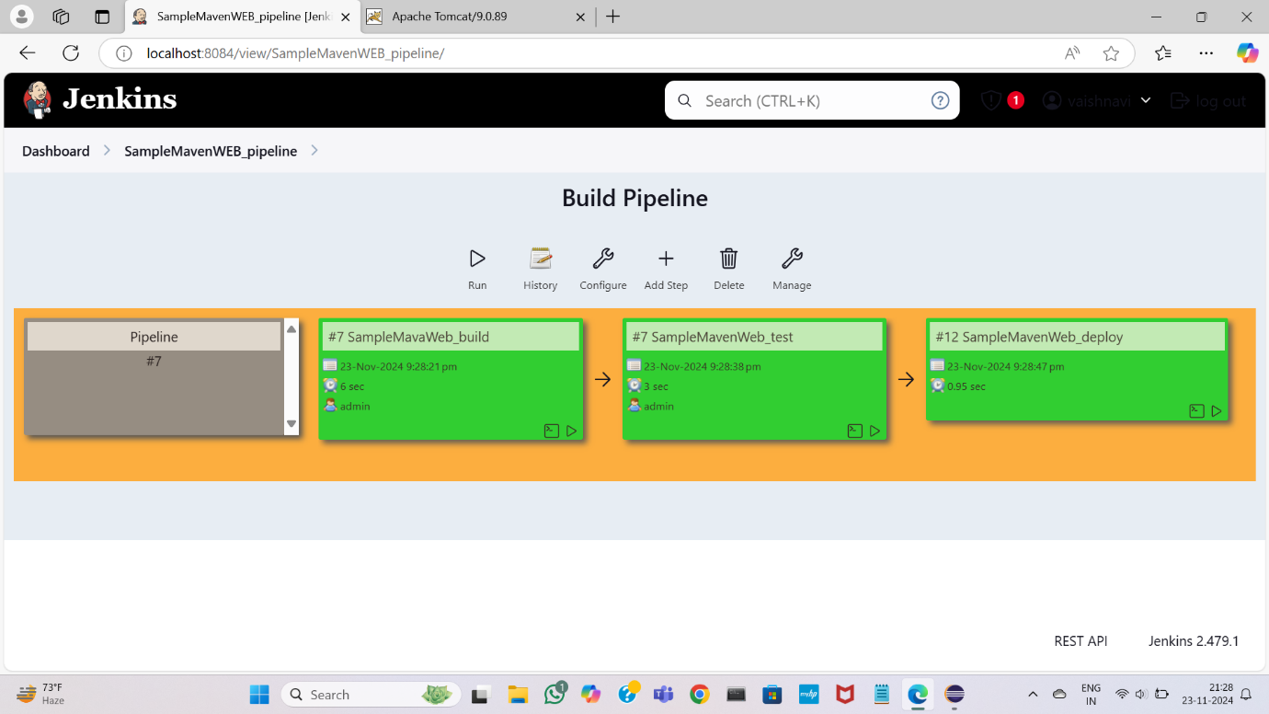

The changes has been committed

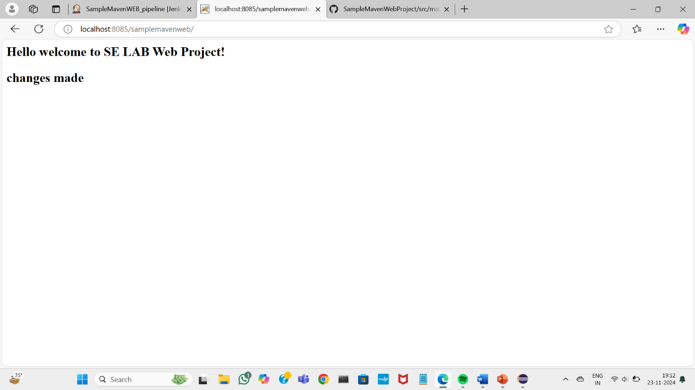

C) BUILDING THE CI/CD SCRIPTED PIPELINE USING JENKINS FOR MAVEN JAVA PROJECT WITH POLL SCM

Open your jenkins dashboard click on new item

Give the name for your pipeline

Select pipeline option and click on “OK”

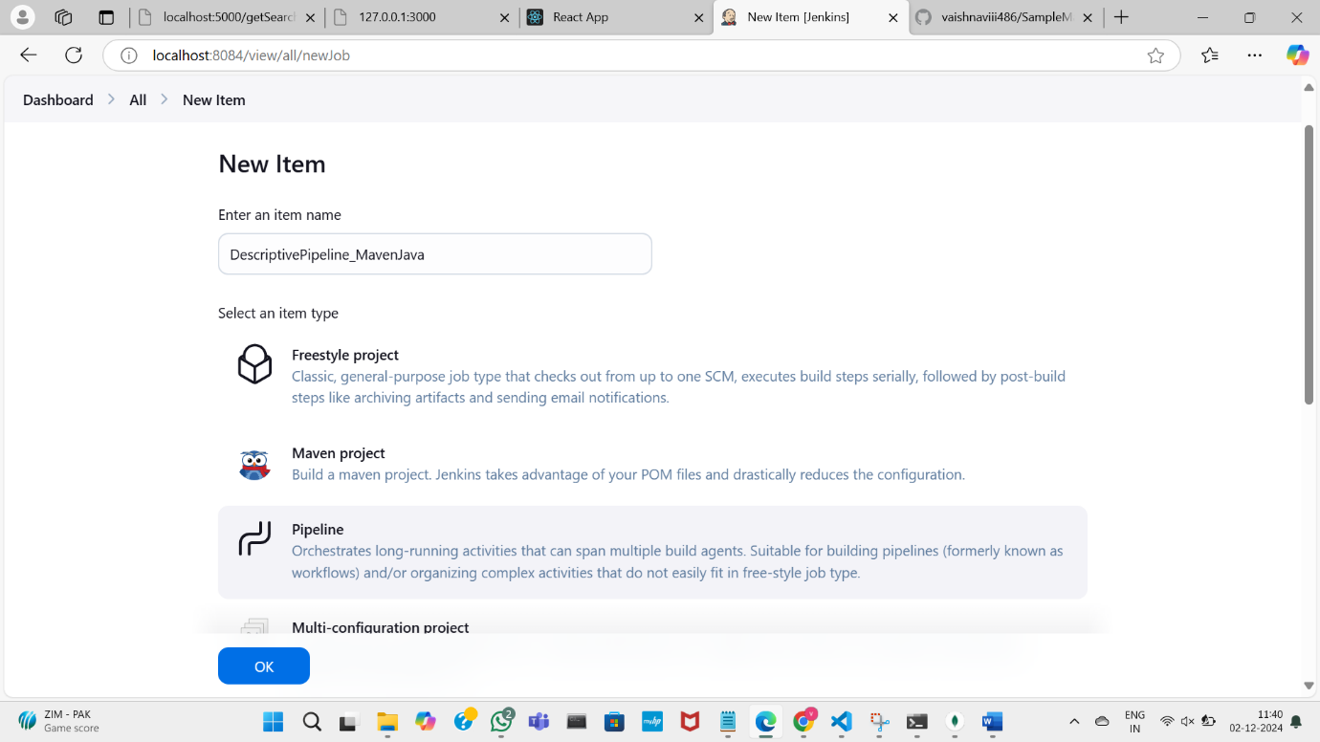

Select the pipeline script option as you are building the script pipeline

Paste the link for the git repository for SampleMavenJava project

Perform the clean install and test options in the script

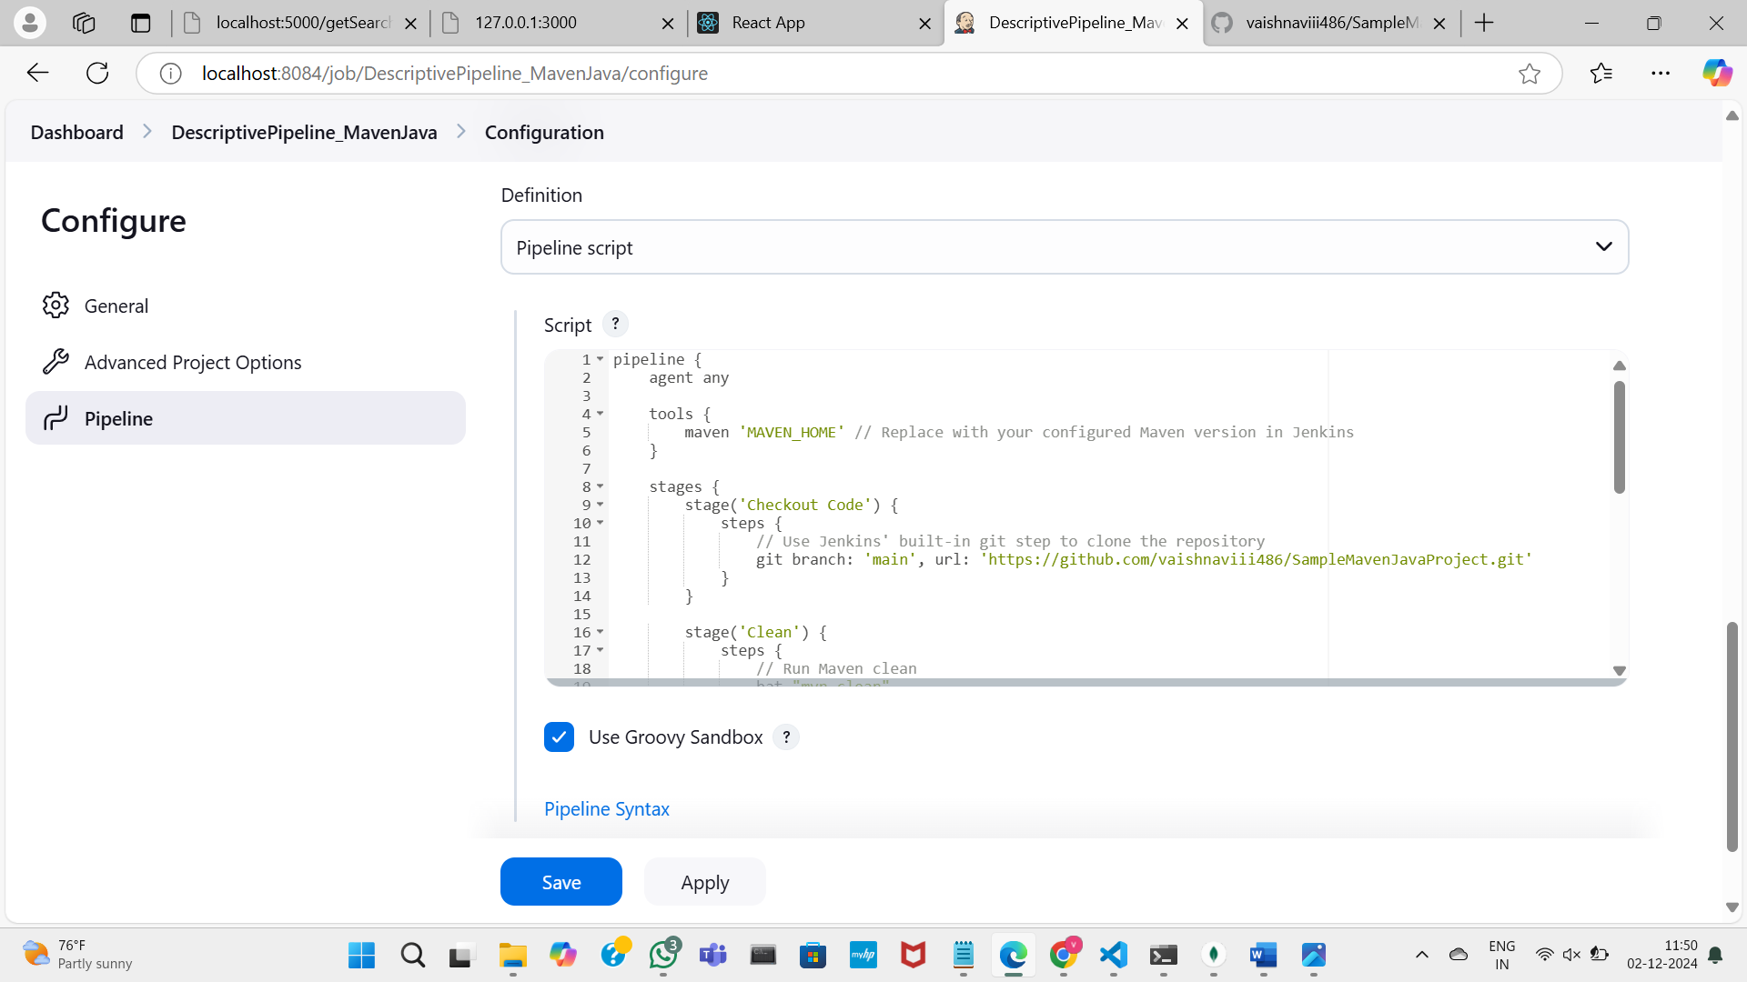

Here is the script pipeline

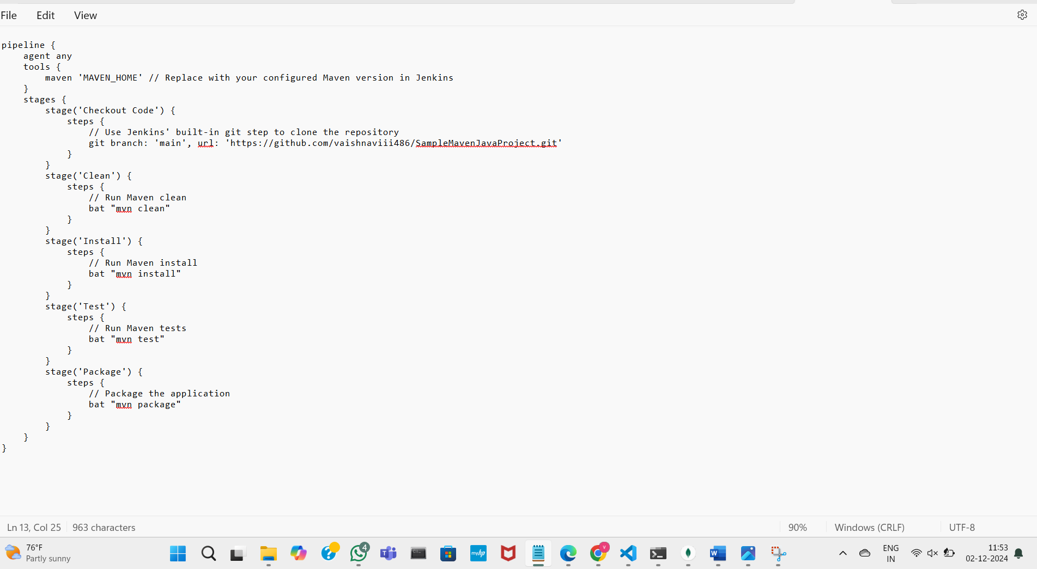

Click on apply and save the changes

Click on build now to build the pipeline

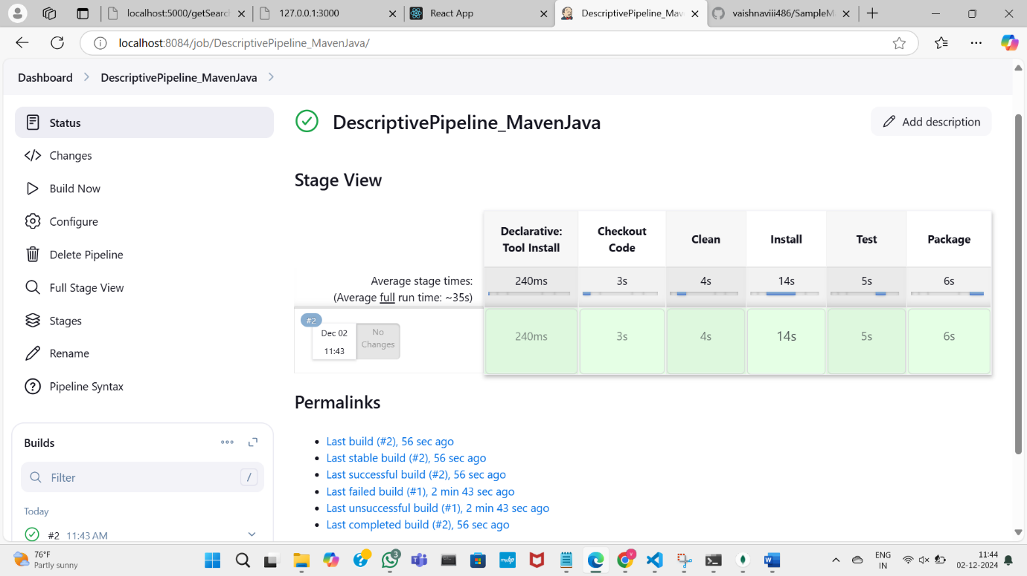

Building script pipeline is completed

You can also modify the build trigger option to modify the build timings

EXPERIMENT:7

A) INSTALLATION OF DOCKER, MINIKUBE, ACCOUNT IN DOCKERHUB

Download the docker from the link as shown

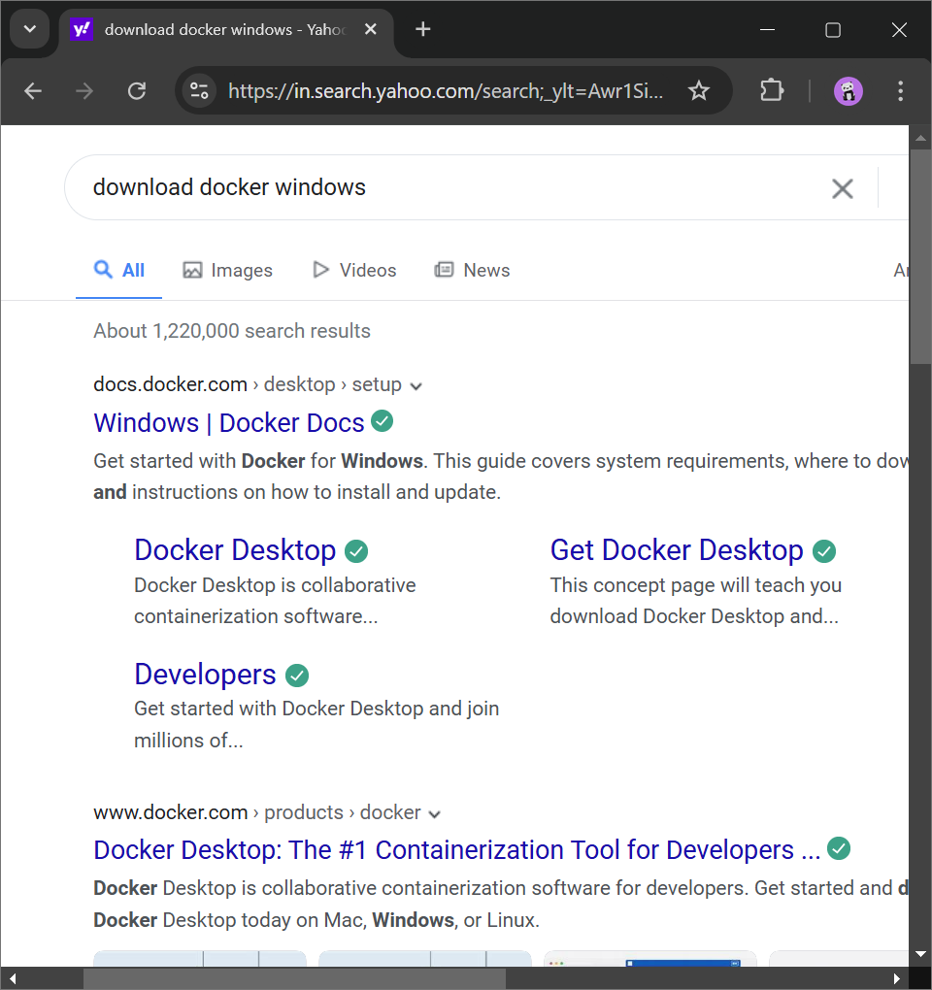

Click on the following link to download the executable file

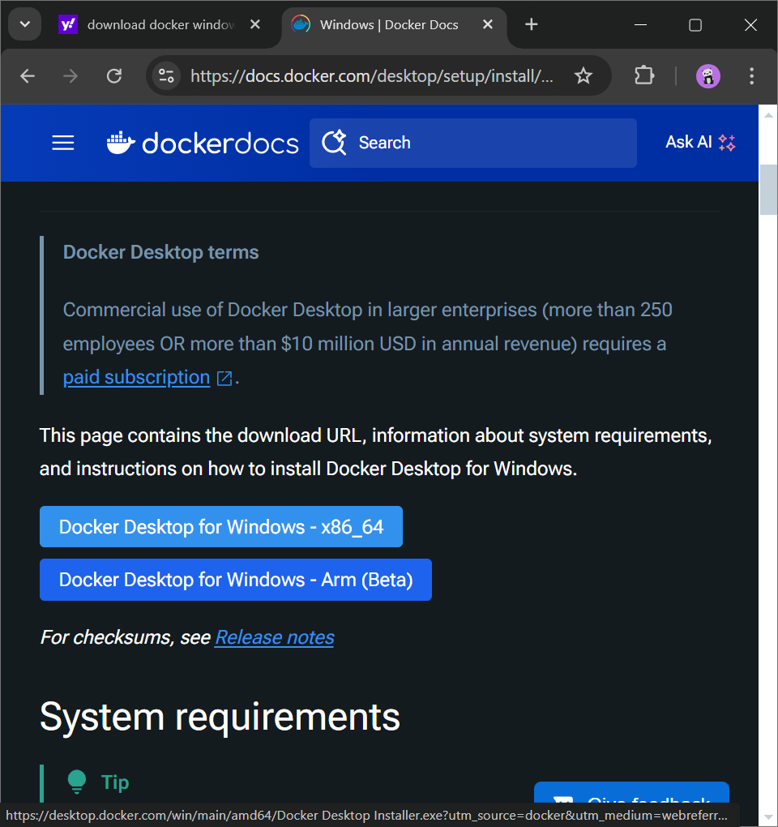

Type winver in Run to check the prerequisites - OS version-Windows 10 pro preferably

Make sure Virtualization is enabled in the system, we can check it in task manager as shown

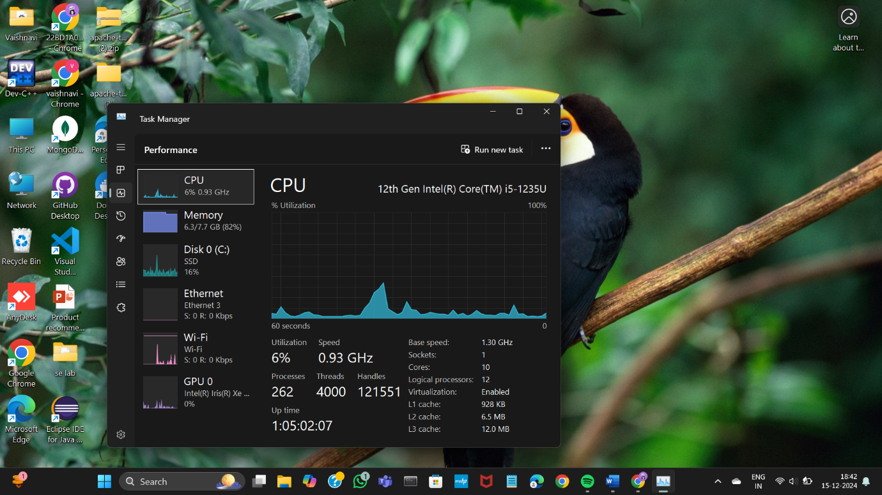

Click on turn windows features on or off in start

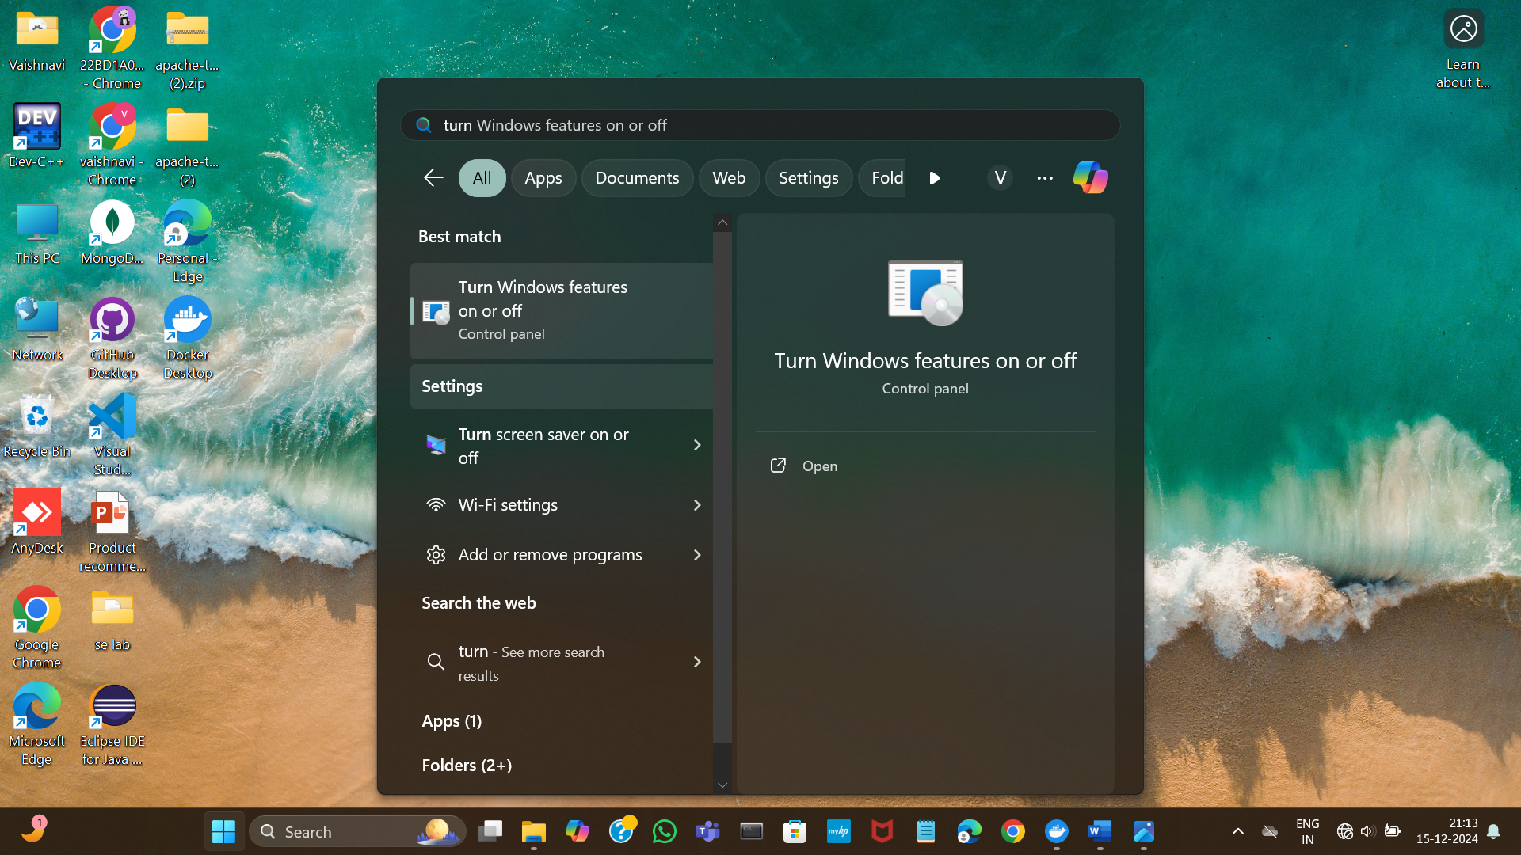

Make sure to check the Hyper-V, Virtual Machine Platform, Windows Hypervisor

Platform and Windows subsystem for Linux checkboxes and click ok

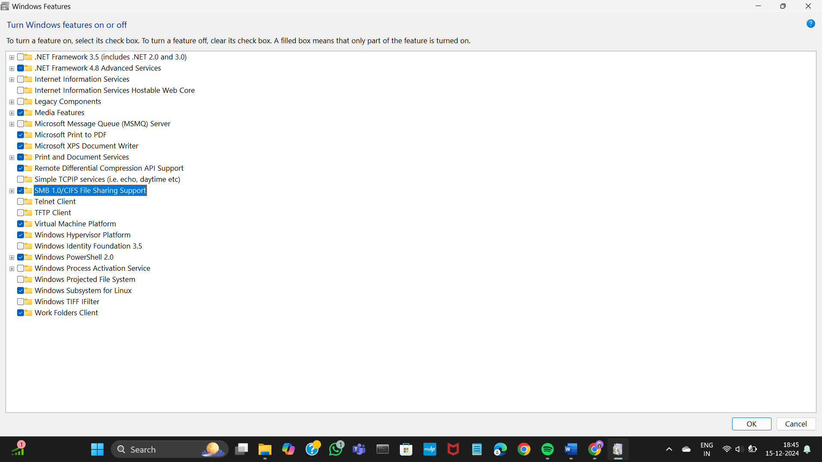

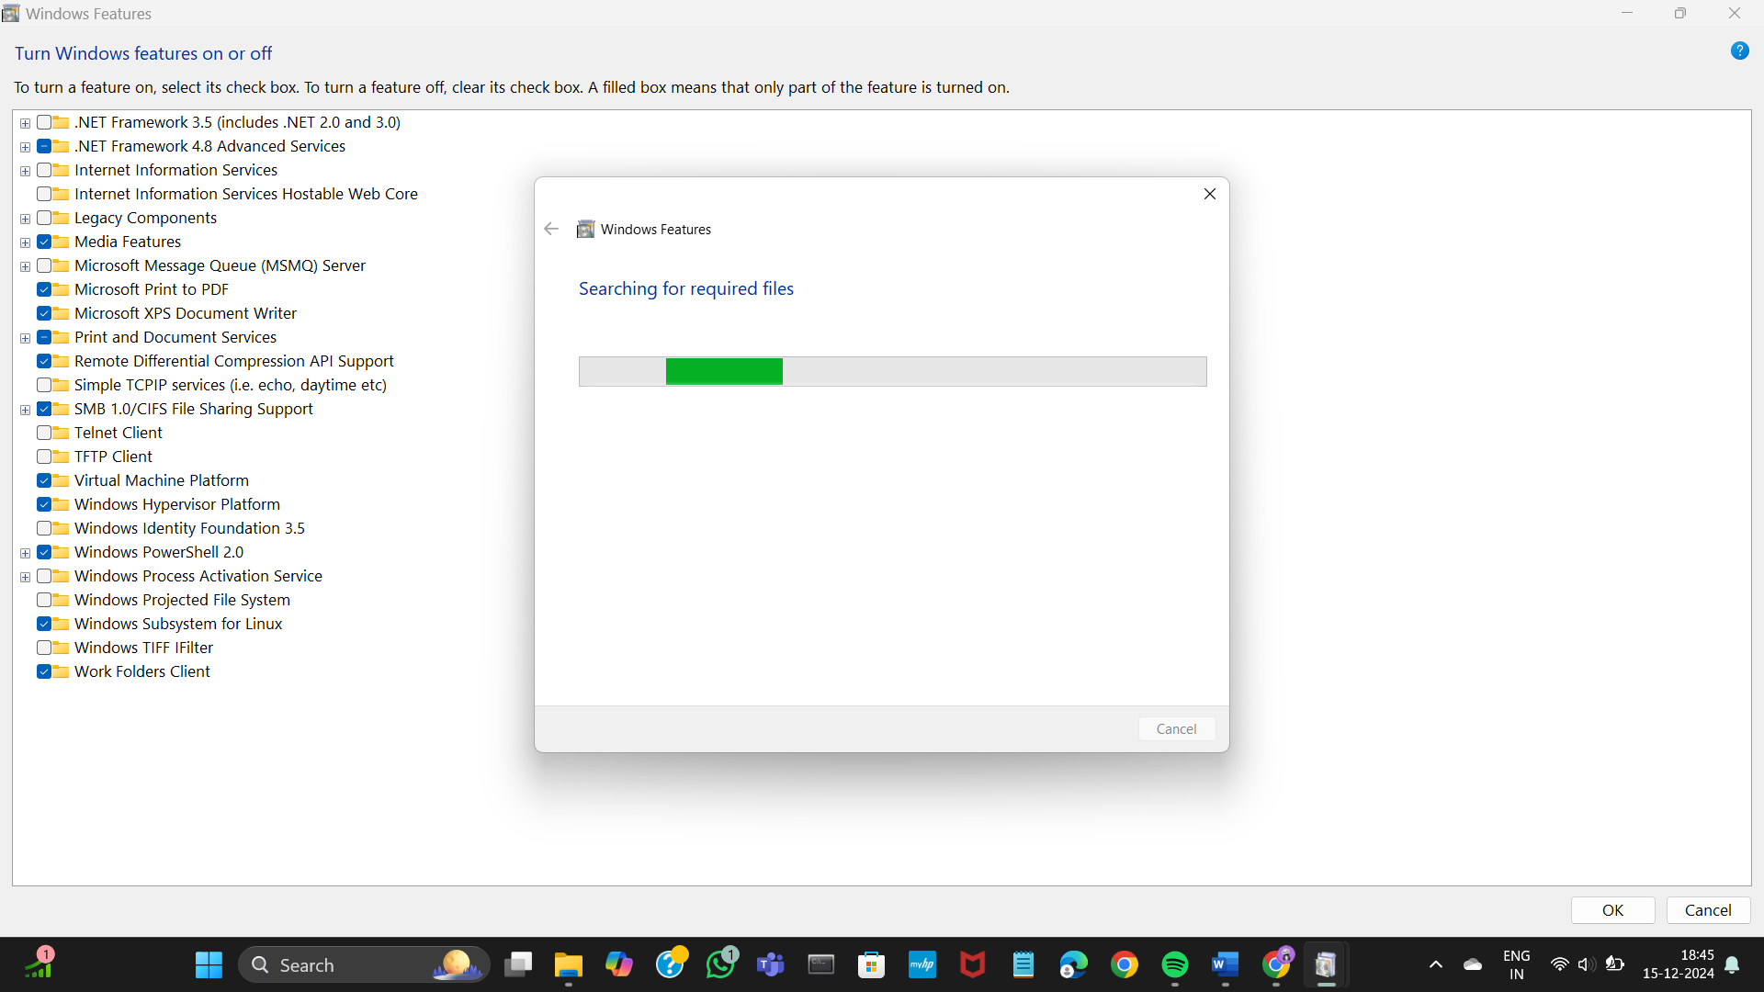

Double click the executable file and click ok as shown,

make sure the following check boxes are selected

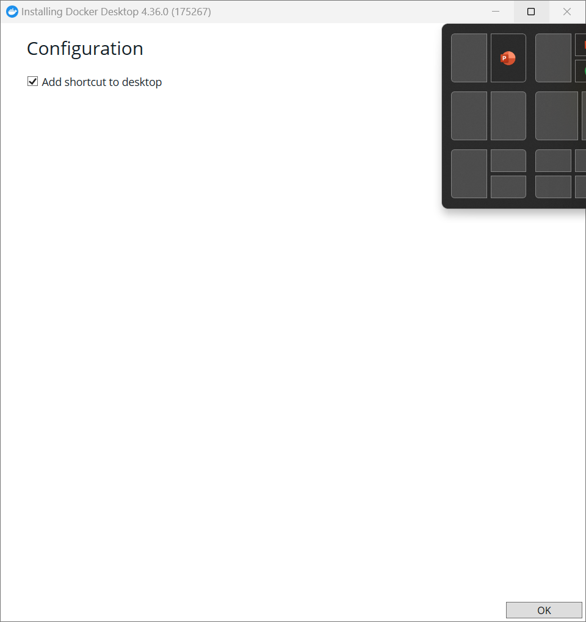

The download has started

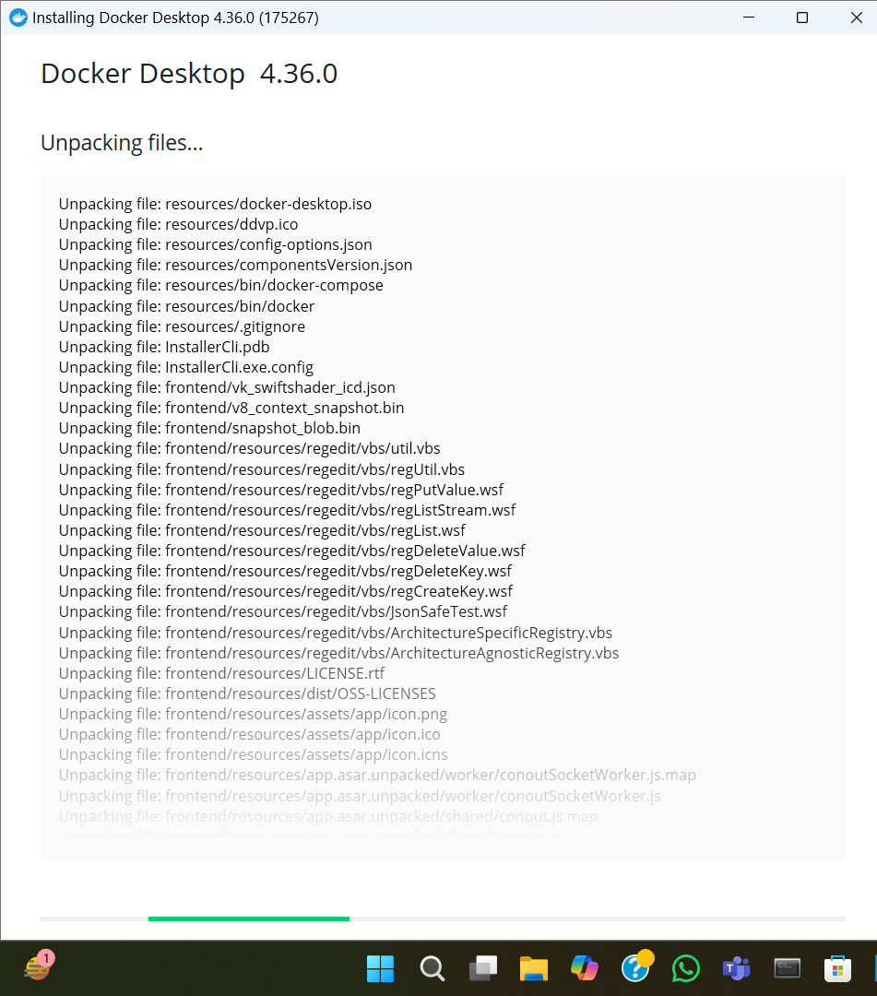

Accept the license -> click Accept

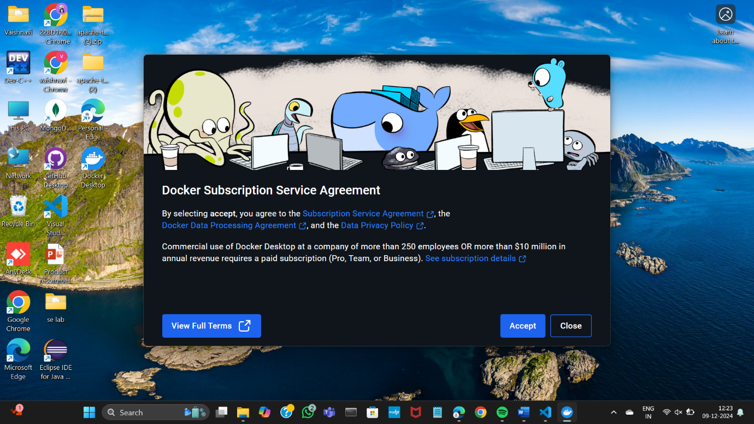

The local Docker Hub is created

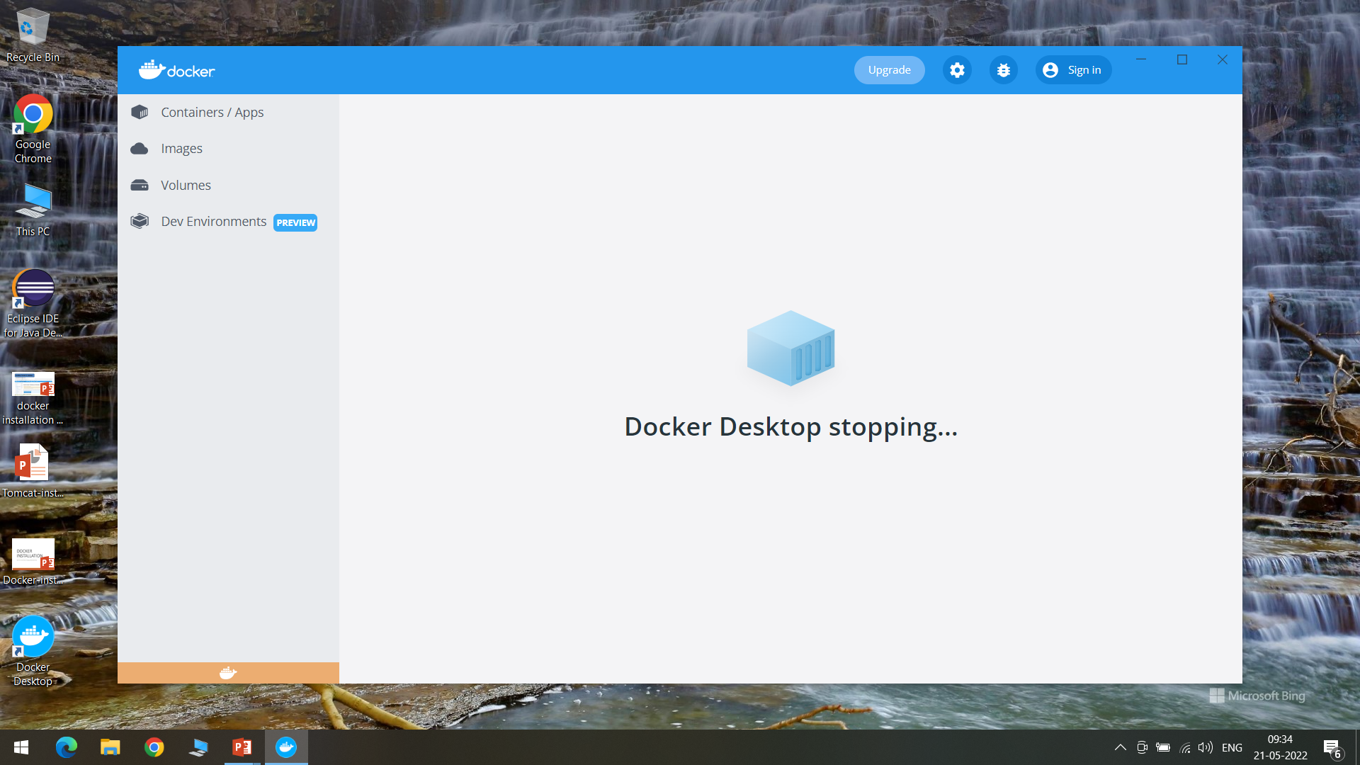

Download WSL2

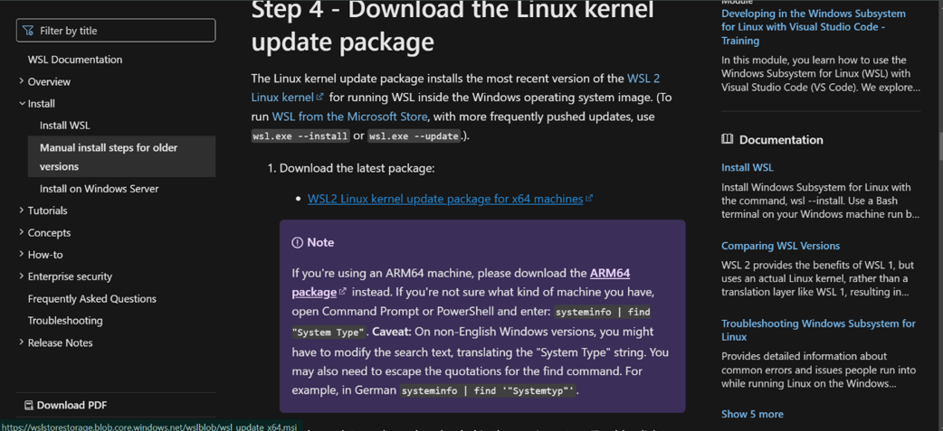

Double click the executable file and click next as shown

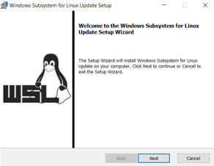

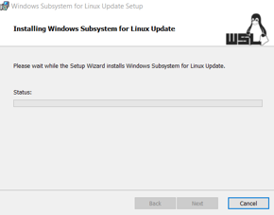

Once the installation is completed click on Finish

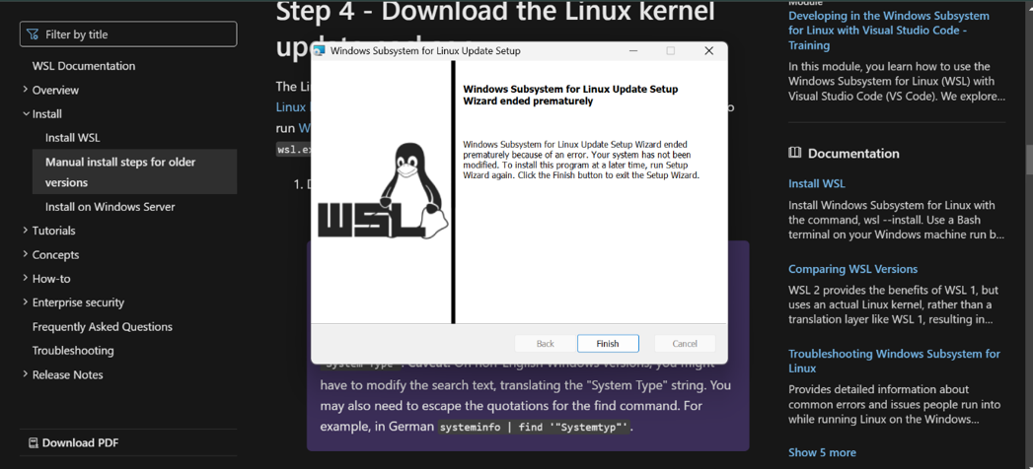

Run as administrator

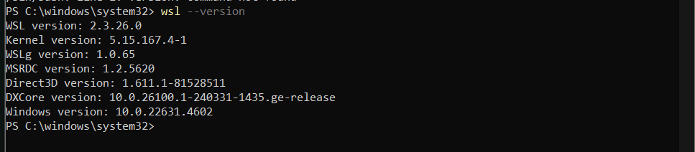

Check docker version in command prompt

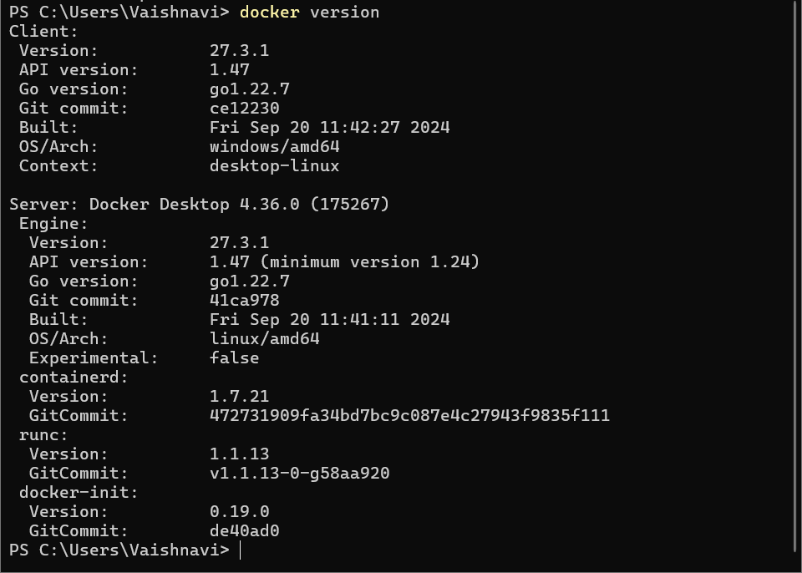

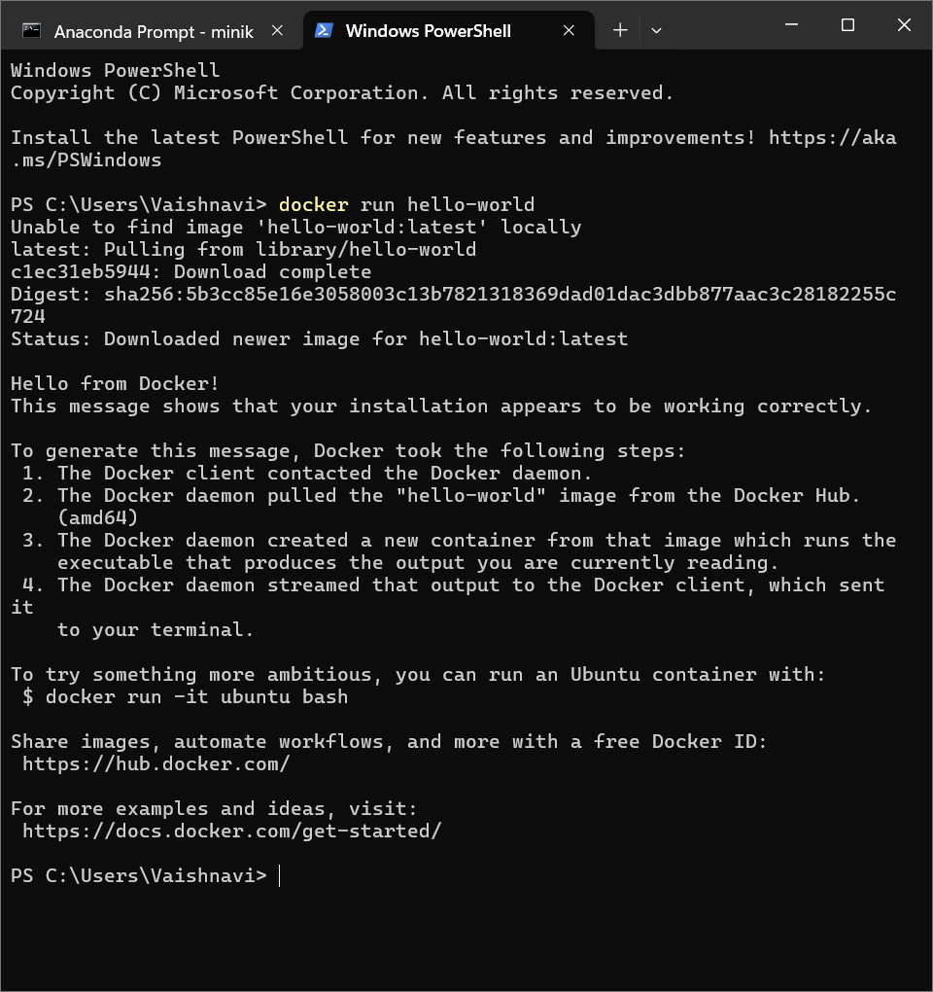

Now we can start the Docker

Click on hub.docker.com and signup as shown

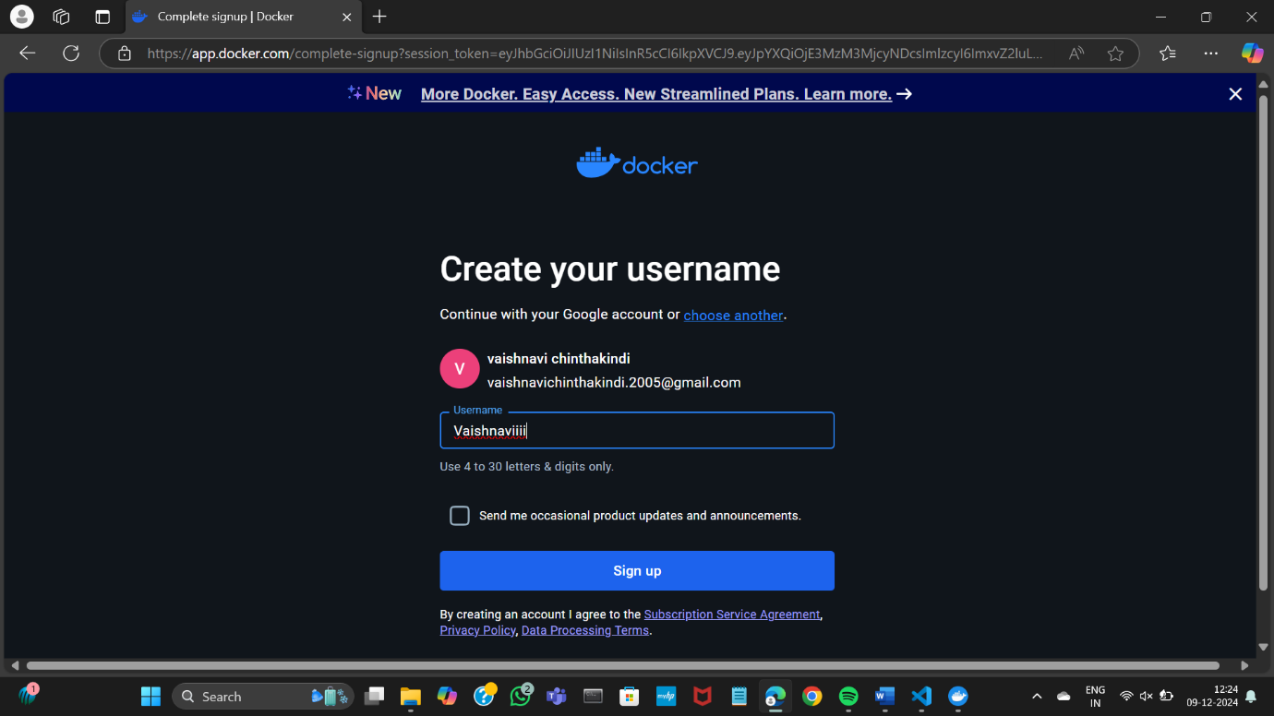

Docker Hub is created

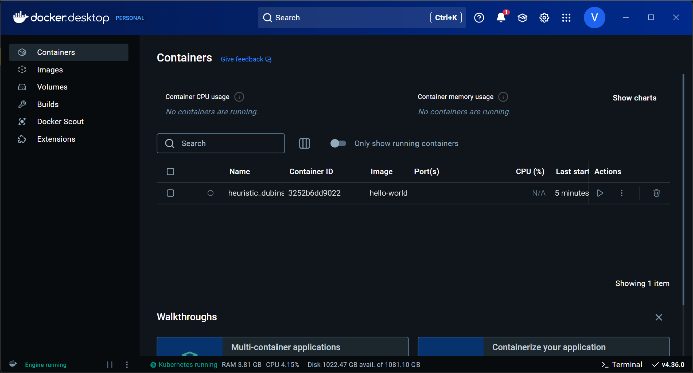

Minikube Installation

Install using Docker Desktop

Settings 🡪 Kubernetes 🡪 Check Enable Kubernetes 🡪 Apply

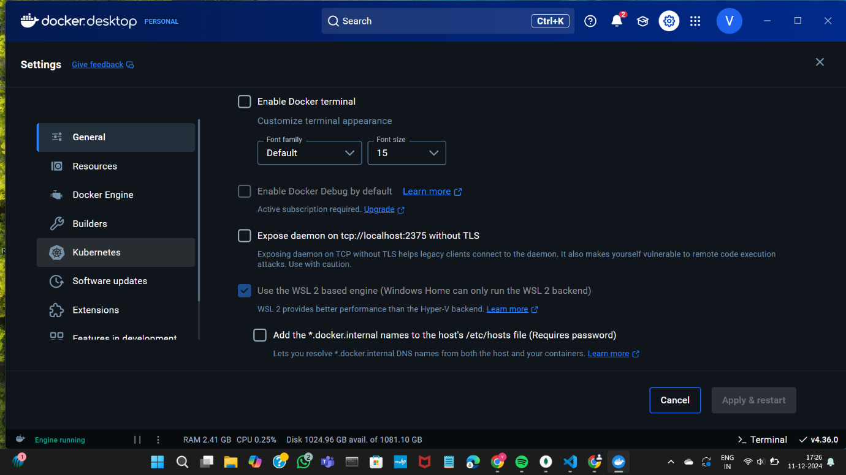

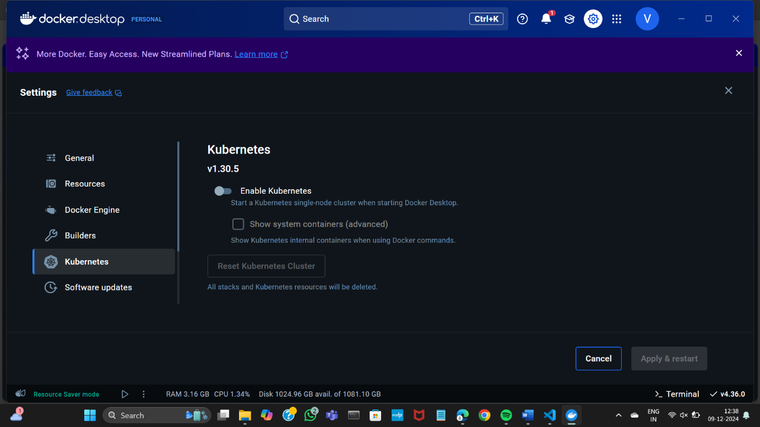

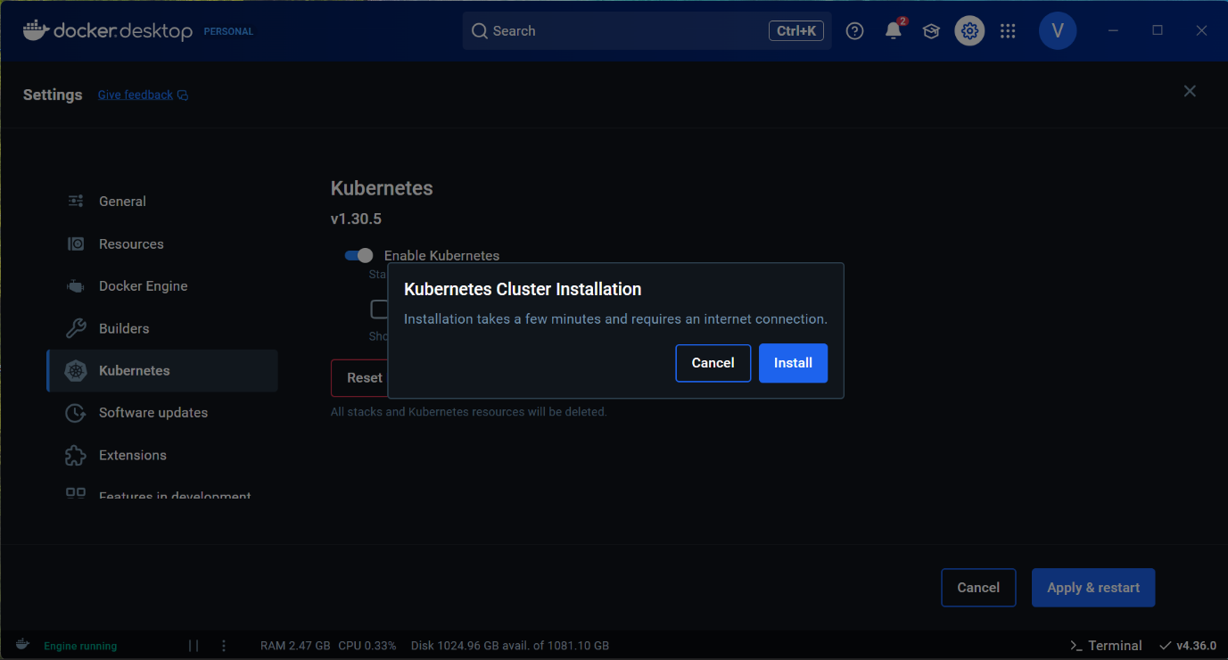

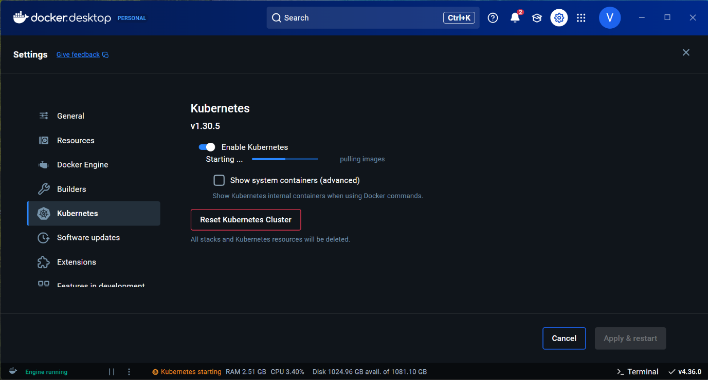

[Minikube](https://github.com/kubernetes/minikube) is a tool that allows you to run a single-node Kubernetes cluster

inside a virtual machine, on your own computer.

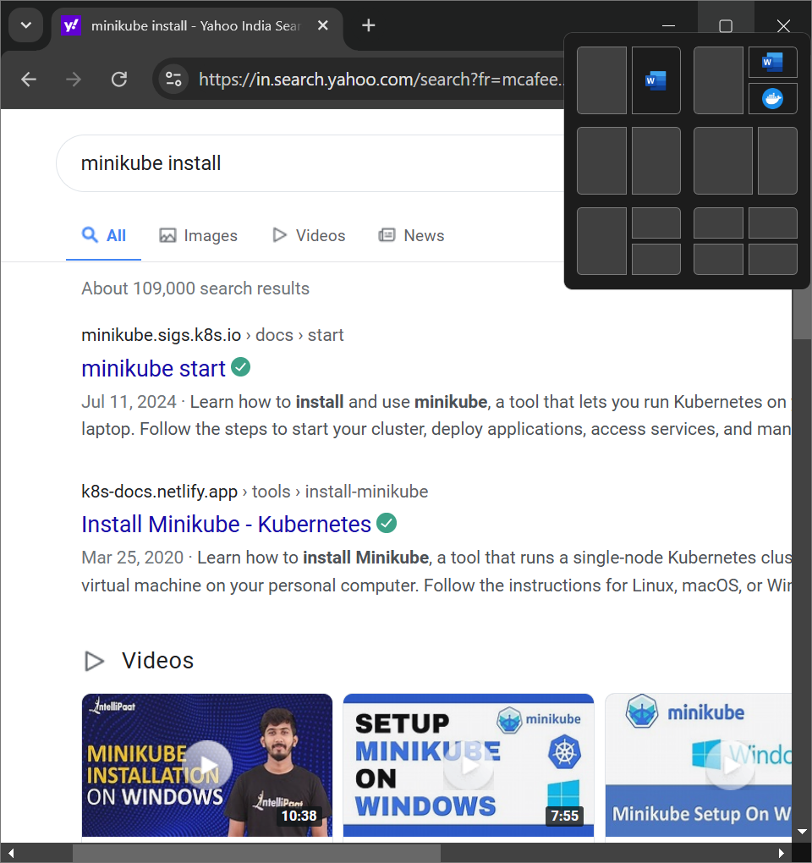

Download the required minikube installer for the windows platform.

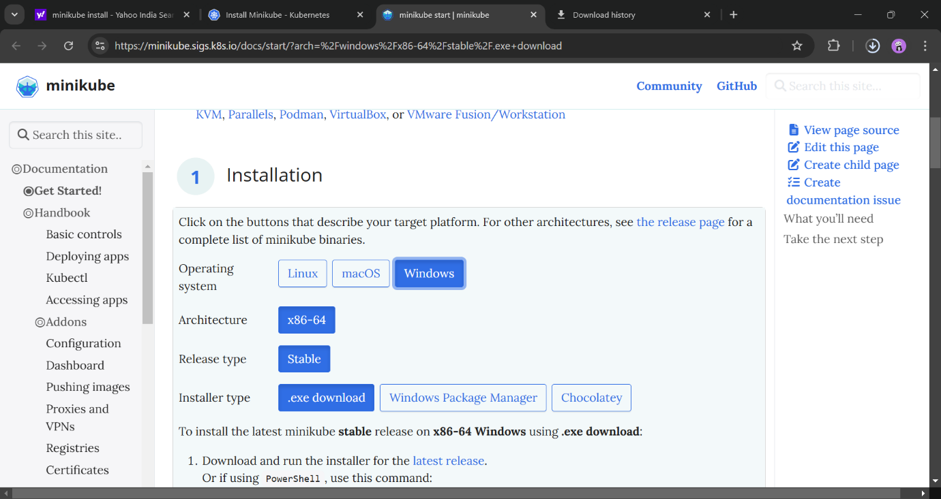

Run the installer to complete the installation process

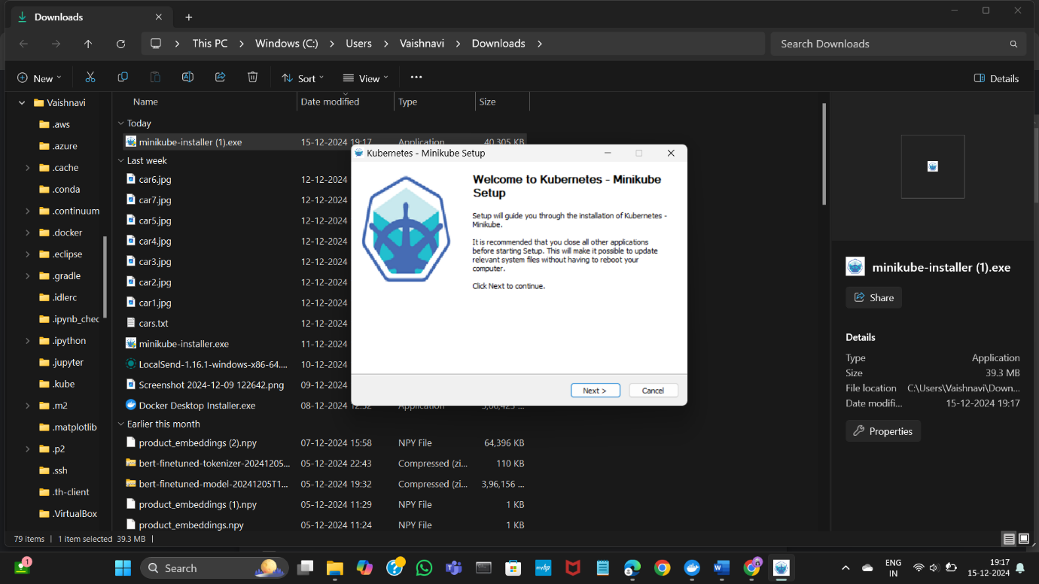

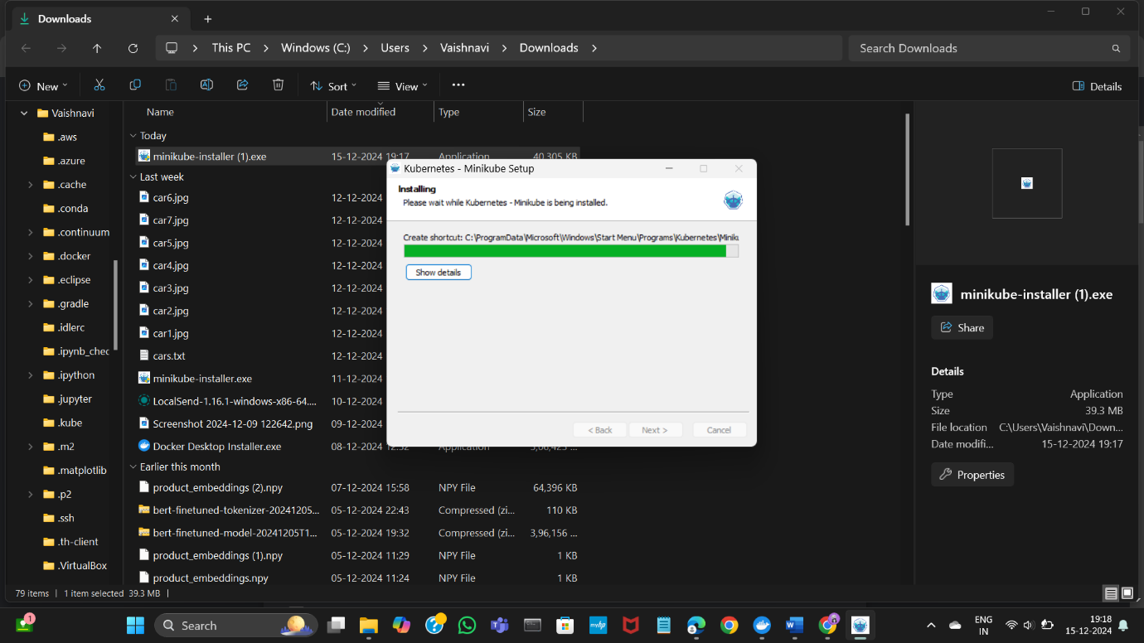

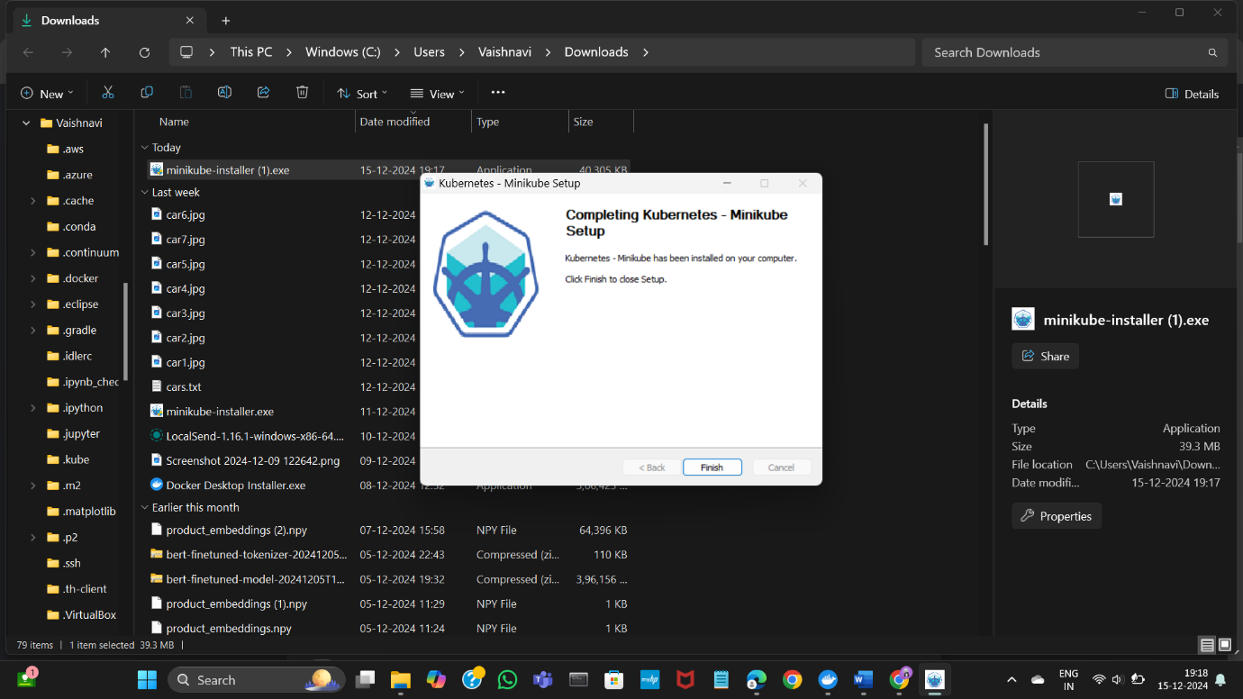

Set the path for minikube in the Environment variables

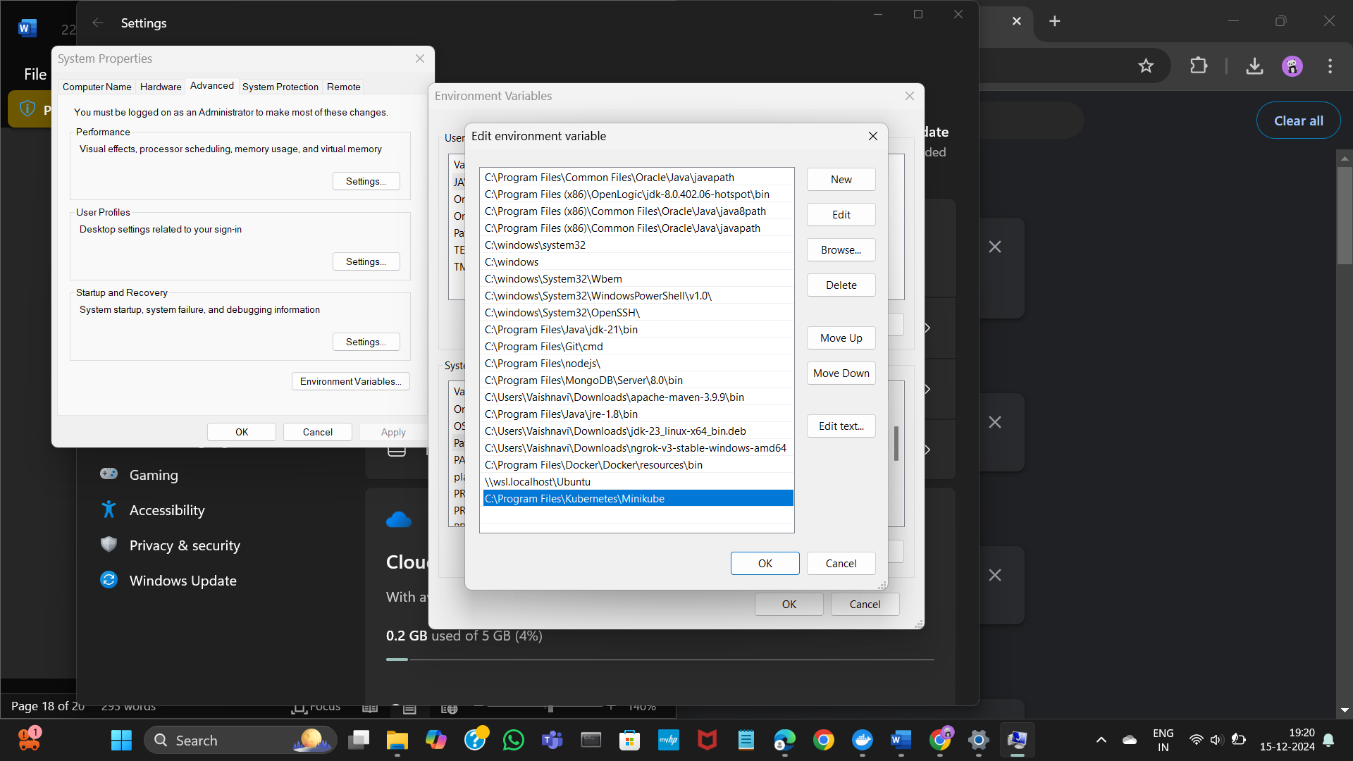

Start your cluster by running the following command in powershell

> minikube start [Docker service should be running]

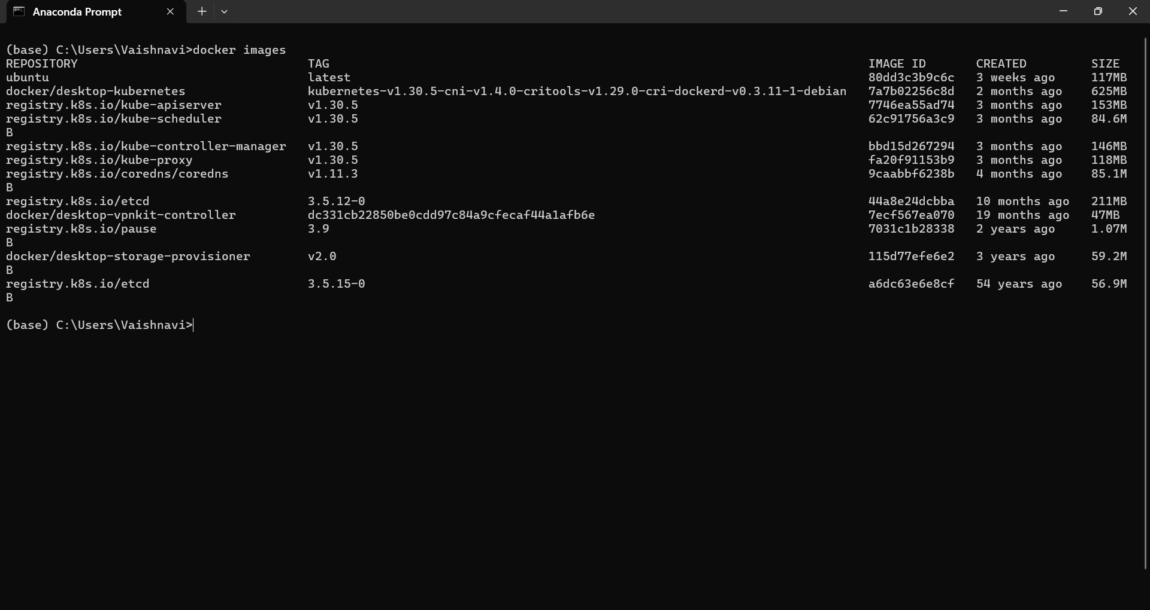

To check which ip address minikube is running

Type > minikube ip

Then type kubectl get po –A to see the nodes

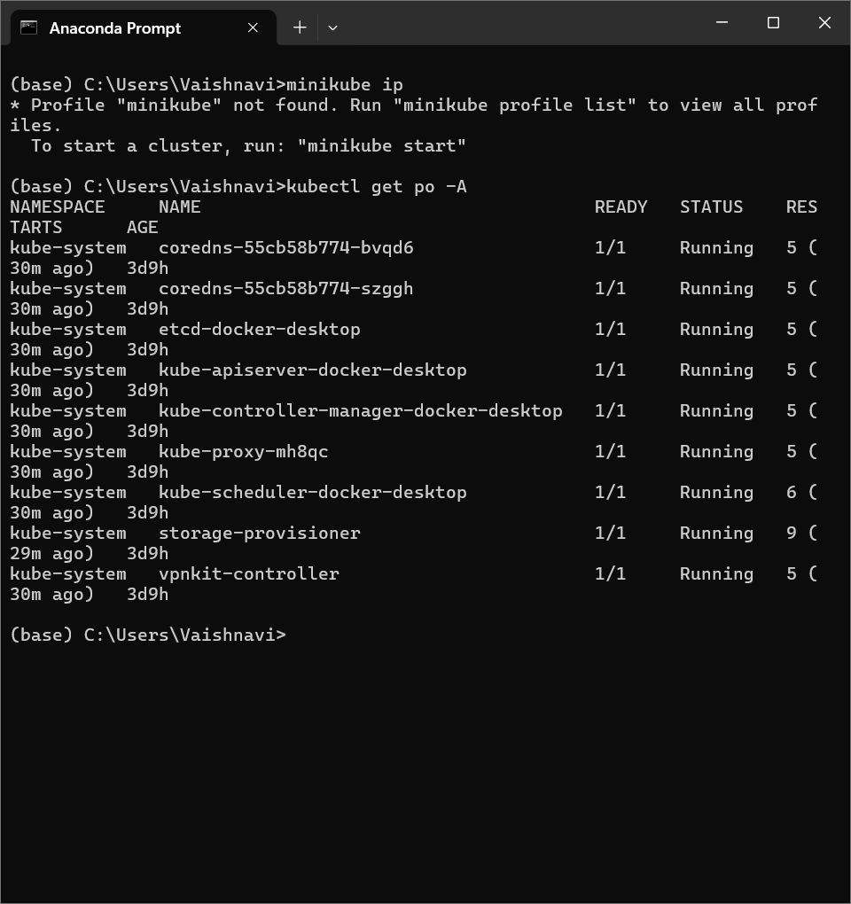

B) DOCKER CLI COMMANDS

Docker desktop



Setting Up Docker

Step 1: Choose the Right Terminal

Step 2: Verify Docker Installation

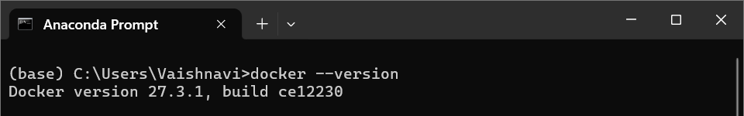

Docker CLI Commands with hello-world

Step 1: Pull the hello-world Image -- Command: docker pull hello-world

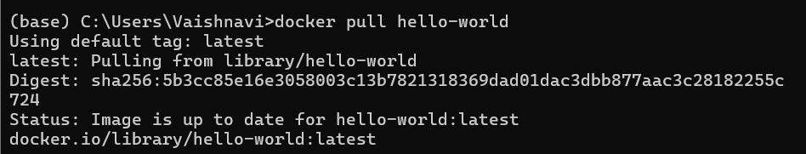

Step 2: Run the hello-world Image – Command : docker run hello-world

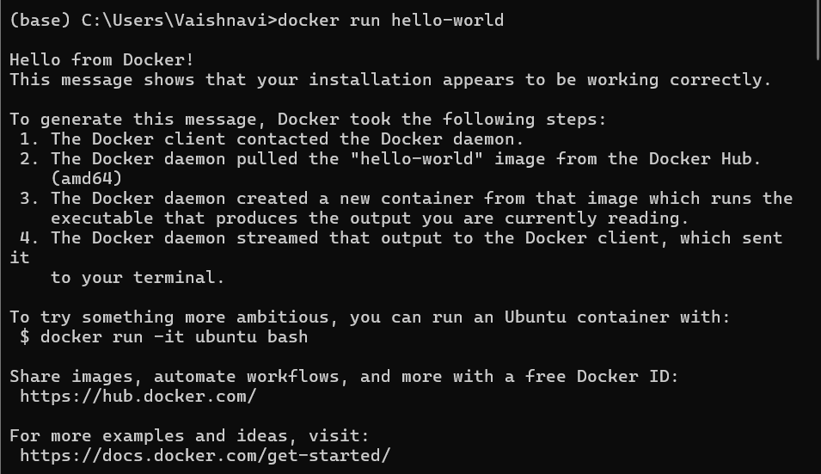

Step 3: View All Containers -- Command : docker ps -a

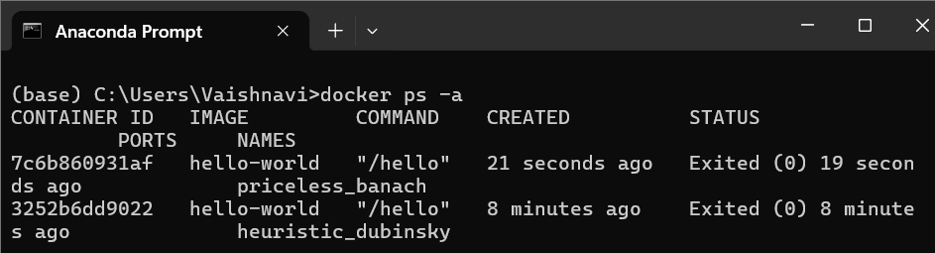

Step 4: Remove the hello-world Container -- Command : docker rm [container-id]



Step 5: Remove the hello-world Image -- Command: docker rmi hello-world

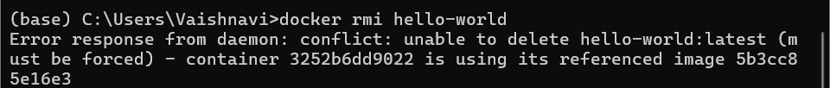

Docker CLI Commands with redis

Step 1: Pull the redis Image -- Command: docker pull redis

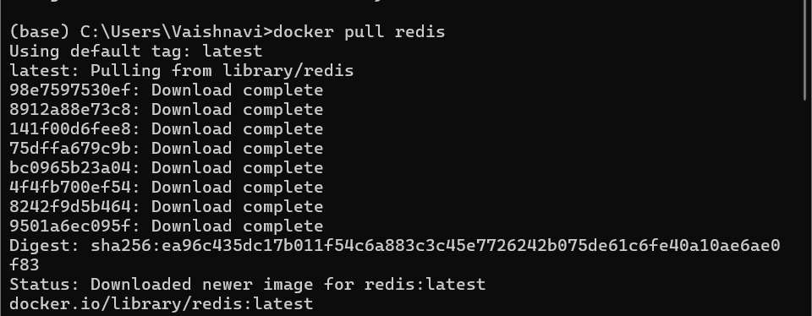

Step 2: Run a Redis Container -- Command: docker run --name my-redis -d redis

Step 3: Check Running Containers -- Command: docker ps

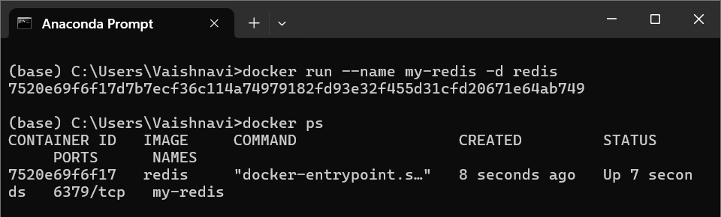

Step 4: Access Redis -- Command: docker exec -it my-redis redis-cli Or winpty docker exec -it myredis redis-cli

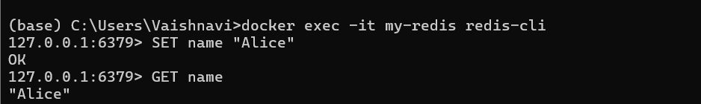

Step 5: Stop the Redis Container -- Command: docker stop my-redis



Step 6: Restart the Redis Container -- Command: docker start my-redis



Step 7: Remove the Redis Container -- Command: docker rm my-redis



Step 8: Remove the Redis Image -- Command: docker rmi redis

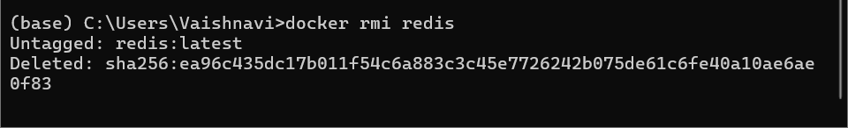

Using a Dockerfile

Step 1: Set Up Your Folder

Create a folder like C:\DockerProjects\Redis.

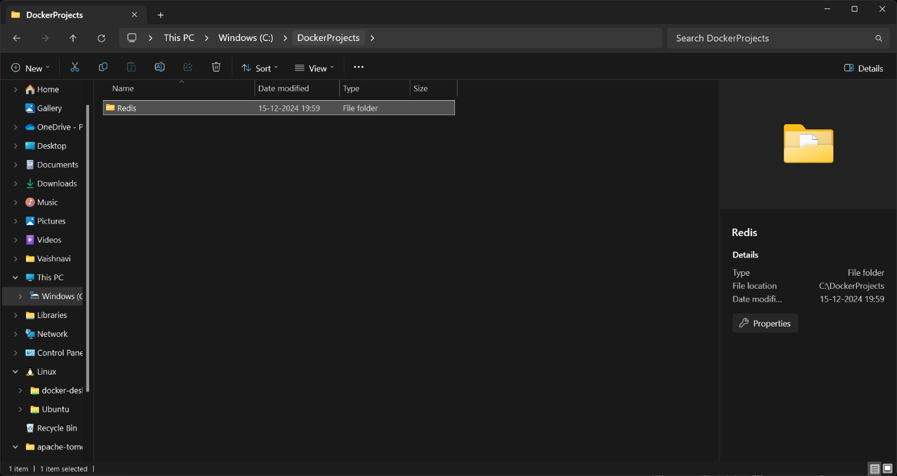

Step 2: Write the Dockerfile

1. Inside the folder, create a file named Dockerfile (no extension).

2. Add the following content:

FROM redis:latest

CMD ["redis-server"]

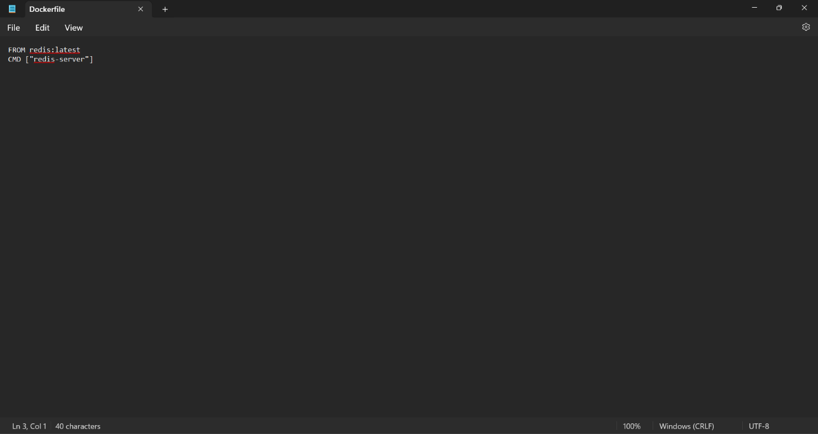

Open powershell as administrator

Open the file location

Docker build

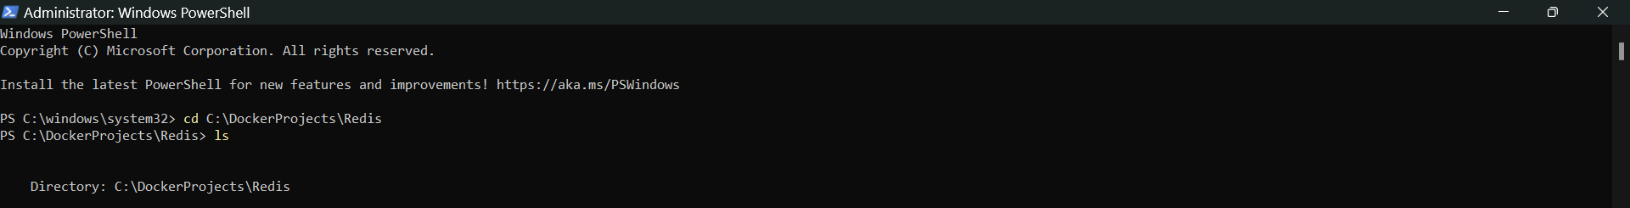

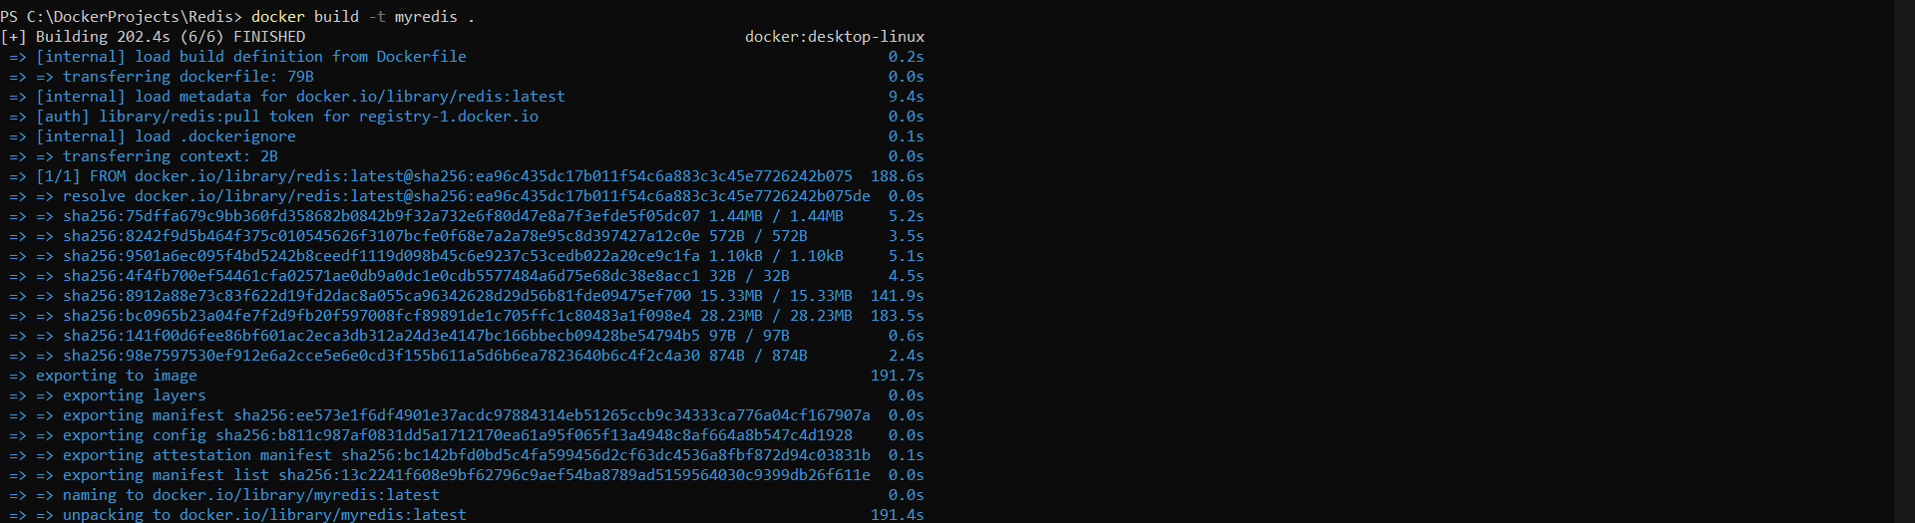

Docker images

Docker run

Docker ps

Docker stop

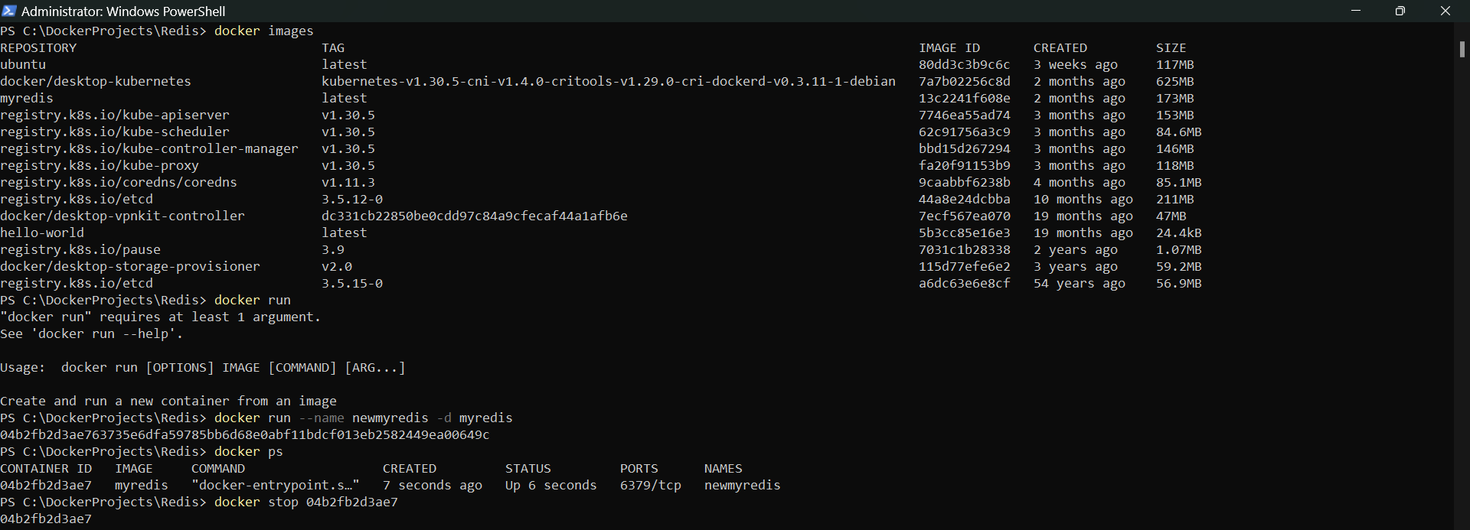

Docker commit

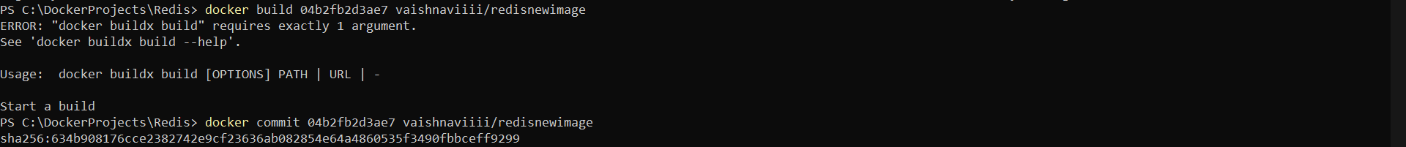

Docker images

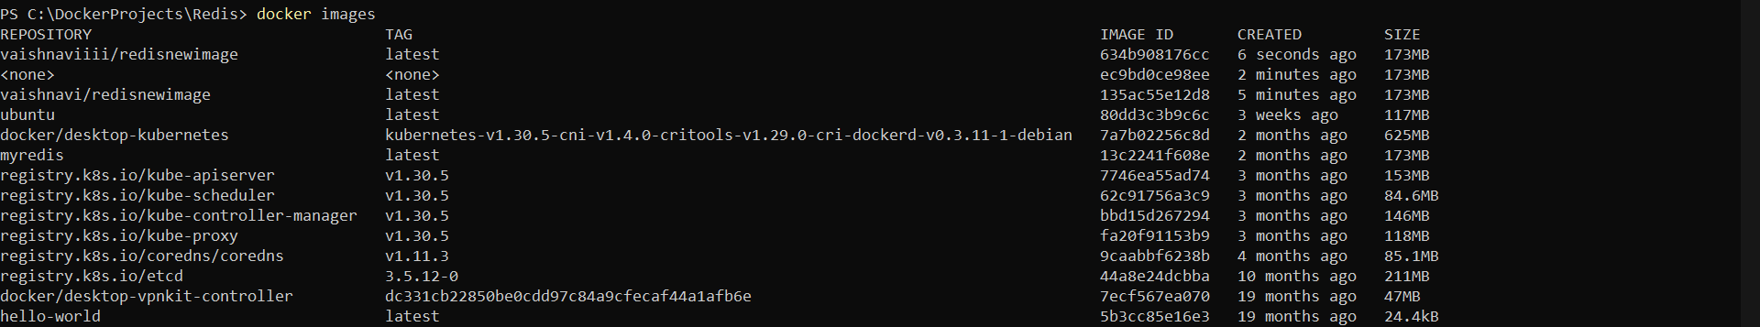

Docker login

Docker push

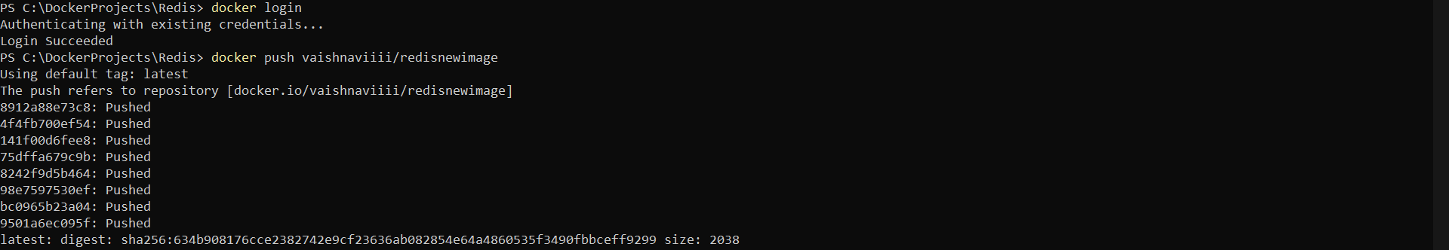

Docker desktop local images

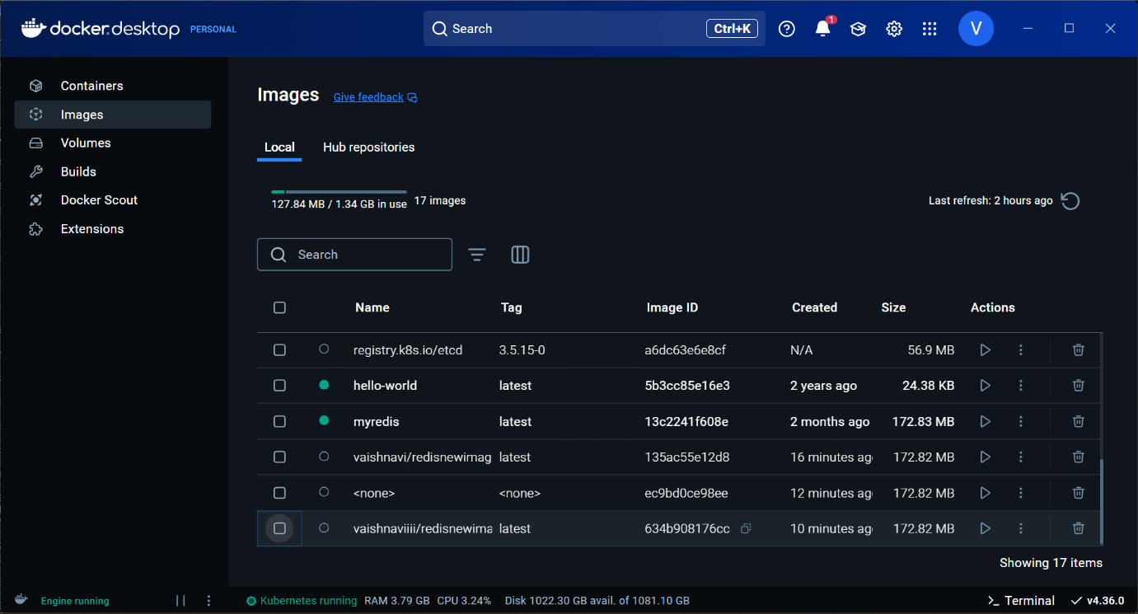

Docker image in docker hub repository

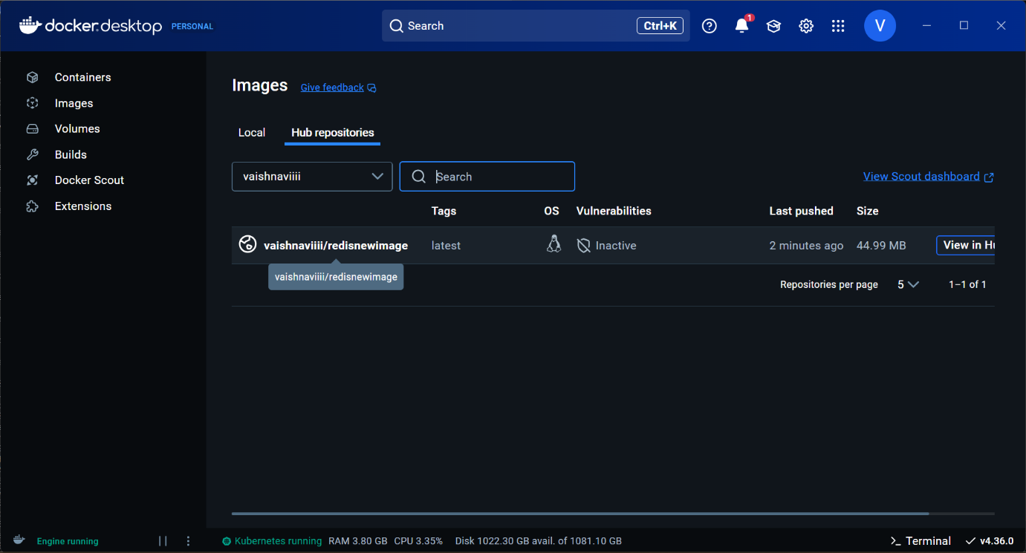

Docker remove container and image

Pull the image to docker

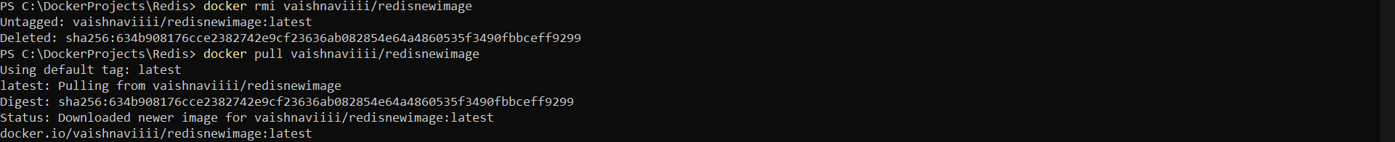

Docker run and exec

Docker logout



C. MODIFYAND PUSH DOCKER IMAGE

D. CREATE AND PUSH DOCKER FILE IMAGE

Docker pull ubuntu

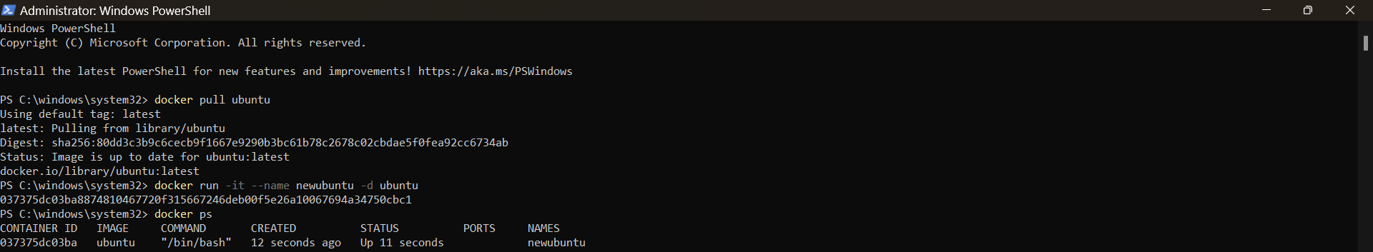

Docker exec

Checking if git is installed

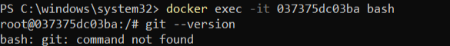

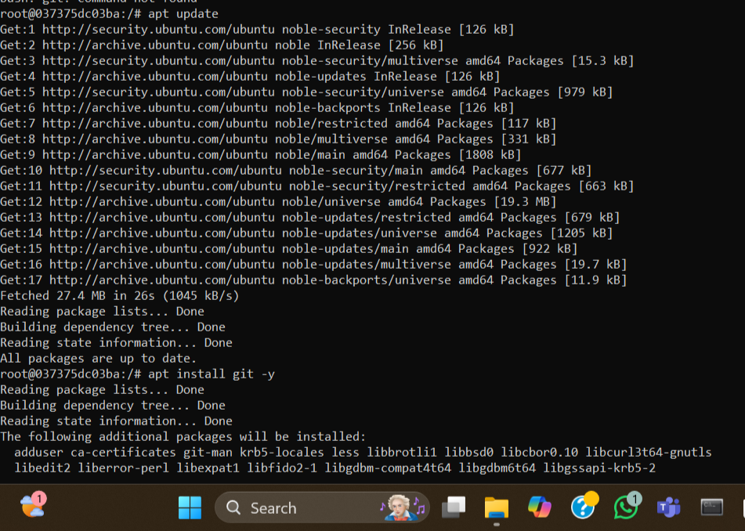

Installing git

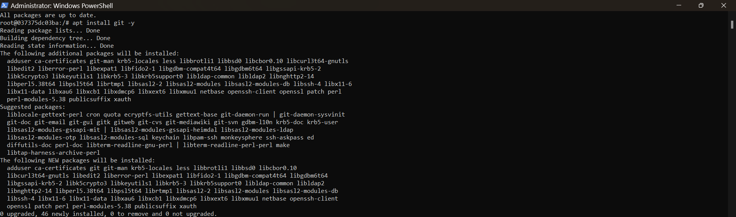

Checking git version after installation

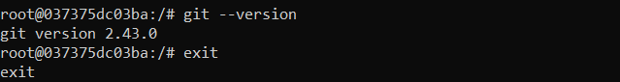

Docker stop

Committing the changes made

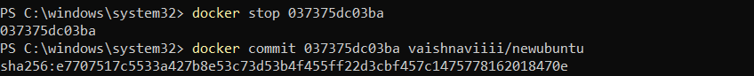

Checking Docker desktop to see if the changes are reflected

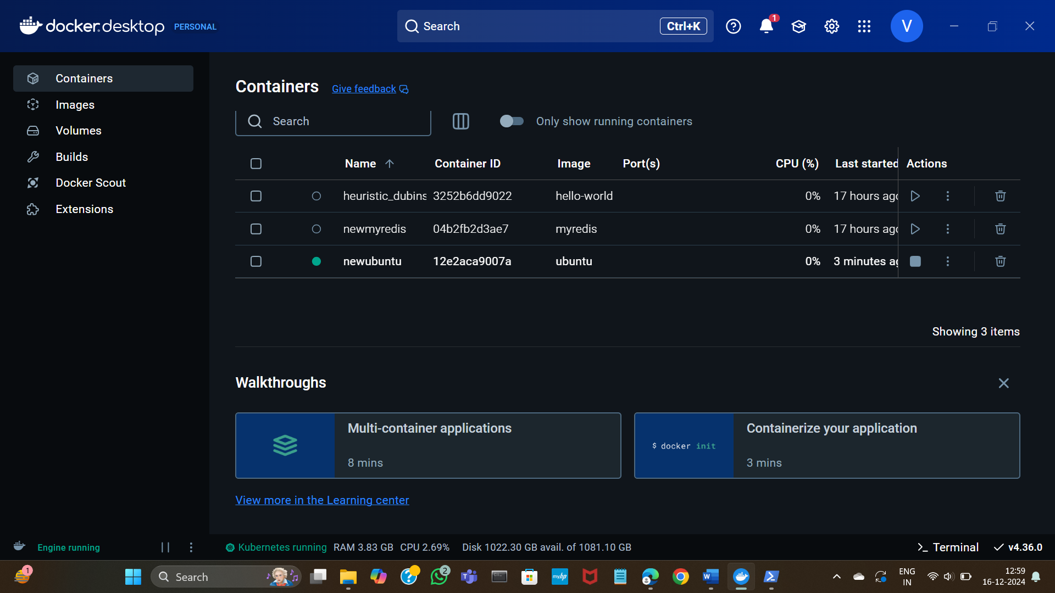

Docker login

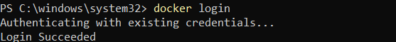

Docker push

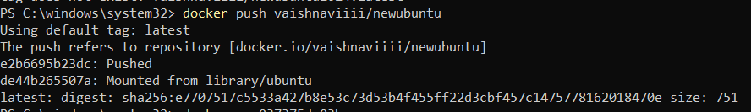

Checking docker hub to see if the changes are reflected

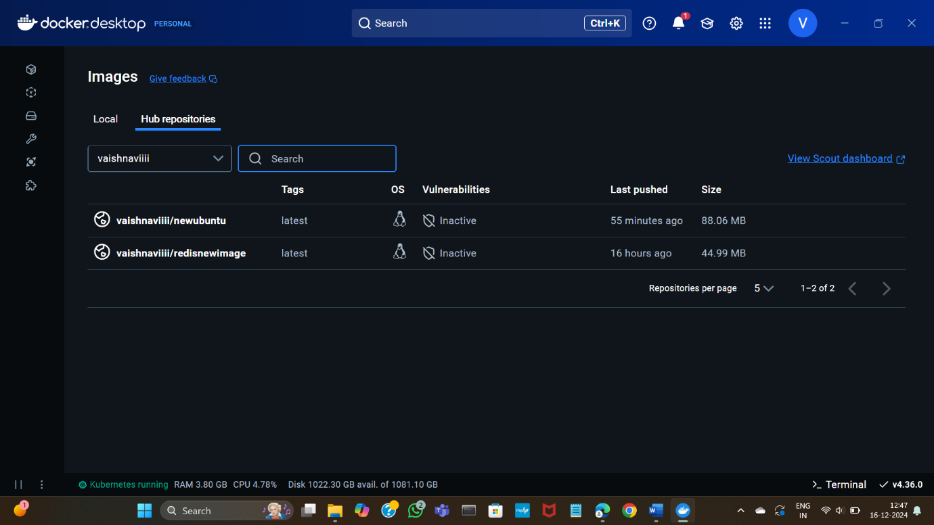

Docker rm

Docker rmi

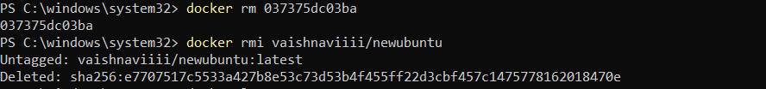

Logging out

Docker pull

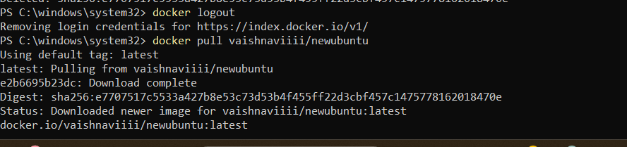

Checking Docker desktop

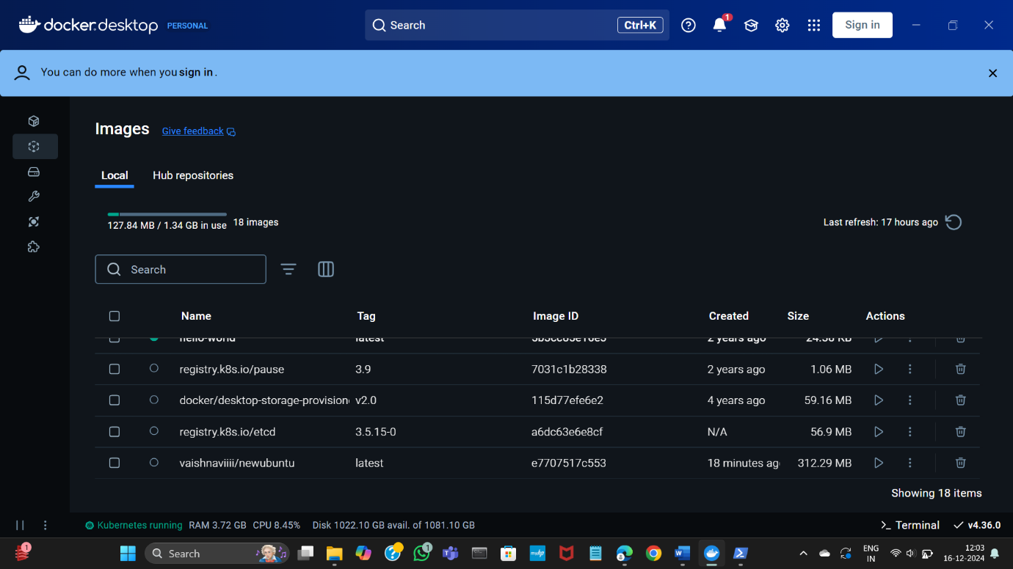

Docker run

Checking git version

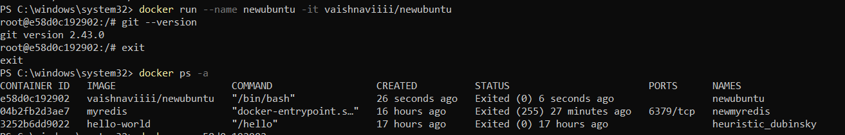

Docker rm

Docker rmi

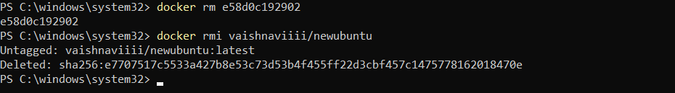

E. RUNNING MULTIPLE CONTAINERS USING DOCKER COMPOSE

Docker Compose

Create a compose folder

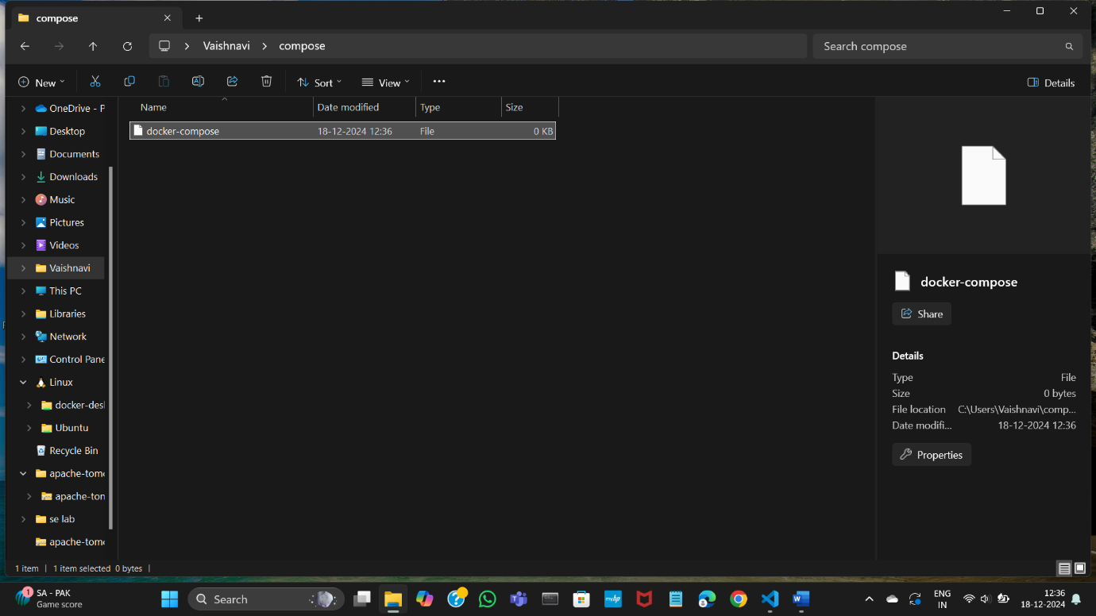

Docker compose yaml file

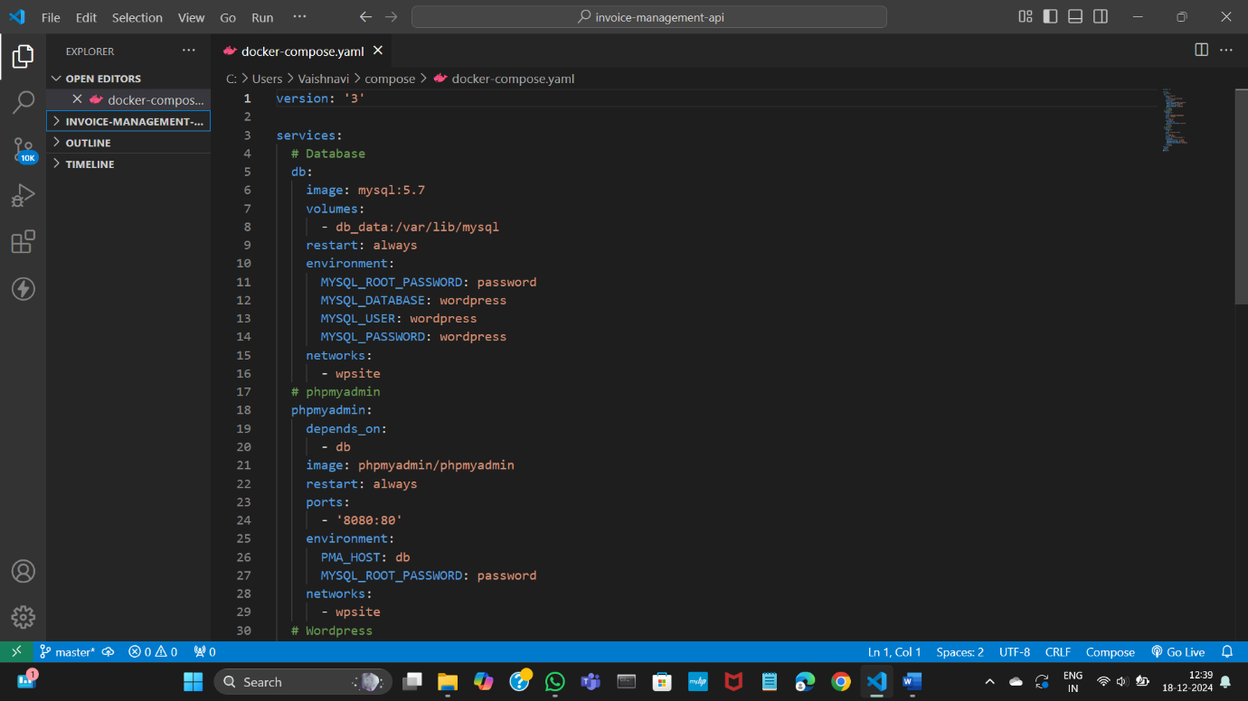

Docker-compose up -d

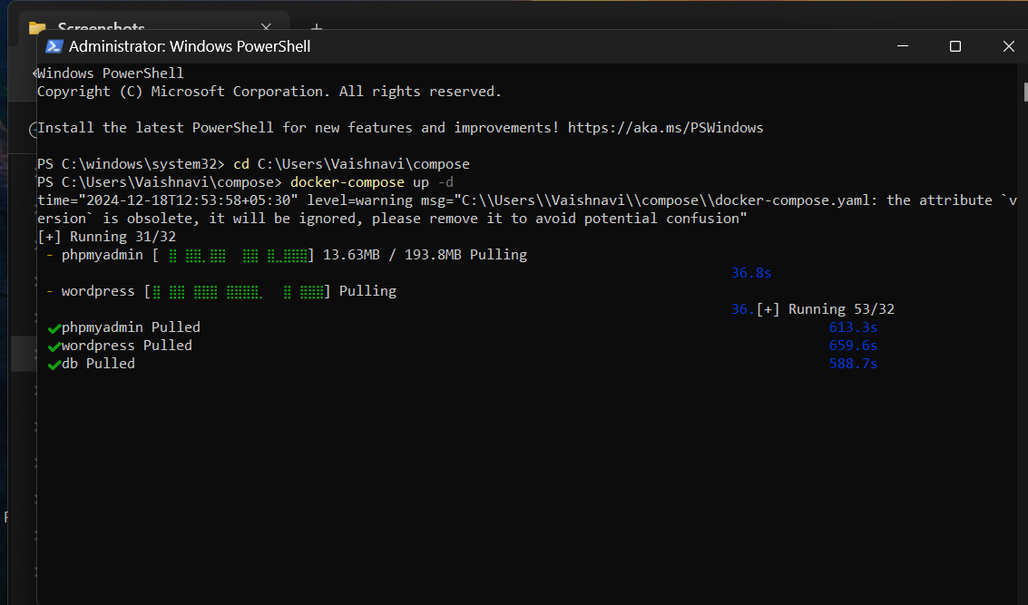

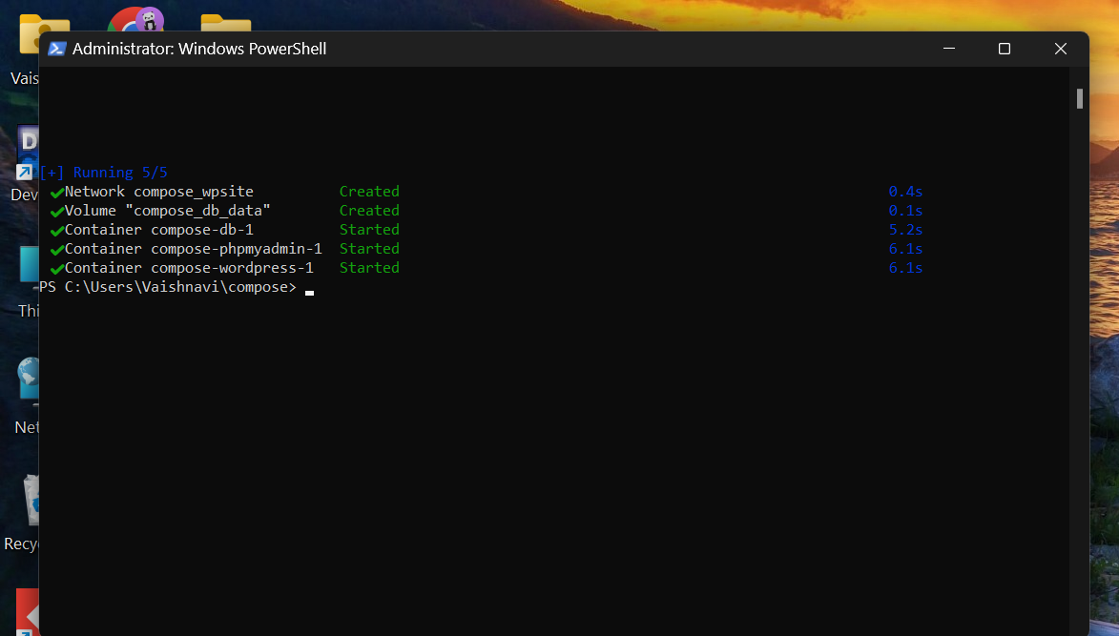

Local host 8000

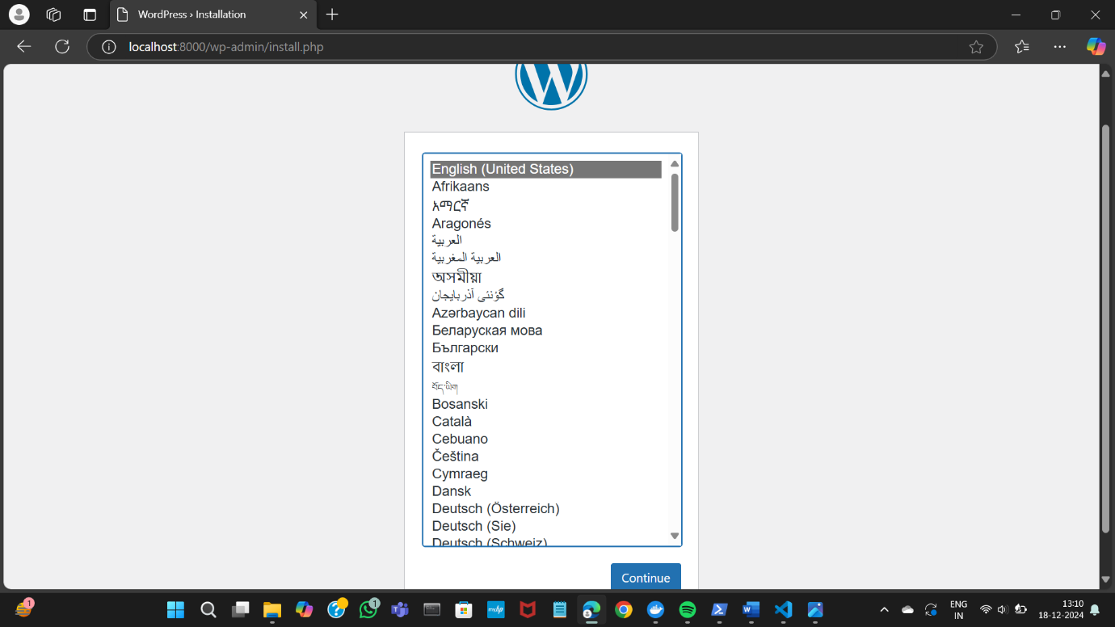

Create word press account

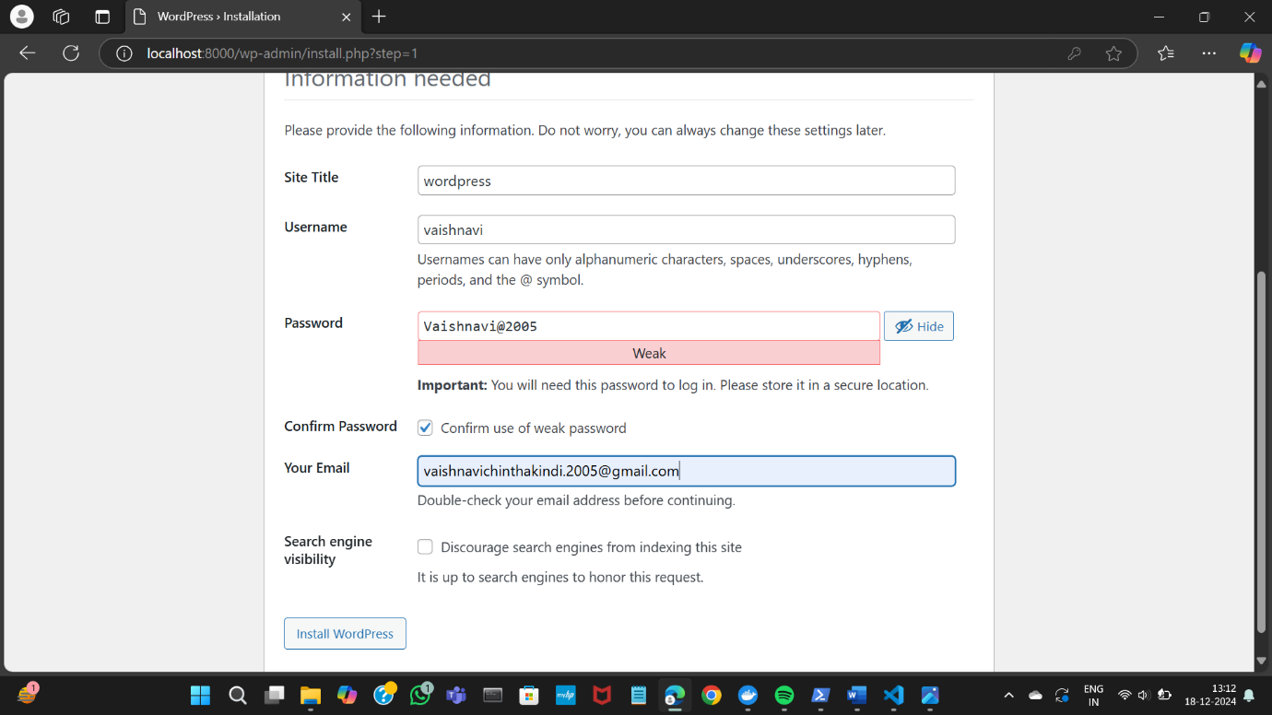

Log into word press

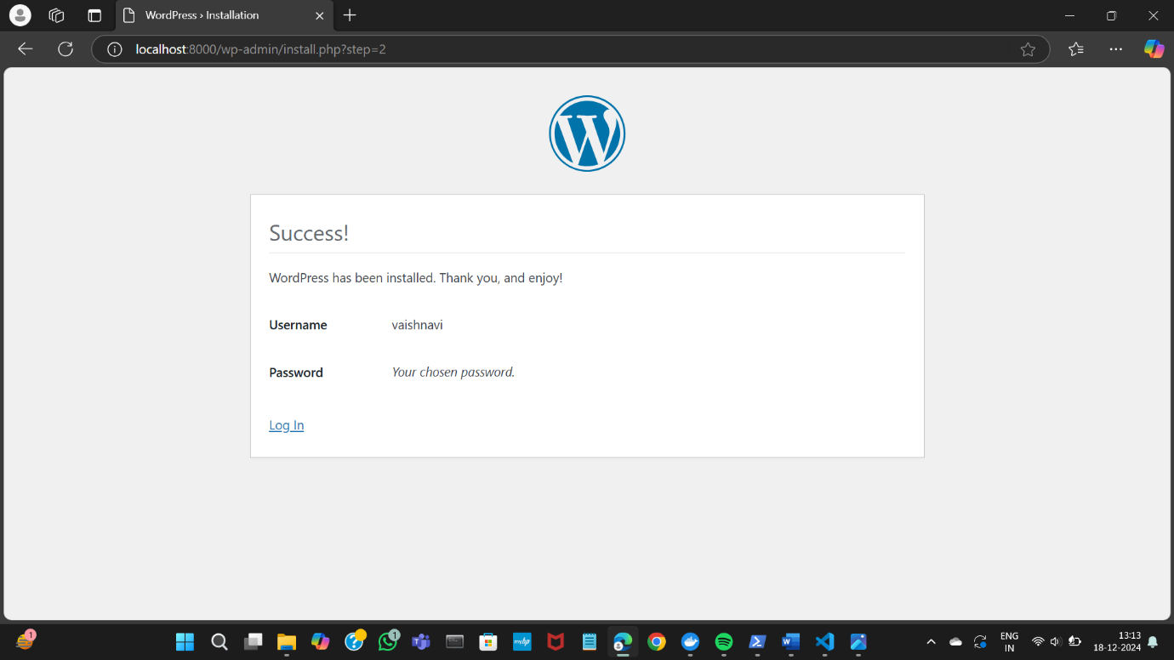

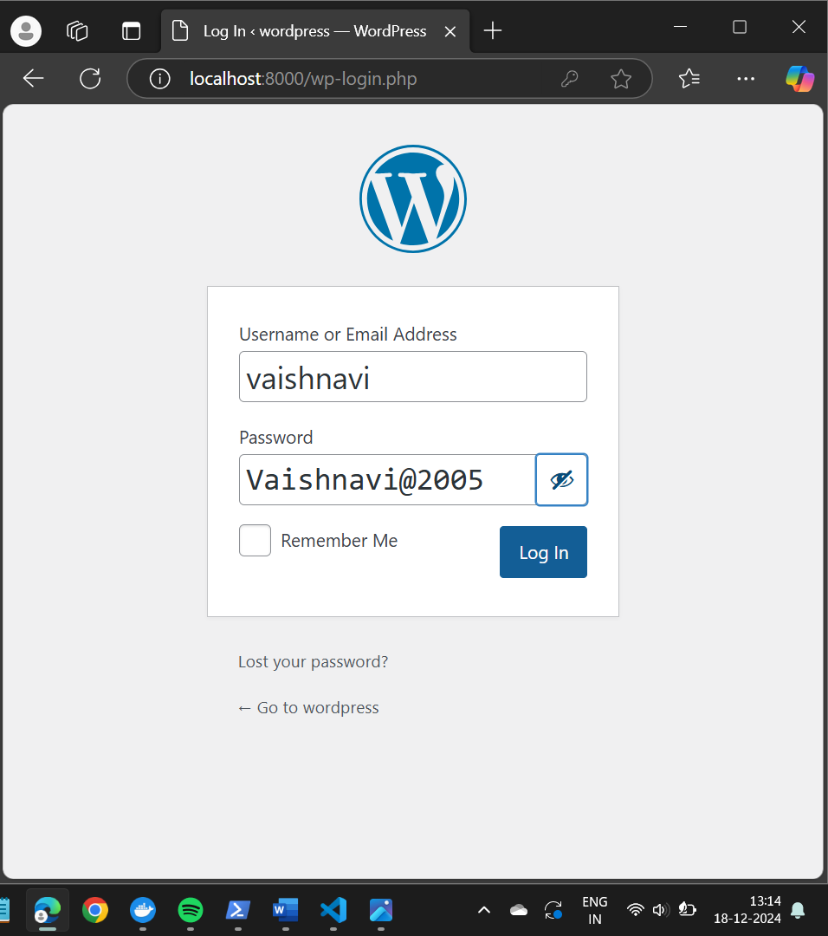

Word press dashboard

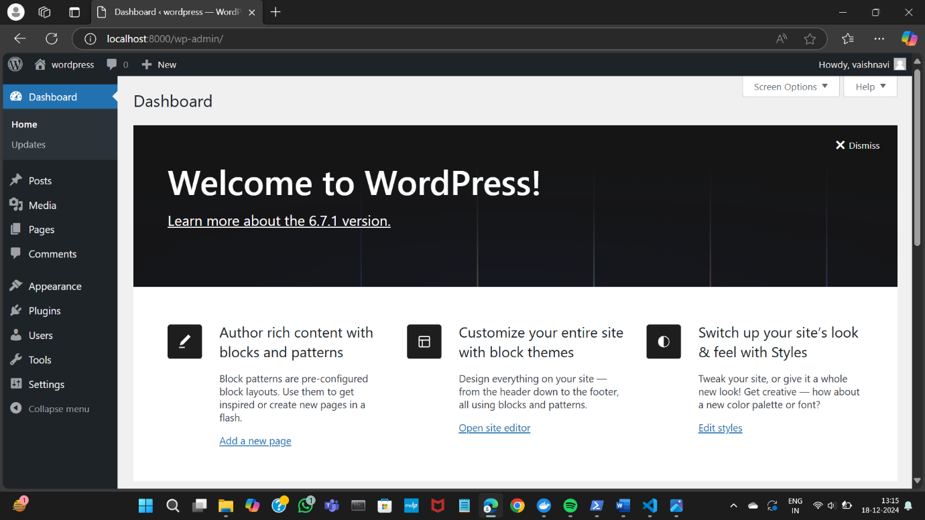

Docker-compose stop

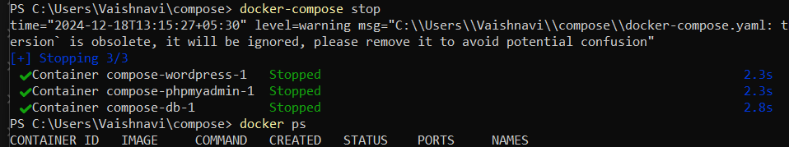

localhost:8000

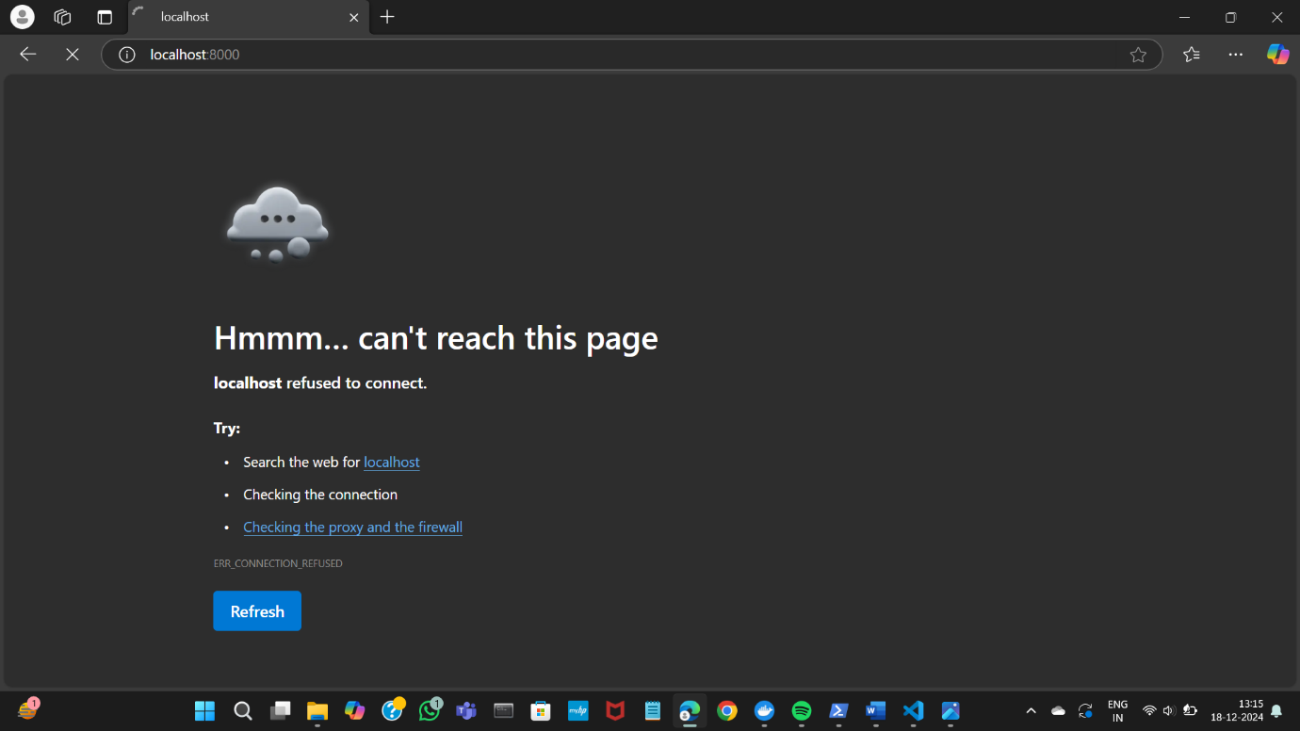

Docker-compose start

Docker-compose down

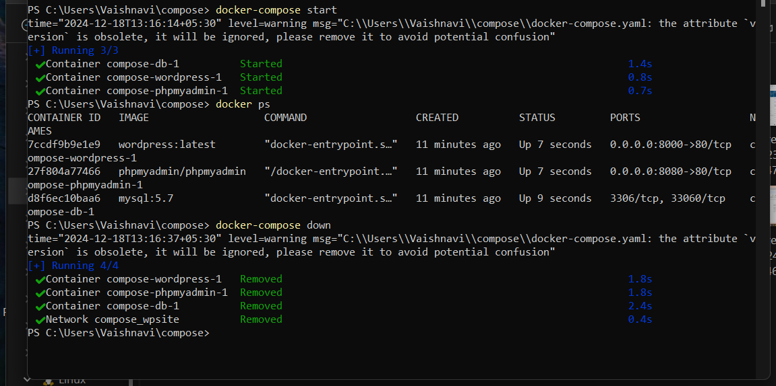

B) DEPLOYING AND SCALING APPLICATIONS USING MINIKUBE

1.Setting up minikube and Kubernetes

Minikube start

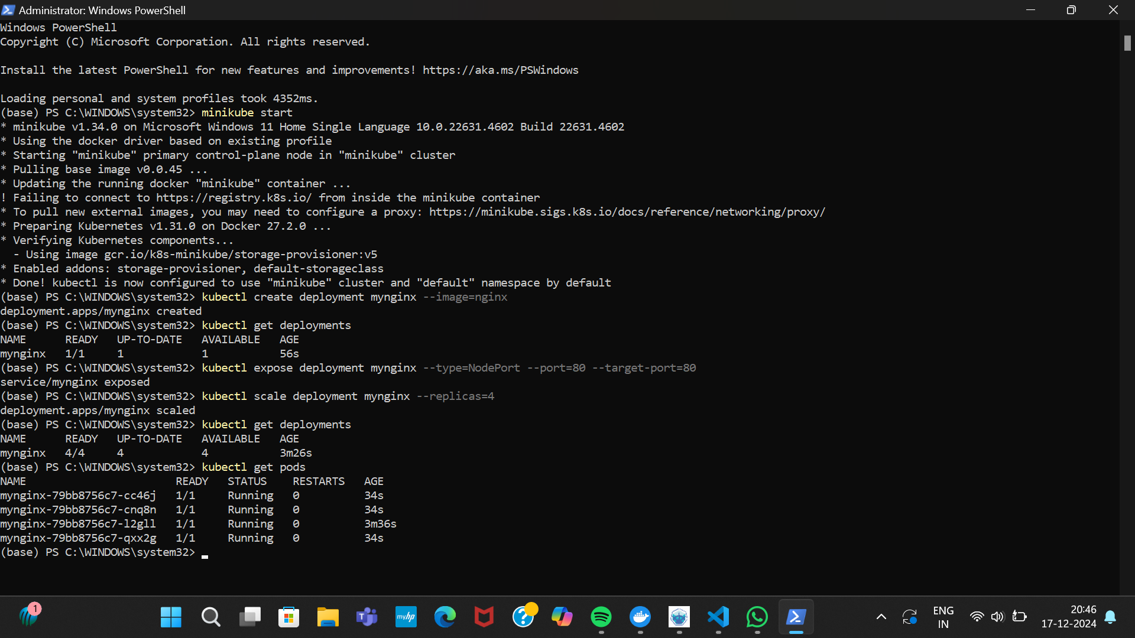

2.create and management deployment

Kubectl create deployment mynginx –image=nginx



Kubectl get deployments



Expose the niginx deployment to outside world

Kubectl expose deployment mynginx –type=NodePort –port=80 –target -port =80



Kubectl scale deployment mynginx –replicas=4



3. accessing nginx app

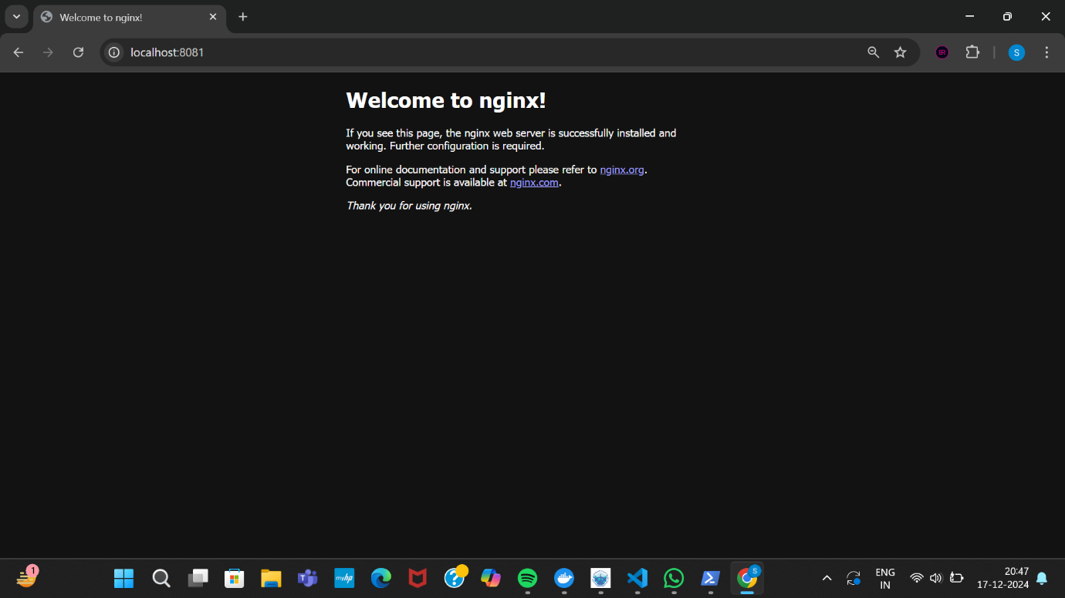

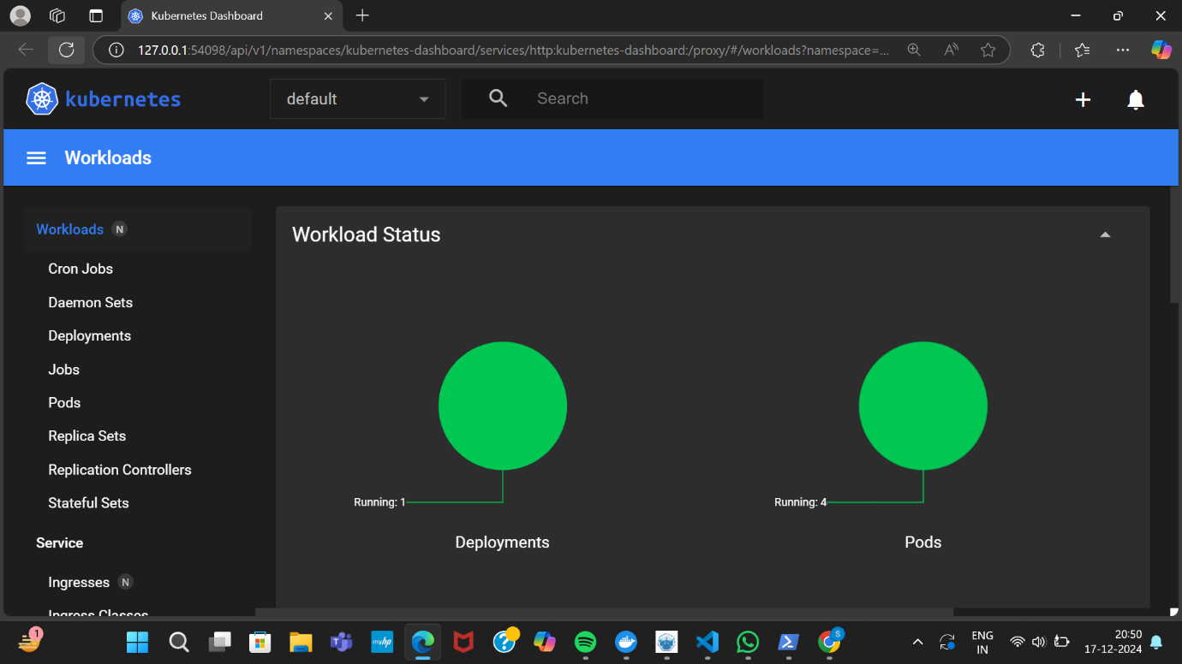

4. stopping and cleaning up everything

Kubectl delete deployment mynginx

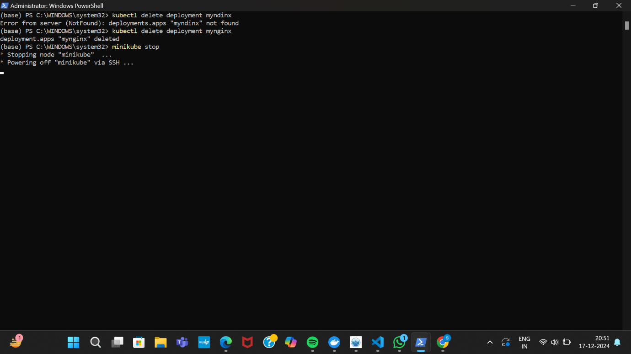

Minikube stop



G. DEPLOYING AND MANAGING MONITORING SYSTEMS USING NAGIOS IN DOCKER

Docker pull jasonrivers/nagios:latest

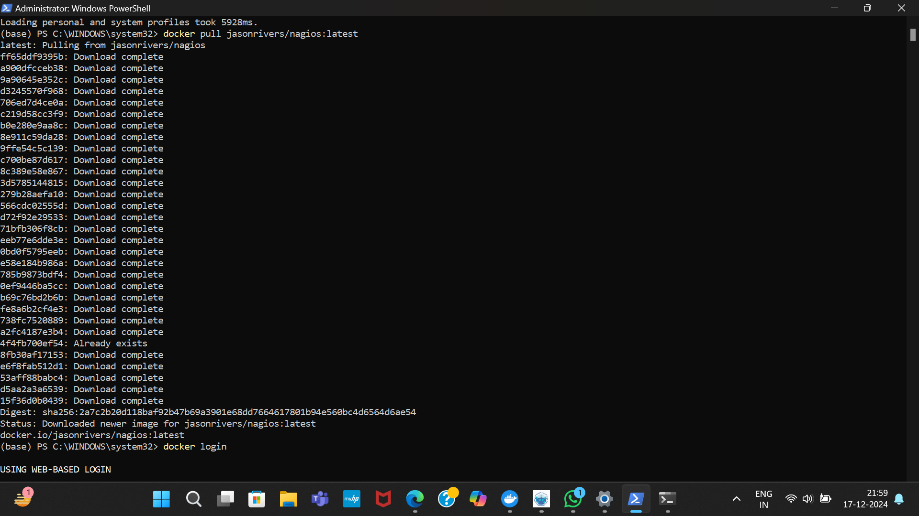

Running nagios

docker run –name nagiosdemo -p 8888:80 jasonrivers/nagios:latest

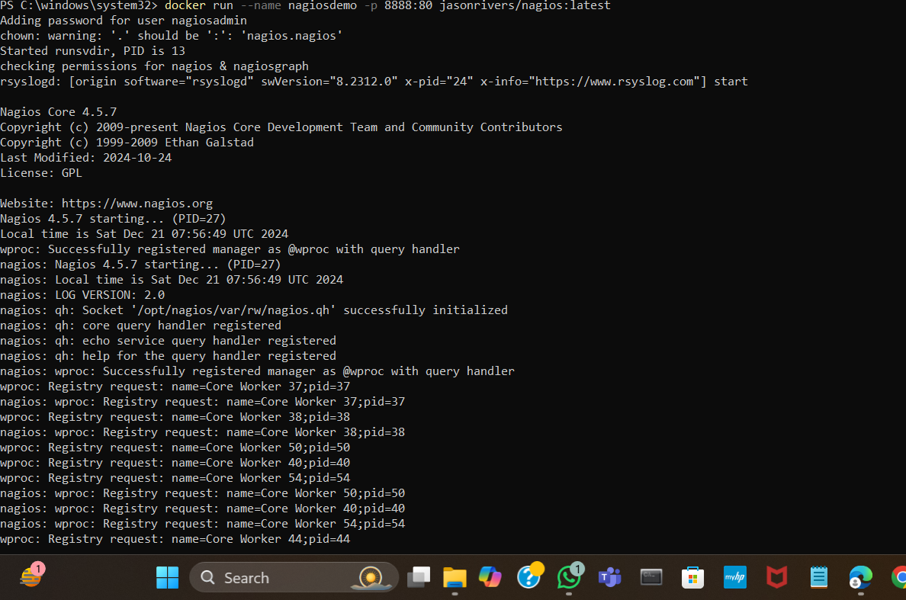

3. Accessing nagios

Fill the credentials

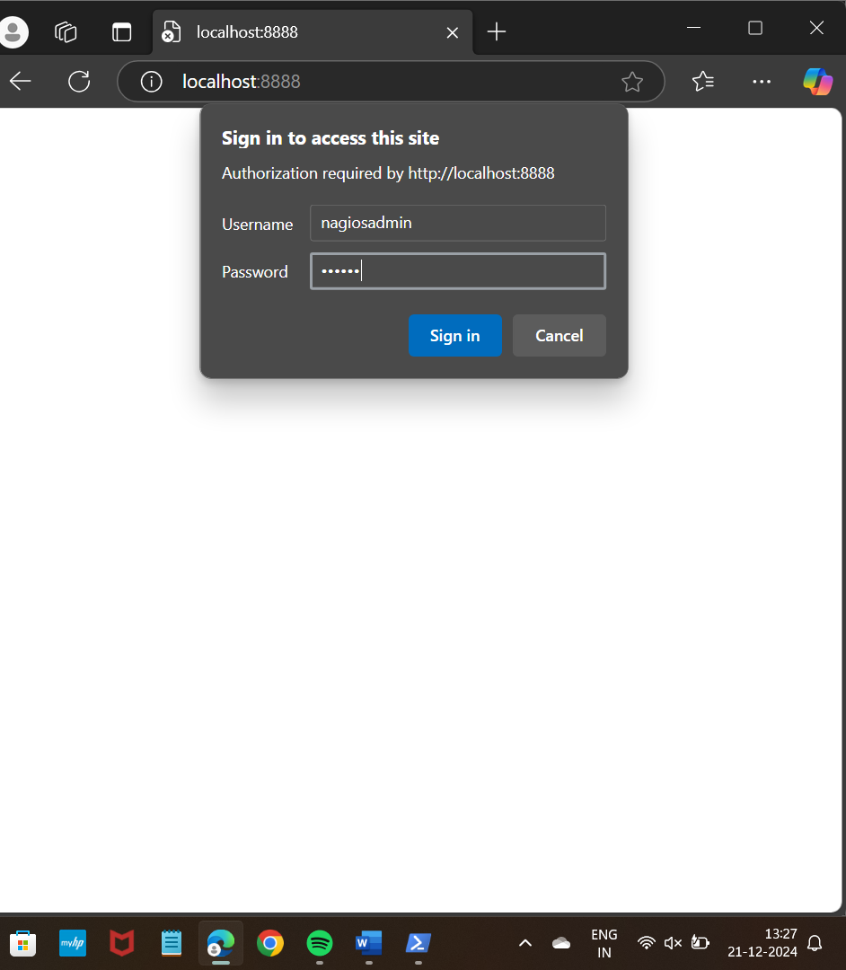

The nagios dashboard

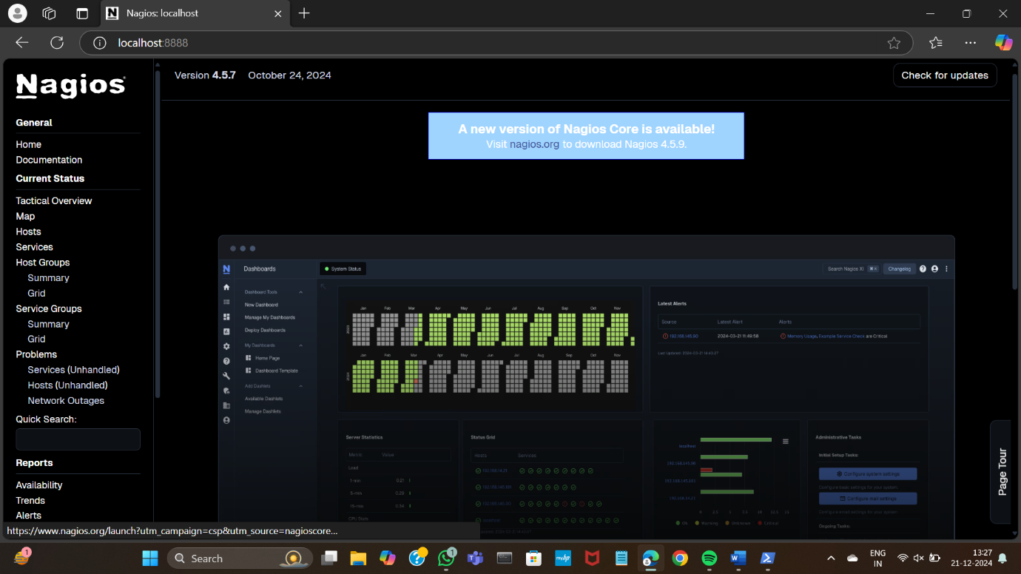

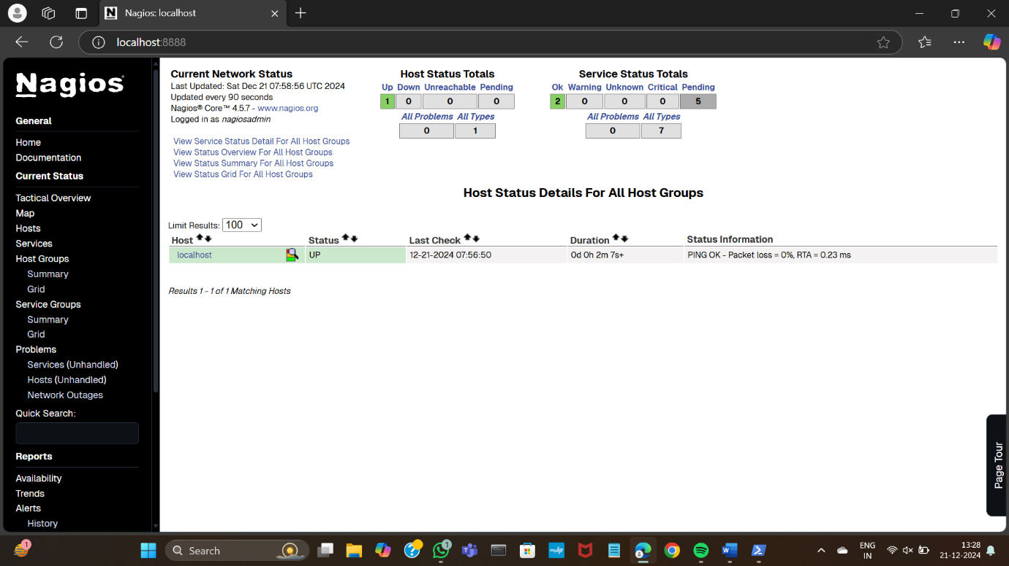

Stopping nagios

docker ps

docker ps-a

Docker stop nagiosdemo

Docker images

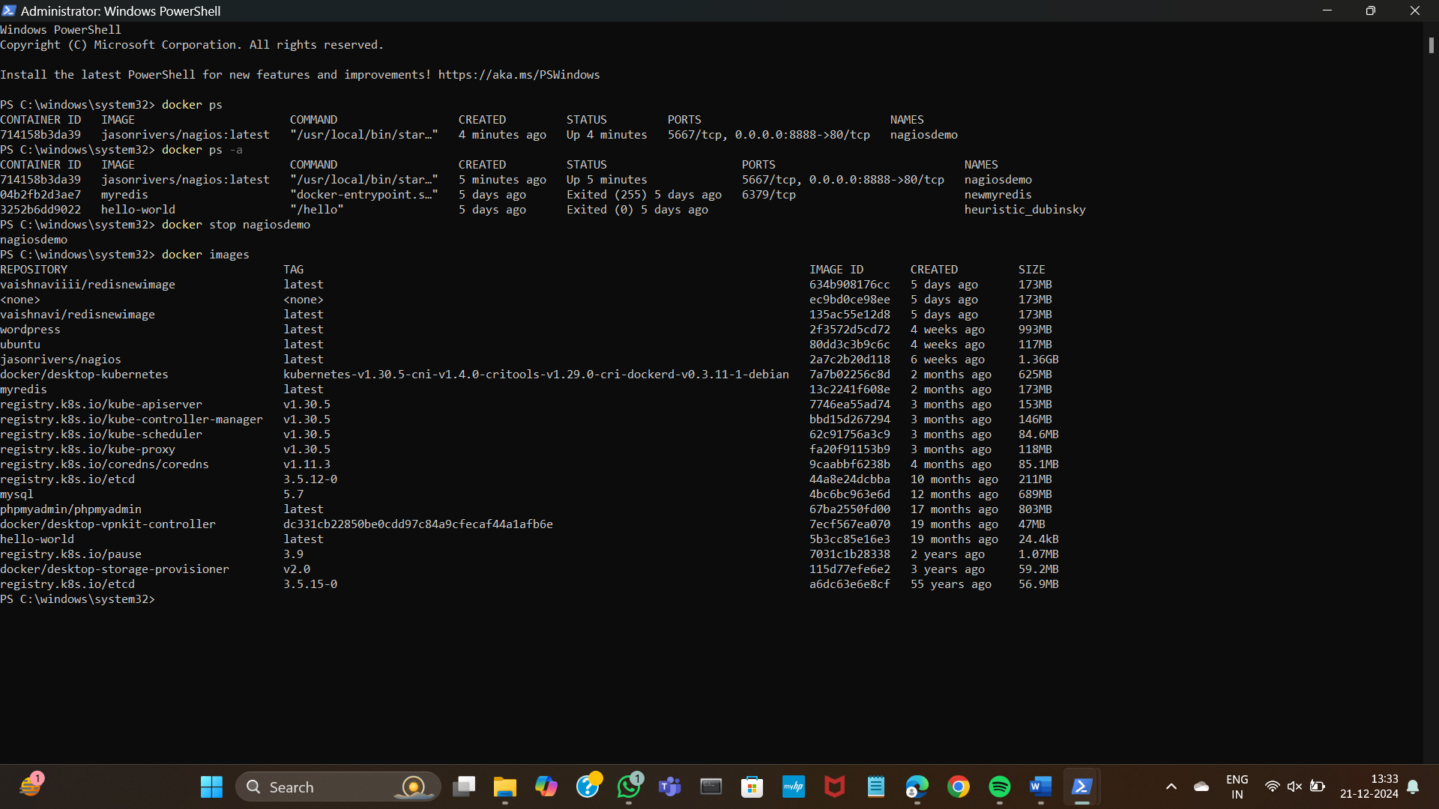

The image will get deleted

EXPERIMENT:8

A) AWS ACADEMY LEARNING ACCOUNT CREATION

Click on Get Started from the invitation

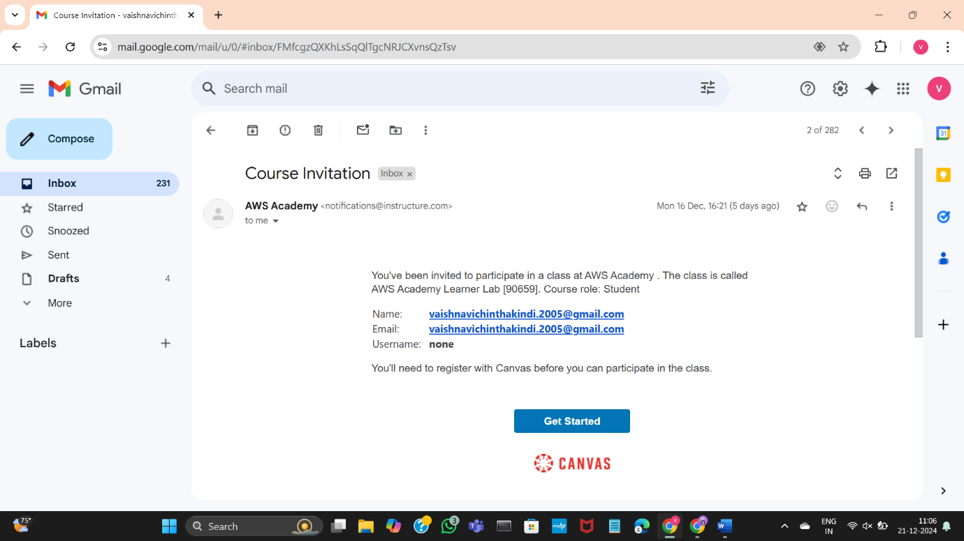

Click on Create My account

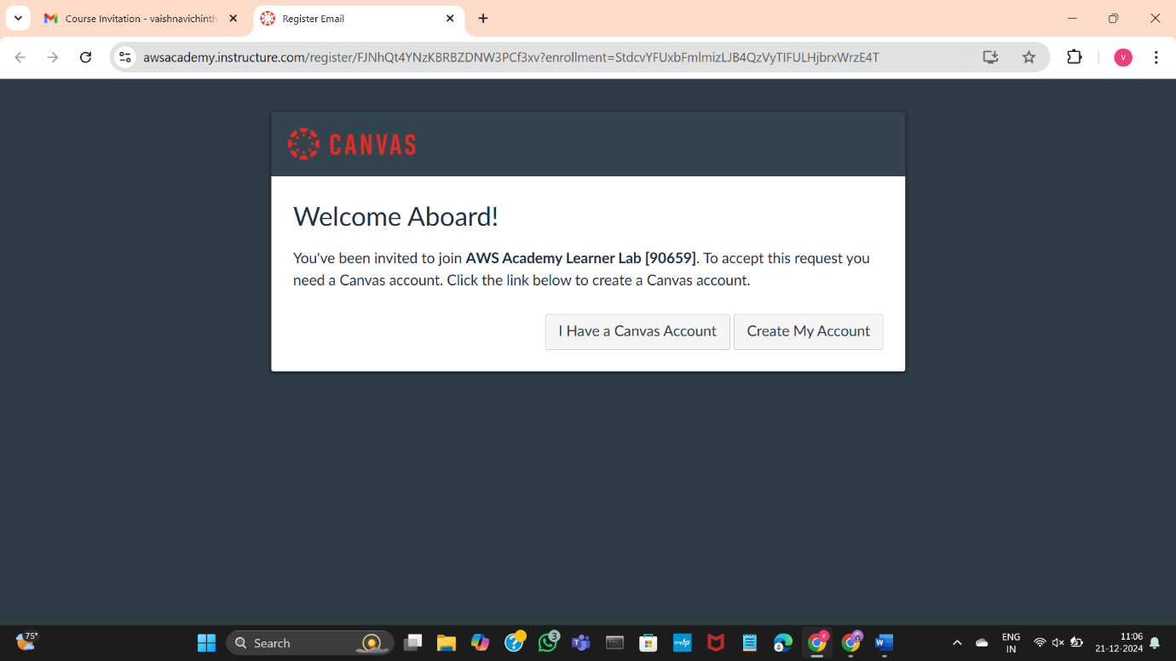

Provide a password for the AWS account

Click on the terms and conditions

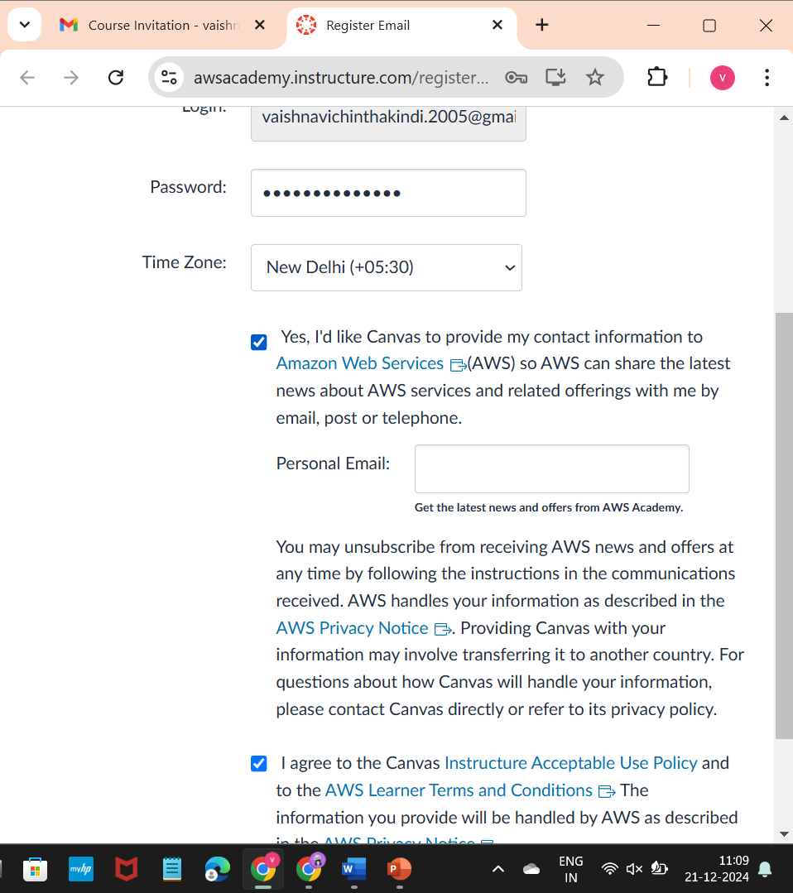

Scroll down and click on Register

You will direct the following page

Click on Account

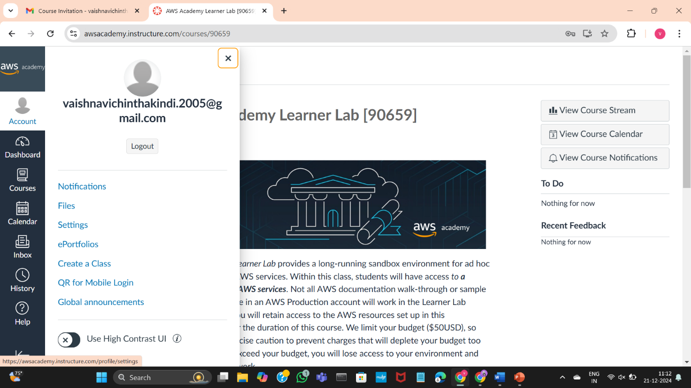

Let's see how to logout and login again 🡪CLICK on logout



Click on student login

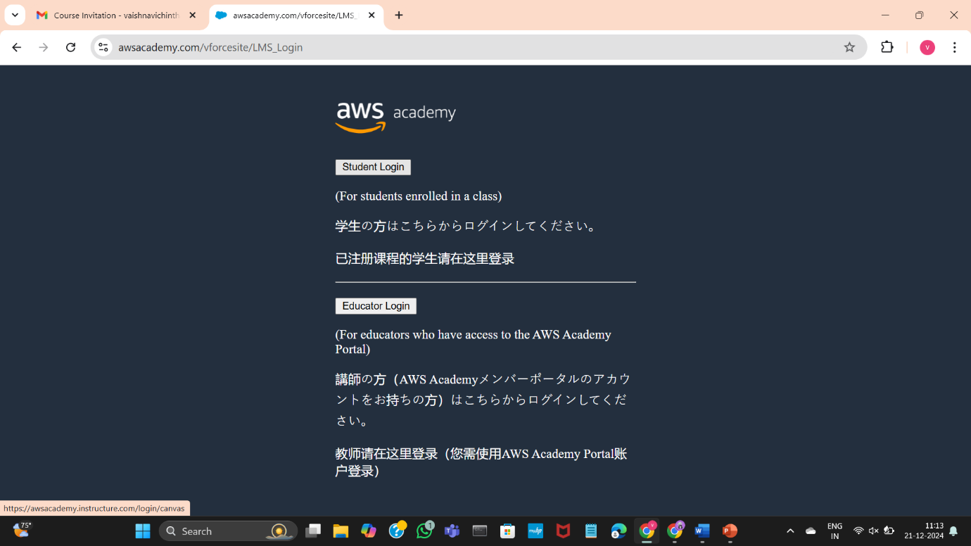

Fill the Username and password

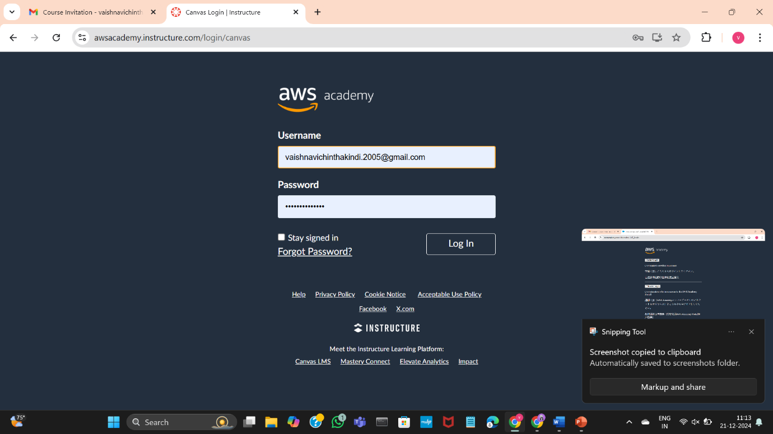

After login,you will direct to dashboard

Click on the AWS academy learner lab

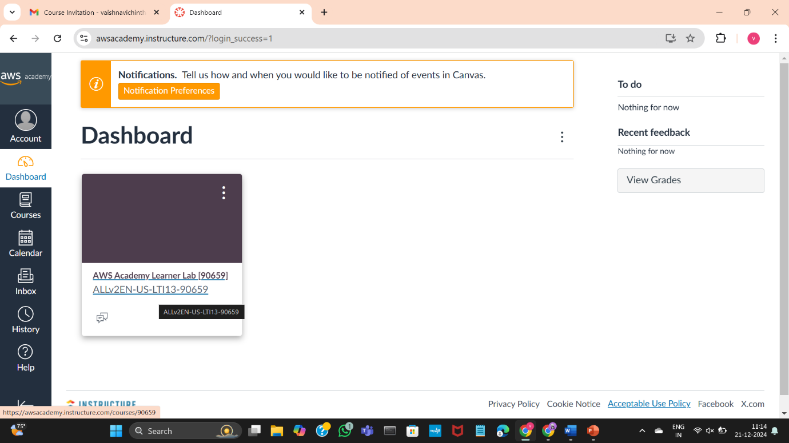

Click on Modules

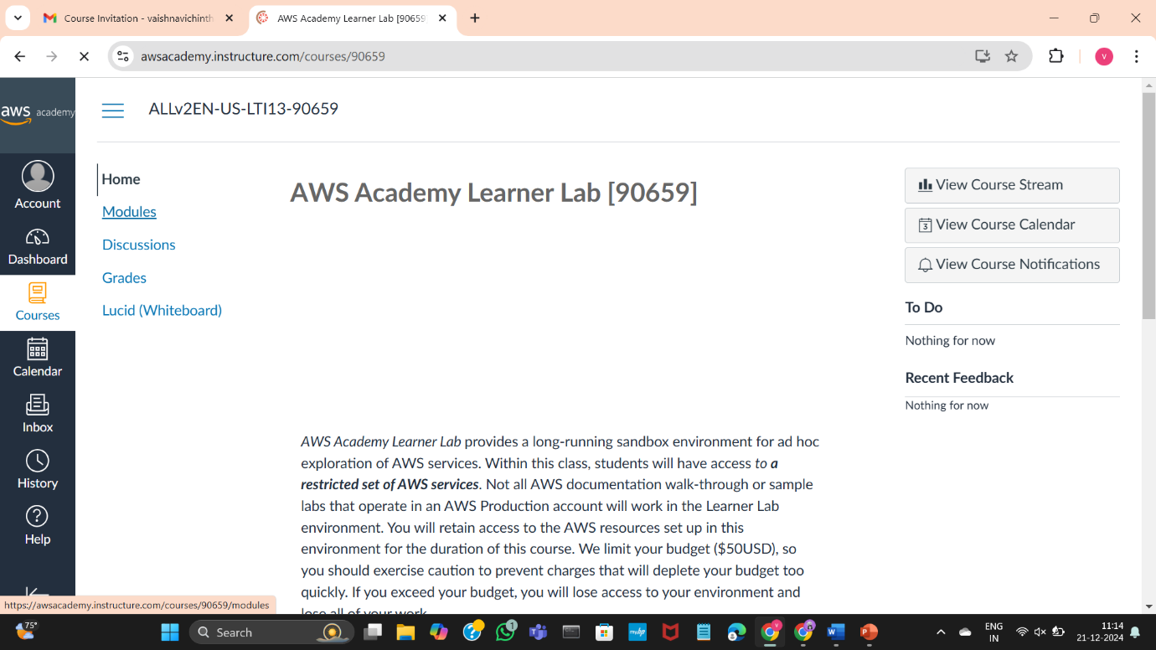

Scroll down and click on AWS Academ Learner lab

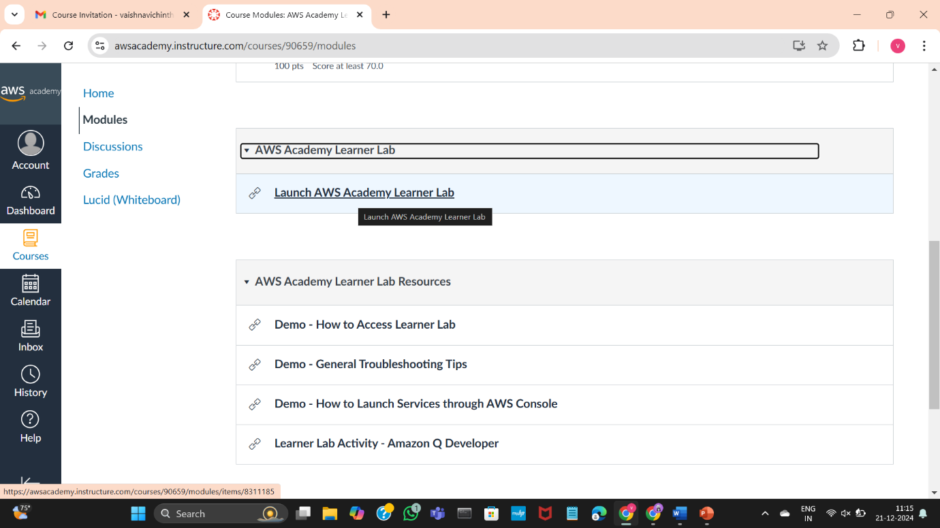

Accept all the terms and conditions

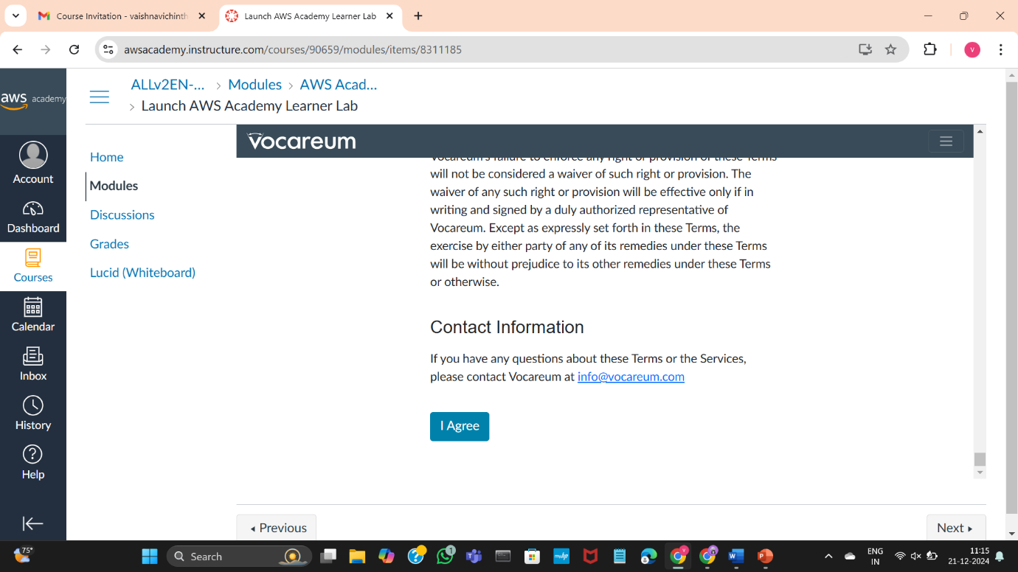

If there is red dot beside AWS it means the sandbox (AWS Learning Environment) is in stop state, click on Start Lab

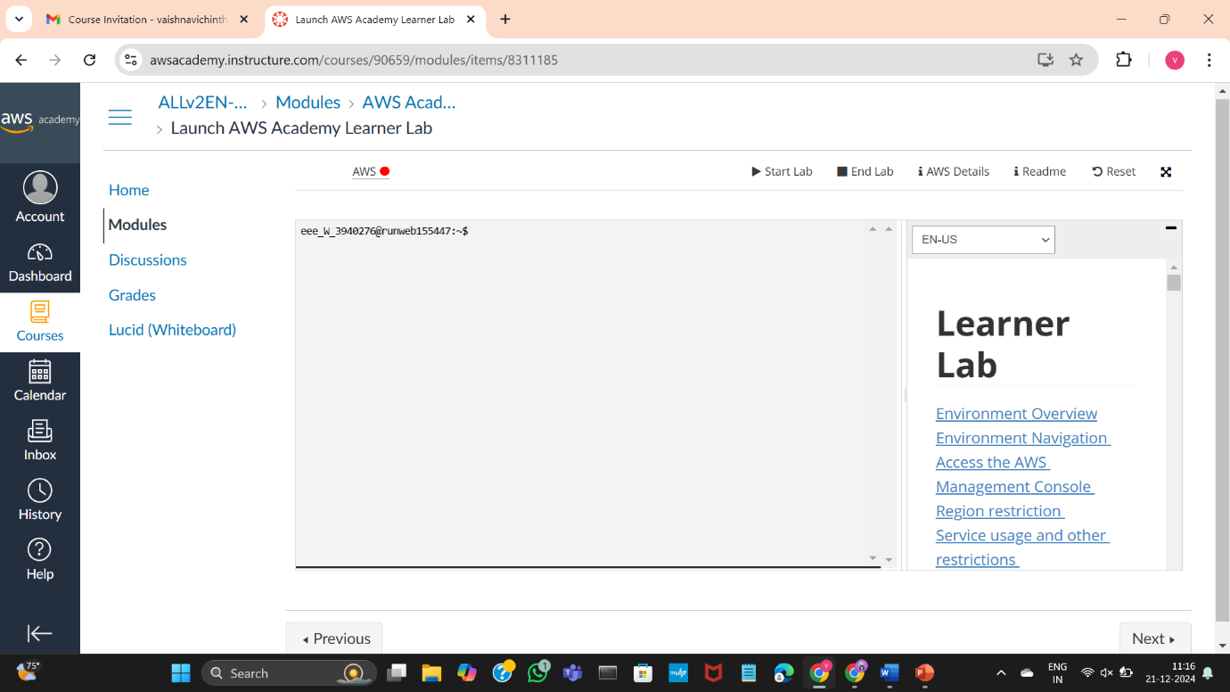

Once the AWS turns green, click on it

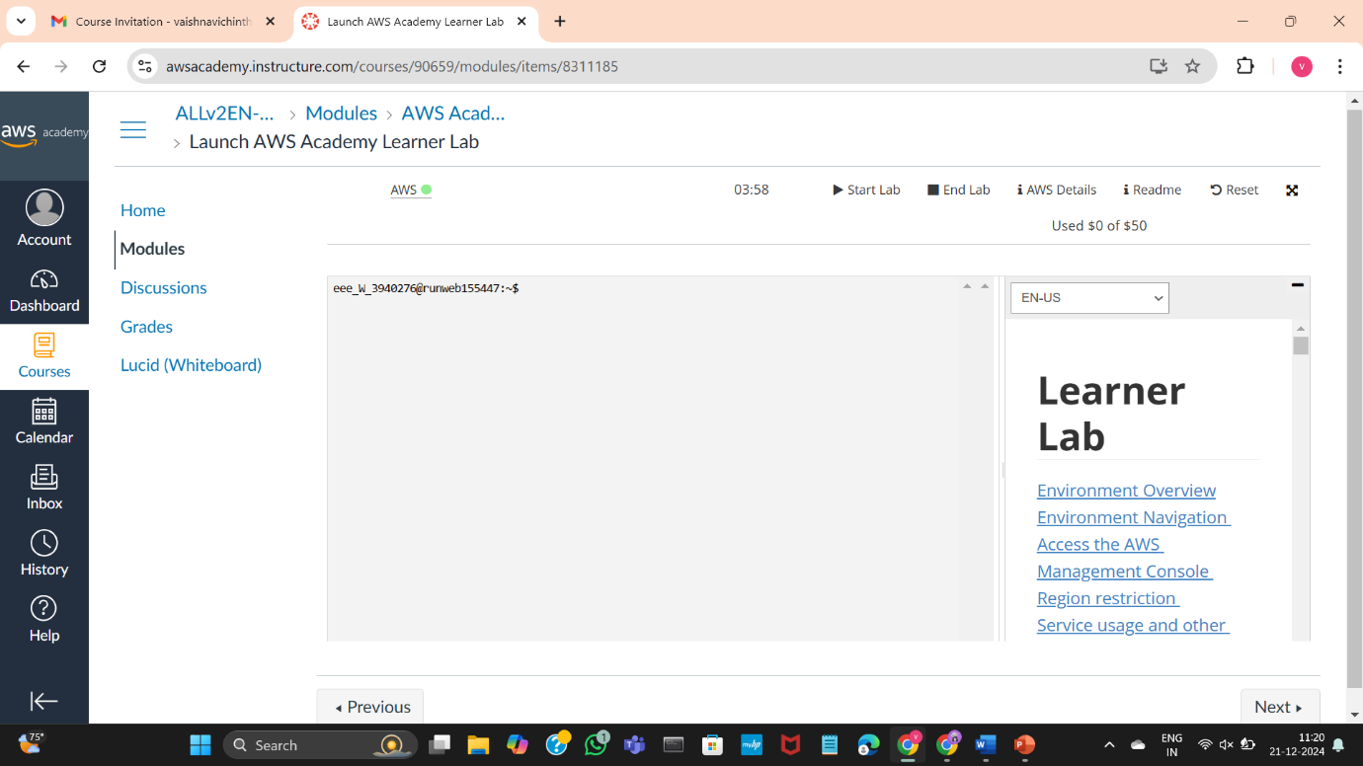

You will land to the AWS Dashboard

Click in EC2 in the recent visited box

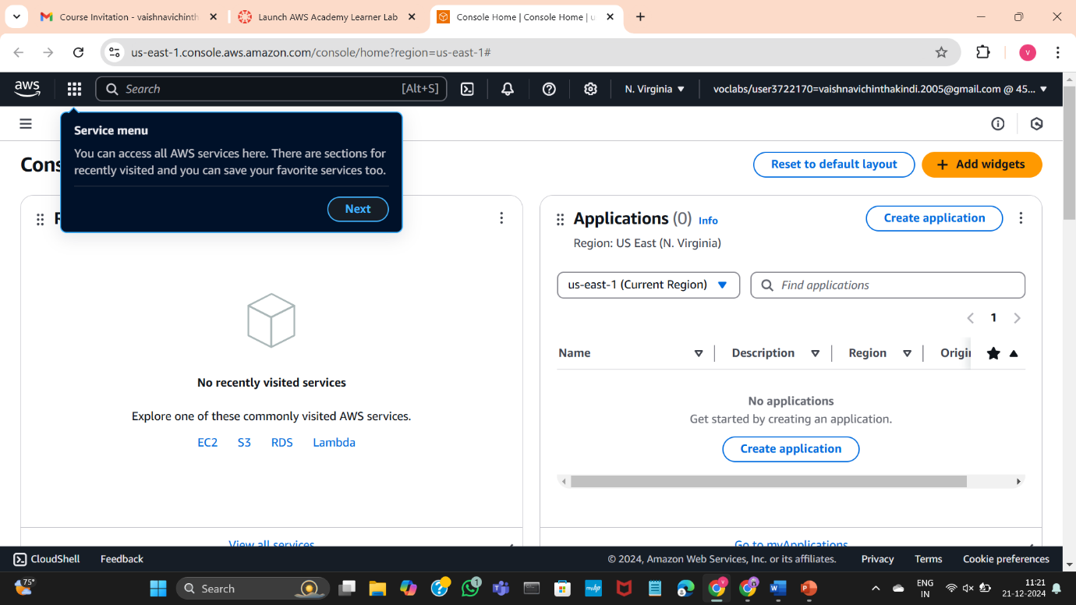

We can start exercises from here

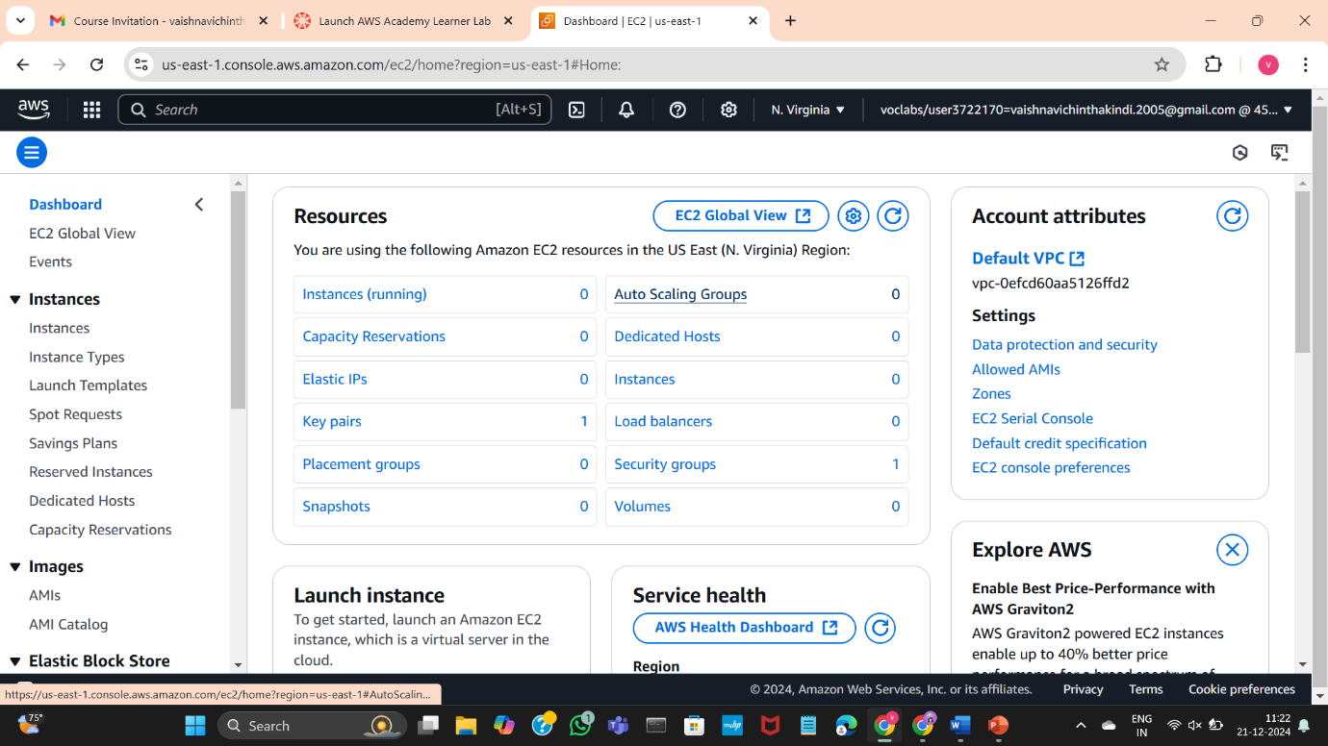

Once your lab work is done, click on end lab

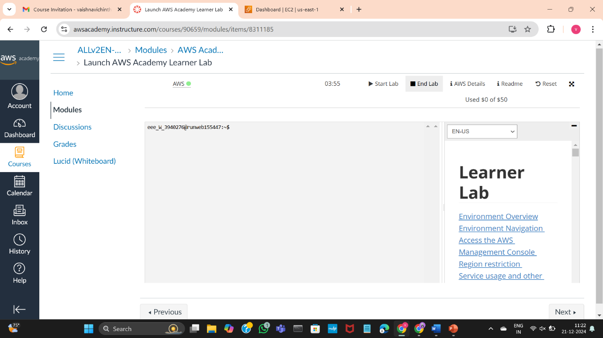

Click on yes to end the lab

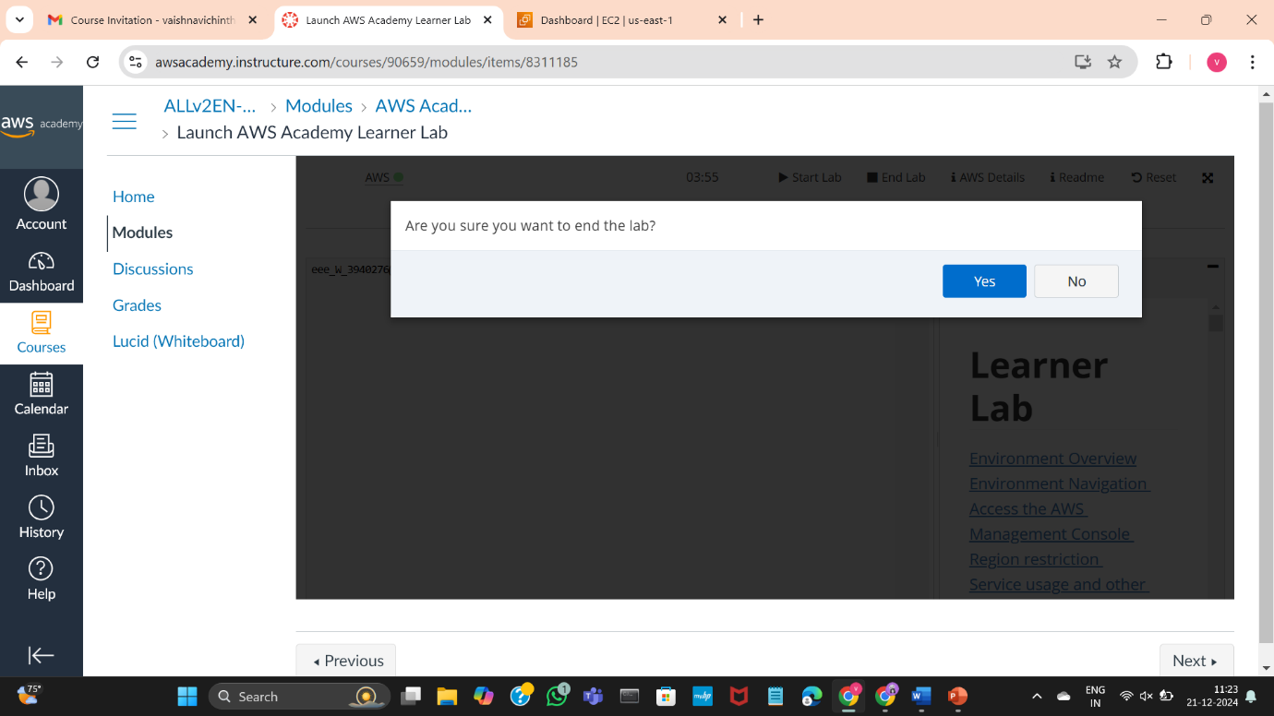

Once you get the red color dot beside the AWS, it indicates that the lab has been stopped

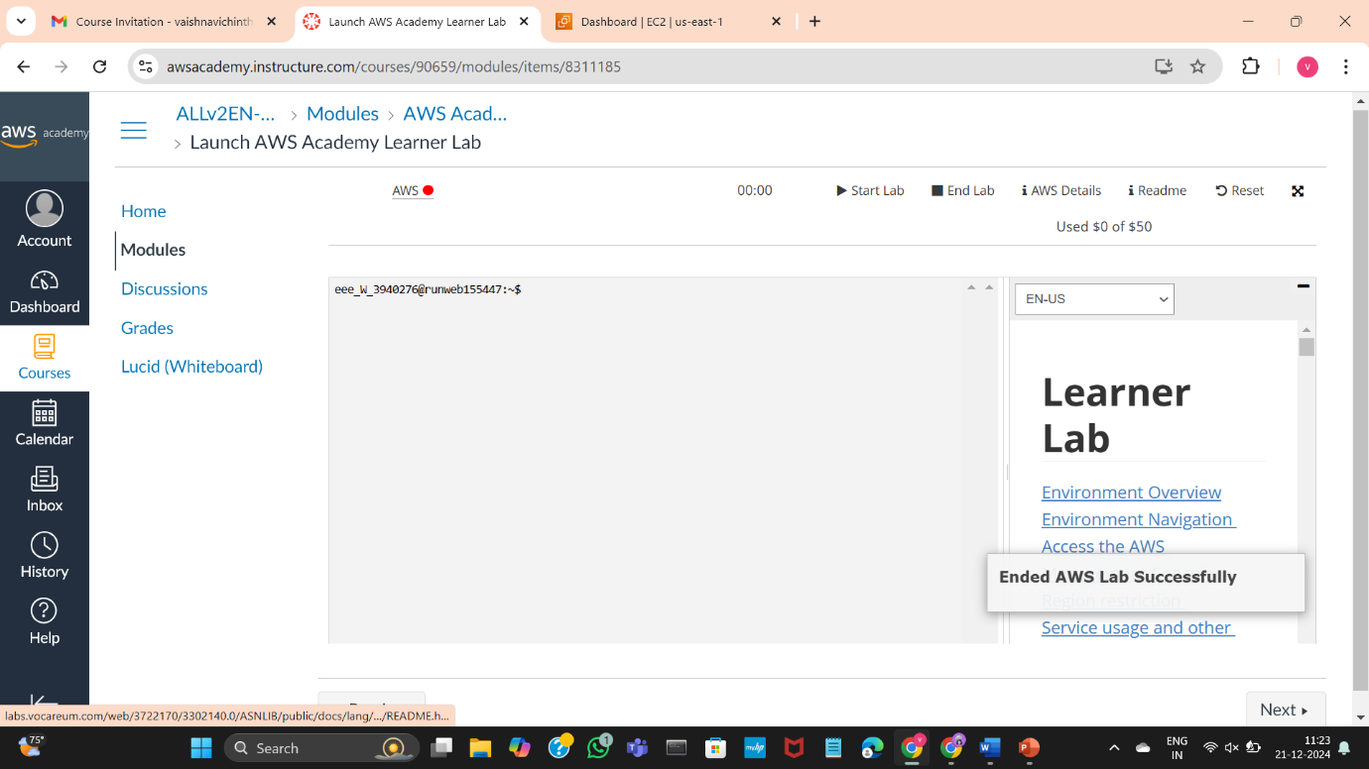

B ) PROJECT DEPLOYMENT IN THE AWS CLOUD USING EC2 INSTANCE

AWS Project – To deploy a web page

go to the AWS Dashboard

start the lab

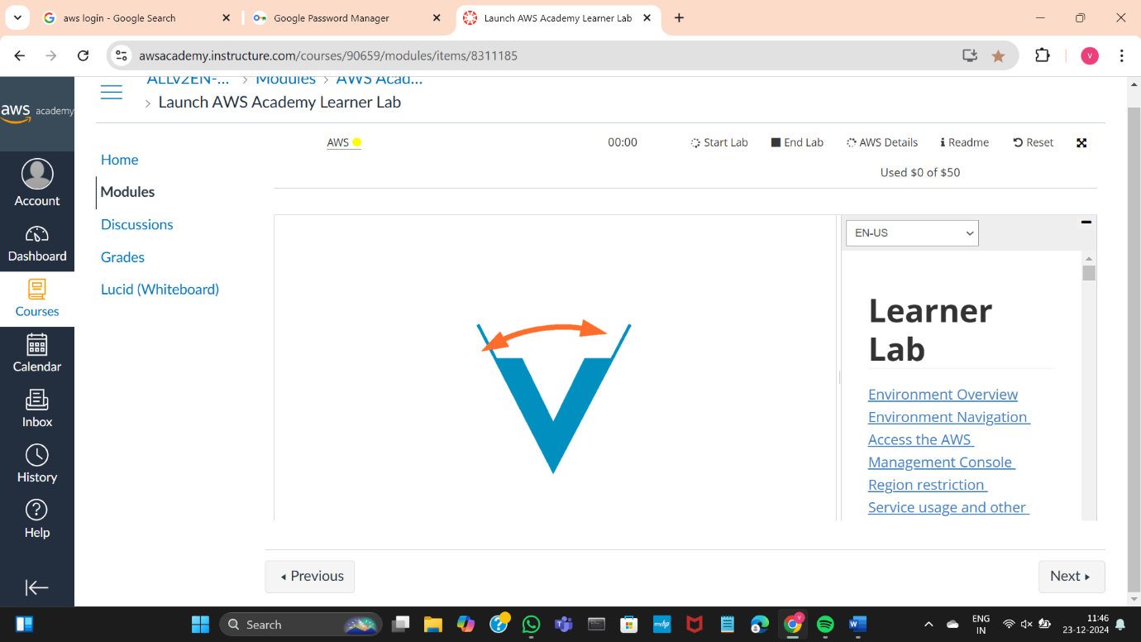

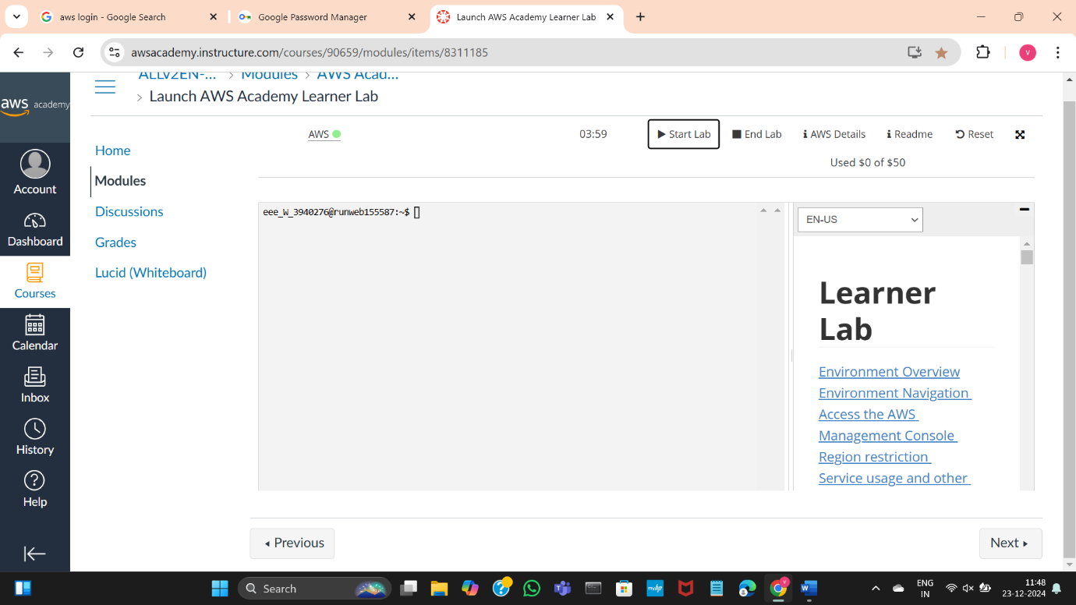

click on EC2

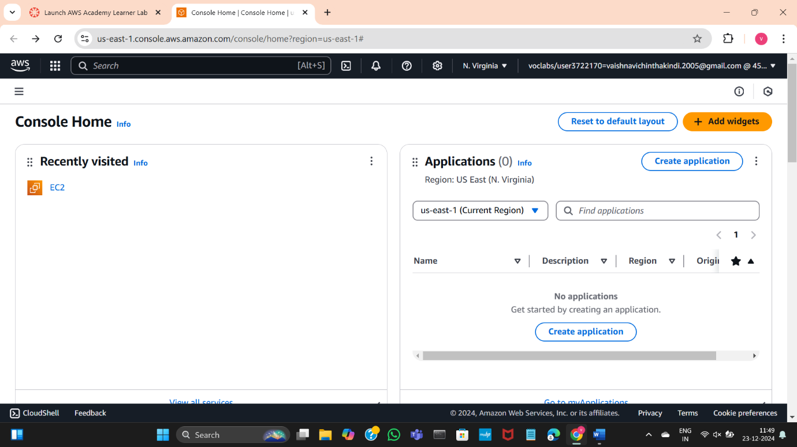

This is the EC2 Dashboard

Click on launch instance to Launch the instance

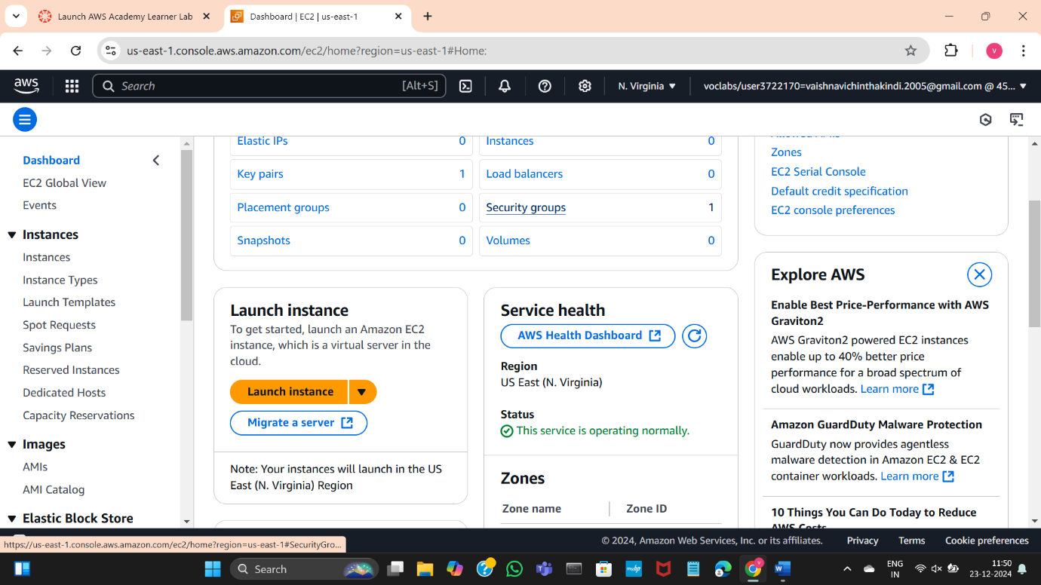

Give a name to the instance

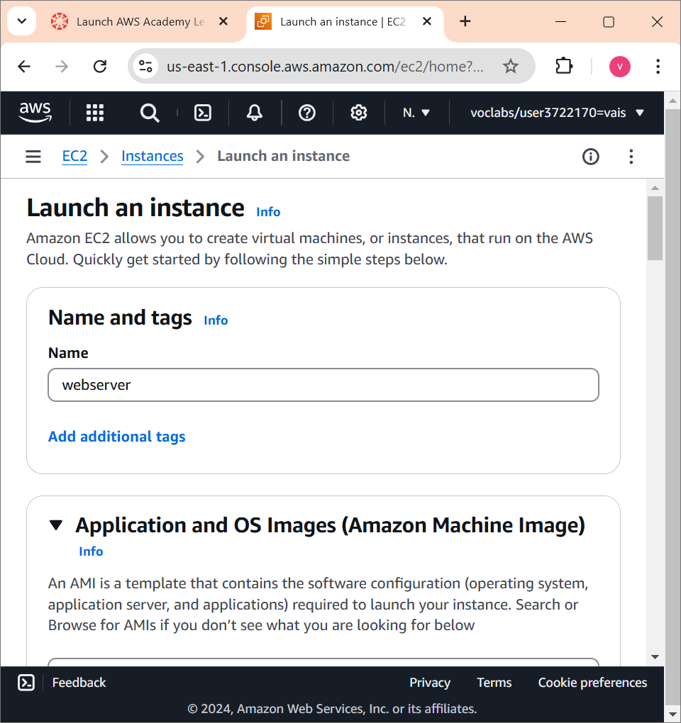

In the application and OS Images section, select ubuntu

In the Amazon Machine Image select any free tier one

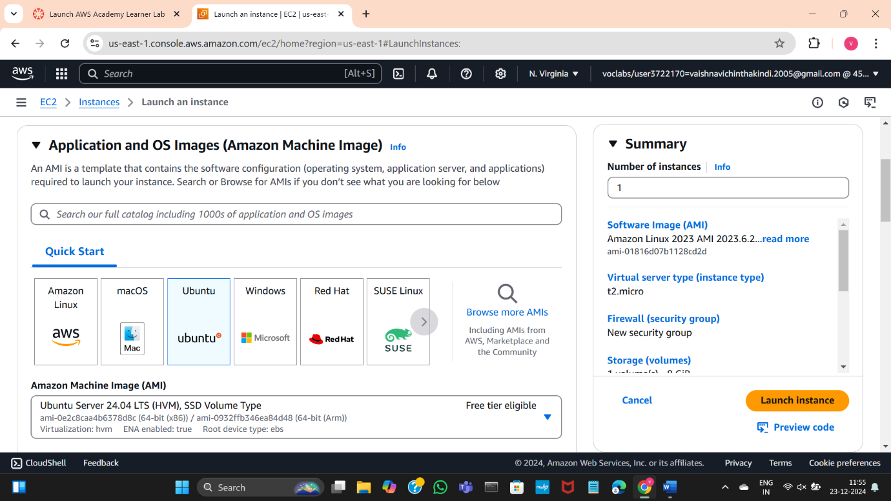

The Instance type should be t2.micro

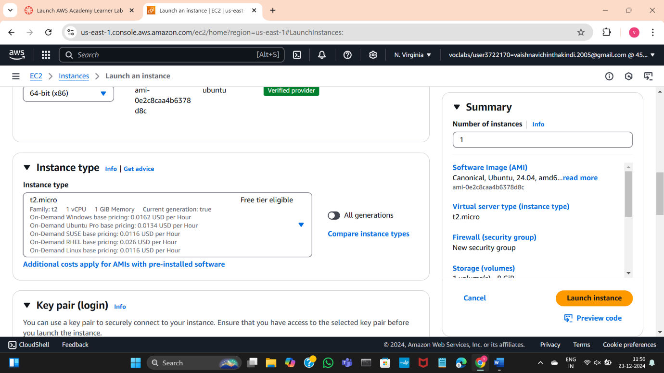

Click on Create new key pair in the Key Pair section

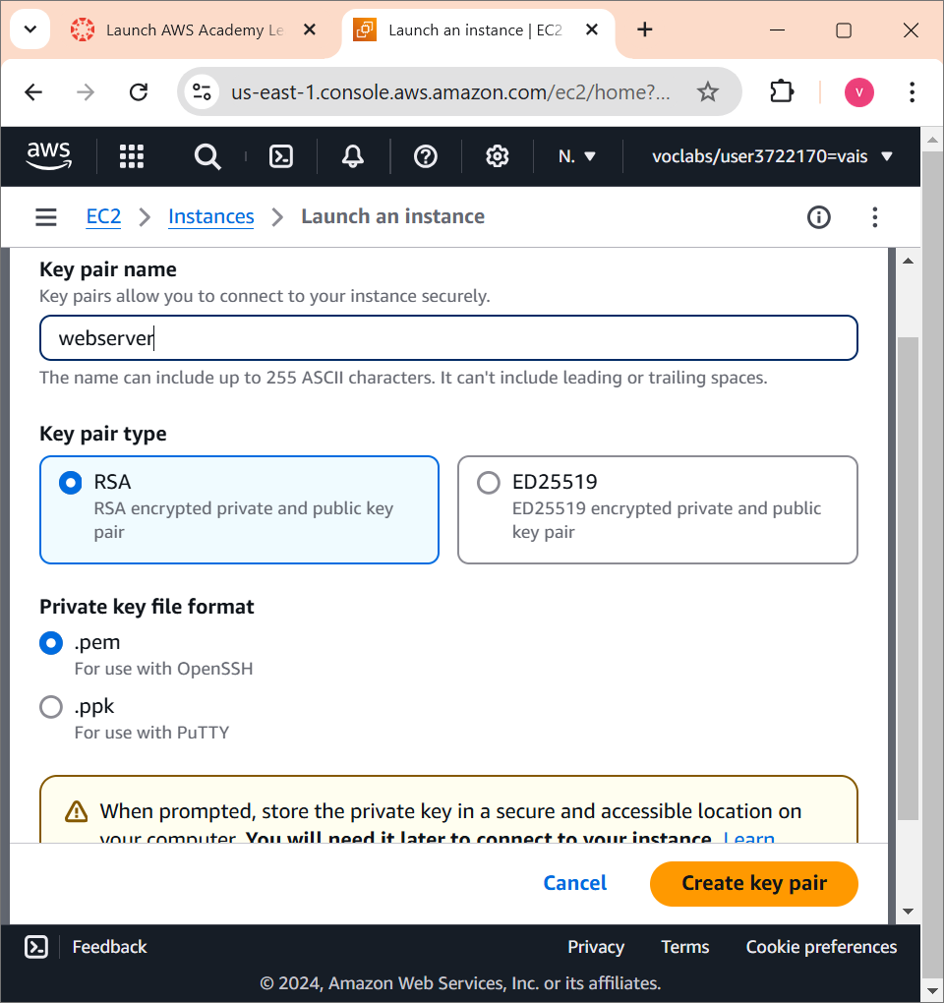

A file with .pem extension will be downloaded

Create a folder and add the file in it

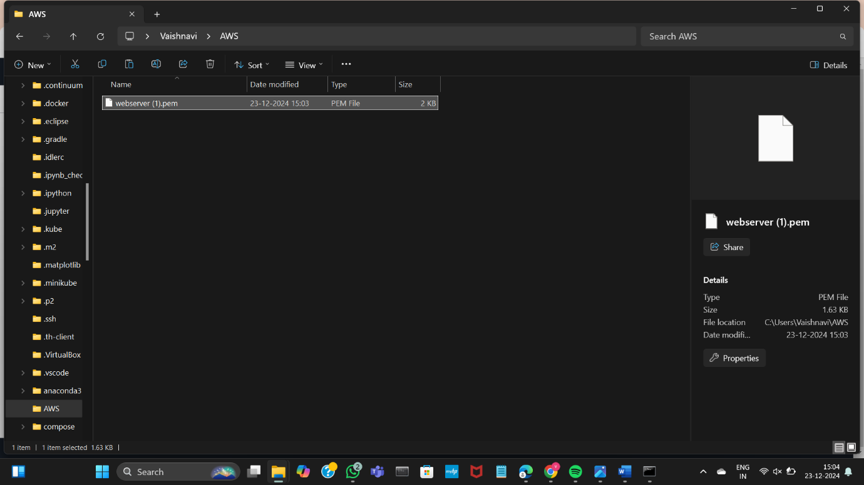

Make sure that the all the boxes should be checked under Network Settings

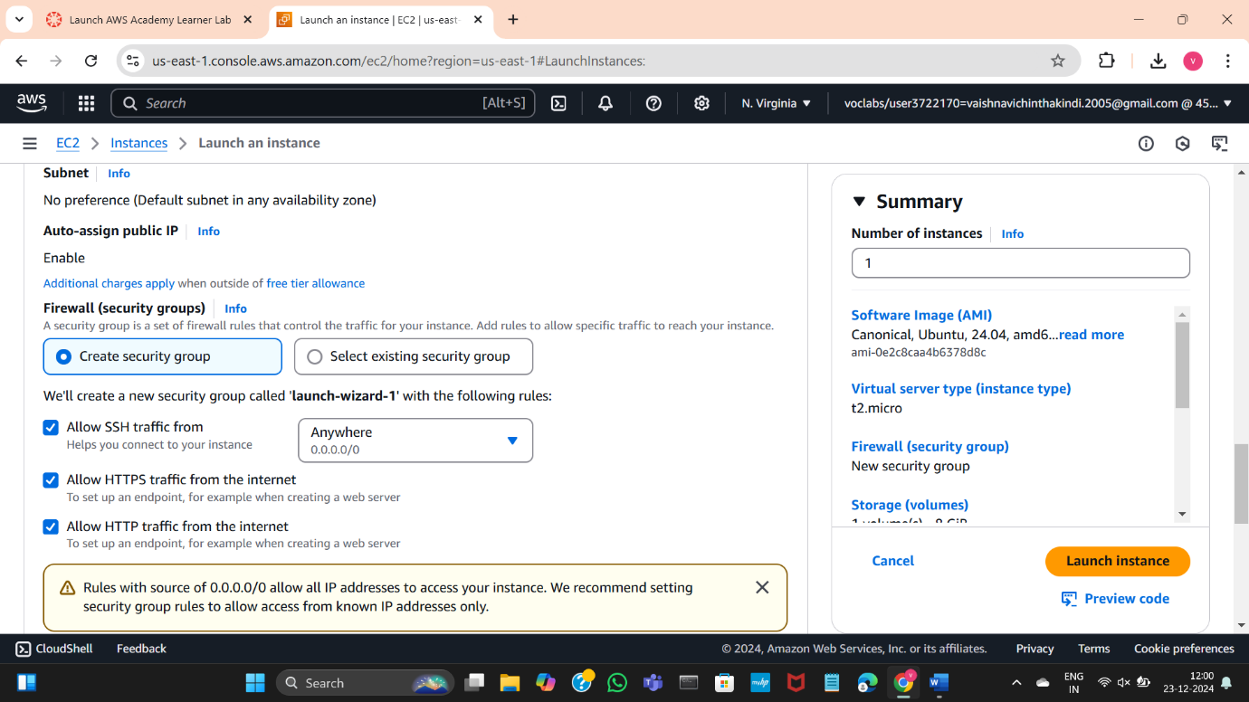

Click on launch instance to launch

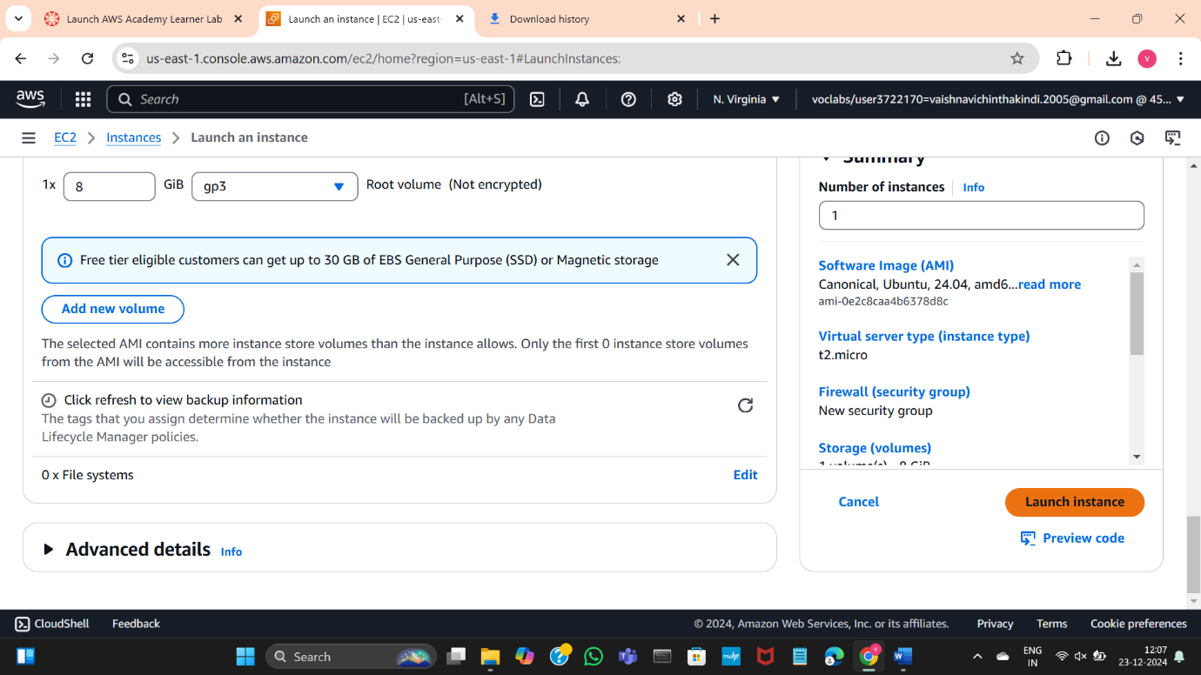

Wait until it turns green

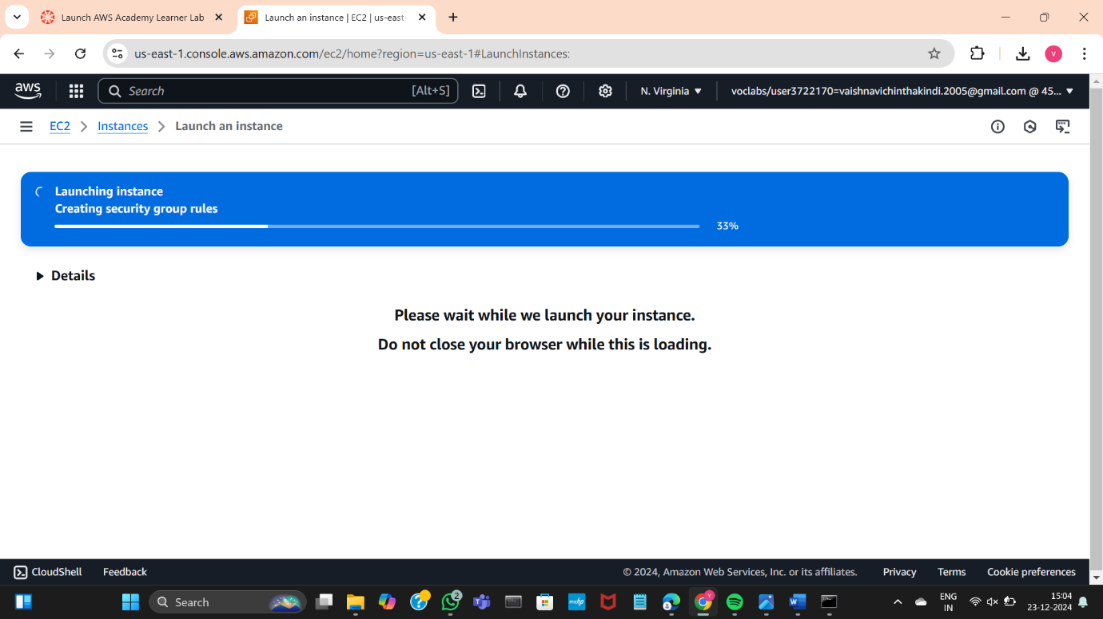

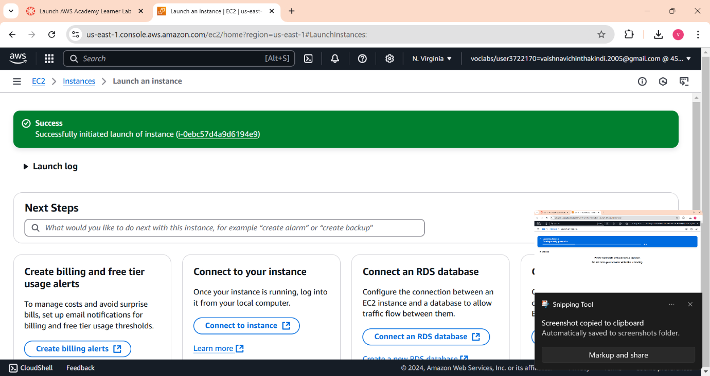

Click on Instances button and you will be redirected to this page

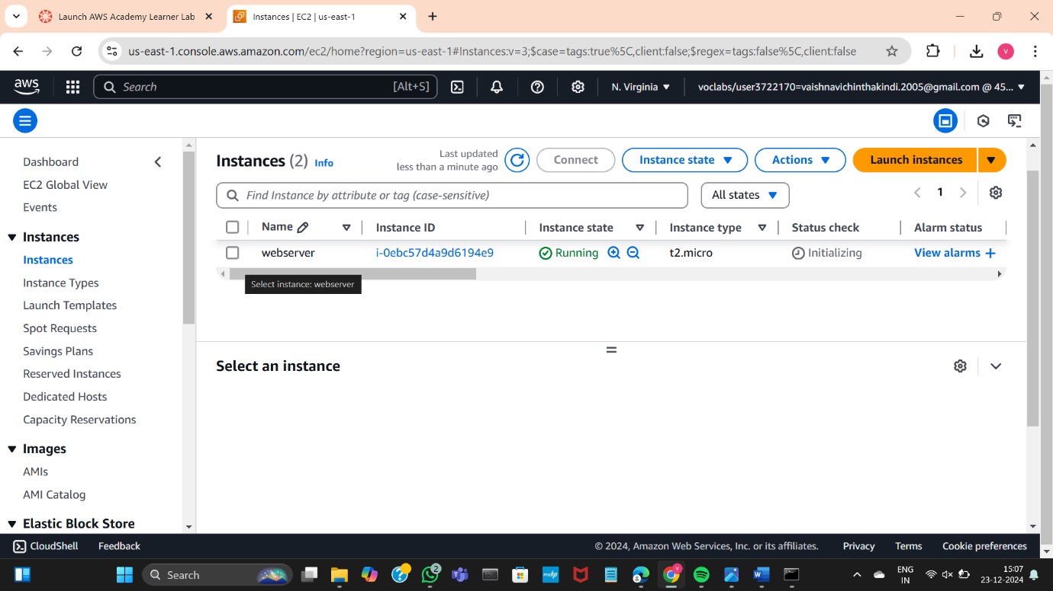

Wait until the status check gives the following message and turns green

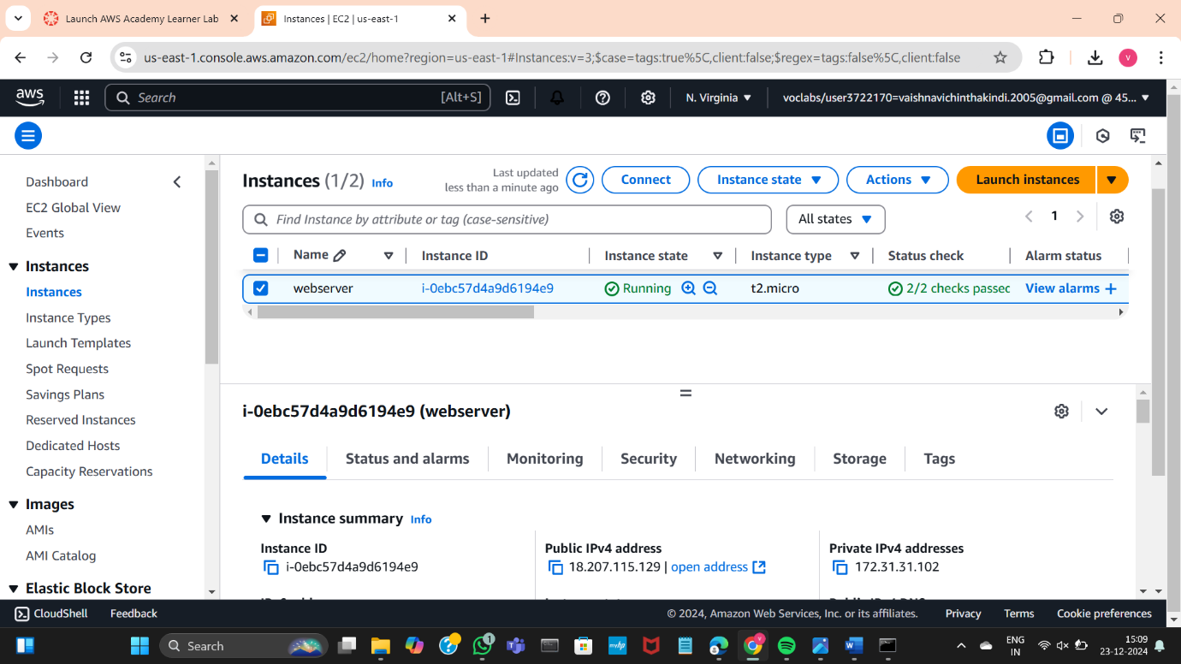

Then click on the check box on the left and click connect

You will be redirected to this page

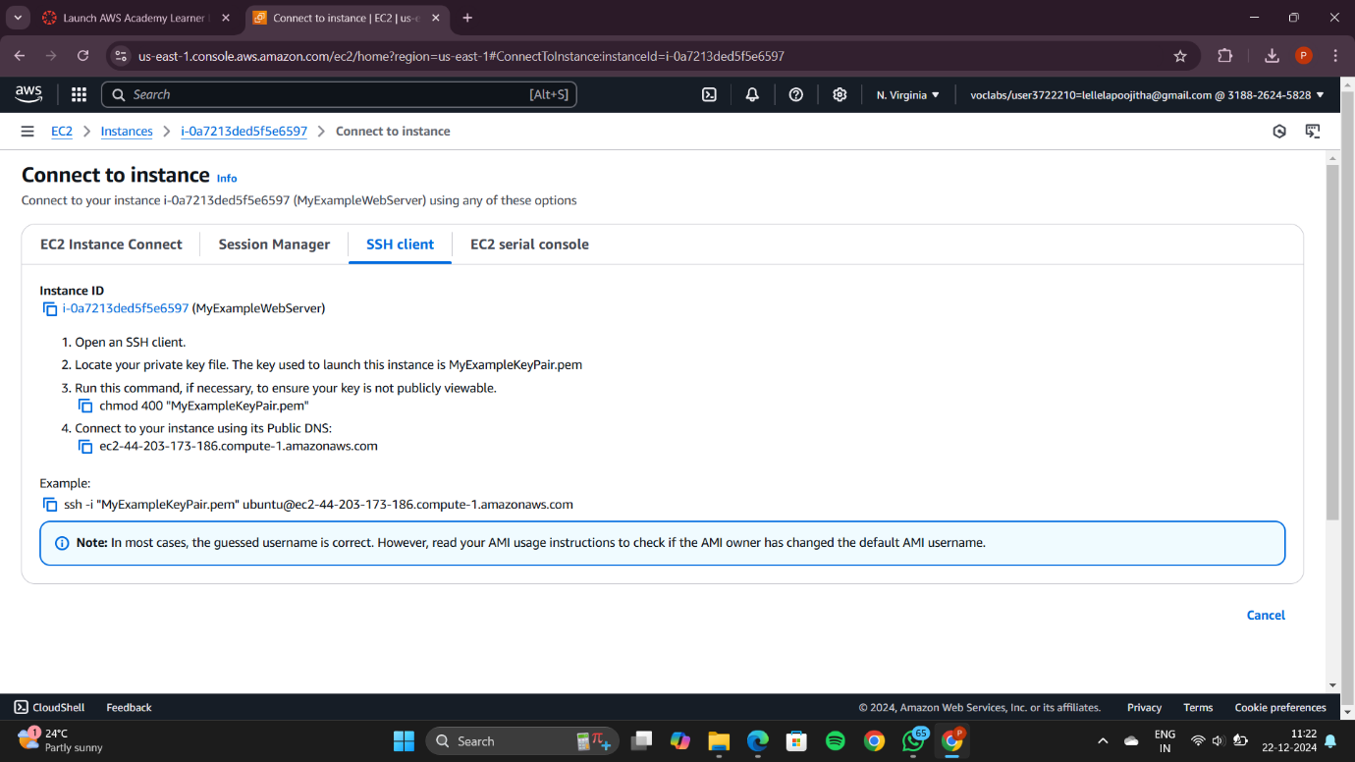

Open Command prompt in administrator mode

redirect to the folder where the .pem file is present

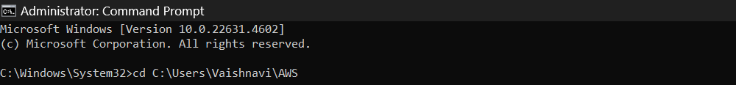

Copy the example command below

The command is copied as shown

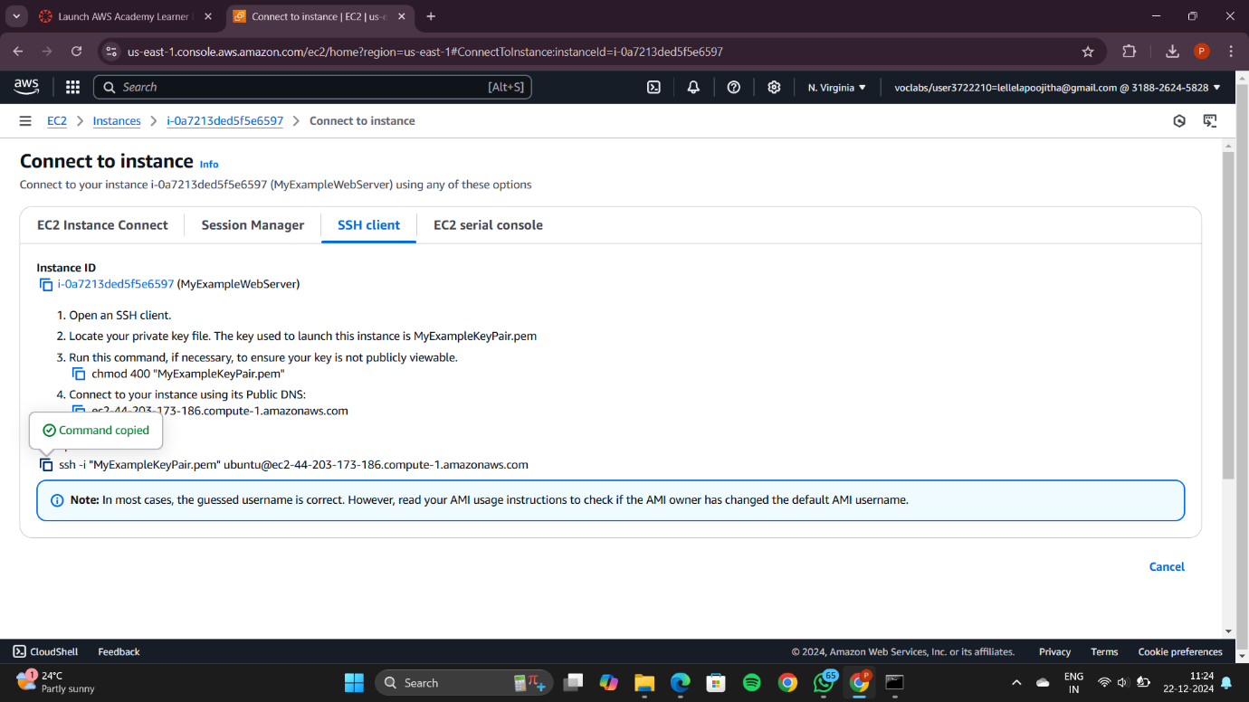

Paste the example command copied from the AWS instance

Type Yes to establish the connection

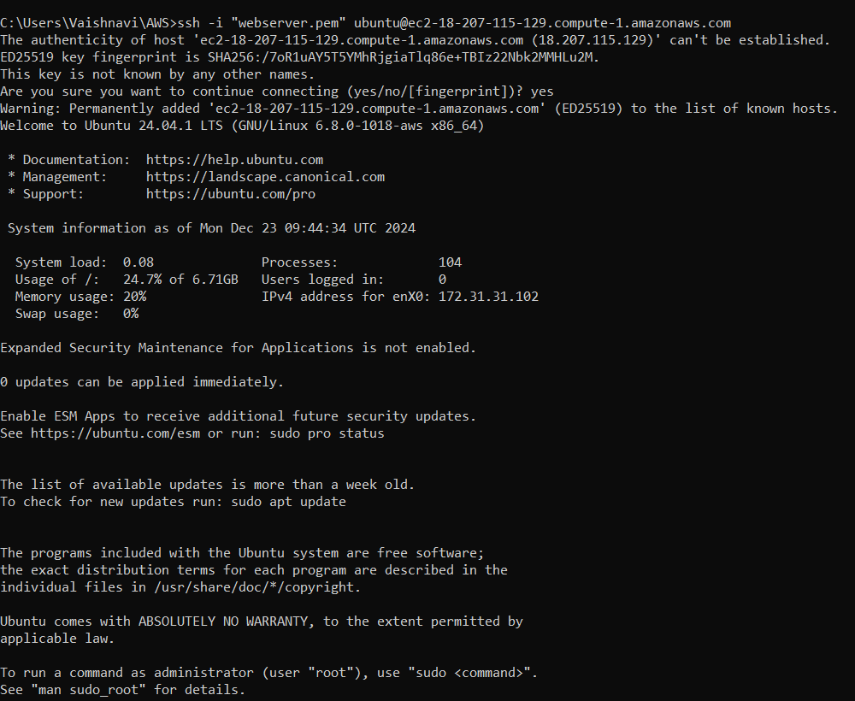

Update Ubuntu using the highlighted command: sudo apt update

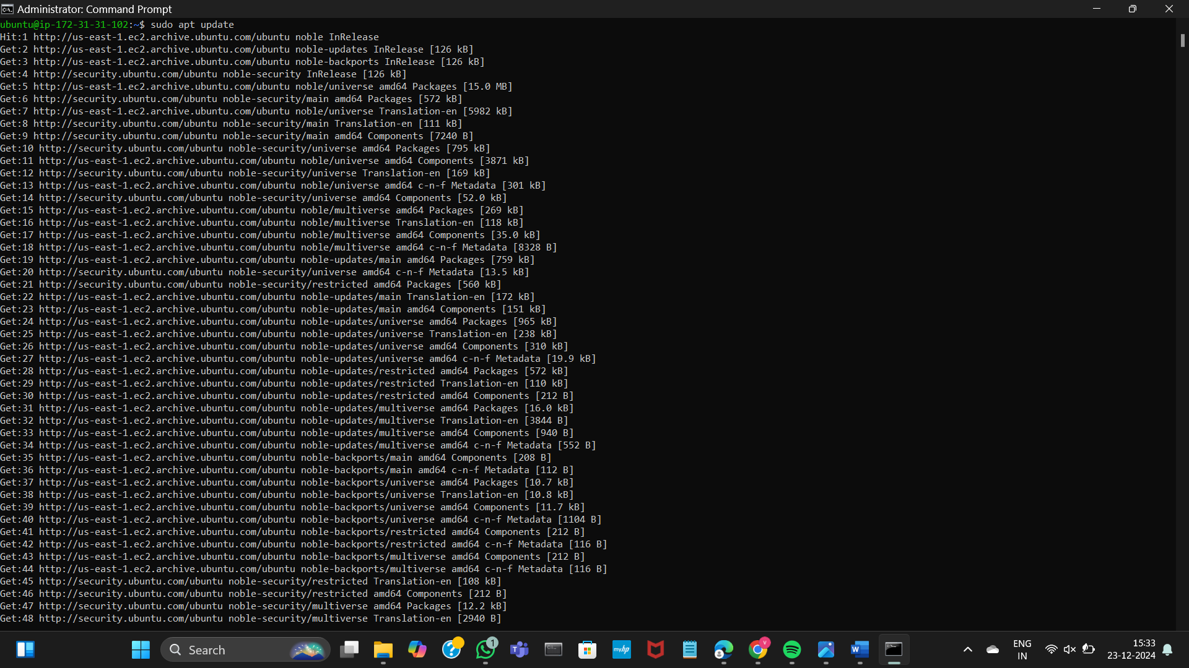

After updating Ubuntu install Docker using the command:   
sudo apt-get install docker.io  
Click Y to continue

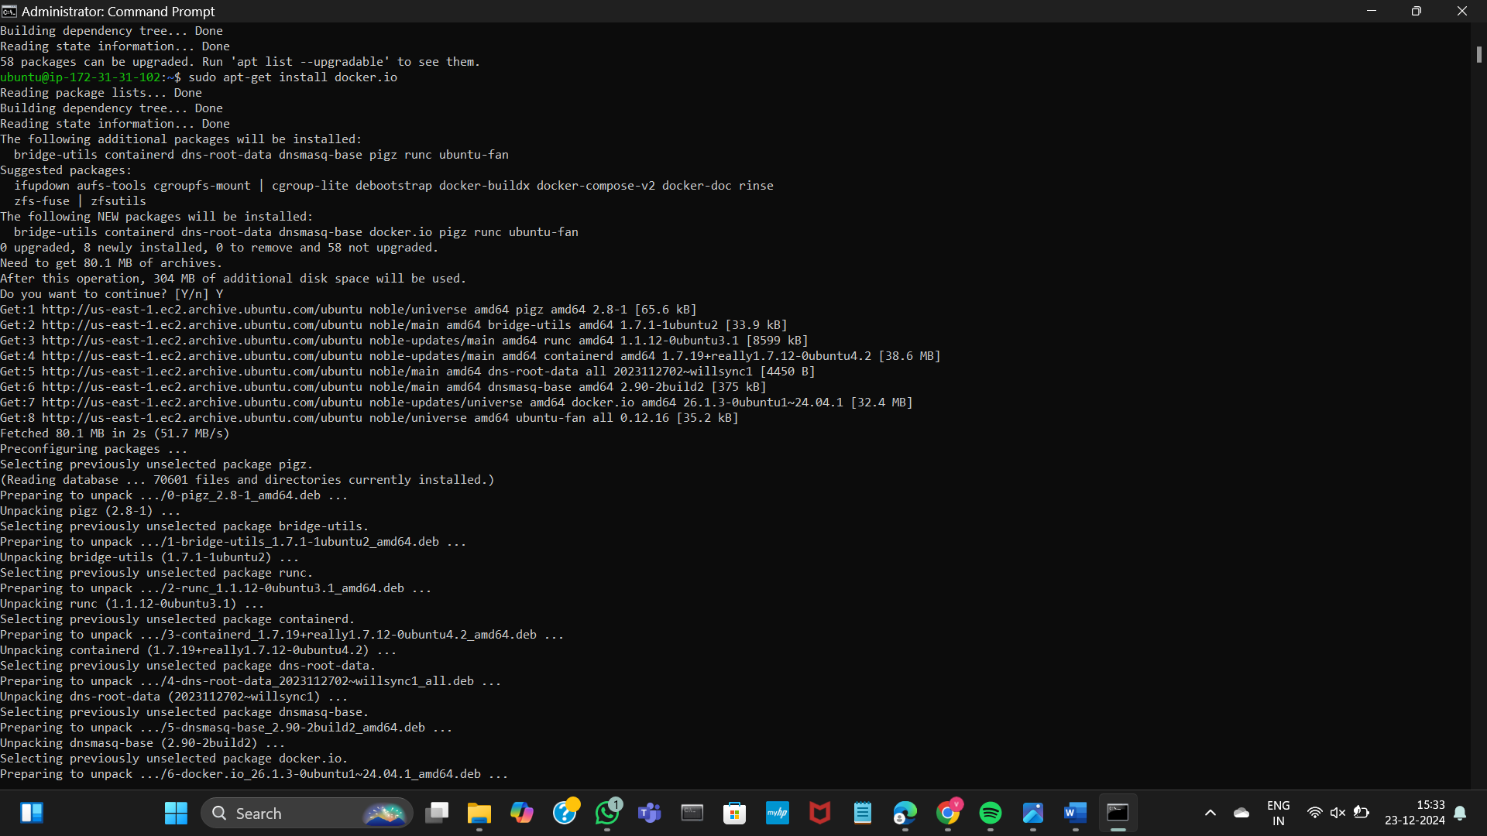

Docker is successfully installed

Install git using the following command:  
sudo apt install git

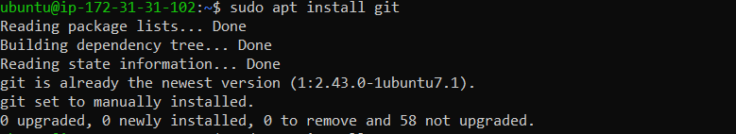

Now install nano editor using the command:  
sudo apt install nano

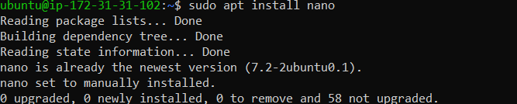

Open any editor like notepad or vs code and write a simple web application

using html and save the file as index.html only

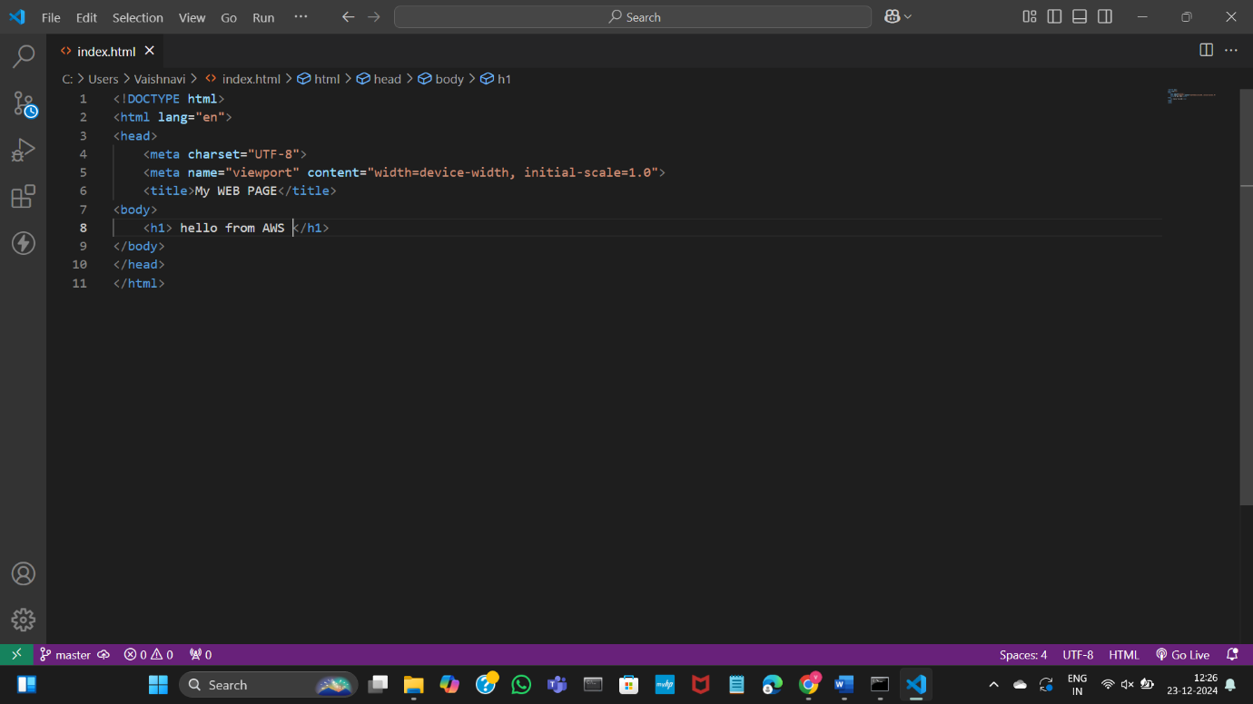

Open the folder where your index.html file is located 🡪 right click and open GitBash here

Type the following Git commands:  
git init  
git add .  
git commit

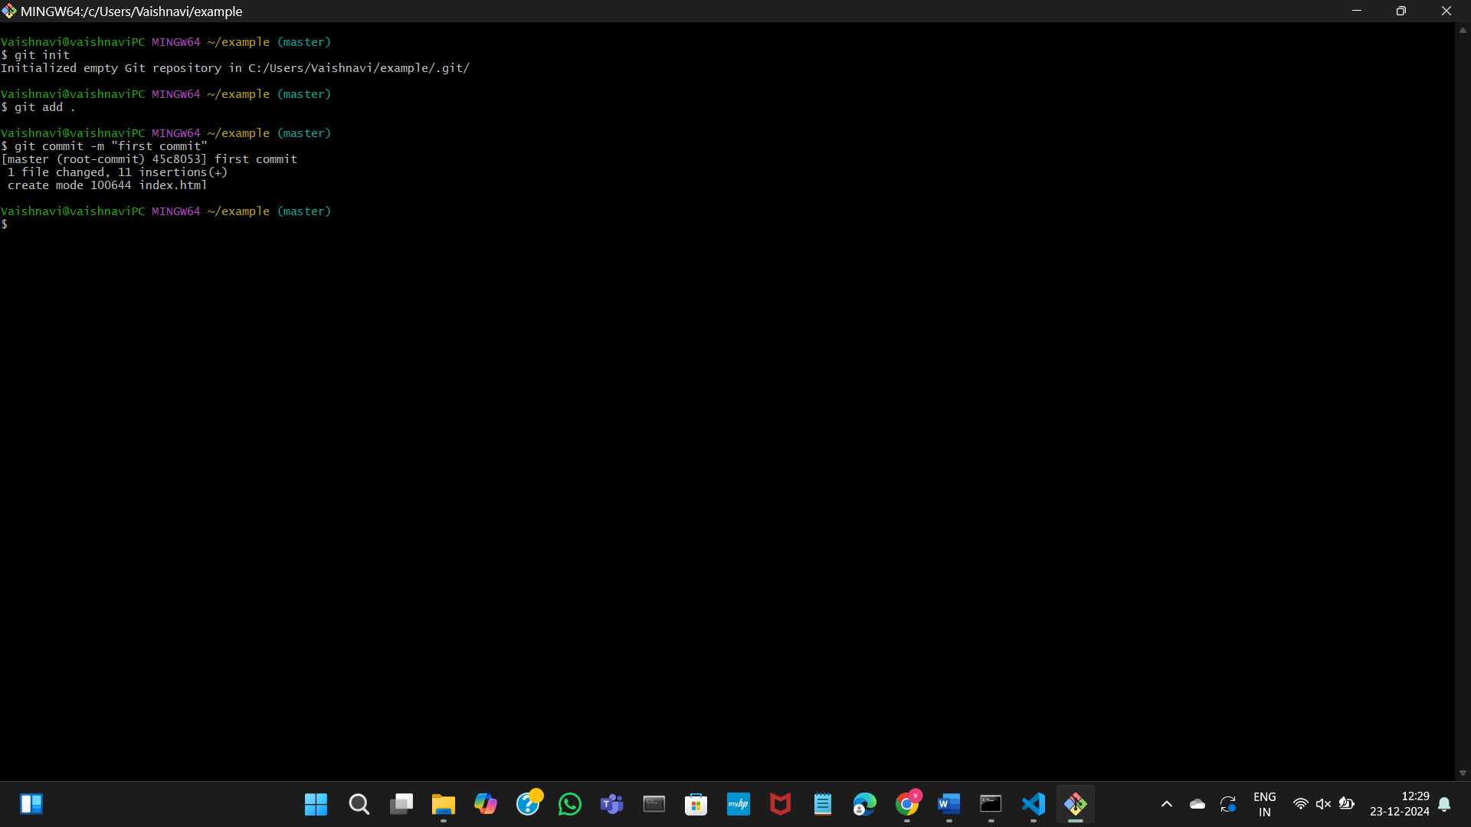

Open github

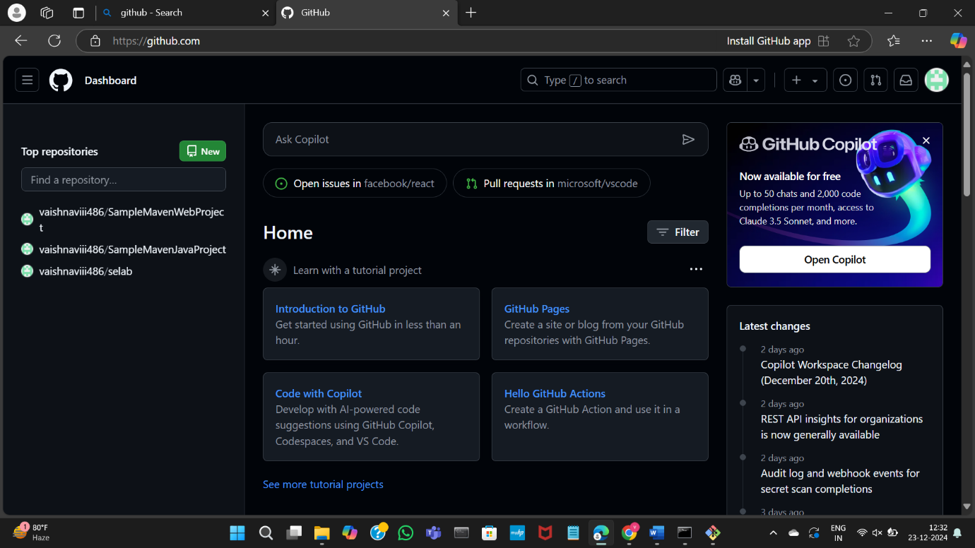

Create a repository in GitHub

Give any name of your choice and click on create

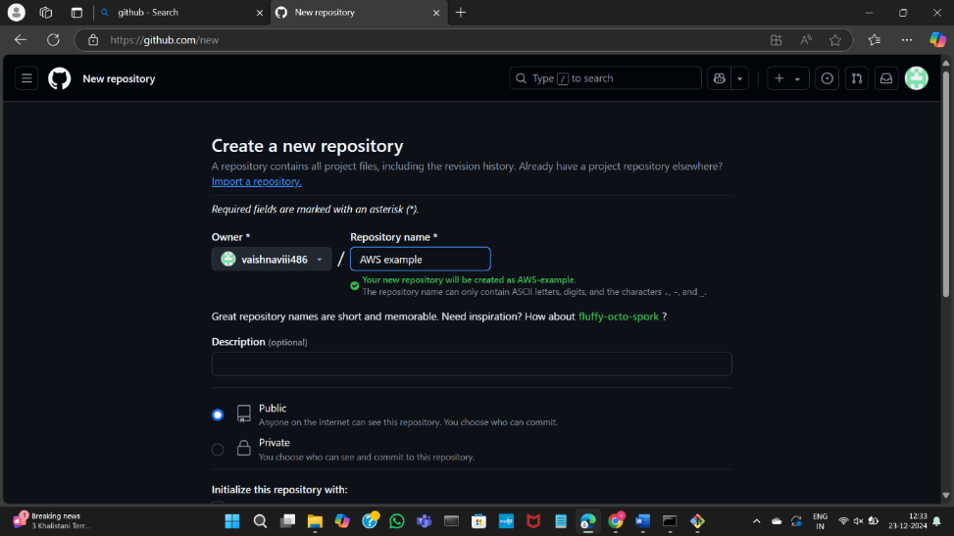

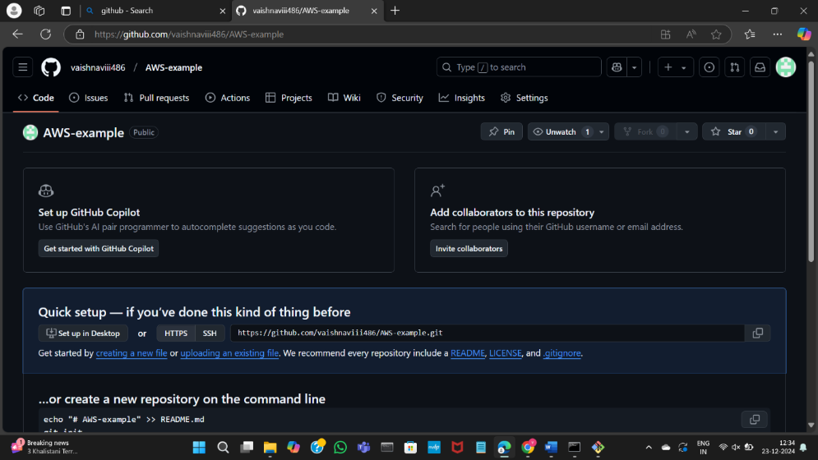

Copy the commands from the git hub and paste it in the git bash

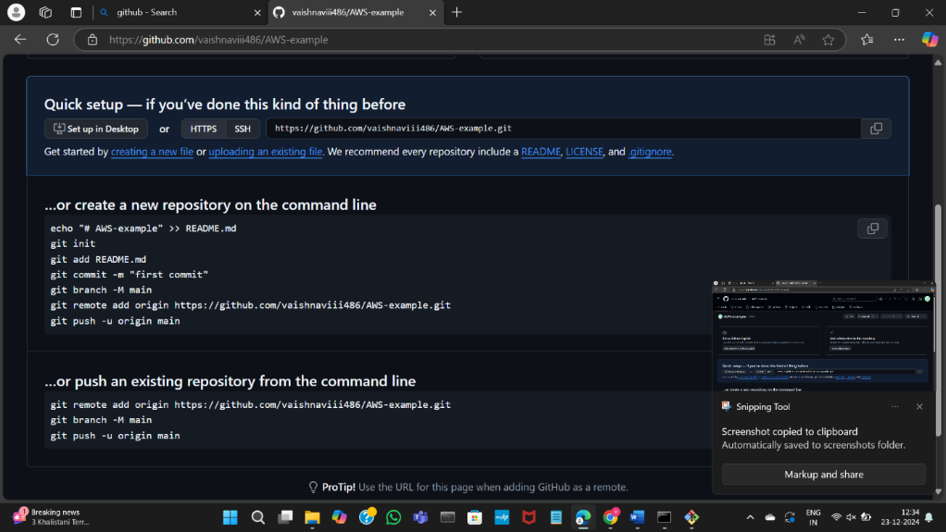

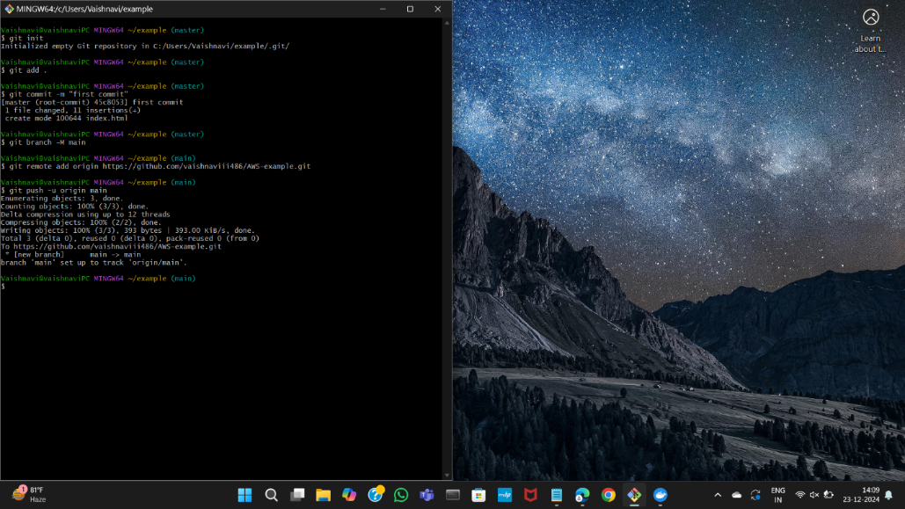

Refresh the GitHub page to see the pushed file

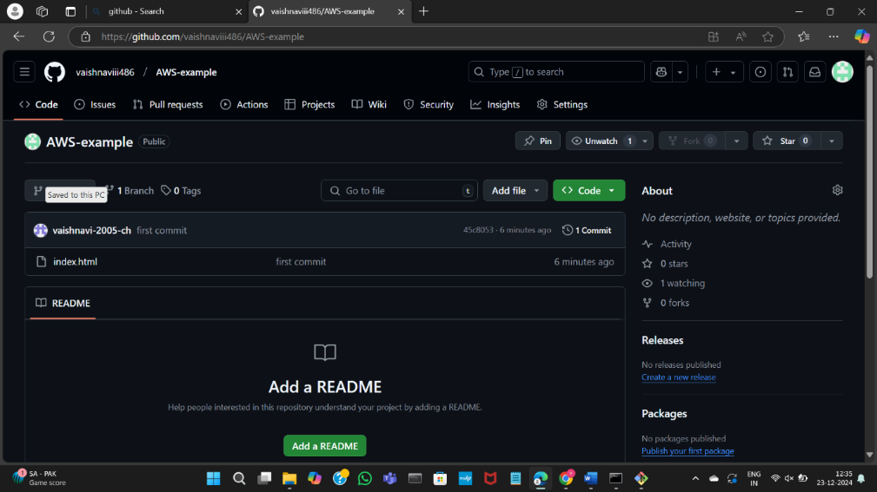

Clone the repository

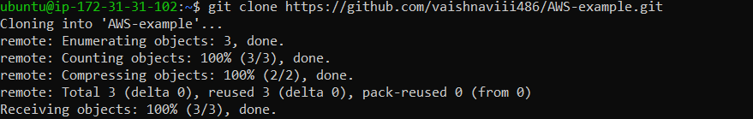

List the files in the directory using ls command

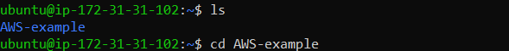

create a Dockerfile using nano command

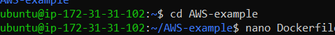

This line of code is like making a special box using NGINX (a type of web server) and

Alpine Linux (a lightweight system). The "COPY . /usr/share/nginx/html" part is putting our website files

(whatever is in the current folder) into the box, so when it runs, NGINX shows our custom content from that folder.

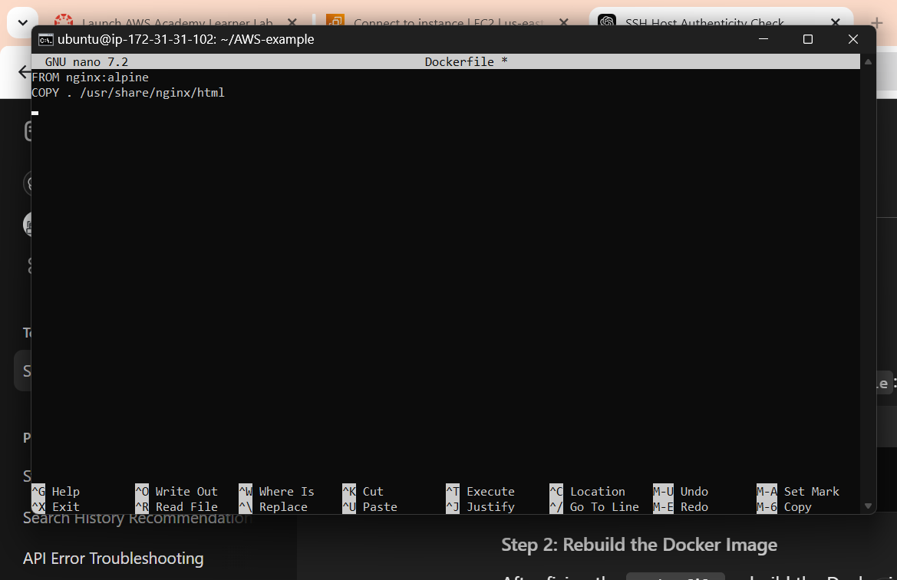

Build a Docker image as shown:  
The command "sudo docker build -t html-mywebapp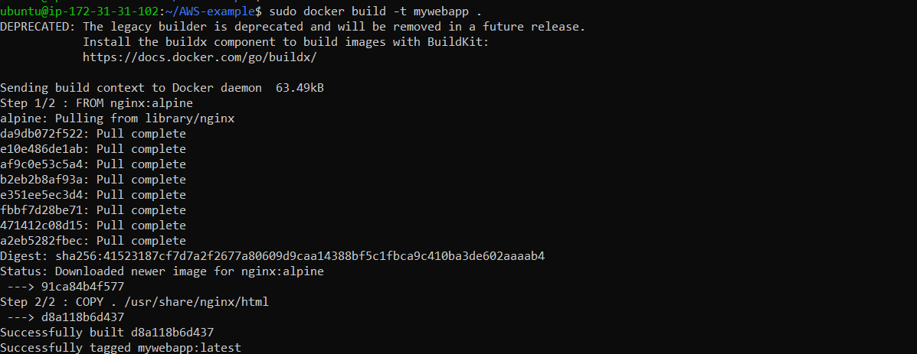

Run the Docker container as shown:  
The command "sudo docker run -d -p 80:80 html-mywebapp:latest

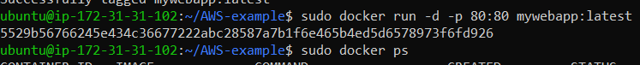

we can access the web-application using the Public IP address as shown

Go to the instances🡪 Copy the address and paste in any browser

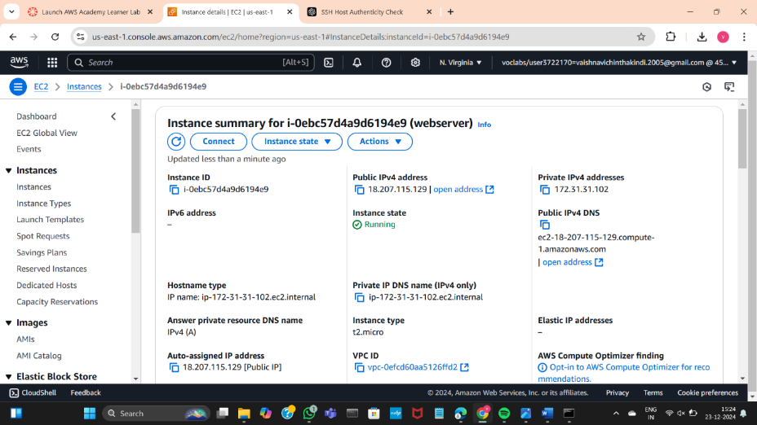

We can now see the deployed web application

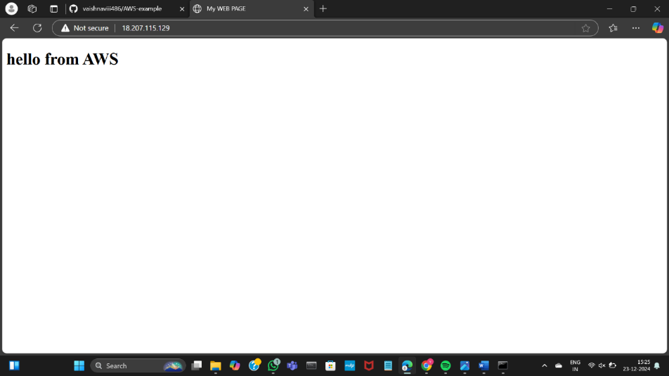

Now stop the running container:  
use the command: “sudo docker ps” which list the running containers 🡪 copy the container ID4

Use the command:  
sudo docker stop <Container ID> to stop the running container

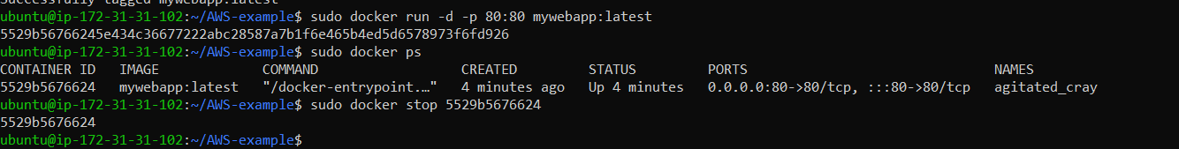

Go back to the AWS 🡪 click on the instance checkbox

Go to Instance State and click on Terminate Instance

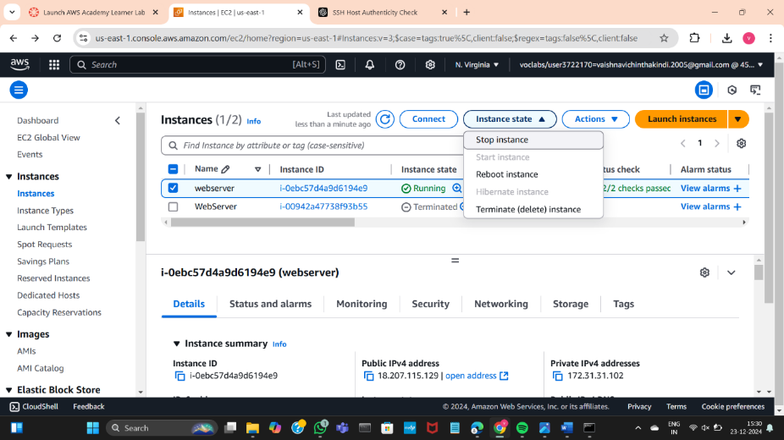

Click on terminate to delete the instance

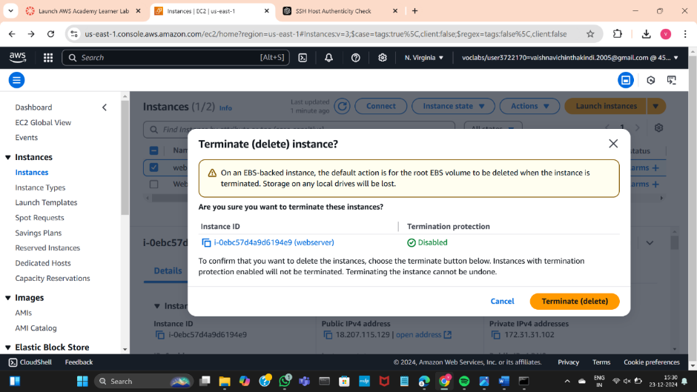

The instance is successfully terminated

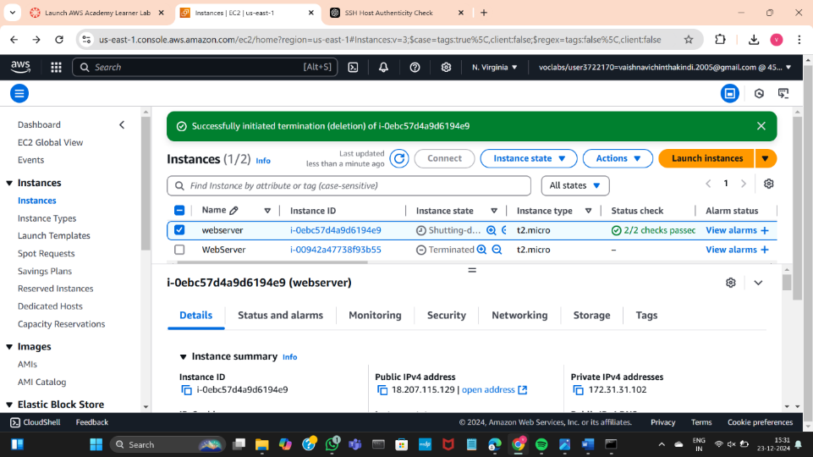

Reload the page to see that no instances are running

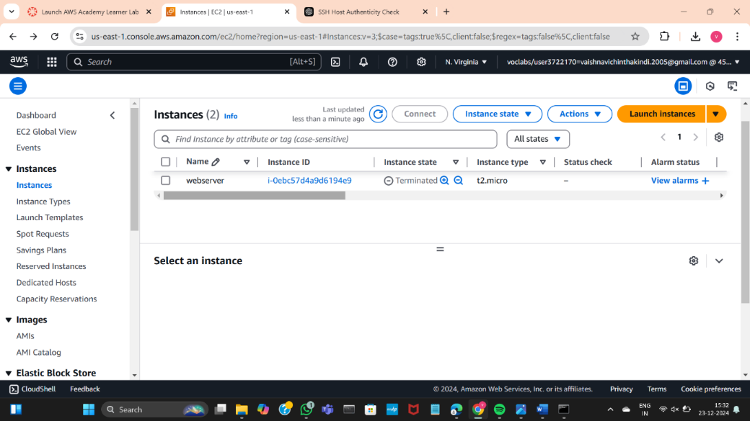

Now go to Aws academy learner lab and click End lab

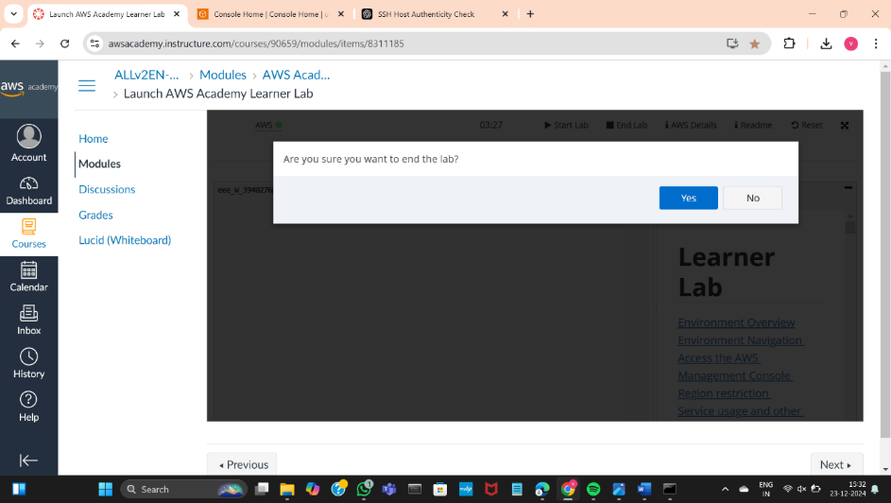

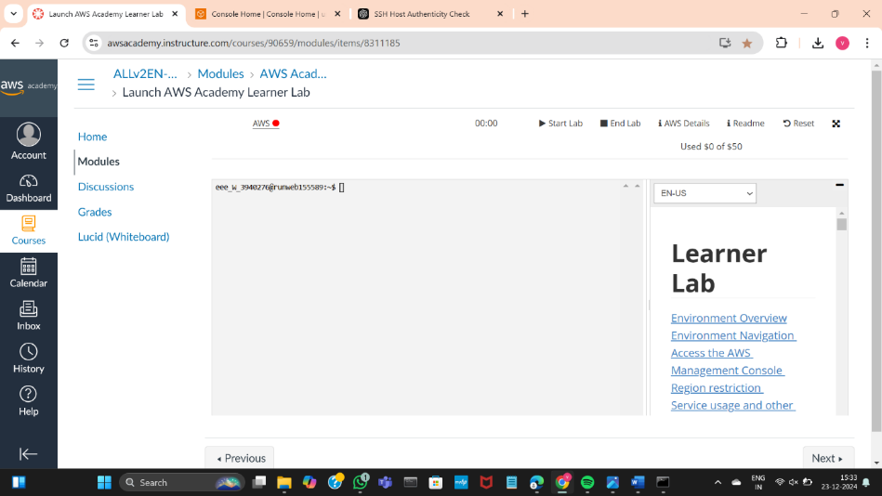

C)MAVEN WEB PROJECT DEPLOYMENT IN THE AWS CLOUD USING EC2 INSTANCE

Enter to the AWS Dashboard

Click on start lab and wait until the red dot turns to green

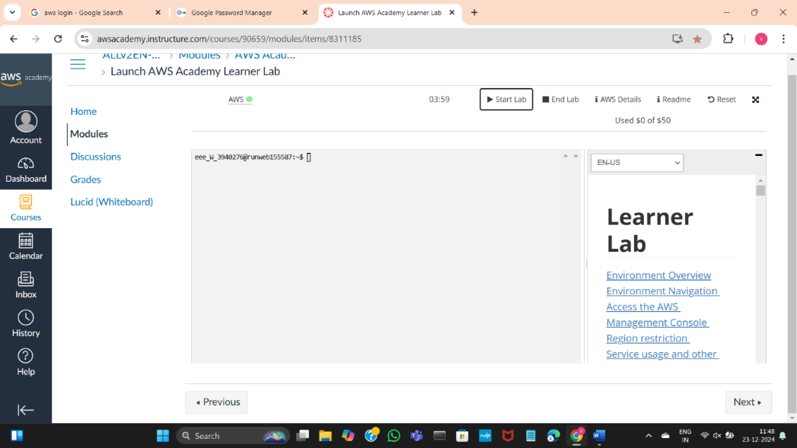

Go to the AWS and click on EC2

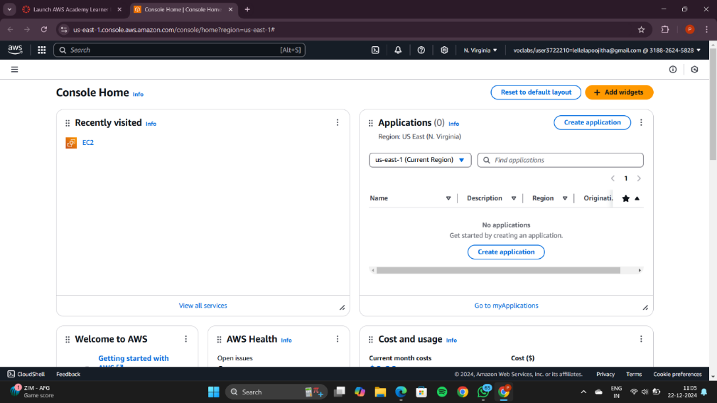

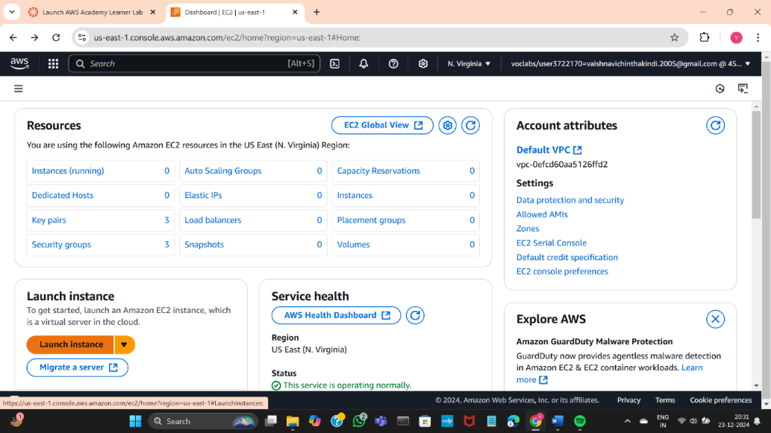

Now click on the Launch Instance button

You can view the page like this

Now, add a name for your instance

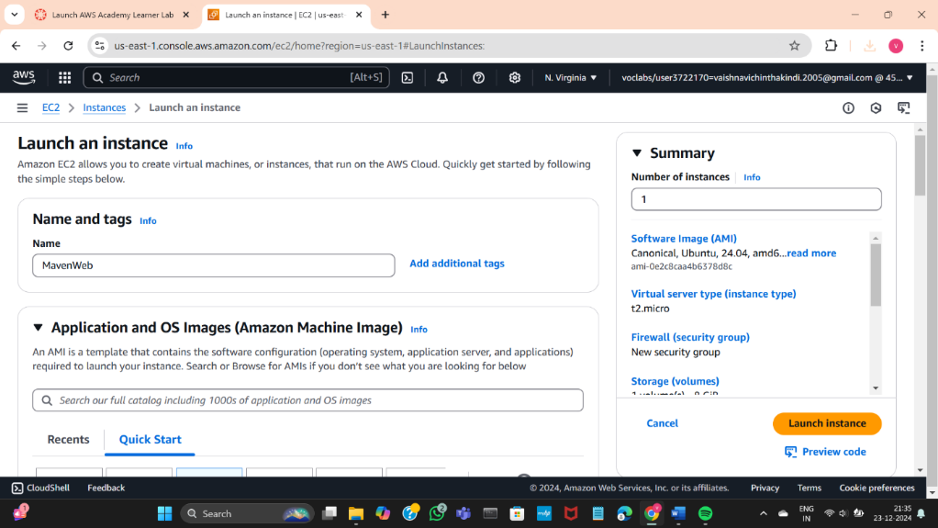

In the application and OS Images section, select ubuntu

And the Amazon Machine Image should be as it is

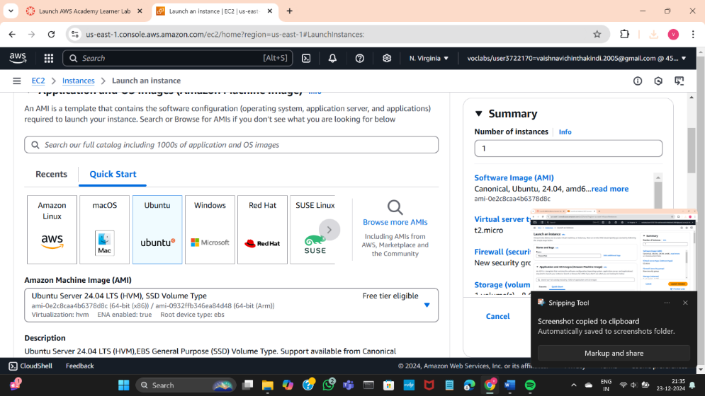

Now create a new key pair

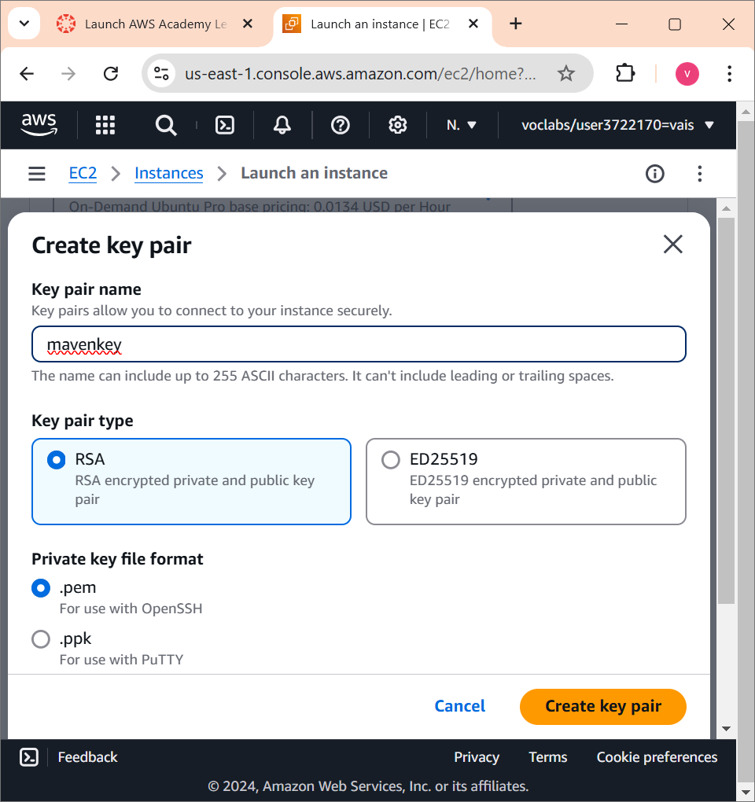

Move the downloaded .pem file to a new folder

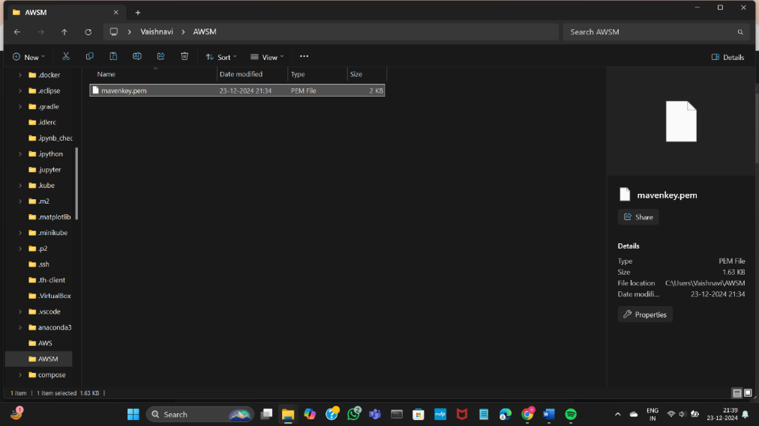

Make sure that the all the boxes should be checked under Network Settings

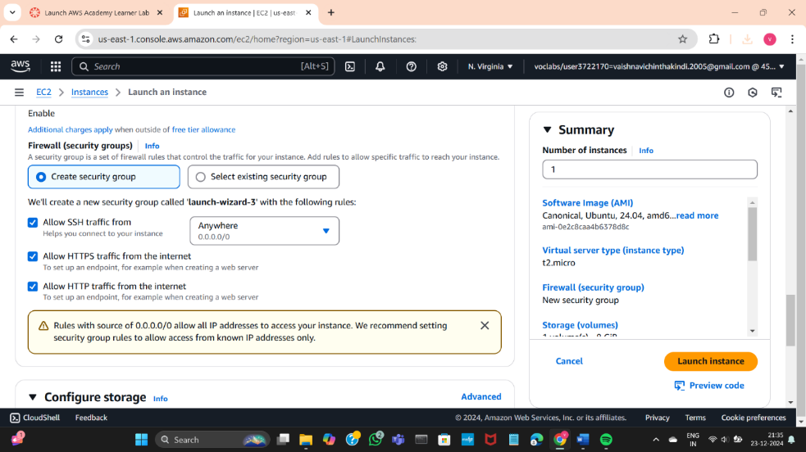

Now click the Launch Instance button present on bottom right corner

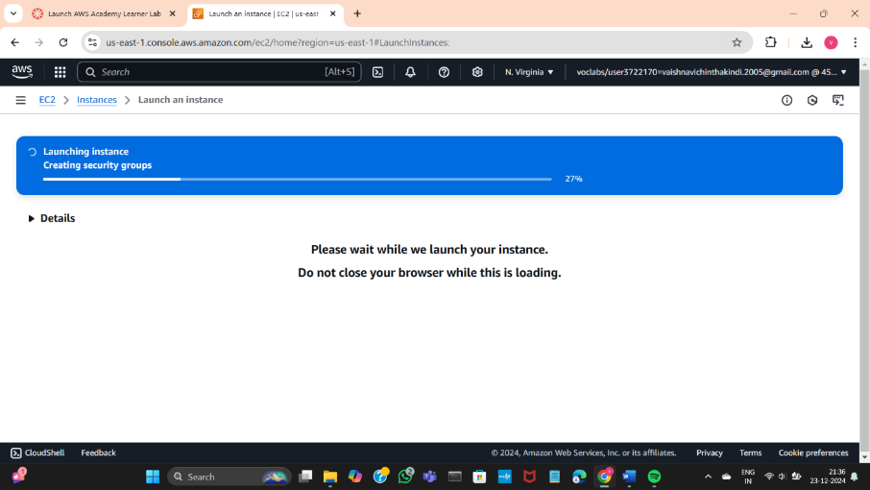

Wait until it turns green indicating the instance has launched

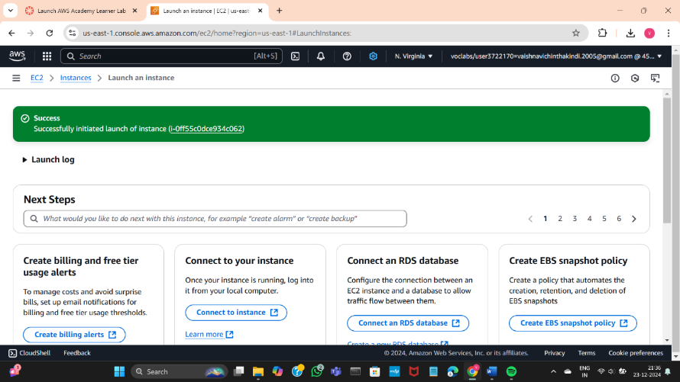

Now click on instances

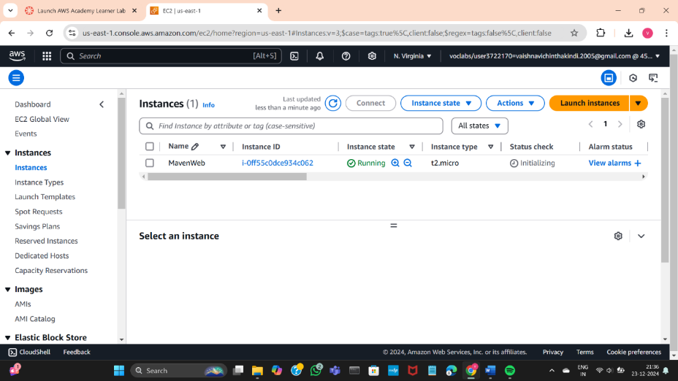

After 2 Minutes it should indicate the following message turning green

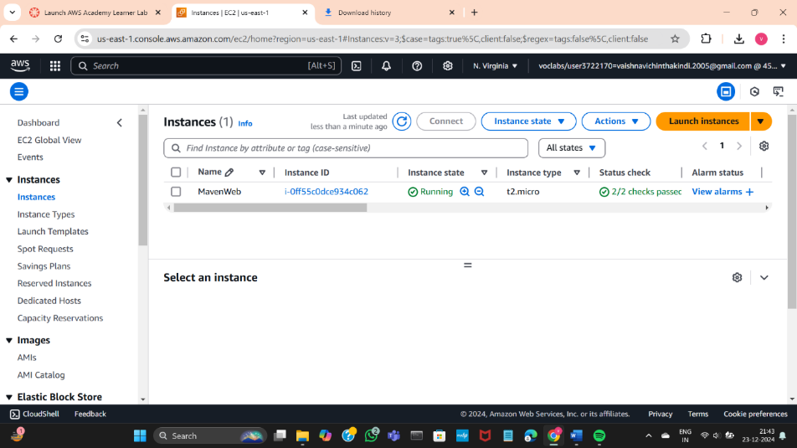

Click on the Instance MavenWebProjectExample and click on Connect

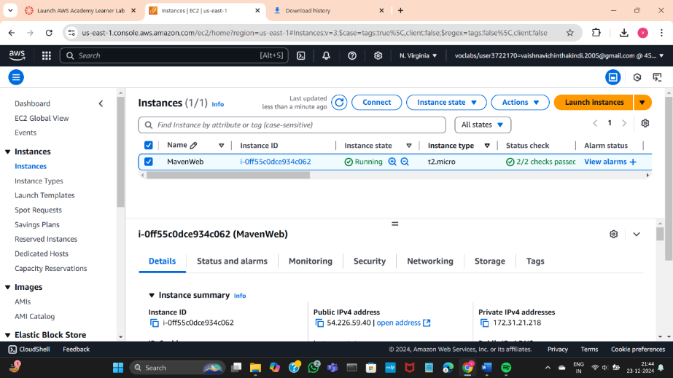

You will be redicted to the following page

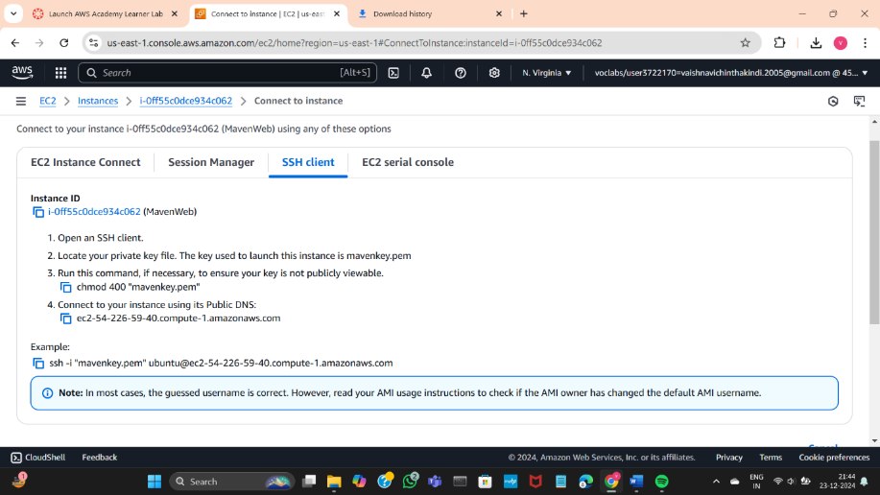

Open command prompt in administrator mode and move the directory where you have saved the .pem file

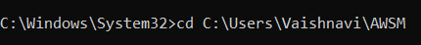

Copy the example command below

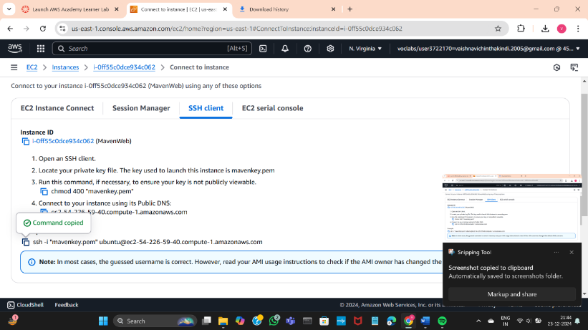

Paste the command copied from the AWS instance

Type Yes to establish the connection

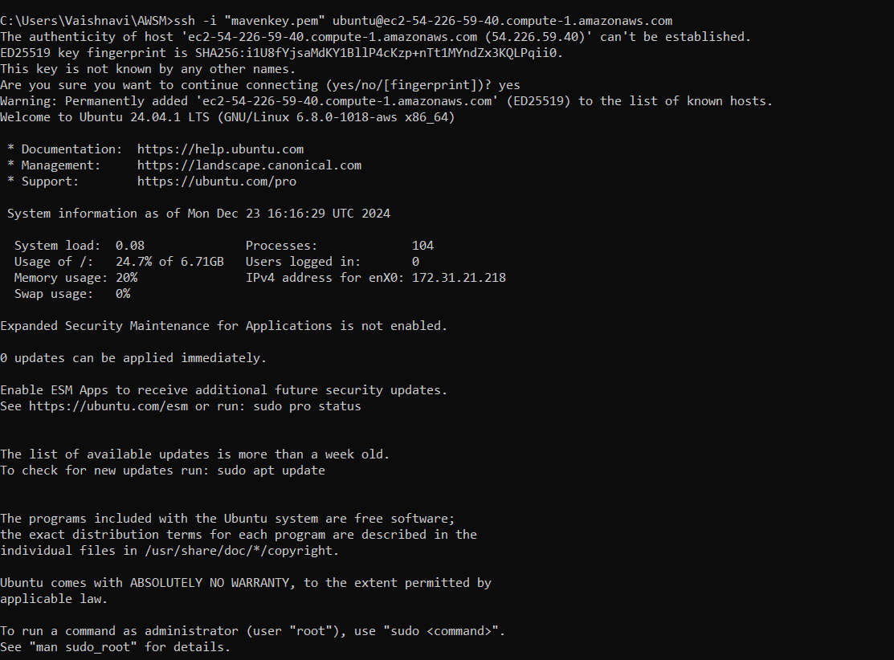

Update Ubuntu using the highlighted command: sudo apt update

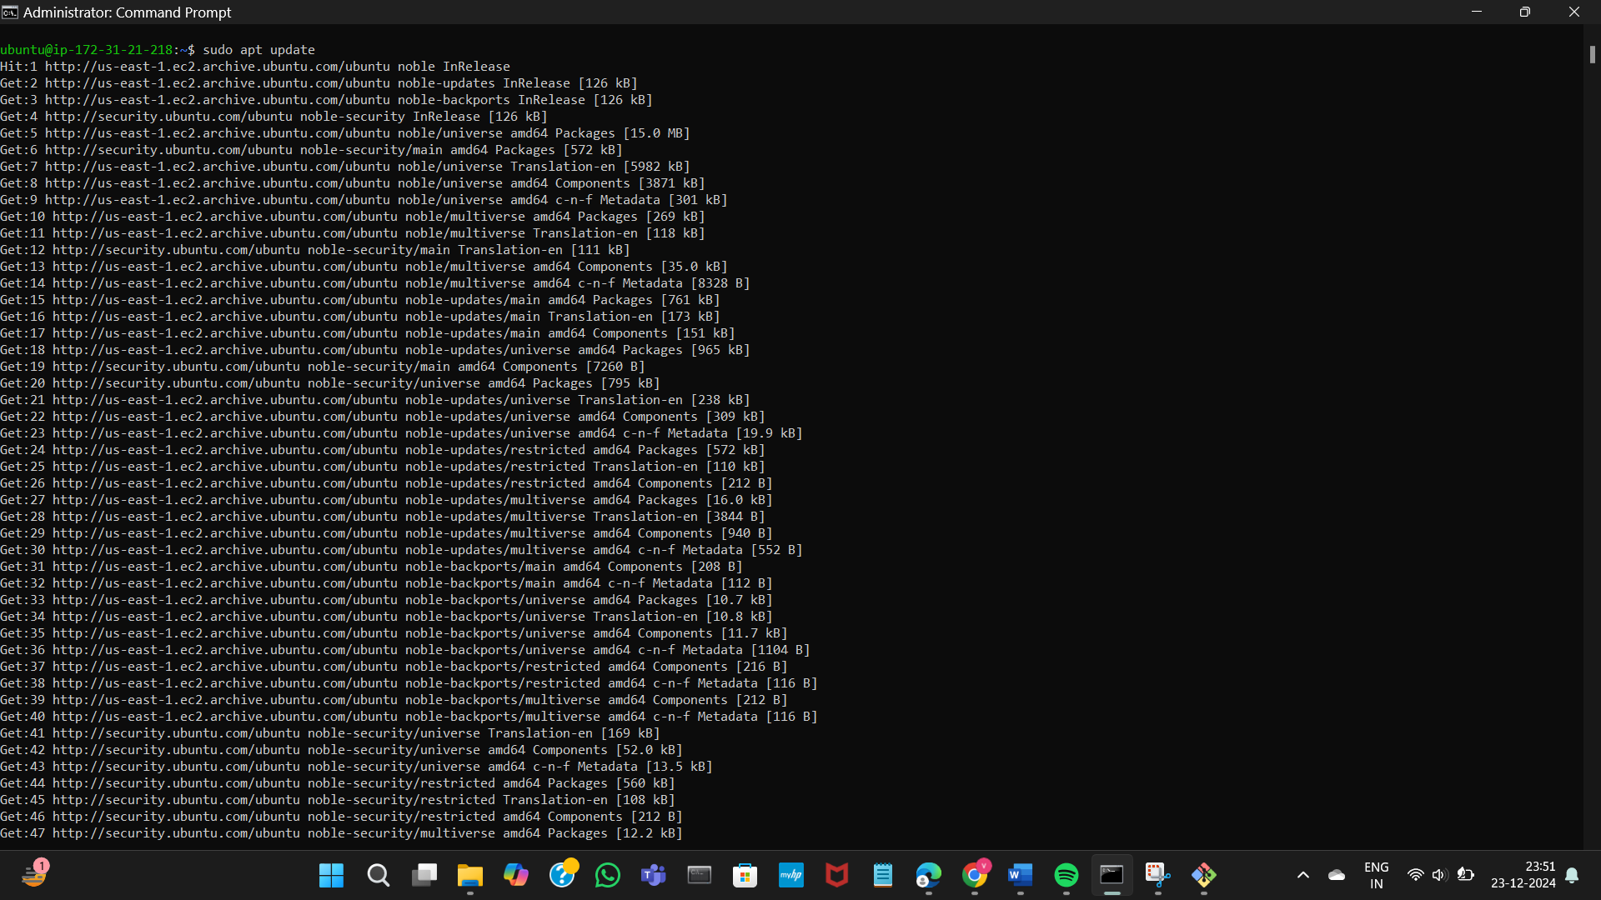

After updating Ubuntu install Docker using the command:   
sudo apt-get install docker.io  
Click Y to continue

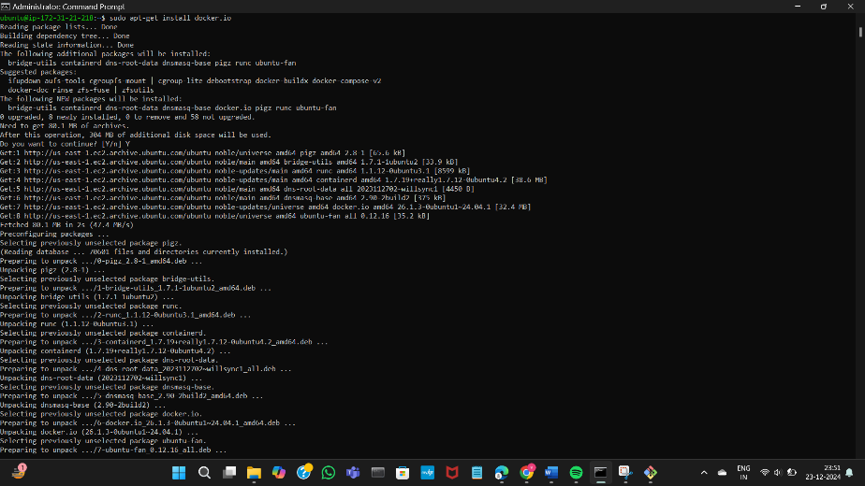

Install git using the following command:  
sudo apt install git

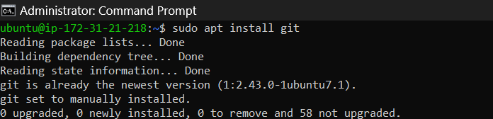

Now install nano editor using the command:  
sudo apt install nano

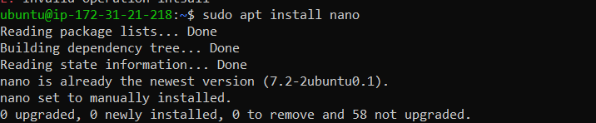

Go to the git hub dashboard where sample maven web project is created before

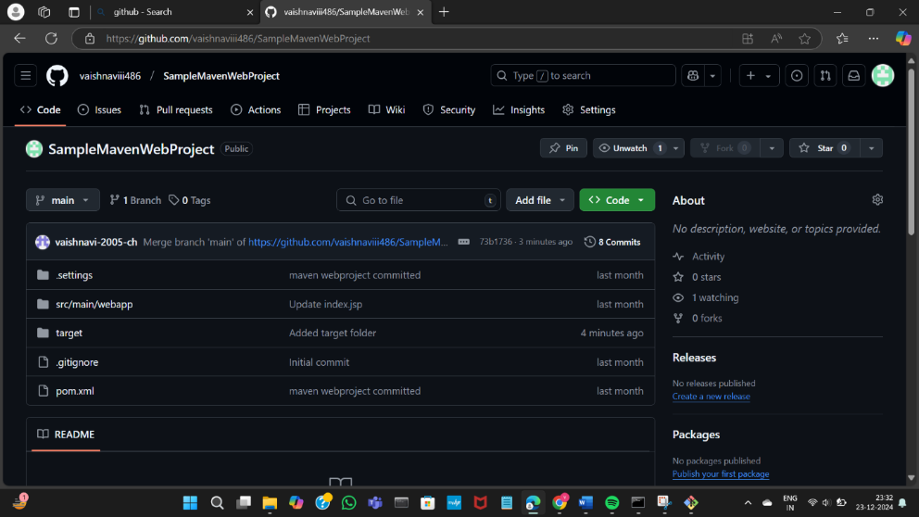

Make sure that the target folder contains .war file

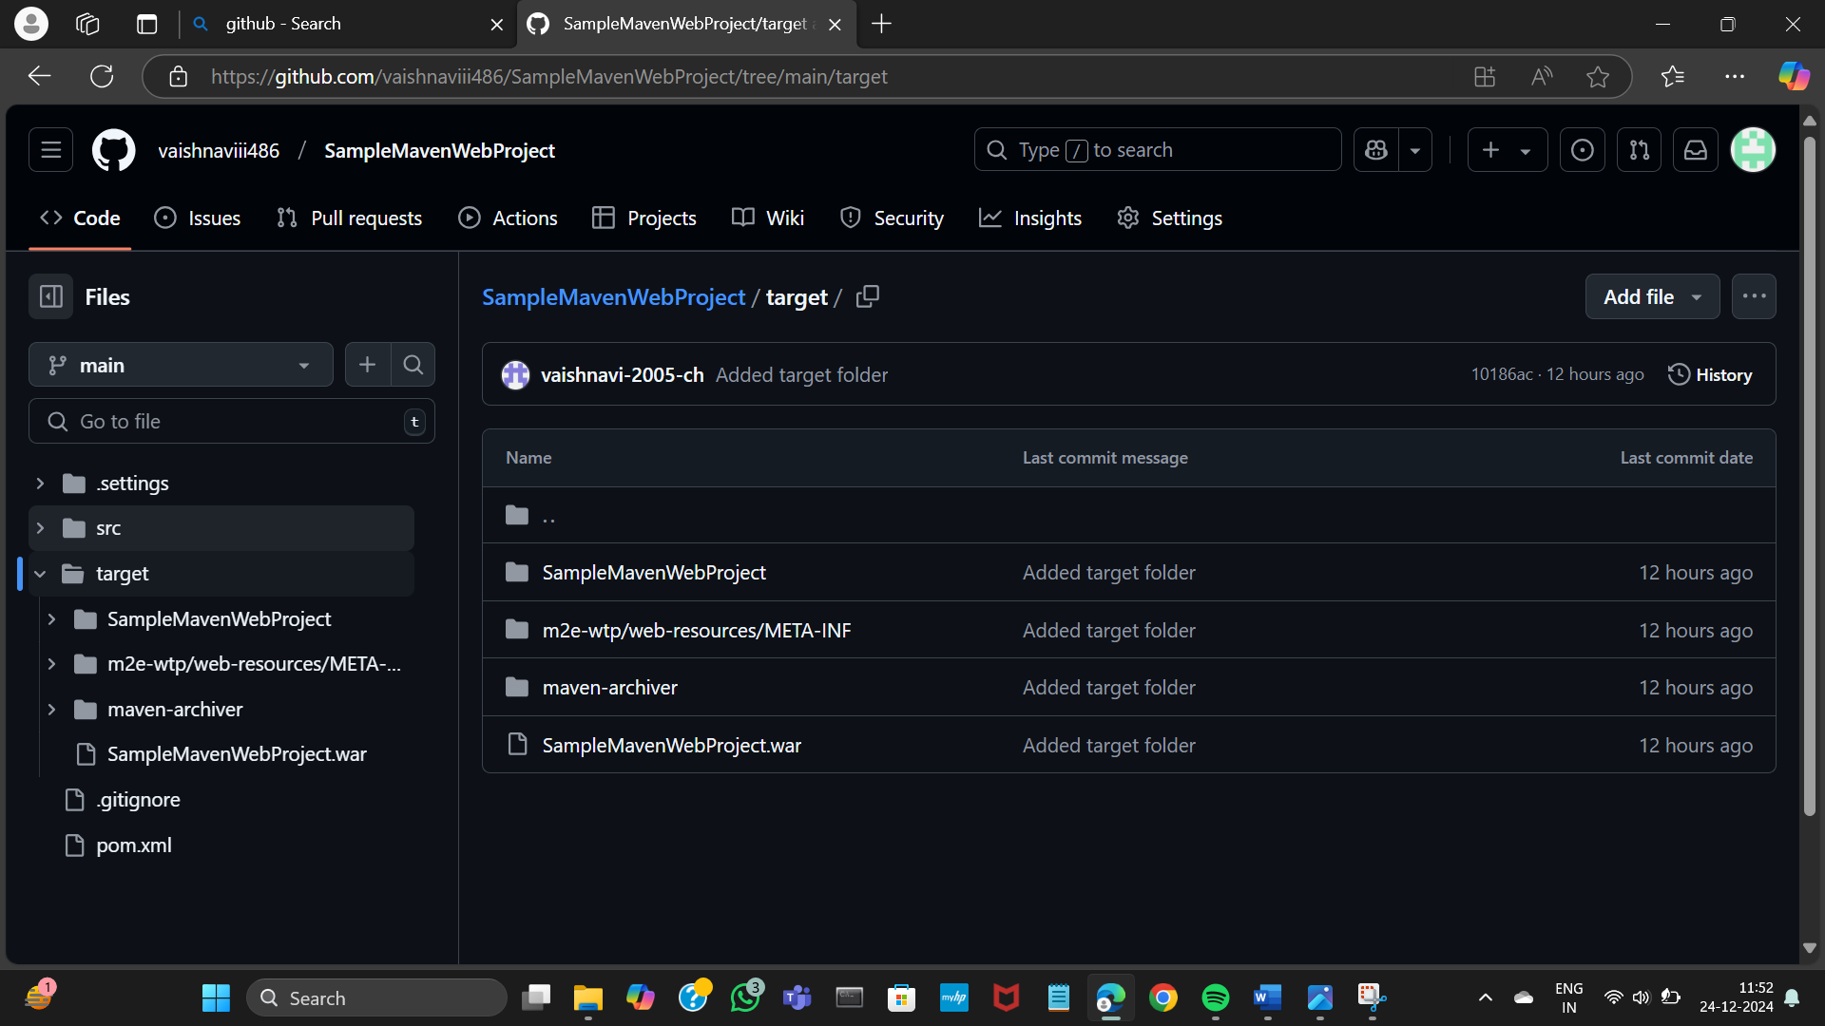

Copy the url from the git hub and paste it in the command prompt

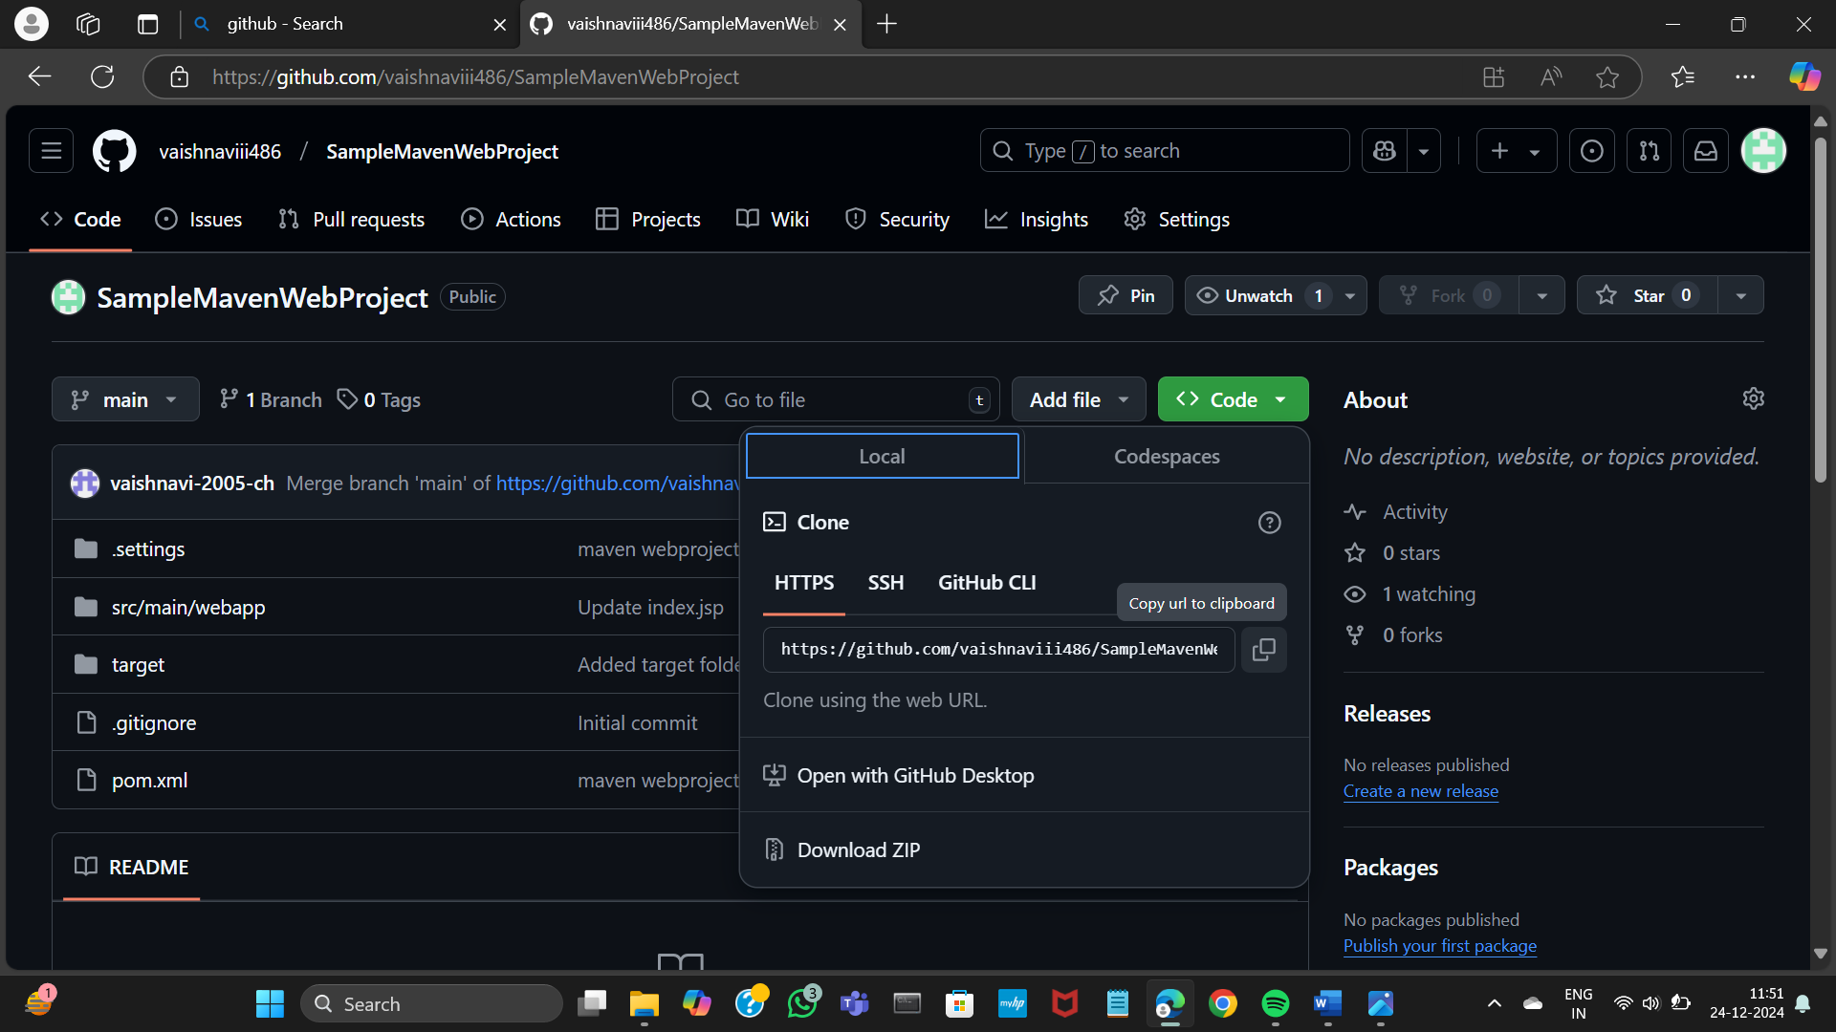

Type ls It should give the repository name

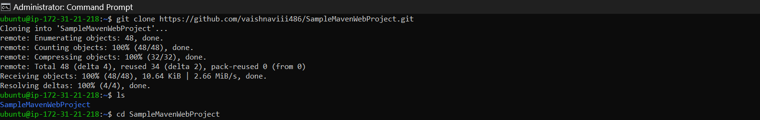

Go to the directory where the repository is present

Create a file Dockerfile

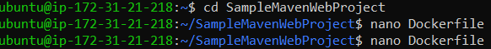

Write the content in the docker file

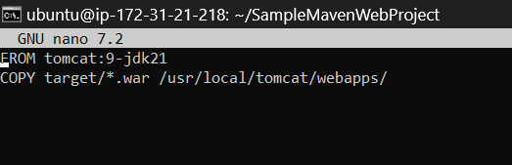

To build the project type the command : sudo docker build -t mavenwebproject .

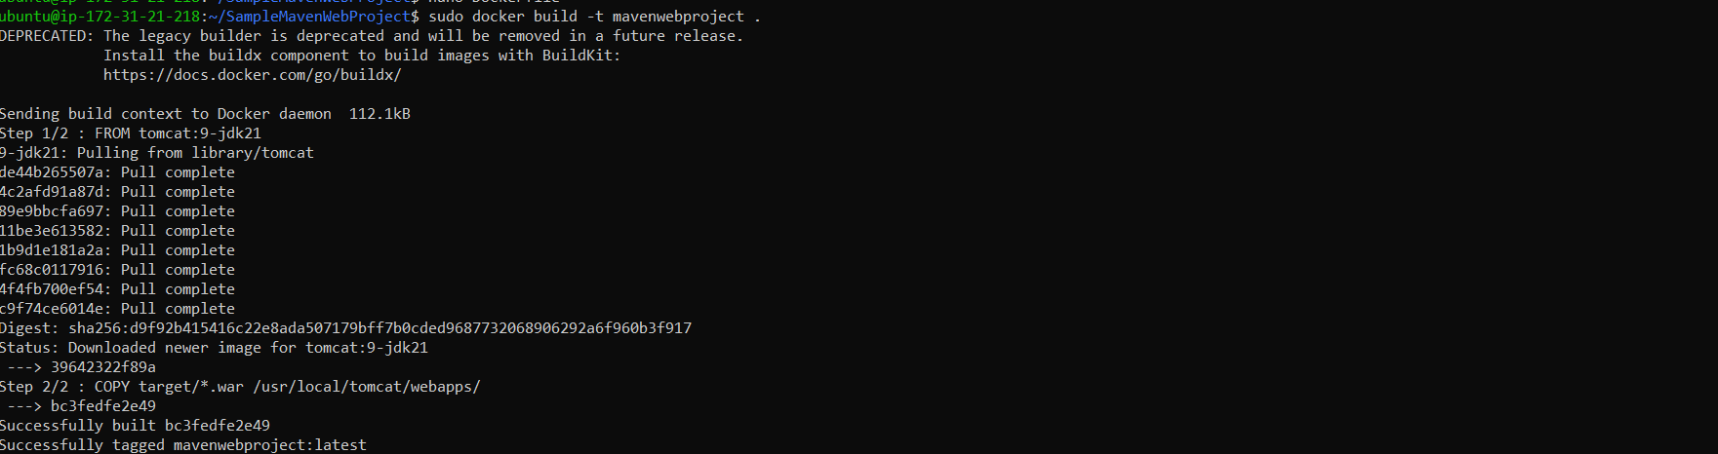

To visit the project in a browser type the following command

sudo docker run -d -p 9090:8080 mavenwebproject

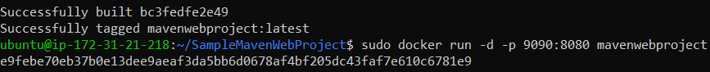

Go to the instances page and copy the ipv4 address

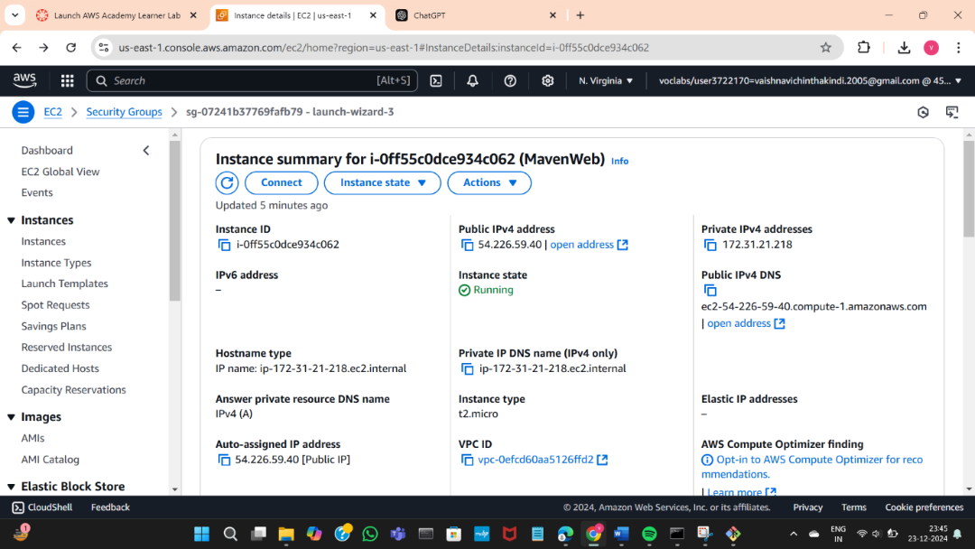

Open a new tab and type the copies address along with :9090/SampleMavenWebProject

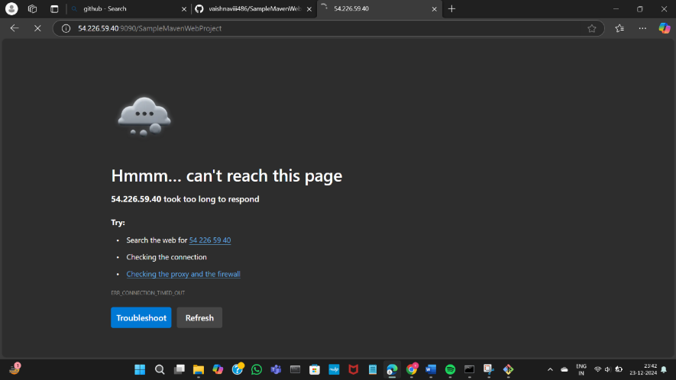

If this is giving a error go to the instances , scroll down for security button

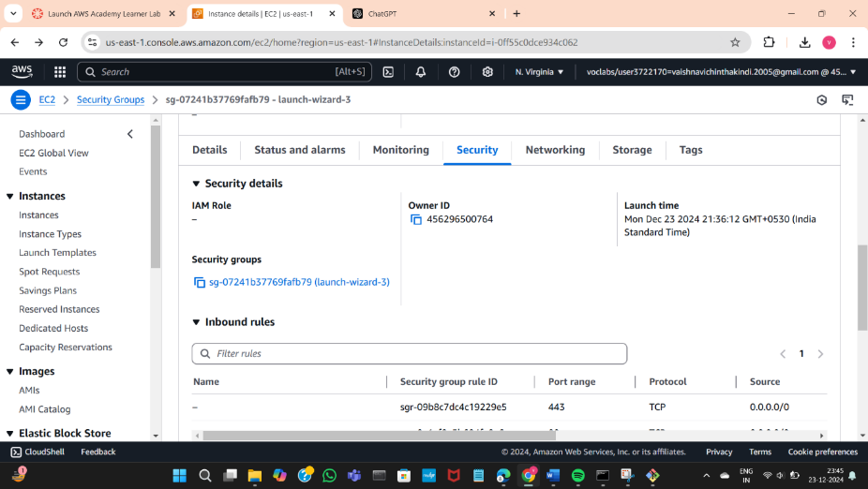

Scroll down and check if the prot 9090 is present in the inbound rules

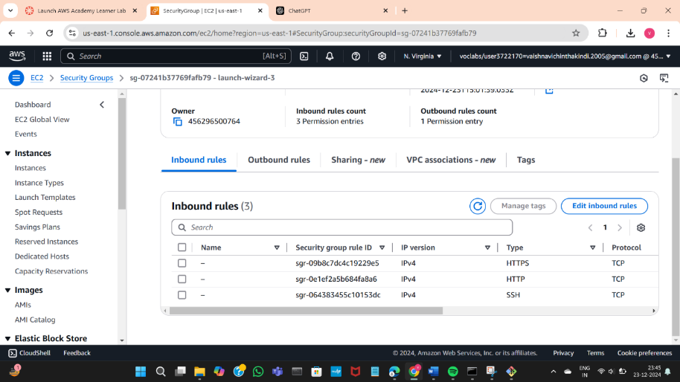

Check for security groups and click the below link

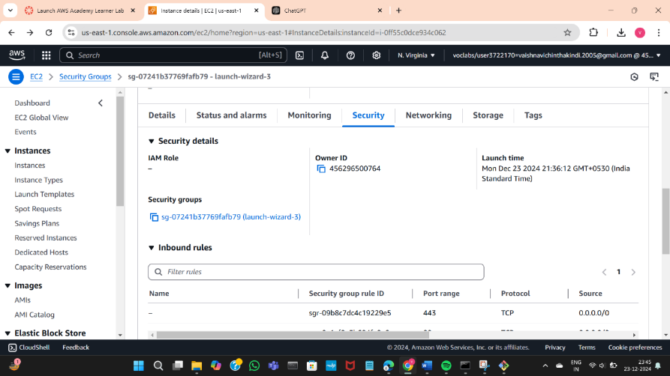

If it is not present, add the port manually Add 9090 port number and select 0.0.0.0/0

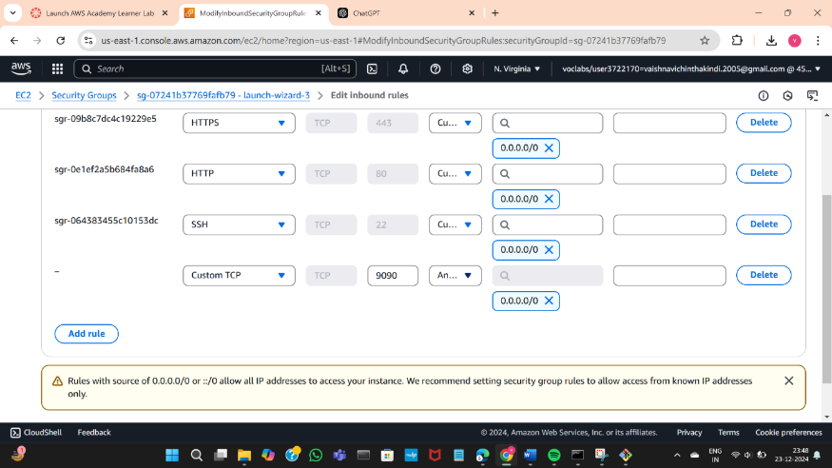

Click on save rules button present in the bottom right corner

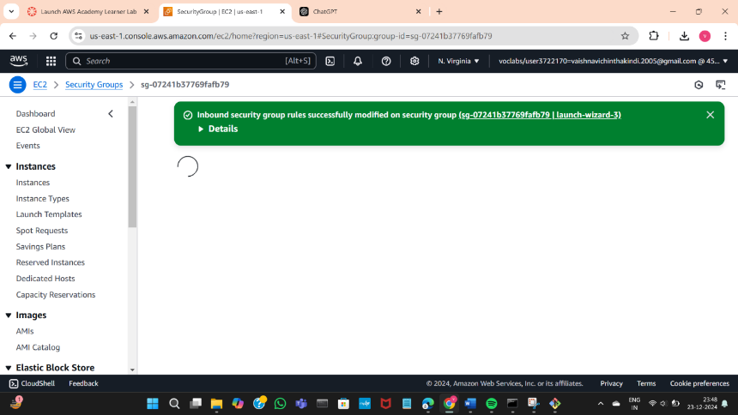

Now you can see port 9090 in the inbound rules

You can now refresh the page where you have entered the ipv4 address

You can see the message which you have created in the maven web project

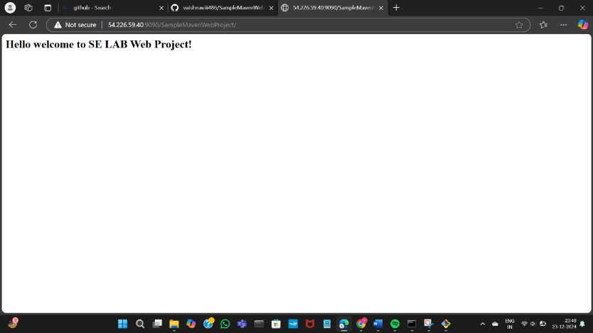

Docker ps

sudo docker stop ,exit

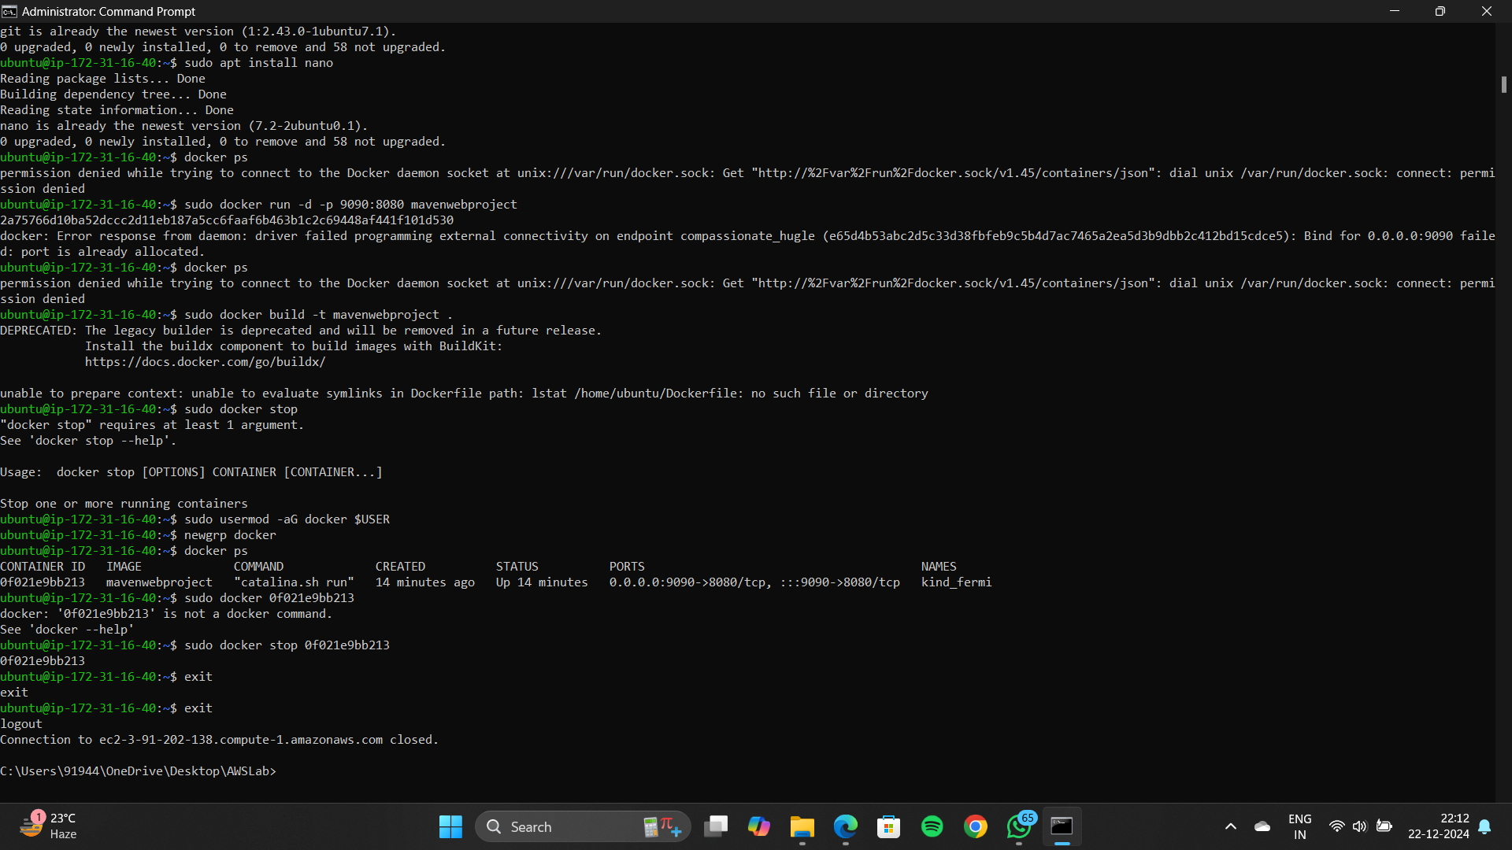

Now go to instances page and click on instance state and select terminate instance

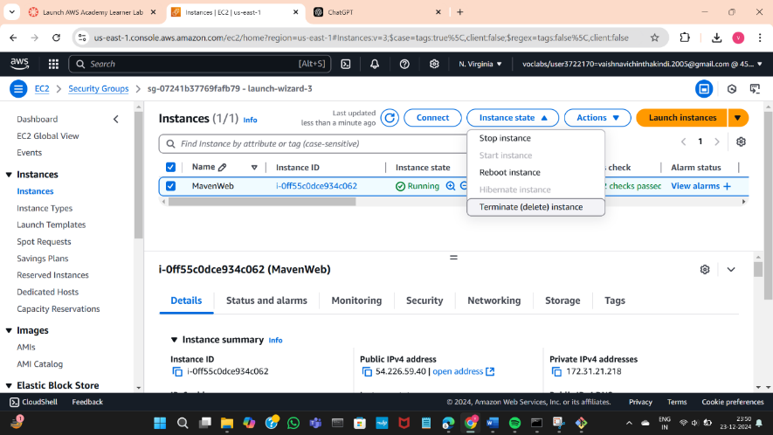

Click on terminate(delete)

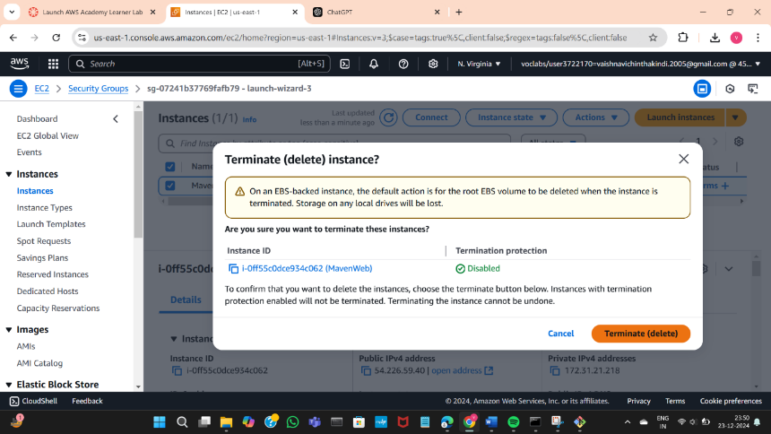

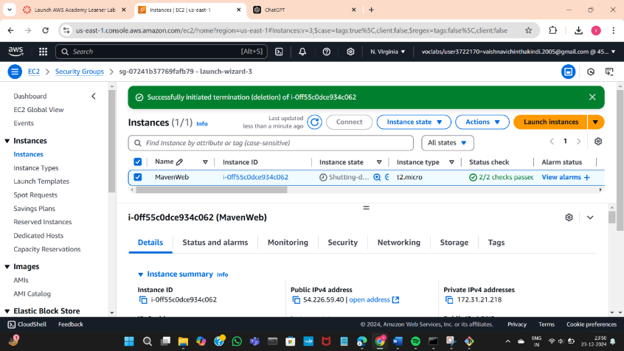

Wait until the message turns to terminated

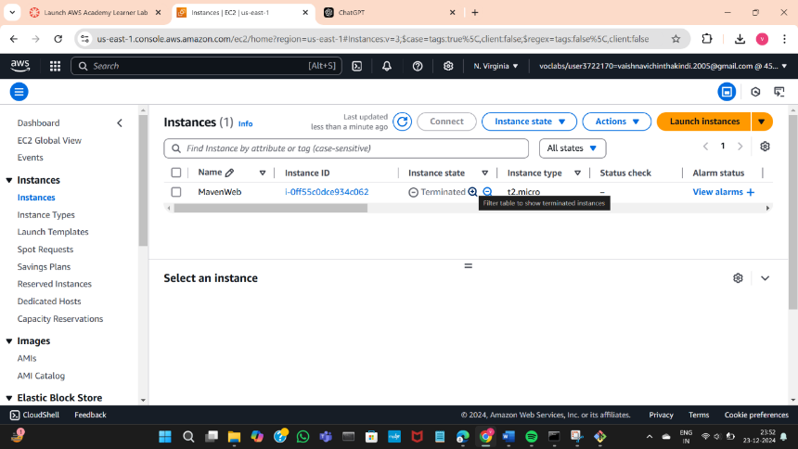

Now go to AWS lab click on end lab, click yes

